SBC – Sept. 6, 2026
#52
Revelation 21:5-8 (NKJV)
“A Contrast of Destiny”

Prayer

Slide # 1

Revelation 1:19 – Inspired Outline
Revelation 1:19 (NKJV)
19 “Write the things which you have seen, and the things which are, and the things which will take place after this.
- “have seen” – Past (Vision of Christ) – Ch. 1
- “which are” – Present (Church Age) – Ch. 2-3
- “after this” – Future (Post-Church Age) –Ch. 4-22
- - Scene in heaven –Ch. 4-5
- - Tribulation – Ch. 6-18
- - Second Coming – Ch. 19
- - Kingdom – Ch. 20
- - Eternal State – Ch. 21-22

In our study, we have come to the END – which we commonly refer to as the Eternal State.

Slide # 2
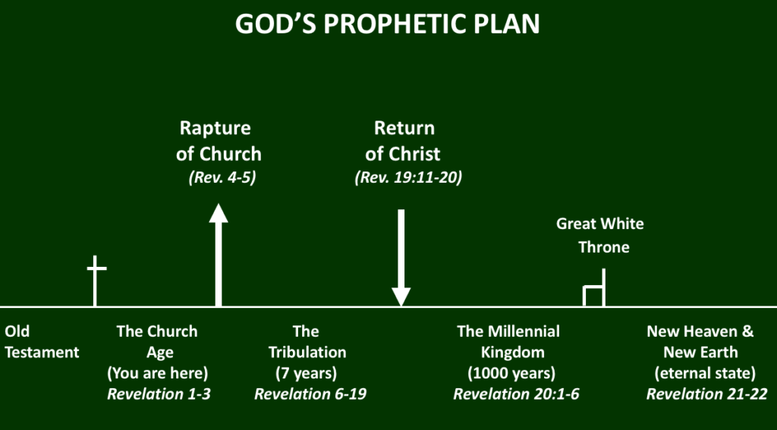

All people have an eternal destiny. The saved will end up in the New Jerusalem, which is the special place God has prepared for His people. In contrast, the unsaved will end up in the lake of fire, eternally separated from God.

Revelation 21 and 22 are largely a description of the New Jerusalem, but scattered throughout are final warnings concerning the alternative destiny – which is the lake of fire.
The warnings are CLEAR and GRAPHIC because God does not want anyone to go to the lake of fire. He takes no pleasure in the death of the wicked (cf. Ezek. 18:32; 33:11; 2 Pet. 3:9).

In the eternal state, we find that the first heaven and earth are passed away, and God creates a new heaven and a new earth. Then John saw the holy city New Jerusalem coming down out of heaven from God, which will apparently reside on the new earth.

Rev. 21:1-4 brings out several salient points about the New Jerusalem.

Slide # 3
THE NEW JERUSALEM

A holy city
A prepared city
An indescribably beautiful city
A city where God intimately dwells with His people
A city where never again will the effects of sin be felt
- No more tears
- No more death
- No more sorrow
- No more crying
- No more pain

All these “negatives” (the “no mores”) are said to have belonged to the former things which in the eternal state will have passed away never again to be experienced by God’s people. They will be forever behind us!

But as noted last week, the most wonderful thing about the New Jerusalem is that this will be where God most intimately dwells with His people forever. Three times in the single verse of Revelation 21:3, this is emphasized.

We now continue our study, picking it up at Revelation 21:5…

Revelation 21:5–8 (NKJV)
5 Then He who sat on the throne said, “Behold, I make all things new.” And He said to me, “Write, for these words are true and faithful.”

Clearly God is the One on the throne.

But there is some debate over whether this is the Father speaking or the Son. Some point to 1 Corinthians 15:24-28, where, before the beginning of the eternal state, the Son delivers the kingdom over to the Father and therefore assume this is the Father speaking.

Others point to the fact that in the eternal state the THRONE is now said to be occupied by the Father and the Son, as seen in Revelation 22:1.

In the end, this is clearly God speaking, whether it be specifically the Father or the Son, and what God from His eternal throne says is, “Behold, I make all things new.”

The word “new” (kainos) emphasizes “new in character.” It can also mean “new in time” in that it is, in fact, a NEW reality that was not in place before. However, there is a different word for “new” (neos) that more naturally emphasizes new in time, and that word is not used here.

Heaven is still heaven, earth is still earth, Jerusalem is still Jerusalem, but they are now transformed into a BRAND NEW FORM! In fact, all the relationships of the previous order are now made NEW!

The old order involving the heaven, and the earth was tainted by sin. But now God has made a total purge of all sin and all things contaminated by sin.

What is in view here is the end of all things temporal as polluted by sin.

Slide # 4

Acts 3:21 (NKJV)
21 whom heaven must receive until the times of restoration of all things, which God has spoken by the mouth of all His holy prophets since the world began.

Romans 8:21 (NKJV)
21 because the creation itself also will be delivered from the bondage of corruption into the glorious liberty of the children of God.

And what makes this restoration, this making of all things new, possible is the work of Christ on the cross.

Slide # 5
Colossians 1:20 (NKJV)
20 and by Him to reconcile all things to Himself, by Him, whether things on earth or things in heaven, having made peace through the blood of His cross.

The reconciliation won by Christ reaches to all the alienations that result from our sin—alienation from God, from ourselves, between persons, and between us and our physical environment. The biblical picture therefore is at once personal, ecological, and cosmic. As mind-boggling as the thought is, Scripture teaches that this reconciliation even includes the redemption of the physical universe from the effects of sin as everything is brought under its proper headship in Jesus (Rom. 8:19–21).[15] – Howard A. Snyder

Aren’t NEW things great?

As a young man bought a brand new car. It was a cheap PINTO, but it was new nonetheless. I remember the SMELL of the car. It was so fresh – the smell of newness. I remember when I had a new office built onto the house we lived in. I would walk around in it and just enjoy the NEWNESS of it. There is something about NEW that is invigorating and stimulating.

But the problem with NEW things in the here and now is that they begin to age right away – to break down. The second law of thermodynamics immediately goes to work. It does not take long or much use, and the newness begins to wear off. Soon it needs to be replaced.

However, God is going to make ALL THINGS NEW! And it will be in a context where nothing will ever get old. How great is that going to be?

Everything will be new, fresh, and perfect, just as in creation week, and they will stay that way. The entropy law (aging, decay, death) will have been repealed, for the curse will be done. – Henry M. Morris

Jesus will bring healing and peace to all creation, including the earth, land, and all creatures. In every area where sin mars and destroys, Jesus fixes and renews – “I am making all things new” (Rev. 21:5).
– Dr. Michael Vlach

This is a brief glance at the thinking behind God’s eternal plan; to allow sin and its destruction to produce a greater work of making all things new. – David Guzik

God said, “I make all things new,” and then He told John, “Write, for these words are true and faithful.” The words in view are those found in Revelation 21:1-5a pertaining to the creation of a new heaven and earth and the realities presented in connection with the New Jerusalem.

God wants this recorded! Perhaps John was so flabbergasted by what he was seeing that he momentarily forgot to keep writing. In the book of Revelation, when God wants a special emphasis made, He says, “write” (cf. Rev. 14:13; 19:9).

God at this point wants an exclamation point made here! He wants this stressed and emphasized as being true and faithful!

True and faithful are very close in emphasis, making it the sense of a DOUBLE emphasis, making this the sense of a solemn guarantee of truthfulness.

True means genuine or authentic, and faithful means reliable or trustworthy! This is absolutely certain! You have God’s emphatic WORD on it (cf. Rev. 22:6; also see Rev. 3:14; 19:9, 11).

Slide # 6

2 Peter 3:13 (NKJV)
13 Nevertheless we, according to His promise, look for new heavens and a new earth in which righteousness dwells.

6 And He said to me, “It is done! I am the Alpha and the Omega, the Beginning and the End. I will give of the fountain of the water of life freely to him who thirsts.

We sometimes joke about wishing to have an “easy button” where we just push the button, and it is done. But no problem for God. He no sooner says, “Behold, I make all things new,” and then immediately He follows up with “It is done!” That was quick! No drawn-out process needed!

“It is done!” Signifies completion of the NEW CREATION. The transition from the old to the new is now complete. It is a statement of finality.
It is in the perfect tense, indicating completed action with continuing results! It stands as accomplished and completed forever!

The FOREVER STATE of the NEW ETERNAL STATE is now in place. This is the ETERNAL STATE. Things will never change again! This is the permanent state of things forever.

There are three great “It is finished/It is done” statements in Scripture.

Slide # 7

“It is finished!” – Atonement completed – John 19:30
“It is done!” – Judgment on earth completed – Rev. 16:17
“It is done!” – A New World Order established – Rev. 21:6

Slide # 8

Ephesians 1:10 (NKJV)
10 that in the dispensation of the fullness of the times He might gather together in one all things in Christ, both which are in heaven and which are on earth—in Him.

At this point, the reconciliation of all things in Christ will be complete. Everything at this point will find unity and order in Christ. The harmony and unity that God intended for His universe will have been restored in Christ. The goal of history is moving to the point when the whole of redemptive history will all be in tune with Jesus Christ as the head of the universe.

Note the whole of the universe (heaven and earth) is in view here. This looks to the time when there is a new heaven and a new earth (cf. Rev. 21-22).

The One who does and says this is “the Alpha and Omega, the Beginning and the End.”

Alpha is the first letter of the Greek alphabet, and Omega is the last letter. “The Beginning and the End” is interpretive, giving the sense of the “Alpha and Omega”.

He was the Alpha in the book of Genesis. Now in this book He is the Omega. Whatever He originated, He will complete.
– Unknown Author
The “Alpha and Omega” title is used of the Lord four times in the book of Revelation. Two of those times it is definitively used specifically of the Lord Jesus Christ, showing that He is God (cf. Rev. 1:8, 11; 21:6; 22:13; also see Isa. 44:6; 48:12).

Slide # 9

Revelation 22:12–13 (NKJV)
12 “And behold, I am coming quickly, and My reward is with Me, to give to every one according to his work.
13 I am the Alpha and the Omega, the Beginning and the End, the First and the Last.”

Everything starts and ends with God! He is the Creator and the Consummator of all things! He begins and completes His plan! And He owns everything in between, as He is totally sovereign over every detail of history.

"There is not a square inch in the whole domain of our human existence over which Christ, who is Sovereign over all, does not cry: 'Mine!'" - Abraham Kuyper

God is sovereign over the sum of all things! He created all, He controls all, He ends all – in terms of the old order! As the Bible says, “Of Him and through Him and to Him are all things.” (Rom. 11:36; cf. Eph. 4:6).

The Sovereign One (the Alpha and Omega, the Beginning and the End) then interjects this promise: “I will give the fountain of the water of life freely to him who thirsts.” The issue in view is who is now going to share in the all things made new? It is those who drink of the water of life!

This is GIVEN – it is a gift that is given. God says, “I will give.” It is not earned or merited! Note: It is given “freely,” meaning it is all of grace! This is a take off from Isaiah 55:1…

Slide # 10

Isaiah 55:1 (NKJV)
1 “Ho! Everyone who thirsts, Come to the waters; And you who have no money, Come, buy and eat. Yes, come, buy wine and milk Without money and without price.

The “fountain of the water of life” descriptively speaks of eternal life as defined by Christ (cf. Jn. 7:37-39).

Slide # 11

John 4:13–14 (NKJV)
13 Jesus answered and said to her, “Whoever drinks of this water will thirst again,
14 but whoever drinks of the water that I shall give him will never thirst. But the water that I shall give him will become in him a fountain of water springing up into everlasting life.”

It is given “freely” to “him who thirsts.” To be thirsty is to want it. You gotta wanna! There is no hope for the satisfied person! This is speaking of spiritual thirst that looks to Jesus and finds satisfaction in Him!

Slide # 12

John 7:37–38 (NKJV)
37 On the last day, that great day of the feast, Jesus stood and cried out, saying, “If anyone thirsts, let him come to Me and drink.
38 He who believes in Me, as the Scripture has said, out of his heart will flow rivers of living water.”

Thirst implies a spiritual need that is acknowledged and looks to God for fulfillment as found in Jesus. Being thirsty implies wanting to be satisfied and looking to Jesus for fulfillment! It acknowledges a spiritual need and finds the spiritual thirst quenched in the gift of God.

Being “thirsty” implies coming; it implies desire, as seen in Revelation 22:17.

Slide # 13

Revelation 22:17 (NKJV)
17 And the Spirit and the bride say, “Come!” And let him who hears say, “Come!” And let him who thirsts come. Whoever desires, let him take the water of life freely.

Here [in Rev. 21:6] God gives the water freely; in 22:17 the thirsty one receives it freely. … God’s promise implies a thirst that is ready and eager to accept…” – Robert Thomas
It is free, but you have to come. It is free, but you have to want it! It is free for the taking, but you have to come to Jesus and receive Him on His terms to get it! And His terms are believing on Him as Lord and Savior!

Slide # 14

John 6:35 (NKJV)
35 And Jesus said to them, “I am the bread of life. He who comes to Me shall never hunger, and he who believes in Me shall never thirst.

Matthew 5:6 (NKJV)
6 Blessed are those who hunger and thirst for righteousness, For they shall be filled.

Thou hast made us for thyself, O Lord, and our heart is restless until it finds its rest in thee. - Augustine

“I do not know about you, but I have never really been satisfied with this life. I have found myself frustrated, I have found myself hemmed in, and I have never been able to accomplish all that I have wanted to accomplish. I’ve never been the man I wanted to be. I’ve never been the husband I’ve wanted to be. I’ve never been the father I’ve wanted to be. And I’ve never preached the sermon I’ve wanted to preach. I just do not seem to have arrived.” – J. Vernon McGee

In Christ we know satisfaction in the here and now, and yet in our human weakness we are not yet totally complete. We long for eternity. As Paul said: In these bodies we groan, “earnestly desiring” the time when “mortality will be swallowed up by life” (2 Cor. 5:2, 4). In the eternal state, we will know complete fulfillment, complete satisfaction as found in Christ (cf. Rev. 7:16-17).

'If I find in myself desires which nothing in this world can satisfy, the only logical explanation is that I was made for another world.'
– C.S. Lewis
Slide # 15

Ecclesiastes 3:11 (NKJV)
11 He has made everything beautiful in its time. Also He has put eternity in their hearts, except that no one can find out the work that God does from beginning to end.
No one in this life fully finds the complete and total fulfillment for which they are destined. That awaits eternity, which God has put in our hearts. We were made for eternity!

7 He who overcomes shall inherit all things, and I will be his God and he shall be My son.

Who can fathom the grandness of this verse?

In the book of Revelation, true believers are called “overcomers.” The devil and the whole world are against them, but by the grace of God they are overcomers!

“Overcomes” means to conquer, to triumph, to have the victory, to be the winner.

Slide # 16

1 Corinthians 15:57 (NKJV)
57 But thanks be to God, who gives us the victory through our Lord Jesus Christ.

Overcomers are repeatedly made special promises in reference to Christ addressing the 7 churches in Revelation 2-3. (cf. Rev. 2:7, 11, 17, 26; 3:5, 12, 21; cf. 12:11).

Slide # 17
OVERCOMERS IN REVELATION…

Right to eat from the tree of life – Rev. 2:7
Protected from the Second Death – Rev. 2:11
Clothed in white garments – Rev. 3:5
Name written in the Book of Life – Rev. 3:5
Will sit with Christ on His throne – Rev. 3:21
Overcome by the blood of the Lamb and by the word of their testimony – Rev. 12:11
Are willing to die for Christ – Rev. 12:11
Will inherit all things – Rev. 21:7

John also wrote the book of 1 John and there he plainly said what defines an overcomer.

Slide # 18

1 John 5:4–5 (NKJV)
4 For whatever is born of God overcomes the world. And this is the victory that has overcome the world—our faith.
5 Who is he who overcomes the world, but he who believes that Jesus is the Son of God?

Overcomers are those who put their FAITH in Jesus as the Son of God, meaning they believe in Him as God of very God – the One who shares in the very nature of God.

True believers (overcomers) “shall inherit all things.” This is an incredible promise – so awesomely great that we can’t get our minds around it.

Inheritance is most commonly what is bestowed on someone because of family union and relationship. As overcomers in union with God, we will inherit ALL THINGS as His children.

“All things” means all things! Everything in the New heaven and earth, everything in the New Jerusalem we shall have part in. It’s all ours! Let’s explore the new heaven and what God has there for us; let’s explore the new earth and what is our inheritance there. But most special, let’s explore the New Jerusalem and all that is in store for us there.

And this verse is not in isolation. Romans 8:17 says we are “heirs of God and joint heirs with Christ.” We will share in all that belongs to Christ. And what belongs to Him? Everything! Hebrews 1:2 says of the Son, “whom He has appointed heir of all things.” God has given all to His Son, and the Son shares it all with us as joint-heirs. We have a share in all that belongs to Jesus!

Slide # 19

Romans 8:32 (NKJV)
32 He who did not spare His own Son, but delivered Him up for us all, how shall He not with Him also freely give us all things?

1 Corinthians 3:22 (NKJV)
22 whether Paul or Apollos or Cephas, or the world or life or death, or things present or things to come—all are yours.

But again, most special and most precious will be our eternal relationship with God, and so He says, “I will be his God and he shall be My son.”

Yes, all the “all things” will be gloriously special, but nothing is more precious than our eternal intimate relationship with God.

The Greek word son here (huios) emphasizes “rights of sonship.” Another Greek word (teknon) is more commonly used, which emphasizes an intimate relationship bond. Here, the word emphasizing all the rights of sonship is used! This relates closely to “inheritance.” The word “son” (Gk. huios) denotes a person who is a rightful heir! God shares the inheritance of all things with His children!

When people die, they often leave everything they have to their children. In this case, the living God is going to give everything to His children! And He has a lot to GIVE – the fullness of a new heaven, a new earth, and a new Jerusalem!

Slide # 20

Psalm 16:11 (NKJV)
11 You will show me the path of life; In Your presence is fullness of joy; At Your right hand are pleasures forevermore.

Even in this life we have the privileged position of adopted sons (cf. Jn. 1:12; Rom 8:14-17; 2 Cor. 6:18; Gal. 4:5; Eph. 1:5; Heb. 12:5-9; 1 Jn. 3:1). But only in the eternal state will we enter into the fullness of our inheritance (1 Pet. 1:4; Rom. 8:23). Right now we have the pledge of our inheritance in the Holy Spirit, but then we will enter into the full inheritance (Eph. 1:13-14).

Receiving the full inheritance is special, but nothing is as wonderful and precious as the personal relationship we have with the person who bestows on us the inheritance. And so it will be with us and God!

Our personal relationship with Him as God is most valuable. He is everything to us! Our Savior! Our protector! Our provider! Everything wonderful is from His good hand. As James 1:17 says, “Every good gift and every perfect gift” is from the Father. We can’t thank God as our God enough. We can’t adore Him enough. We can’t worship Him enough. This is how we will feel through all eternity. It will be constant worshipful adoration as we revel in the glories of the glory land!

And He will love us supremely forever! He will enjoy us supremely and fully! We will be His intimate children with whom He shares absolutely everything. Nothing will be withheld. All that is good and glorious will be for us for all eternity! He will be our God, and we will be His sons and daughters.

This wonderful truth is so awesome that it is repeated twice in close succession, being found in verse 3 and now again in verse 7. This is the greatest thing about the eternal state for God’s children. We will be forever in glorious relationship with our God, and He in glorious relationship with us.

Slide # 21
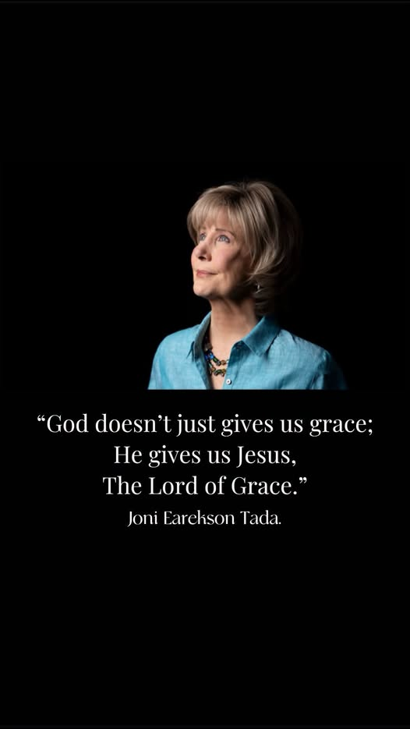

8 But the cowardly, unbelieving, abominable, murderers, sexually immoral, sorcerers, idolaters, and all liars shall have their part in the lake which burns with fire and brimstone, which is the second death.”

But is a contrast word. There is no greater contrast of destiny than that which is found in verse 7 versus that which is found in verse 8. On the one hand is the eternal blessed state of the overcoming believers – on the other hand is the lake of fire for the damned.

What an awful reality is introduced by this word “But”. It is almost jarring to have it introduced into this discussion of all things new and the inheritance of the believer. What a graphic contrast, emphasizing those who not only won’t inherit all things, but rather will have their destiny in the lake of fire.

God is making a point. Ultimately, there are two destinies, and every person here will share in one or the other. They are polar opposites. The one is all forever good and glorious, and the other is all forever bad and horrendous!

Often at the graveside committal, I will read from Revelation 21. Once as I was reading, I felt pressure to end at verse 7 on a good note, and so I did. But God convicted me that this is not the full story. Ever since, I have consistently included verse 8. People in their depravity don’t like to hear this! Oh, they are good with it up through verse 7 but want to stop there! But verse 8 is also part of the word of God and needs to be shared!

In contrast to the eternal overcomers/winners, these are the eternal losers as seen in verse 8.

The lost here in verse 8 are cataloged under 8 characteristic headings. There are similar lists of what characterizes the lost in Romans 1:28-32, 1 Corinthians 6:9-10, Galatians 5:19-21, 2 Timothy 3:2-5, and Revelation 22:15. The bottom line is that these people don’t have a saving relationship with Jesus, and it reflects itself as a pattern of life in these ways.

The bottom line of why people are lost is because they are not believers in Christ. John the gospel of belief makes it emphatically clear the ultimate issue is BELIEF/FAITH/TRUST, which are all interchangeable!

Slide # 22
John 3:18 (NKJV)
18 “He who believes in Him is not condemned; but he who does not believe is condemned already, because he has not believed in the name of the only begotten Son of God.

But this is not some easy believism that has no relation to how we live. No, true saving faith results in regeneration and transformation. It alters the direction of one’s life. It does not signify perfection in our practice but rather a lifestyle change in direction.

As reformers were known to say: “We are saved by faith alone, but the faith that saves does not remain alone.” This is the consistent teaching of Scripture. A saving faith is a life-changing faith!

UNBELIEF reflects itself in how people characteristically live. That is the point of Revelation 21:8.
“At the day of doom men shall be judged according to their fruits. It will not be said then, did you believe? But were you doers or talkers only?”
– John Bunyan

Note the following categories of lost people…

- The cowardly: The foremost thing mentioned is cowardice. The idea of “cowardly” is to be fearful or afraid to commit to Christ because of the consequences.

“It refers to those who repudiate their faith in Christ when faced with persecution and opposition. Without steadfast endurance based on that faith, they are not true followers of the Lamb. … These are people who have never taken to heart the words of Jesus, which said, “Whoever wishes to save his life will lose it, but whoever loses his life for My sake and the gospel’s shall save it” (Mk. 8:35). – Robert Thomas

These people won’t commit to Christ because of the ridicule, persecution, or difficulties that will come if they do truly come to Christ. What will family say? I might lose my friends. I will be made fun of. I may lose my job. I may be tortured or killed. They are fearful cowards! Consequently, they don’t commit to Christ and are eternal losers instead of overcomers!

- Unbelieving: Can also be understood as untrustworthy or disloyal. These are people who may profess, but they are not genuine followers of Christ. They do not have a faith that follows Christ.

- Abominable: Meaning vile or polluted. They are engaged in detestable practices that God hates as a pattern of life. This is what characterizes their lives.

- Murderers: They do not value human life. They are cold-blooded killers. This is not talking about self-defense or involvement in war. This is homicide whether in the womb or otherwise – it is the taking of human life (cf. Gen. 9:6; Matt. 5:21-22). 1st John 3:15 equates hatred to the sin of murder in seed form in the heart.

- Sexually immoral: This refers to those who practice sex outside the bounds of marriage, whatever form it may take. It includes people who immorally live together outside of marriage, adulterers, homosexuals, etc.

Slide # 23

Ephesians 5:3 (NKJV)
3 But fornication and all uncleanness or covetousness, let it not even be named among you, as is fitting for saints;

1 Thessalonians 4:3 (NKJV)
3 For this is the will of God, your sanctification: that you should abstain from sexual immorality;

Hebrews 13:4 (NKJV)
4 Marriage is honorable among all, and the bed undefiled; but fornicators and adulterers God will judge.

Sex is blessed by God in the context of marriage (Song of Solomon) – but outside of marriage it is absolutely forbidden and is characteristic of the lost!

Paul absolutely hammers this point with the Corinthians. In 1 Corinthians 5 he says believers should not even so much as eat with a professing believer involved in sexual immorality (1 Cor. 5:9-11). Then in chapter 6 he exhorts them to not be deceived, saying those who practice immorality will not inherit the kingdom (1 Cor. 6:9-11).

There are always those who claim to be Christian and yet live immorally. They are deceived! Someone says, “What about David? Yes, he fell and was miserable until repentance (Ps. 32, 51) and then had to live with life-long consequences. Still, it didn’t define the overall pattern of his life.

- Sorcerers: This is the translation of the Greek word (pharmakeus), which is related to our English word “Pharmacy”. It denotes the combination of drug use and occult involvement. Often, drug-altered states of consciousness are involved in occult practices. These people are involved in witchcraft, magic arts, the occult, and traffic with demons.

- Idolaters: Those who worship something else as a “god” other than the one true God. Idolatry is putting anything else in the rightful place of God. It is living for anything else before God.

“Idolaters are those who are devoted to any object, spirit, person or practice which replaces the love of God in their lives.”
– Henry M. Morris
- And all liars: People by nature are natural liars. It is one of the first sins that children do. You don’t have to teach them to do it – it comes naturally. People in general are pathological liars. “The heart is deceitful above all things, and desperately wicked” (Jer. 17:9). God hates a lying tongue (Prov. 6:16-19).

“Once Abraham Lincoln entertained a friend at his home in Springfield, Illinois. The guest, upon seeing Lincoln’s small son peeking timidly at him from another room, lured the child to his lap by promising him his watch charm. As he was preparing to leave, Mr. Lincoln reminded him of his promise to his son. Oh, that charm – the man said, laughing – I couldn’t part with it. It’s been in the family for generations. Lincoln sternly replied: Then, sir, I ask that you never visit this home again. I don’t want my son to remember me as entertaining liars.”

However, we need to remember that the apostle John, who wrote the book of Revelation, also wrote the book of 1st John, and there he defined what he means by a “liar.”

Slide # 24
1 John 2:3–4 (NKJV)
3 Now by this we know that we know Him, if we keep His commandments.
4 He who says, “I know Him,” and does not keep His commandments, is a liar, and the truth is not in him.

A liar according to John is someone who claims to have a saving relationship with Jesus, but their life of disobedience shows them to be a liar.

“Liars are foremost among those doomed to an eternity outside the new creation as evidenced by their appearance in each of the three lists of the ones excluded therefrom (cf. 21:8, 21:27; 22:15).”
– Robert Thomas

In Revelation 20:12, it says the lost will be judged according to their works. In view here, in 21:8 are those works.

Slide # 25
Those Characterized by…

- Cowardly = Afraid to stand for Jesus
- Unbelieving = faithless, faithlessness
- Abominable = Vile/Offensive Lifestyle
- Murderers = hateful/murderous ways
- Sexually Immoral = illicit sexual practices
- Sorcerers = traffic in drugs and demons
- Idolaters = place anything ABOVE or in the place of God
- Liars = pretend Christians

Destined for the LAKE OF FIRE!

“It should be obvious that this passage is not affirming salvation by works, but rather is referring to works as indicative of whether one is saved or not.” – John Walvoord

Those who live this way give evidence that they are not saved, and the text says that they shall all have…

“Their part in the lake of which burns with fire and brimstone, which is the second death.”

Their part – is in contrast to the inheritance that belongs to the believer. Their lot is in the lake of fire.

Sin has wrecked and ruined this world, and God is determined it will not ruin the world to come. – John Phillips

The first reference to fire in the Bible was in Genesis 19:24 in regard to Sodom and Gomorrah, where it was also connected to brimstone, which is sulfur. Here is the last reference to fire in the Bible, and again it is associated with brimstone.

The picture is one of an environment of suffering involving a stifling sulfur that makes you gag and takes your breath away. It is a picture of anything but satisfaction. There is no rest there. No respite. Just eternal unsatisfied desires.

This is further described as “second death,” which is eternal death in which body, soul, and spirit will be eternally separated from God in the lake of fire.

The choice is clear, and God has made it very graphic. Psalm 1 describes two men, two ways, and two destinies. This is the conclusion of the Bible: There are two kinds of people, two different lifestyles, and two contrasting destinies. There are overcomers who will inherit all things, and there are those who will have their part in the lake of fire.
In the end, either your destiny is Revelation 21:7 or it is Revelation 21:8.

Slide # 26
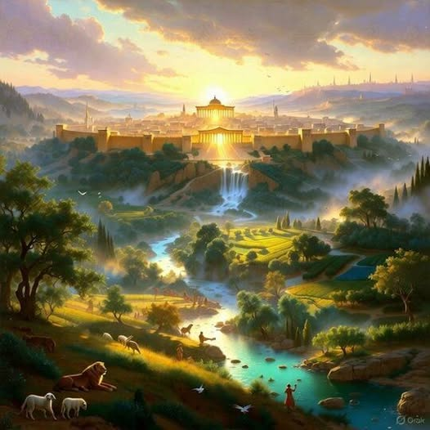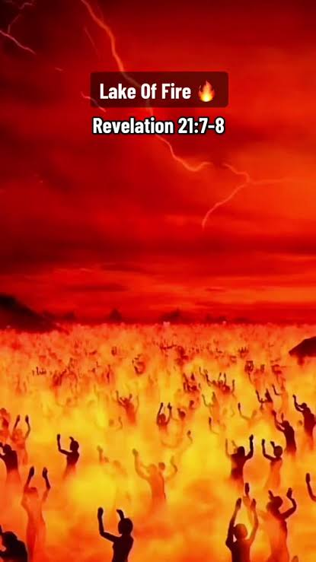

And the difference depends on what we do with Jesus in the here and now. It is appointed unto men once to die, and after that the judgment (Heb. 9:27).

Slide # 27
John 3:36 (NKJV)
36 He who believes in the Son has everlasting life; and he who does not believe the Son shall not see life, but the wrath of God abides on him.”

1 John 5:12 (NKJV)
12 He who has the Son has life; he who does not have the Son of God does not have life.

It all comes down to Jesus and whether you have Him as your personal Lord and Savior or not! That is the great divide for all eternity.

At the funeral, it's all good news or all bad news. There is no “in between” news! God alone renders the final verdict on everyone's life – but I, as a messenger, am here to warn us all that eternity is in the balance and that without a life-changing faith in Christ, all is lost forever.

Death is the point of no return!

When you finally get where you are going – where will you be? Will your destiny be Revelation 21:7 as an overcomer, or will it be Revelation 21:8 in the lake of fire?

Believe on the Lord Jesus Christ, and you will be saved!

