SBC – Aug. 9, 2026
#48
Revelation 20:7-10 (NKJV)
“The Final Revolt”
Prayer

Slide # 1

Revelation 1:19 – Inspired Outline
Revelation 1:19 (NKJV)
19 “Write the things which you have seen, and the things which are, and the things which will take place after this.
- “have seen” – Past (Vision of Christ) – Ch. 1
- “which are” – Present (Church Age) – Ch. 2-3
- “after this” – Future (Post-Church Age) –Ch. 4-22
- - Scene in heaven –Ch. 4-5
- - Tribulation – Ch. 6-18
- - Second Coming – Ch. 19
- - Kingdom – Ch. 20
- - Eternal State – Ch. 21-22

For many centuries, man has dreamed of a “golden age,” a “utopia” in which the human race will be free from war, sickness, and even death. Men have tried to achieve this goal on their own and have failed. It is only when Jesus Christ reigns on David’s throne that the kingdom will come and the earth will be delivered from the oppression of Satan and sin. – Warren Wiersbe

As noted in Revelation 20:1-6, at the Second Coming of Christ Satan will be bound in the abyss for 1000 years and all the saints brought back to life under the umbrella of “First Resurrection” will share in the reign of Jesus Christ. It will truly be a golden age for humanity with Jesus ruling as King of kings and Lord of lords.

Slide # 2
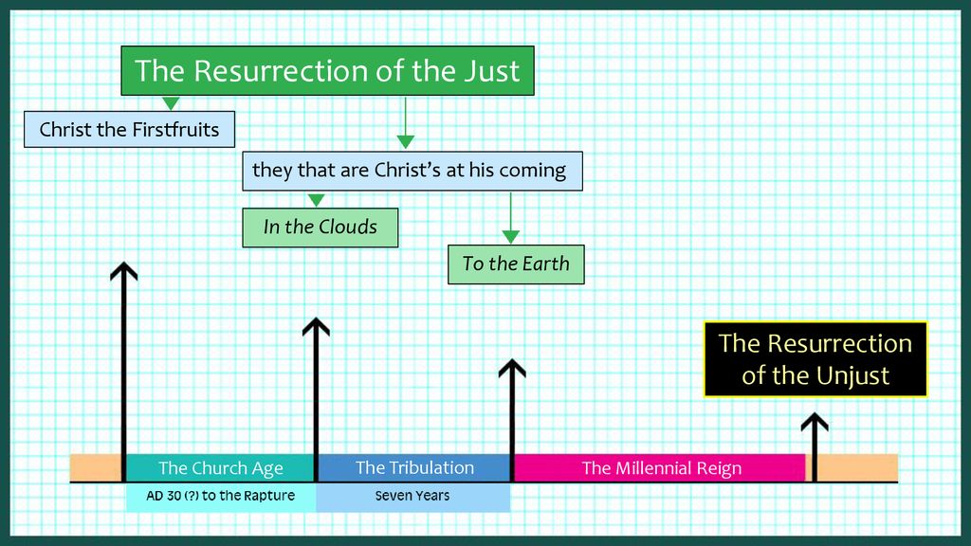
This resurrection of the Just takes place in stages but in total is called the FIRST resurrection, which is so designated in contrast with the LAST resurrection, which is the resurrection of the unjust (lost). Revelation 20:5 specifically says the LOST will not be resurrected until after the 1000-year reign of Christ.

Dr. Michael Vlach, in his book titled “Premillennialism” with the subtitle, “Why there must be a Future Earthly Kingdom of Jesus,” gives four reasons for the coming millennial (1000-year) reign of Jesus.

Slide # 3

- There must be a successful reign of man and the Last Adam (Jesus) from and over the realm where God tasked the first Adam to rule.
- Jesus must have a sustained and visible reign in the realm where He was rejected.
- There must be a vindication and reign of the saints in the realm where they were persecuted.
- There needs to be a time in history when all aspects of the biblical covenants and promises are fulfilled. Dr. Michael Vlach

In our study today, we are in that little niche of time following the millennial kingdom and before the Great White Throne judgment.

Slide # 4
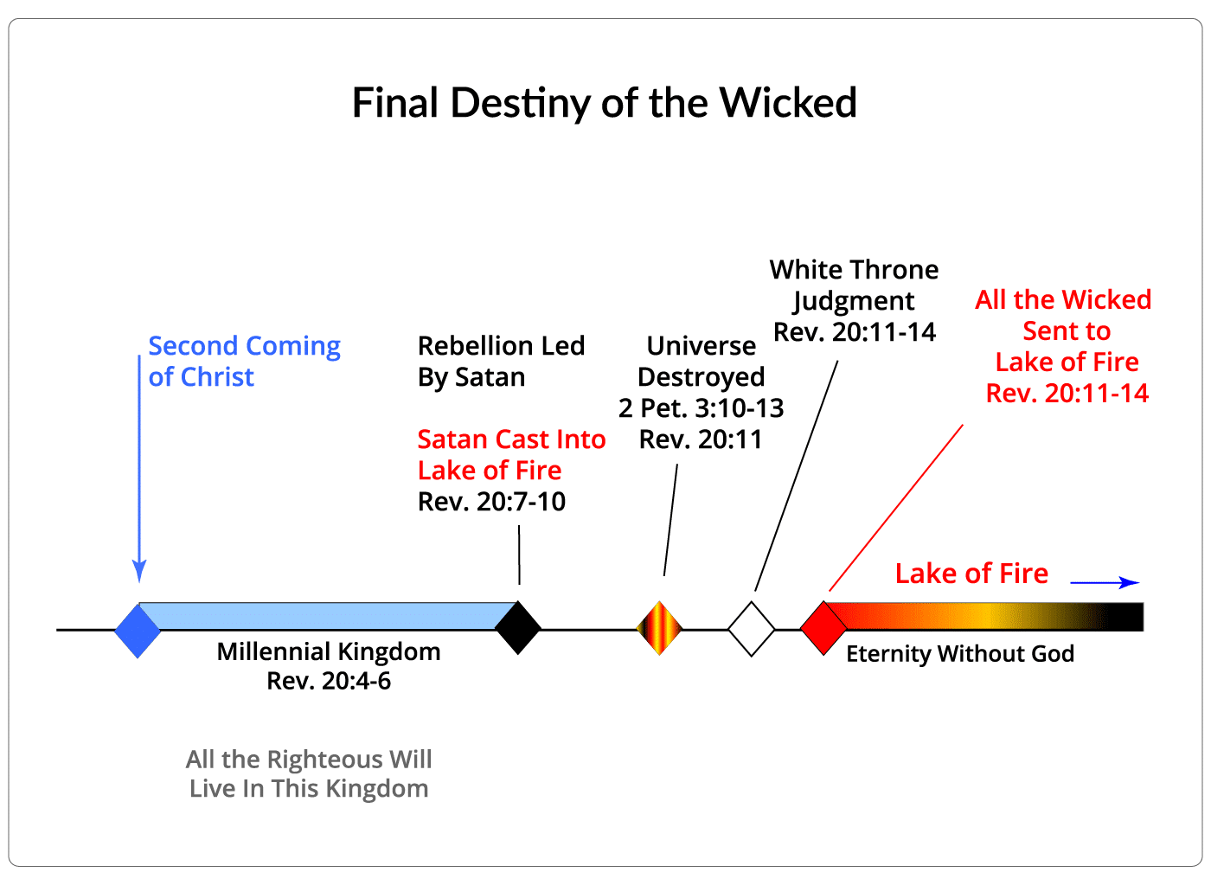

Revelation 20:7–10 (NKJV)
7 Now when the thousand years have expired, Satan will be released from his prison

For one thousand years Satan has been in the bottomless pit (the abyss where the spirits of the wicked are found). But now he is released from his prison.

Satan’s actions are always subject to what God allows (cf. Job 1:12; 2:6). God permits some things, He prevents some things, and He promotes some things, but all things are under His sovereign control.

So the question arises as to WHY God would allow Satan to be released? Well, we are not specifically told, but most solid Bible scholars believe this is the final TEST for the human race. Just as the Tribulation Period came upon the whole world “to test those who dwell on the earth” (Rev. 3:10), so likewise this release will serve as a TEST to those who were born in and lived during the golden age of the kingdom.

Children of believing parents today sometimes become gospel-hardened; so, during the Millennium many will become glory-hardened. – John Phillips

Those who live in the millennial kingdom will have lived in essentially perfect conditions for 1000 years.

No war
No crime
No death (except for rare cases)
No bad weather – if they stay in line
No food shortages
No injustice
No corrupt leadership

The kingdom will be a perfect environment – so we might expect (at least those who think that mankind is essentially good) that people would be HAPPY and celebrate this situation. You would think they would be rejoicing in the goodness and blessing of God – grateful for His kingdom reign.

Wrong! The opposite is true!

Here is a PERFECT example that things could be PERFECT and depraved people still would not be happy.

Man is depraved, through and through, totally corrupted by sin! Depravity is UGLY through and through!

At the conclusion of the 1000 years we find that Satan hasn’t changed his deceitful ways a bit.
You might think that after a thousand years in the bottomless pit he would have had a change of mind. You would be wrong. His nature has not changed.

Also, people have not changed. They too still have a fallen, rebellious nature, and given the opportunity to demonstrate itself, it does so in mass. You see, it is a lie that people are basically good. It is a lie that if their environment was favorable, they would be good. It is a myth that if their circumstances were ideal, they would live right. NO- NOT TRUE!

As to the theologically reasonings as to WHY God allows this, note that down through history God has consistently TESTED man in various ways. Man has always FLUNKED the test, showing his depraved nature and the need for the grace of God.

We call these eras of testing, stewardships, or – DISPENSATIONS.

Slide # 5
“Dispensationalism is a system of interpretation that seeks to establish a unity in the Scriptures through its central focus on the grace of God. Although dispensationalists recognize differing stewardships or dispensations whereby man was put under a trust by the Lord, they teach that response to God’s revelation in each dispensation is by faith (salvation is always by grace through faith). Dispensationalists arrive at their system of interpretation through two primary principles: (1) maintaining a consistently literal method of interpretation, and (2) maintaining a distinction between Israel and the church.” - MOODY HANDBOOK OF THEOLOGY

A Dispensation is a distinguishable economy, era, or stewardship in human history in which God TESTS mankind under a distinct rule of life, proving man to be a FAILURE and at every point and in need of the grace of God.

Commonly, there are often 7 dispensations that are recognized. There is overlap, and we can haggle over these details, but the basic format is clear.

In dispensational theology, history is divided into distinct periods where God tests mankind under a specific responsibility. In each era —from Eden to the millennial kingdom- we see human failure and subsequent divine judgment. This demonstrates that apart from the GRACE of God, humanity is a total failure, lost in total depravity.
For example, under Innocence: Adam and Eve were tested and failed by eating the forbidden fruit, resulting in the fall and expulsion from the garden.

Under Conscience, humanity was guided by an internal moral compass but failed as corruption and violence filled the pre-flood world, resulting in the judgment of the worldwide FLOOD.

Under the Mosaic Law, Israel proved unable to keep it and ultimately rejected their Messiah, resulting in worldwide dispersion.

Under the current dispensation of Grace, the gospel has gone out far and wide only to see advancing last days apostasy which will result in the false church going into the judgment of the Tribulation Period.

Finally comes the dispensation of the Kingdom involving a golden age of perfect conditions. Surely, mankind will succeed this time! Nope! As we see in our text today, after Christ's thousand-year reign on earth, when Satan is released, an innumerable amount of people will follow him in rebellion.

In all dispensations, including the golden age of the millennial kingdom, mankind is shown to be a total failure, lost in total depravity apart from the GRACE of God!

As I say, there is overlap in some of the responsibilities from dispensation to dispensation, but in and of himself mankind is not GOOD! Every “code of conduct” and corresponding context that God places man in – He demonstrates His depravity. God has shown this 7 times over. We need God! We can’t be right or live right without His grace. The rebellion at the close of the kingdom era puts the capstone on this truth.

Upon his release Satan…

8 and will go out to deceive the nations which are in the four corners of the earth, Gog and Magog, to gather them together to battle, whose number is as the sand of the sea.

Satan’s whole career as “Satan” has been about deception! It’s what he does. He is the father of lies (Jn. 8:44). He misled 1/3 of the angels (Rev. 12:4). He deceived Eve (Gen. 3).

Slide # 6
Revelation 12:9 (NKJV)
9 So the great dragon was cast out, that serpent of old, called the Devil and Satan, who deceives the whole world; he was cast to the earth, and his angels were cast out with him.

He is very good at what he does (deception) and has had great success. He deceives the whole world!

For one thousand years he was unable to apply his craft! There was no outside deception. The work of Satan was halted. The truth went forth unabated.

Slide # 7

Habakkuk 2:14 (NKJV)
14 For the earth will be filled With the knowledge of the glory of the Lord, As the waters cover the sea.

In the kingdom, ALL will know Who Jesus is, and they will bow to His sovereign authority. There will be no argument! As it says in Psalm 2:9; Revelation 2:27, and 19:15, Christ “will rule them with a rod of iron.” This is how it was for one thousand years!

But now there is a change in that Satan is again on the loose, and allowed to once again apply his deception, and people will be allowed to decide. Will they submit to the truth of Christ’s Lordship which has been on obvious display for a millennium, or will they listen to the lies of Satan that they can throw off His rule and be in charge of the world themselves!

It’s always a LORDSHIP issue. Will Christ rule or will people insist on self-rule? Satan’s deception is that self-rule is the better way! The devil’s theme song is “I did it my way!” God way is Jesus! He is the way, the truth, and the life (Jn. 14:6).

Satan goes out to deceive the nations “which are in the four corners of the earth.” This is a worldwide thing! Under the masterminded leadership of Satan, it spreads like wildfire, involving a worldwide movement!

Understand that when Christ comes at His Second Coming, there will be those who survive the Tribulation Period and go into the kingdom in their natural bodies just like you and I have today. They will procreate and repopulate the world under ideal kingdom conditions.
Slide # 8
Matthew 25:32–34 (NKJV)
32 All the nations will be gathered before Him, and He will separate them one from another, as a shepherd divides his sheep from the goats.
33 And He will set the sheep on His right hand, but the goats on the left.
34 Then the King will say to those on His right hand, ‘Come, you blessed of My Father, inherit the kingdom prepared for you from the foundation of the world:
Matthew 25:41 (NKJV)
41 “Then He will also say to those on the left hand, ‘Depart from Me, you cursed, into the everlasting fire prepared for the devil and his angels:

Only the saved will go into the kingdom!

Slide # 9
Zechariah 13:8–9 (NKJV)
8 And it shall come to pass in all the land,” Says the Lord, “That two-thirds in it shall be cut off and die, But one-third shall be left in it:
9 I will bring the one-third through the fire, Will refine them as silver is refined, And test them as gold is tested. They will call on My name, And I will answer them. I will say, ‘This is My people’; And each one will say, ‘The Lord is my God.’ ”

Romans 11:26 (NKJV)
26 And so all Israel will be saved, as it is written: “The Deliverer will come out of Zion, And He will turn away ungodliness from Jacob;

In the kingdom will be the saints in glorified bodies who partake in the “first resurrection.” There will also be the saints who survived the Tribulation who go into the millennial kingdom in their mortal bodies. So there will be this interesting combination of glorified people and people living in their natural bodies – all living together on planet earth. What an interesting combination that will be.

Then add to the mix those unregenerate children who will be born to those in natural bodies. It is those children who are in view here in verse 8.

Though the initial inhabitants of the millennial kingdom [those in their natural bodies] will all be redeemed, they will still possess a sinful human nature. And as all parents have done since the Fall, they will pass that sin nature on to their offspring. – John MacArthur
Many of these children will not be converted. Even though they have lived in a perfect environment, they will still not be converted. Thus, they are ripe for Satan’s deception.

By the way, if Satan could lead a rebellion in heaven amongst the angels, he can certainly do this on earth at the close of the millennial kingdom. And, as allowed by God, he will do so!

In the millennial kingdom, evidently most people will live the duration of the one-thousand years. The curse will largely (but not completely) be removed, as some will still die. Apparently only people that are overt rebels will die, and if a person dies at the age of one hundred it will be as though a child died, suggesting lengthened lifespans will be the norm– perhaps extending throughout the entire millennium.

Slide # 10
Isaiah 65:20 (LSB)
20 “No longer will there be in it an infant who lives but a few days, Or an old man who does not fulfill his days; For the youth will die at the age of one hundred, And the one who does not reach the age of one hundred Will be thought accursed.

As Satan goes out to deceive the whole world, those under this umbrella of deception are described as “Gog and Magog.” This linkage of Gog and Magog is found only one other place in the Scriptures, and that is in Ezekiel 38-39. Now some think that what is described in Ezekiel is the same thing being described here. But there are too many differences for that to be the case. What we have here in Revelation 20:8 is a TYPE of “Gog and Magog” as seen in Ezekiel.

The war of Gog and Magog (cf. Gen. 10:2) in Ezekiel 38-39 actually takes place before the millennial kingdom, before the conversion of Israel (Ezek. 39:22), and before the Spirit is poured out on the house of Israel at the Second Coming (Ezek. 39:29).

Slide # 11

Ezekiel (Before the Kingdom)

Chapter 37 – Israel back in the land in UNBELIEF.
Chapter 38-39 – Gog and Magog in the “latter years.”
Chapter 40… - Millennial Temple/Kingdom

Revelation (After the Kingdom)

Chapter 19 – Second Coming.
Chapter 20:1-6 – Millennial Reign.
Chapter 20:7-10 – Gog and Magog.
Chapter 20:11-15 – Great White Throne Judgment.
Chps 21-22 – Eternal State

I take it the war of Gog and Magog in Ezekiel 38-39 takes place early in the Tribulation Period because Ezekiel 39:22 says from that time forward Israel will know YHWH as their God.

Slide # 12
DISTINCTIONS

Ezekiel 38-39 Revelation 20:8

Before the Millennium After the Millennium
Before Israel’s Conversion After Conversion
From North… From Whole World
Extended Burial… Incineration
Extended Cleansing Period THE END

Slide # 13
SIMILARITIES

Ezekiel 38-39 Revelation 20:8

Gog – key human leader Gog – key human leader
Magog – core constituents Magog – core constituents
Vast Alliance Vast Alliance
Invade the Land of Israel Invade the Land of Israel
Totally Decimated by God Totally Decimated by God

The conclusion is that “Gog and Magog” here in Revelation 20:8 is a type of Gog and Magog in Ezekiel 38-39, but it is a different event. Sometimes in the book of Revelation, names and places are used in a symbolic sense. When this is the case, it is obvious. For example, in Revelation 11:8 Jerusalem is symbolically called “Sodom and Egypt,” indicating how corrupted it had become under the Antichrist. In Revelation 17 the false church is called “Mystery Babylon the Great” (Rev. 17:5).
The best explanation is that John uses [Gog and Magog] as a kind of shorthand to describe what will happen. In Revelation 20 he’s saying, “It’s going to be Gog and Magog all over again.” …John may be using it much the same way that people today use the term Waterloo (the scene of Napoleon’s major defeat in 1815) to describe a crushing defeat. … Likewise, we speak of World War I and World War II. In the same way, I believe the Bible speaks of Gog and Magog I and Gog and Magog II. – Mark Hitchcock

Satan deceptively gathers this great alliance from around the world, evidently under key human leadership (Gog and his core constituency, Magog) with the purpose of banding together to battle the LORD and His people in Israel.

By the way, what are they going to fight with? In the kingdom, all weapons of war have been dispensed.

Slide # 14

Isaiah 2:4 (NKJV)
4 He shall judge between the nations, And rebuke many people; They shall beat their swords into plowshares, And their spears into pruning hooks; Nation shall not lift up sword against nation, Neither shall they learn war anymore.

But here they come with the intent to battle the Lord and His people. In their folly, they must have primitive clubs and knives or makeshift swords, or something. Or maybe in their sheer stupidity, they think simply that as a massive crowd we will physically take over them. All we know is that they are coming to Jerusalem with the intent to battle.

And the number involved is astounding.

Revelation 20:8 says, “whose number is as the sand of the sea.” This is hyperbole for saying they are innumerable. Realize that in the kingdom we will have utopian conditions. People will multiply and live LONG lives. We may have 30-40 generations of people living all at once in the kingdom

I am no math expert, but they tell us that over the span of 40 generations, the total number of ancestors in your direct family tree doubles each generation (2⁴⁰), which equals about 1.1 trillion potential ancestors.
Of course, that is not allowing for all kinds of negative extenuating circumstances. But again, we are talking about the kingdom where the negatives will largely be removed. It will be a population explosion that results in more people living on the earth, probably far more than have ever lived here before. And masses of them will not know the Lord even though He is here in person ruling from Jerusalem.

If the devil is so great as he seems to think he is, then why doesn’t he just overthrow God himself? In the famous “5 I wills” section of Isaiah 14, five times Satan says he himself is going to assume the position of God.

But it seems the devil himself doesn’t really believe that. He has always had the dumb idea that if he can just get the masses behind him, he will be able to defeat God. He got 1/3 of the angels in heaven to follow him (Rev. 12:4). But then he fell from heaven like lightning (Lk. 10:18). Under Antichrist, the world at large will follow him, and yet he will be cast into the pit for a thousand years. At every point he fails!

Sin is stupid! Depravity is stupid! Insanity is trying the same thing over and over, expecting different results! This is spiritual insanity.

Slide # 15
Revelation 19:19 (NKJV)
19 And I saw the beast, the kings of the earth, and their armies, gathered together to make war against Him who sat on the horse and against His army.

Revelation 20:8 (NKJV)
8 and will go out to deceive the nations which are in the four corners of the earth, Gog and Magog, to gather them together to battle, whose number is as the sand of the sea.

Here we go again! Let out of the prison of the bottomless pit, Satan is out to try again to overthrow God by getting a massive following to follow him in rebellion.

[These rebels who follow Satan] will be as unmoved by the peace, joy, and righteousness of the Millennium as sinners were by the devastating judgments of the Tribulation (cf. 9:20-21; 16:9, 11, 21).
– John MacArthur

Revelation 20:8 is one of the most astounding verses in the Bible, showing the absolute depravity of mankind. The issue is not a lack of evidence!
For crying out loud, the LORD Himself has been here ruling with a rod of iron for 1000 years, and they all knew it. They knew the truth of Him being King of kings and Lord of lords! Everybody in the kingdom “believes” in an intellectual sense. Intellectually, there is no denying the truth of the Lord!

But here is the deal: although outwardly they will submit, as Christ rules with a rod of iron, yet in their hearts they are rebels. Remember how it says in Zechariah 14 that if there are those who refuse to come “year to year to worship the King, the LORD of hosts,” that there will be no rain and they will receive the plague of the LORD (Zech. 14:16-19).

They say, “A person forced against his will is of the same opinion still.” Exactly! These people still have a heart problem. They are not repentant.

A child was forced to stand in the corner, and he muttered, “I'm standing on the outside but sitting on the inside.” These people are sitting on the inside in rebellion against Christ, and under Satan’s leadership, it manifests itself in an overt uprising of rebellion.

“Children born during this age will be born with sinful natures, needing to be saved, just as today, Children of believing parents today sometimes become gospel-hardened; so during the Millennium many will be glory hardened.” – John Phillips

By way of application: Just because people are in a church context or know the right lingo or go through the right motions does not mean they are believers in their heart. It is easy to play church and not be a real Christian.

In the end, it will all come out. I think especially of young people who grow up in the Christian culture. They float along – learning intellectually all we feed them, but where are their hearts really at? That is the ultimate issue!

The issue is always the HEART! The Bible says, “with the heart one believes unto righteousness…” (Rom. 10:10).

Note this is totally a LORDSHIP issue. Jesus comes as “KING OF KINGS AND LORD OF LORDS” to reign supreme. These people know the truth of Who He is, but they refuse in their hearts to bow before Him. Outwardly they do so, but in their hearts they are rejecting His LORDSHIP rule. This is always the issue in the matter of saving faith.

It is essentially a LORDSHIP issue. People are saved the same way in every generation, in every dispensation. The Hall of Faith chapter of Hebrews 11 makes that very clear.

God is no respecter of persons (Acts 10:34). He saves every person on the very same basis, namely on the basis of grace through faith. But it must be the right kind of faith. And the right kind of faith believes on Christ from the heart as Lord and Savior!

These rebels in the kingdom show once and for all that the great issue is one of LORDSHIP! They have a problem with Christ’s LORDSHIP authority! This is their problem, and it is the problem of every person who is lost. Savior cannot be divorced from Lord. Lord and Savior are an indissoluble package!

Slide # 16
Zephaniah 3:9 (NKJV)
9 “For then I will restore to the peoples a pure language, That they all may call on the name of the LORD, To serve Him with one accord.
Zechariah 13:9 (NKJV)
9 I will bring the one-third through the fire, Will refine them as silver is refined, And test them as gold is tested. They will call on My name, And I will answer them. I will say, ‘This is My people’; And each one will say, ‘The Lord is my God.’ ”

The expression of this in New Testament terms is when “Doubting Thomas” said to the risen Lord, “My Lord and my God!” and Jesus said, “Thomas, you have believed.” (Jn. 20:28-29) This is what it means to believe! My Lord is my Master, as Lord means Master. Thomas called on Jesus as “My God-Master.” That is the stuff of saving faith!

Calling on God as your LORD and Savior has application to every dispensation. We see it in the OT prophetically applied to the day of the Lord. We see it applied to the Church Age by Peter on the Day of Pentecost, and we see it applied to the church age by Paul. In each case, the issue is calling on the NAME of the Lord, which is a LORDSHIP issue.

Calling on the name of the LORD is personally recognizing Jesus for Who He is as sovereign Lord-Master and recognizing Him as your Savior! You call on Him as Lord to save you. That is saving faith.

Slide # 17

Joel 2:32 (NKJV)
32 And it shall come to pass That whoever calls on the name of the Lord Shall be saved. …

Acts 2:21 (NKJV)
21 And it shall come to pass That whoever calls on the name of the Lord Shall be saved.’

Romans 10:13 (NKJV)
13 For “whoever calls on the name of the Lord shall be saved.”

Only those who sincerely call on Him as LORD from their hearts are saved. These rebels in the kingdom will not do that. Those who are rebels in the here and now will not do that! They are lost. Have you made that call?

The sin of these “kingdom” rebels is glaring! The greater the light, the greater the accountability (Lk. 12:47-48).

Balaam was a false prophet who received direct messages from the LORD. Twice in Numbers 24 he admitted that he saw the vision of the Almighty and “falls down with eyes wide open.” (Num. 24:4, 16). He saw alright – he just wouldn’t submit to the truth of God’s LORDSHIP!

Slide # 18

2 Peter 2:15 (NKJV)
15 They have forsaken the right way and gone astray, following the way of Balaam the son of Beor, who loved the wages of unrighteousness;

2 Peter 2:20–21 (NKJV)
20 For if, after they have escaped the pollutions of the world through the knowledge of the Lord and Savior Jesus Christ, they are again entangled in them and overcome, the latter end is worse for them than the beginning.
21 For it would have been better for them not to have known the way of righteousness, than having known it, to turn from the holy commandment delivered to them.

These people KNOW the truth, and then they turn from it. There are many in Christendom in that condition. They know the truth, but they just won’t yield to it. They play all kinds of games with God to their own detriment!

Jesus said, MANY will say to Him, “Lord, Lord” (they say the right thing), but Jesus will say to them, “I never knew you; depart from Me.” (Mt. 7:21-23). They say Lord but never knew Him as Lord!

At Christ’s first coming, He told those who rejected Him that their accountability was greater because He was here in person (cf. Matt. 11-12). That was in His state of humility. Now He is back in all His glory… how much more accountable must these people be?

Note this speaks to the reality of an eternal hell! After 1000 years in torment, Satan is unchanged. After 1000 years, these rebels are unchanged, even though they live in the glory of kingdom conditions. People will never get out of hell because they will never repent. At death their nature is sealed forever! The reason hell is forever is that their rebellion is forever! There is no repentance in hell!

This is depravity at its darkest! It is the stuff we are all made of apart from the grace of God.

Slide 19
Jeremiah 17:9 (NKJV)
9 “The heart is deceitful above all things, And desperately wicked; Who can know it?

Slide # 20
Romans 3:10–12 (NKJV)
10 As it is written: “There is none righteous, no, not one;
11 There is none who understands; There is none who seeks after God.
12 They have all turned aside; They have together become unprofitable; There is none who does good, no, not one.”

Romans 3:23 (NKJV)
23 for all have sinned and fall short of the glory of God,

In Romans 3:10-18, Paul makes a 14-point indictment against the whole of humanity with the verdict that all have sinned and fall short of the glory of God. We have all come short of God’s holy standard.
That is why we need Jesus. That is why we need a Savior. There is no “holier than thou” amongst those who really understand grace. We are simply sinners saved by grace. Grace, grace, God’s amazing grace.

9 They went up on the breadth of the earth and surrounded the camp of the saints and the beloved city. And fire came down from God out of heaven and devoured them.

They come from the four corners of the earth – a massive collection of rebel humanity.

They went up on the breath of the earth or as it is also translated, “the broad plain of the earth.” They take up a large swath as they move into the holy land. At the Second Coming the topography of the world was so changed as to allow the whole world access to Jerusalem (cf. Zech. 14:4, 9-11).

They surround the camp of the saints and the beloved city. The word “camp” is commonly used of an encampment. And the thought is that on the outskirts of Jerusalem many of God’s people will be living. All God’s people will want to live CLOSE to Jesus.

The “beloved city” is Jerusalem. Repeatedly the Bible says God loves Jerusalem above all other locations (cf. Ps. 78:68; 87:2). It will be kingdom headquarters. It is the city of the great King (Ps. 48:2).

Slide # 21
Jeremiah 3:17 (NKJV)
17 “At that time Jerusalem shall be called The Throne of the Lord, and all the nations shall be gathered to it, to the name of the Lord, to Jerusalem. No more shall they follow the dictates of their evil hearts.

Isaiah 24:23 (NKJV)
23 Then the moon will be disgraced And the sun ashamed; For the Lord of hosts will reign On Mount Zion and in Jerusalem And before His elders, gloriously.

It’s always about Jerusalem! The most volatile place in the world today is Jerusalem. Israel is said to be the center of the world (Ezek. 5:5; 38:12). The center of Israel is Jerusalem and the epicenter is the Temple Mount. Spiritual warfare rages around Jerusalem! Prophetically, it is the epicenter!

At Armageddon, the whole world will rally against Jerusalem (Zech. 14:2). Here at the end of the millennium, Satan once again rallies the entire world against Jerusalem. Satan realizes that if he can take Jerusalem, he wins! But of course this is impossible!

God responds with a one-knockout punch – a decimating bolt of fire that instantly wipes them all out! Fire flashes from heaven, and they are incinerated.

There is no battle – they show up for one, and then they get FIRED! It is swift, complete, and final! It was not a battle at all – rather an execution! There is no burial here. They are totally consumed by fire! Hebrews 12:29 says, “our God is a consuming fire.”

“There is not a word about a conflict; not a shot is fired; not a saint is harmed. With a flash, the fire of God falls, and it is all over. Nothing remains but a heap of ashes. No carrion birds are summoned… They are cremated in the fires that slay them.” – John Phillips

The Bible uses just two verses to describe God summarily dispensing with the Antichrist at His Second coming and then with this vast Satanically arrayed army at the end (cf. Rev. 19:19-20; Rev. 20:8-9).

Just that quick it is over. This was NO CONTEST for God! It is beyond crazy to take on God! Only losers – eternal losers take on God!

10 The devil, who deceived them, was cast into the lake of fire and brimstone where the beast and the false prophet are. And they will be tormented day and night forever and ever.

He is called “Satan” in verse 7, meaning “adversary,” and he is called “devil” in verse 10, meaning “slanderer.” He is a slandering deceiver. He deceived these masses into thinking they could actually take God on and win.

Fallen, depraved people are easy victims for the devil. Fallen people in deception believe what they want to believe. In rebellion against God, “they willfully” overlook the truth (2 Pet. 3:5), they “suppress the truth in unrighteousness” (Rom. 1:18), “they love darkness rather than light” (Jn. 3:19); and they do not receive the love of the truth that they might be saved (2 Thess. 2:10). Hence they are deceived by the master deceiver!
His strategy never changes! He came to Eve in Genesis 3:1 saying, “Has God indeed said?” This is always his deception – to undermine and challenge what God has plainly said. And fallen people are very susceptible to his lies because depravity is already inclined to rebellion.

The devil at this point is cast into the lake of fire, which is his final destination. This is the ultimate bruising of his head (a fatal wound) which was predicted in Genesis 3:15.

Slide # 22

The devil’s downward progression…

Rev. 12:9-10 – Cast to the earth
Rev. 20:1-3 – Cast into the abyss for 1000 years
Rev. 20:10 – Cast into the lake of fire

Romans 16:20 (NKJV)
20 And the God of peace will crush Satan under your feet shortly. The grace of our Lord Jesus Christ be with you. Amen.

His destiny is described as “the lake of fire and brimstone.” Brimstone is essentially sulfur. This phrase consistently denotes the final place of everlasting punishment and torment. Once people are in the lake of fire there is no getting out. It is forever!

And note that he is cast into the lake of fire where the beast (who is antichrist) and the false prophet are. They were cast into the lake of fire 1000 years earlier, and they are still there (cf. Rev. 19:20). The devil now joins them, so the “evil Trinity” is forever together in the lake of fire.

This verse provides strong evidence that the lake of fire punishment is not temporary. Annihilation is not in view. For 1000 years the beast and false prophet (both humans) have been in the lake of fire, and they are still there. They were not annihilated as some wrongly teach.

In fact, the text goes on to say that they will be tormented day and night forever and ever. There is never any relief throughout eternity. This is unimaginable, but it is true.

This place was prepared for the devil and his angels (demons) but sadly all those who follow the devil in his deception will join him there.
Slide # 23
Matthew 25:41 (KJV)
41 Then shall he say also unto them on the left hand, Depart from me, ye cursed, into everlasting fire, prepared for the devil and his angels:

Matthew 25:46 (KJV)
46 And these shall go away into everlasting punishment: but the righteous into life eternal.

The very same Greek word that defines punishment is the one that defines eternal life. If the punishment is not eternal, neither is the life, but in fact both are eternal in duration, meaning never-ending.

They will be “tormented day and night forever and ever.” This is a way of saying continually and perpetually. This is never-ending torment. “Forever and ever” means forever. It is irreversible and eternal. There is no escape! There is no relief!

Margaret Sangster, a social worker, told her colleagues about seeing a small boy in an urban ghetto sitting on the stairs of a tenement. He appeared to be little more than a bit of twisted human flesh. The youngster had been struck by an automobile several months before, but his parents, fresh from Appalachia, neglected to get him proper medical attention. Although not part of her caseload, she took the boy to an orthopedist and learned that through an involved series of operations the child’s body could be made normal again. She cut through the red tape, raised the funds, and set the process of a cure in motion.
Two years after the boy entered the hospital, he came to her office. To her astonishment, he walked in without crutches, and to demonstrate the completeness of his recovery, he turned a cartwheel for her. The two embraced. When the youngster left, Margaret said to herself – “If I never accomplish anything else in my life, at least here is one young man to whom I can point where I have made a real difference!” As Margaret tells this story at this point, she pauses and says, “This was all several years ago now – where do you think the boy is today?” Perhaps a school teacher – a physician – or perhaps a social worker? Another long pause: No, he is in the penitentiary for one of the foulest crimes a human can commit.
Then Margaret says: “I was instrumental in teaching him how to walk again, but there was no one to teach him where to walk.”
Only God can change a human heart! As Jeremiah said, it is no more possible for a person to change themselves spiritually than it is for a leopard to change its spots (Jer. 13:23).

You might train the flesh to behave to a point. You might change the environment, the circumstances, but unless one is born again, they spiritually remain unchanged! One can have the MOST FAVORABLE status imaginable and yet the nature of a person is never truly changed until they are born again. Come to Jesus!

Slide # 24

Devil Crossover Point Jesus
Deception (Repentance/Faith) Truth
Damnation Life

Conversion

John 5:24 (NKJV)
24 “Most assuredly, I say to you, he who hears My word and believes in Him who sent Me has everlasting life, and shall not come into judgment, but has passed from death into life.

Have you crossed over? Have you passed from death into life through faith in Jesus!

Romans 10:13 (NKJV)
13 For “whoever calls on the name of the Lord shall be saved.”
In the end, there are REBELS to Christ’s Lordship, and there are those who call on Him as Lord and Savior. Which camp are you in?

Believe on the Lord Jesus Christ, and you will be saved!

