SBC – Aug. 2, 2026
#47
Revelation 20:4-6 (NKJV)
“First Resurrection and the Kingdom Reign”

Prayer

We have now come to the “kingdom chapter” in the book of Revelation.

Slide # 1

Revelation 1:19 – Inspired Outline
Revelation 1:19 (NKJV)
19 “Write the things which you have seen, and the things which are, and the things which will take place after this.
- “have seen” – Past (Vision of Christ) – Ch. 1
- “which are” – Present (Church Age) – Ch. 2-3
- “after this” – Future (Post-Church Age) –Ch. 4-22
- - Scene in heaven –Ch. 4-5
- - Tribulation – Ch. 6-18
- - Second Coming – Ch. 19
- - Kingdom – Ch. 20
- - Eternal State – Ch. 21-22

The whole of history is moving towards the coming kingdom.

The kingdom of God is the great and grand theme of Scripture.
– Dr. Michael Vlach

Depending on how you count, prophecy scholars tells there are at least 300 biblical prophecies about the Messiah that were fulfilled in Christ at His first coming. In contrast, they say there are about 1800 prophecies about the Second Coming. You can see there is a tremendous emphasis in the Bible concerning the Second Coming that ushers in the kingdom.

The OT prophesied of the coming Messiah who would rule over an eternal kingdom.

Slide # 2

Isaiah 9:6–7 (NKJV)
6 For unto us a Child is born, Unto us a Son is given; And the government will be upon His shoulder. And His name will be called Wonderful, Counselor, Mighty God, Everlasting Father, Prince of Peace.
7 Of the increase of His government and peace There will be no end, Upon the throne of David and over His kingdom, To order it and establish it with judgment and justice From that time forward, even forever. The zeal of the Lord of hosts will perform this.

The birth of Christ was announced to Mary in terms of the child she was to give birth to being this promised Messiah who brings in the kingdom.

Slide # 3

Luke 1:31–33 (NKJV)
31 And behold, you will conceive in your womb and bring forth a Son, and shall call His name Jesus.
32 He will be great, and will be called the Son of the Highest; and the Lord God will give Him the throne of His father David.
33 And He will reign over the house of Jacob forever, and of His kingdom there will be no end.”

But alas, although Jesus came offering the kingdom on the condition of repentance, the people (apart from notable exceptions) did not repent. Thus, Jesus taught us to pray, “Your kingdom come. Your will be done on earth as it is in heaven.” (Mt. 6:10).

Progressive revelation revealed that first would come the Church Age, followed by the Tribulation Period, and then would come the kingdom as outlined in the book of Revelation.

That time has now come as seen in Revelation 20.

At the Second Coming, the rebel world has been put down. The Antichrist and his false prophet have been cast into the lake of fire, and Satan has been bound for a thousand years. The kingdom has now come!

The binding of Satan for a thousand years corresponds to the millennial reign of Christ for a thousand years. The phrase “thousand years” is found 6 times in Rev. 20:2-7.

We commonly call this the “millennial reign” of Christ, which will then merge into the eternal state. The word “millennium” is the Latin word for “thousand,” so the millennial reign is the thousand-year reign of Christ.

Slide # 4
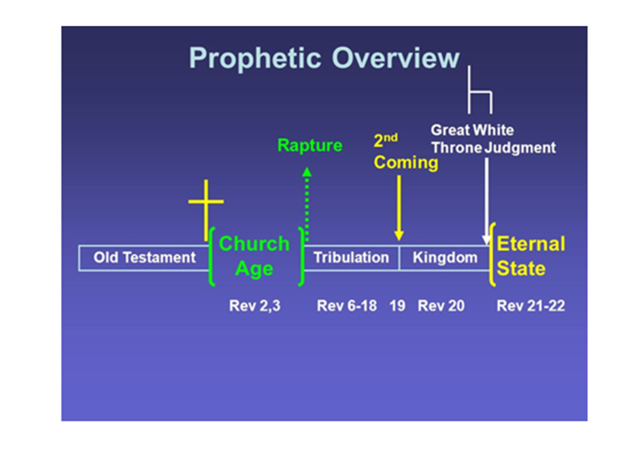

As Christ comes to reign, He is not coming alone. The armies of heaven (including the church) are coming with Him (Rev. 19:14). All the saints of all the ages are going to share in His kingdom reign, which is what is in view in Revelation 20:4-6.

Revelation 20:4–6 (NKJV)
4 And I saw thrones, and they sat on them, and judgment was committed to them. Then I saw the souls of those who had been beheaded for their witness to Jesus and for the word of God, who had not worshiped the beast or his image, and had not received his mark on their foreheads or on their hands. And they lived and reigned with Christ for a thousand years.

The first sentence, in a sense, stands alone as a summary statement. It is vague in the sense that it is a general statement. But I want you to connect three statements that build on each other, which gives us the full sense of what is being said.

Slide # 5

Q. Who are the “they” who are seated on thrones?

v. 4a And I saw thrones, and they sat on them, and judgment was committed to them.

v. 4b And they lived and reigned with Christ for a thousand years.

v. 5b This is the first resurrection.

A. All who have part in the FIRST RESURRECTION!

The Bible is clear that three groups will have a “reigning” role in the coming kingdom of Christ. They are the OT saints, the church (cf. 1 Cor. 6:3; 2 Tim. 2:12), and the tribulation saints.

Slide # 6

OLD TESTAMENT SAINTS…

Daniel 7:18 (NKJV)
18 But the saints of the Most High shall receive the kingdom, and possess the kingdom forever, even forever and ever.’

Daniel 7:22 (NKJV)
22 until the Ancient of Days came, and a judgment was made in favor of the saints of the Most High, and the time came for the saints to possess the kingdom.

Slide # 7

THE CHURCH…

Revelation 2:26 (NKJV)
26 And he who overcomes, and keeps My works until the end, to him I will give power over the nations—
Revelation 3:21 (NKJV)
21 To him who overcomes I will grant to sit with Me on My throne, as I also overcame and sat down with My Father on His throne.
Revelation 5:10 (NKJV)
10 And have made us kings and priests to our God; And we shall reign on the earth.”

Slide # 8

THE TRIBULATION SAINTS…

Revelation 20:4 (NKJV)
4 And I saw thrones, and they sat on them, and judgment was committed to them. Then I saw the souls of those who had been beheaded for their witness to Jesus and for the word of God, who had not worshiped the beast or his image, and had not received his mark on their foreheads or on their hands. And they lived and reigned with Christ for a thousand years.
Even though special mention is made of the Tribulation saints (which is fitting in relation to the book and this climactic time of persecution), all those that related to “first resurrection” are included, which is where the train of thought goes. In view are all those who have part in the “first resurrection.”

In view are undoubtedly the armies of heaven accompanying Christ as seen in Revelation 19:14.

A…view with great plausibility is that the occupants of the thrones are all the saints who comprise the armies of Christ in 19:14. It is an unvarying principle that those who win a war become the ones who assume the rulership over the conquered entity. – Robert Thomas

Slide # 9
Jude 14–15 (NKJV)
14 Now Enoch, the seventh from Adam, prophesied about these men also, saying, “Behold, the Lord comes with ten thousands of His saints,
15 to execute judgment on all, to convict all who are ungodly among them of all their ungodly deeds which they have committed in an ungodly way, and of all the harsh things which ungodly sinners have spoken against Him.”

It makes sense that those who are going to reign with Christ are the armies of heaven who accompany Him in the victory of His Second Coming.

Being on a throne is a regal position, and having judgment committed to them is a judicial position. These have a ruling position serving under Christ with real kingdom authority.

Christ in the parable of the minas in Luke 19 said that in the kingdom His people would be rewarded in keeping with their faithful service here in this life. He said some would be made ruler over 10 cites, others over 5 cities.

We will all reign on earth with Christ, but the extent and responsibility of that reign is being determined right now in your life and mine.
– Mark Hitchcock

Again, special mention is made of the tribulation martyrs. As a group, they will have endured the worst form of persecution in the history of the world. The law of the whole world will have a death warrant out for them.
As seen back in Rev. 13:15 the law of the world will be that whoever will not worship the image of the beast (Antichrist) is to be killed.

These are those who refused to worship the Antichrist. They were beheaded for their witness to Jesus and for their faithful commitment to the Word of God. “Beheaded” is literally “killed with an ax,” which was a means of execution in ancient Rome. It signifies brutal martyrdom.

They would not compromise; they would not worship the Antichrist or identify with him by taking his mark, and consequently they died for it!

We saw back in chapter 6 the martyred souls wondering how long until they were fully avenged, and they were told to wait a little while until their fellow brethren who were to be martyred as they were was completed (cf. Rev. 6:9-11). Then in chapter 7 we saw an innumerable company standing before the throne, and we are told that they are the ones who came out of the great tribulation (Rev. 7:9-14). In Rev. 12:11 they are said to be those who “did not love their lives to the death.”

They are now being raised from the dead. When it says “And they lived and reigned with Christ for a thousand years” the word “lived” denotes resurrection, as is clearly seen in the same usage of the word in the next verse where it speaks of the dead who did not live again until after the thousand years (Rev. 20:5, cf. 2:8).

The word “lived” (Gk. ezesen) is more accurately translated “lived again.” It is used 12 times in Revelation and all but once refers to physical life (the lone exception being Rev. 3:1).

As “souls” they were clearly conscious in heaven (cf. 6:9-11), but now they are resurrected with glorified bodies to go into the kingdom. Now, they too received glorified bodies along with the previously raptured church and are privileged to share in the reign of Christ for 1000 years on this earth.

Now the wait is over, and they are being rewarded with a ruling position in the kingdom.

Footnote:

“If the church were raptured prior to this event, as [premillennial thought] teaches, it would make sense to single out these martyred dead for resurrection.” The Bible Knowledge Commentary
Clearly the Church will be involved. Christ said to His disciples that they would “eat and drink at My table in the kingdom, and sit on thrones judging the twelve tribes of Israel.” (Lk. 22:29-30). This argues for the fact that all the saints, including the church age saints and the OT saints identified with Israel, will all have a part here.

5 But the rest of the dead did not live again until the thousand years were finished. This is the first resurrection.

The first sentence here is parenthetical as he inserts that the rest of the dead (that is the lost who are not saved) will not live again until the thousand years are finished.

Then he returns to his train of thought, saying “This is the first resurrection.” What is the first resurrection – well, what he has just mentioned at the end of verse 4 in speaking of the resurrection of the tribulation saints.

Actually there are TWO main resurrections. There is FIRST resurrection, and then there is the LAST resurrection. They go by different descriptions, but this is always what is in view.

Slide # 10

TWO RESURRECTIONS

Daniel 12:2 awake to everlasting life v. everlasting contempt
John 5:29 resurrection of life v. resurrection of condemnation
Acts 24:15 resurrection of the just and unjust

The first resurrection is the resurrection of God’s people – the saints. The last resurrection is the resurrection of the lost. These two resurrections are separated by a one-thousand-year period of time.

After interjecting that the rest of the dead (all the lost) will not be resurrected until after the thousand years, John then makes this summary statement, “This is the first resurrection,” referring to what he had said back in verse 4 regarding the resurrection of those who will reign with Christ.

First resurrection is actually a series of resurrections, but since they all happen in relation to God’s people, and since they all take place before the LAST resurrection of the lost, they are all lumped together as FIRST.
Think of it this way: FIRST comes the resurrection of God’s people and then LAST will be the resurrection of the lost. However, Paul is very clear in 1 Corinthians that there is an order in the resurrection of God’s people.

Slide # 11

1 Corinthians 15:22–24 (NKJV)
22 For as in Adam all die, even so in Christ all shall be made alive.
23 But each one in his own order: Christ the firstfruits, afterward those who are Christ’s at His coming.

Slide # 12

Order in “First Resurrection”

- Christ the firstfruits (Christ the first one resurrected in a glorified body)

Afterward…

- Those who are Christ’s at His coming (2 aspects – in the air and to the earth)

- Rapture of the Church saints (1 Cor. 15, 1 Thess. 4) – in the air.
- Old Testament saints at Second Coming to earth (Dan. 12:1-2).
- Tribulation saints at Second Coming to the earth (Rev. Rev. 20:4).

All of this is included in “the first resurrection.” The reason we believe the OT saints will be resurrected at the time of the Second Coming is because of the clear statement connecting their resurrection to Israel’s deliverance at the end of the tribulation as found in Daniel 12:1-2. The reason we believe the tribulation saints will be resurrected at the Second Coming is because that is the context here in Revelation 20:4-6.

Slide # 13

Daniel 12:1–2 (NKJV)
1 “At that time Michael shall stand up, The great prince who stands watch over the sons of your people; And there shall be a time of trouble, Such as never was since there was a nation, Even to that time. And at that time your people shall be delivered, Every one who is found written in the book.
2 And many of those who sleep in the dust of the earth shall awake, Some to everlasting life, Some to shame and everlasting contempt.

Daniel emphasizes “at that time,” referring to deliverance at the end of the great time of unparalleled tribulation; it is then that “many” (not all) shall awake to everlasting life. We know from the rest of the story as seen here in Revelation that the rest (those resurrected to shame and everlasting contempt) won’t be resurrected for another thousand years.

So at the time of the kingdom all the saved of all the ages who have died will have been resurrected to go into the kingdom. This is FIRST RESURRECTION even though it happens in stages. It is all part of FIRST RESURRECTION in contrast to the LAST RESURRECTION, which comes after the millennium.

“It is first in the sense of before. All the righteous, regardless of when they are raised, take part in the resurrection which is first or before the final resurrection (of the wicked dead) at the end of the Millennium.” – The Bible Knowledge Commentary

Slide # 14

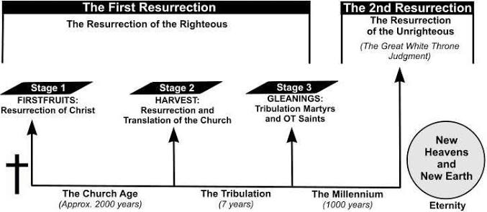

6 Blessed and holy is he who has part in the first resurrection. Over such the second death has no power, but they shall be priests of God and of Christ, and shall reign with Him a thousand years.

Blessed is the condition of being graced of God with joy that is satisfying and fulfilling. It is often said to mean “happy,” but it is deeper than that. It is joyful satisfaction found only in God.

Holy means “to be set apart for God.” In this case, it is to be set apart for special blessing and privilege.

Those who have part in THE FIRST RESURRECTION before the 1000-year reign are spiritually blessed in that they will not experience “second death”.

The Bible teaches the reality of DEATH for sin. The penalty for sin is death (Rom. 3:23; 6:23). That is why Jesus had to DIE for us – this is the penalty for sin. None are exempt - all sin – all die. Death is complete in every generation.

The word death means “separation”.

There are three primary types of death in the Bible.

- Spiritual death. This is what happened to Adam and Eve when they sinned. God told them that on the day you eat of the forbidden fruit – that very day you will die. They ate, and what happened - did they drop over physically dead that very day?

No! However, they were spiritually separated from God, and they hid themselves. They were no longer in right relationship with God – sin had spiritually separated them from God. This is the condition of all people before we are reconciled to God through faith in Jesus Christ. We are all spiritually dead and separated from God. When we are born again through faith in Christ, we now have LIFE – we now have union with God through Christ – we are now reconciled – brought into a right relationship with God.

- Physical death: All people face this reality. At the moment of physical death, the spirit of a person is separated from their body.

Slide # 15
James 2:26 (NKJV)
26 For as the body without the spirit is dead, so faith without works is dead also.

Death is the last enemy – even for the believer. Once we get to the other side, “it is gain,” but dying and death is no fun. In the resurrection, death will then be fully and completely swallowed up in victory (1 Cor. 15:54). However, for believers who are forgiven through faith in Jesus we have the promise of Jesus.

Slide # 16

John 11:25 (NKJV)
25 Jesus said to her, “I am the resurrection and the life. He who believes in Me, though he may die, he shall live.

As believers, we may die PHYSICALLY, but that will only happen ONCE. This is the closest death can get to us, and actually we are released to life even more glorious in the presence of God. Once we get our glorified bodies in the resurrection, they will be bodies that are suited for all eternity to live in God’s presence. They will NEVER die again!

However, for the UNBELIEVER there is a second death.

3) Second Death – Eternal Death

The lost, when they die physically, go initially to a holding place of torment called HADES. This is a holding place in the center of the earth where they go to await final judgment.

Slide # 17

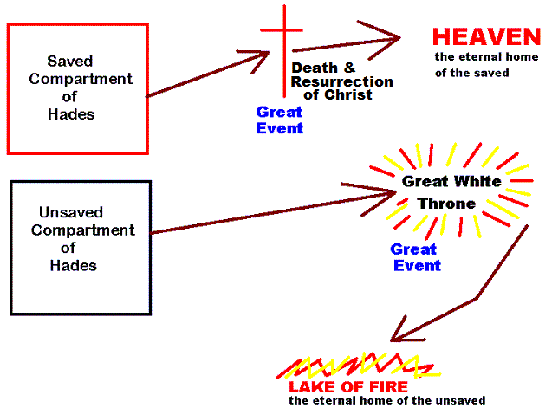

We are not left to wonder what “second death” is because the text plainly goes on to tell us.

Slide # 18

Revelation 20:14–15 (NKJV)
14 Then Death and Hades were cast into the lake of fire. This is the second death.
15 And anyone not found written in the Book of Life was cast into the lake of fire.

Second death is being cast into the lake of fire!

The lost of all the ages are right now in the torment section of Hades. And Hades is continuing to fill up and it will do so right to the end until the Great White Throne judgment.

Those who died in the flood are all here. The wicked people of the OT era. The lost down through the centuries in the church age are there. People who die today without Christ join them this very day in Hades. The lost who die in the tribulation period will go there.

However, this is not their final destiny. They are one day going to be resurrected. Imagine being held there for thousands of years in this place of torment and suddenly being resurrected out of there. What a relief!!

But then they will appear before God at the white throne judgment only to face what is called the sentence of Second Death. In their first death, they were suddenly separated from all that relates to God, His common grace, the blessings of this life, the wooing of the Spirit – suddenly in death they are completely isolated from all that is good and of God.

In the resurrection they are again, momentarily in the presence of God, only to be sentenced to DEATH again – SECOND DEATH! Here many will plead “Lord, Lord” only to hear Jesus say, “I never knew you; depart from Me.” (Mt. 7:21-23).

Slide # 19

Luke 13:24–25 (NKJV)
24 “Strive to enter through the narrow gate, for many, I say to you, will seek to enter and will not be able.
25 When once the Master of the house has risen up and shut the door, and you begin to stand outside and knock at the door, saying, ‘Lord, Lord, open for us,’ and He will answer and say to you, ‘I do not know you, where you are from,’

CAN YOU IMAGINE in the resurrection they thought “we're getting out,” and they plead their case “Lord, Lord”, but then only to be cast into the lake of fire. Yes, they do get out only to appear before the great white throne…only to have their day in God’s court and be found guilty. And then they will experience the SECOND DEATH of being cast into the lake of fire.

The Great White Throne judgment just verifies their lost condition as they are not found written in the book of life, and hence they did not have part in the first resurrection.

Slide # 20

John 5:28–29 (NKJV)
28 Do not marvel at this; for the hour is coming in which all who are in the graves will hear His voice
29 and come forth—those who have done good, to the resurrection of life, and those who have done evil, to the resurrection of condemnation.

Thus they, for the second time, will be separated from God, and this time it will be forever. They will be forever cut off from the life of God! Never again will they have any contact or association with anything having to do with God. Those that persist in being separate from God will have their way for all eternity – forever and ever experiencing eternal death! Second death is the final and forever death! They are sealed in death forever!

"There are only two kinds of people in the end: those who say to God, 'Thy will be done,' and those to whom God says, in the end, 'Thy will be done.'" – C.S. Lewis

Those who insist on rejecting God, who suppress the truth, and harden themselves against the truth in the end will have what they insisted on – eternal separation from God.

In the end people will experience either eternal life – which is God’s life in God’s presence forever, or they will experience eternal death -forever being separated from God for all eternity.
Some (believers in Christ) will have eternal life – unbelievers will suffer the fate of eternal death. Both are eternal.

Slide # 21

Matthew 25:46 (LSB)
46 “And these will go away into eternal punishment, but the righteous into eternal life.”

“The second death is the spiritual death beyond physical death referred to also in 2:11, 20:14; 21:8. Since the first death is clearly the death of the body, the second death must also apply to the body too. So the second death penalizes both the body and the soul (cf. Matt. 10:28). – Robert Thomas

Slide # 22
Matthew 10:28 (NKJV)
28 And do not fear those who kill the body but cannot kill the soul. But rather fear Him who is able to destroy both soul and body in hell.

In summary: Second death is that experience that the lost will have when they receive a resurrected body only to have it (body and soul) forever separated from God in the lake of fire in a body suited for eternal torment.

Yes, as believers we may die physically – but no more. For the believer, in the resurrection death will forever be swallowed up in victory (1 Cor. 15:54, 57). For us the final word on death is VICTORY through Jesus Christ our Lord. For the unbeliever the final word on DEATH is SECOND DEATH – eternal separation from God in eternal torment!

The glorious news for those who have part in the FIRST RESURRECTION is that they do not face the second death. The second death has no power over them. They will not face this horrible reality!

Instead of facing the second death, they will be blessed to serve as priests of God and of Christ.

Priest denotes a special role of service. In denotes intimacy in service. They are close to God! Those experiencing eternal death will be forever cast out of God’s presence; those experiencing the resurrection of life will serve in the most intimate presence of God. The contrast could not be more extreme!
“The function of being “priest of God and of Christ”…. Will consist of the privilege of unlimited access to and intimate fellowship with God.”
– Robert Thomas

And finally, it says those partaking in the first resurrection will “reign with Him a thousand years.” The closest antecedent is Christ, meaning they will reign with Christ for a thousand years.

“They will join Christ in ruling the earth, but in what way this will be is not known. Priesthood and royalty are dual aspects of their future service to God. The thousand years at the end of v. 6 indicates that the priesthood and reign are special and temporary because of the limited duration of this kingdom on earth. This is not to say, however, that both will not continue with the ushering in of the eternal phase of the kingdom. The prophecy is explicit that they will continue (22:3-5).
– Robert Thomas

This section in Revelation 20:4-6 HIGHLIGHTS the kingdom blessings in store for the saved who will experience “the first resurrection,” which is shown to be in explicit contrast to the “second death” destiny of the lost.

There is an old saying that says, “Born once – die twice. Born twice – die once.” I often say, I was born ready, and then after a pause I say, “the second time,” meaning when I was born again.

Jesus told one of the great teachers in Israel named Nicodemus that he had to be born again.

Slide # 23

John 3:3 (NKJV)
3 Jesus answered and said to him, “Most assuredly, I say to you, unless one is born again, he cannot see the kingdom of God.”

The only way into the kingdom is to be born again! There is no other way. How does this happen? Well, the book of John is very clear.

Slide # 24

John 1:11–13 (NKJV)
11 He came to His own, and His own did not receive Him.
12 But as many as received Him, to them He gave the right to become children of God, to those who believe in His name:

13 who were born, not of blood, nor of the will of the flesh, nor of the will of man, but of God.

Note the train of thought here. The great issue is receiving Jesus! Some want to isolate verse 13 “born of God” from receiving Him, but that is the flow of the text. It is those who receive by believing that are then born of God.

One must receive Jesus, and the way Jesus is received is by believing in His Name – that is WHO He is as Lord-God and Savior! It is those who are then born of God. Only God can make us born again, but we must believe. And in the mix of it all is the grace of God bringing us to that point. But note the flow of the text..

Slide # 25

Receive Him

Believe

Born of God

The word "born" in verse 13 is in the aorist passive form. The aorist emphasizes the FACT of action but not necessarily the TIME of action. The priority of thought is that it is only those who receive/believe who are granted the right to become the children of God.

Therefore, verse 12 gives the reason for the new birth, while verse 13 gives the source of it. So, my view is that logically faith comes first, but in fact they happen simultaneously. The moment one believes, they are born again. One cannot claim regeneration without faith, and one cannot claim faith without regeneration. They are inherently and indissolubly bound together.

Slide # 26

SAVED UNSAVED

Born twice Born once
(physically and spiritually) (physically)

Die once Die twice
(physically) (physically and spiritually)

Live forever Die forever

Don’t take it from me, take it from Jesus…

“Unless one is born again, he cannot see the kingdom of God.”
– Jn. 3:3
Born once die twice, born twice die once.

Slide # 27
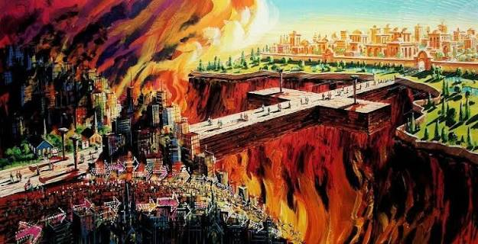

Matthew 7:13–14 (NKJV)
13 “Enter by the narrow gate; for wide is the gate and broad is the way that leads to destruction, and there are many who go in by it.
14 Because narrow is the gate and difficult is the way which leads to life, and there are few who find it.

Slide # 28
John 5:24 (NKJV)
24 “Most assuredly, I say to you, he who hears My word and believes in Him who sent Me has everlasting life, and shall not come into judgment, but has passed from death into life.

John 3:36 (NKJV)
36 He who believes in the Son has everlasting life; and he who does not believe the Son shall not see life, but the wrath of God abides on him.”

Have you passed from death into life? Jesus is the bridge to life, and the way you pass over is by FAITH, by BELIEVING in Him!

Believe on the Lord Jesus Christ, and you will be saved!

