SBC – Aug. 16, 2026
#49
Revelation 20:11-15 (NKJV)
“The Great White Throne Judgment”
Prayer

We are coming down the stretch in the book of Revelation, which reveals the consummation of all things. The next great event on God’s prophetic calendar is the RAPTURE of the Church. This will be followed by the Tribulation Period, followed by the Second Coming, followed by the kingdom. This chronological order is presented in the inspired outline of the book of Revelation, as found in Revelation 1:19.

Slide # 1

Revelation 1:19 – Inspired Outline
Revelation 1:19 (NKJV)
19 “Write the things which you have seen, and the things which are, and the things which will take place after this.
- “have seen” – Past (Vision of Christ) – Ch. 1
- “which are” – Present (Church Age) – Ch. 2-3
- “after this” – Future (Post-Church Age) –Ch. 4-22
- - Scene in heaven –Ch. 4-5
- - Tribulation – Ch. 6-18
- - Second Coming – Ch. 19
- - Kingdom – Ch. 20
- - Eternal State – Ch. 21-22

The more precise breakdown of Revelation 20 goes like this:

Slide # 2

- Rev. 20:1-6 Satan bound for 1000 years – the millennial reign of Christ.
- Rev. 20:7-10 Satan loosed – leads a final revolt – cast into the lake of fire.
- Rev. 20:11-15 The Great White Throne Judgment of all the lost of all the ages.

In our study, we now come to “The Great White Throne Judgment,” a most somber event!

This passage describes the final sentencing of the lost and is the most serious, sobering, and tragic passage in the entire Bible
– John MacArthur
Revelation 20:11–15 (NKJV)
11 Then I saw a great white throne and Him who sat on it, from whose face the earth and the heaven fled away. And there was found no place for them.

This is a GREAT throne because of the issues involved and because of the one who sits on it. The One Who sits on the throne is JUDGE of all! The issues involved are eternal. It is the throne of FINAL JUDGMENT!

It is WHITE, denoting absolute holiness, purity, and righteousness as the standard by which all will be judged.

Him who sat on it is clearly God. As it says in verse 12, the people there are all found “standing before God.” So clearly this is God (cf. v. 12), but there is discussion as to whether it refers to God the Father or God the Son.

In the book, God the Father is consistently pictured as being on the throne. However, in the gospel of John, Jesus made it clear that the Father has committed all judgment to the Son (cf. Acts 10:42; 17:31; 2 Tim. 4:1).

Slide # 3

John 5:22 (NKJV)
22 For the Father judges no one, but has committed all judgment to the Son,

Therefore, most are of the viewpoint that probably Jesus Christ is specifically the one in view. Certainly both the Father and the Son are ONE in this.

And then it says of this one on the throne: “From whose face the earth and the heaven fled away. And there was found no place for them.”

The face of God speaks of His presence. The earth and heaven flee from His presence.

Now we know from the whole counsel of Scripture that God is omnipresent. He is everywhere (cf. 1 Kg. 8:27; Ps. 139:7-10; Prov. 15:3; Isa. 66:1; Jer. 23:23-24; Acts 17:26-27; Eph. 4:6; Col. 1:17; Heb. 4:13).

To go from the presence of God is to go out of existence, and that is what is in view here, as seen in the qualifying statement, “And there was found no place for them.”

This is the point where the whole of earth and heaven vanish. The sudden, violent termination of the heavens and the earth, and all that is left from that realm is people standing right there in the face of God in all His Holy Glory!

There will be no place to hide anywhere in the universe! The whole of heaven and earth fled from the presence of God, and LEFT are the lost souls of all the ages standing before the GREAT WHITE THRONE!

But oh! Sinner, there is no hiding from God. The mountains cannot cover you from Him, even if they would; neither can the rocks conceal you. See, then, at the very outset how this throne should awe our minds with terror. Founded in right, sustained by might, and universal in its dominion, look you and see the throne which John of old beheld.
– Charles Spurgeon

For the believer in the Church Age, all roads lead to the judgment seat of Christ; for the lost of all the ages, all roads lead to the Great White Throne.

Slide # 4
2 Peter 3:7 (NKJV)
7 But the heavens and the earth which are now preserved by the same word, are reserved for fire until the day of judgment and perdition of ungodly men.

2 Peter 3:10 (NKJV)
10 But the day of the Lord will come as a thief in the night, in which the heavens will pass away with a great noise, and the elements will melt with fervent heat; both the earth and the works that are in it will be burned up.

“This judgment takes place in the indescribable void between the end of the present universe (v. 11) and the creation of the new heaven and earth (21:1).” – John MacArthur

There is some debate here as to whether the heaven and the earth are completely annihilated or whether they are simply put into a position of total purge in preparation for renovation. I have come to think that the latter is probable.
Dr. Michael Vlach has written a 400-page book titled, “The New Creation Model,” defending this position.

I would compare it to what God does in conversion when He makes us a brand new person. Indeed, we are a new creation in Christ where old things have passed away and behold, all things have become new (2 Cor. 5:17). Yet, in this reality, the same person remains only in a brand-new form.

So it will be with the present heavens and earth! The old will be completely done away with, and yet out of that reality God will make them brand new. Ultimately we are talking about radical renovation.

In the last two chapters of Revelation, dealing with the Eternal State, we find the nations are still inhabiting the earth, which means the earth does not cease to exist. Indeed, it is renovated, in which all things are made new! But again, I take it this is renovation, not annihilation!

Both the heavens and the earth have been tainted by sin, and now, as it is, they are being completely done away with in a total purge.

This is what Jesus spoke of in Matthew 24:35.

Slide # 5
Matthew 24:35 (NKJV)
35 Heaven and earth will pass away, but My words will by no means pass away.

Psalm 102:25–26 (NKJV)
25 Of old You laid the foundation of the earth, And the heavens are the work of Your hands.
26 They will perish, but You will endure; Yes, they will all grow old like a garment; Like a cloak You will change them, And they will be changed.

“The earth will have been reshaped by the devastating judgments of the Tribulation and restored during the millennial kingdom. Yet it will still be tainted with sin and subject to the effects of the Fall – decay and death; hence it must be destroyed, since nothing corrupted by sin will be permitted to exist in the eternal state (2 Pet. 3:13).”
– John MacArthur

Slide # 6

2 Peter 3:13 (NKJV)
13 Nevertheless we, according to His promise, look for new heavens and a new earth in which righteousness dwells.

Slide # 7
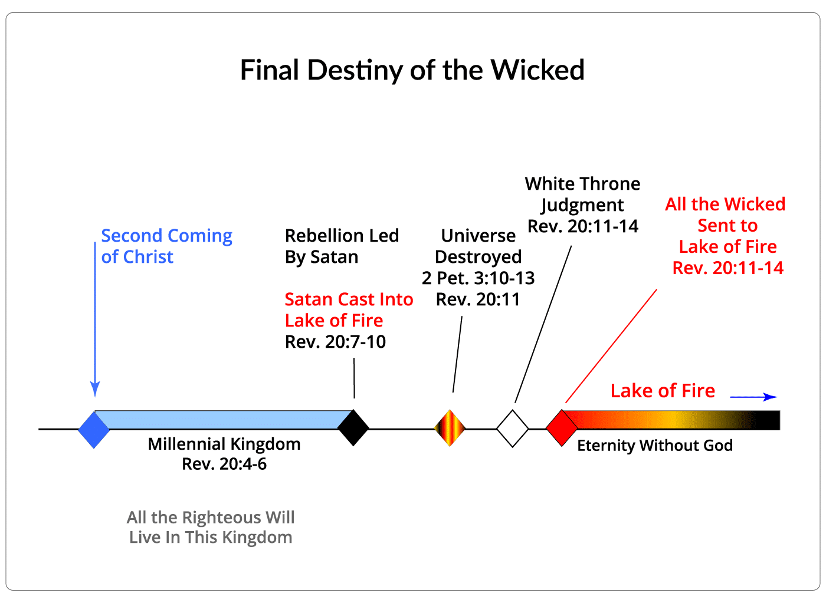

12 And I saw the dead, small and great, standing before God, and books were opened. And another book was opened, which is the Book of Life. And the dead were judged according to their works, by the things which were written in the books.

When it says he “saw the dead,” this refers to all the lost of all the ages who had died in history. They are now resurrected to stand before God in judgment. Standing before God speaks to the fact that they have been resurrected.

This is FINAL RESURRECTION in contrast to the first resurrection (cf. 20:5). The FIRST resurrection involves several stages involving all those who are God’s people. This is in contrast to this SECOND or LAST resurrection, which is a resurrection of all the lost of all the ages.

Slide # 8
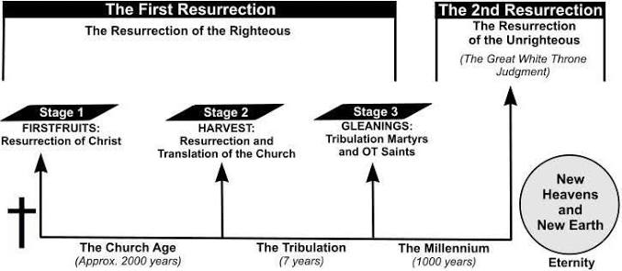
Footnote:
“The question of what happens to the living just persons who are alive at the end of the Millennium does not come up in the passage. Presumably these saints will have divine protection during Satan’s final rebellion and will survive the transition from the old earth and heaven to the new ones. The assumption must be that God will give them new bodies that suit them for conditions of immortality in the new heaven and the new earth.” – Robert Thomas

But admittedly, there is mystery here because we are not told specifics.

Found standing therefore before God are the dead, both “small and great.”
They are all there no matter what station in life they had occupied. It won’t matter whether they were a pauper or a prince; whether they were poor or rich; whether they were unknown or famous. If one dies without Christ, they will be here, whatever their previous station in life. Position in life impresses man, but it means nothing on judgment day before God.

It’s like being in the hospital. When you see people in there, they are all in the same position. They have the same hospital gowns – they have the same beds – they all get the same treatment. I often think of hospitals as great equalizers.

Proverbs 22:2 (NKJV)
2 The rich and the poor have this in common, The Lord is the maker of them all.
And He is also the judge of them all (cf. Gen. 18:25).

Here they stand before the Great White Throne – with nothing in the universe remaining but them and God – one on one. Every person has their day in court! This is it. You think you are good enough to stand before God…. You’ll have your day…. The books will be opened… and we will find out. There will be no place to hide!

And books were opened: This is high drama in the ultimate courtroom scene before God Almighty! We know what these books are about because the last sentence in this verse says, “And the dead were judged according to their works, by the things which were written in the books.”

God has a book on every person’s life, and in context I take it the issue is guilt. Everything is well documented. Every sin, every evil thought, every unkind action, every selfish desire, every evil whisper, everything a person has ever said, done, or thought that is contrary to perfect holiness. It’s all recorded there (cf. Dan. 7:10; Isa. 65:6; Mal. 3:16). The BOOKS WERE OPENED!

Imagine – all the dirty secrets about everyone coming out.

“Every man knows that of himself which he dares not tell his dearest friend.” – Samuel Johnson

You know, don’t you…. Things you will take to your grave and never dare tell anyone. If you're not saved - It’s all coming out – it’s all written down on the record of your life. Romans 2:16 says on judgment day God is going to “judge the secrets of men by Jesus Christ.” It’s all coming out!

Slide # 9

Luke 12:2 (NKJV)
2 For there is nothing covered that will not be revealed, nor hidden that will not be known.

Hebrews 4:13 (NKJV)
13 And there is no creature hidden from His sight, but all things are naked and open to the eyes of Him to whom we must give account.

Romans 2:5 says the wicked are storing up wrath for the day of wrath, when they will be judged according to the righteous judgment of God.

Slide #10

Thoughts…
Luke 8:17 (NKJV)
17 For nothing is secret that will not be revealed, nor anything hidden that will not be known and come to light.

Words…
Matthew 12:37 (NKJV)
37 For by your words you will be justified, and by your words you will be condemned.”
Deeds…
Romans 2:6 (NKJV)
6 who “will render to each one according to his deeds”:

Every person’s thoughts, words, and deeds will be measured up against the holy standard of God’s Word.

In addition to a book on every person's life, I am confident that the Bible will be opened. Because this is what people will be judged by.

An unknown source recounted this story. “A man once said to me. ‘There are a thousand different interpretations of every verse in the Bible.’ ‘Do you mean that?’ I inquired. He replied, ‘I certainly do.’ ‘Very well, said I. I’ll be easy on you and deduct 997 from the thousand: I’ll ask you to give me only three different interpretations of this verse of Scripture.’ And then I showed him John 12:48.”

Slide # 11

John 12:48 (NKJV)
48 He who rejects Me, and does not receive My words, has that which judges him—the word that I have spoken will judge him in the last day.

“He hemmed and hawed, and if it had not been serious it would have been amusing to see him wiggle and squirm and try to change the subject. But I held him to it, and he stumbled and stammered as he tried to read this verse aloud. Finally he read it through, and then with a sigh he said, ‘Well, I guess it means what it says.’”

I picture the open book of a person's life and beside that the open Bible – with the issue being: how does your life measure up against the HOLY standard of God’s Word?

Slide # 12

Romans 3:19 (NKJV)
19 Now we know that whatever the law says, it says to those who are under the law, that every mouth may be stopped, and all the world may become guilty before God.

Romans 3:23 (NKJV)
23 for all have sinned and fall short of the glory of God,

If you are judged according to your works that are recorded in God’s books, you will go straight to hell – no ifs, ands, or buts about it.

The books are PROOF of guilt. The evidence is all there.

And another book was opened, which is the Book of Life.

In contrast to all the books (plural) on everyone's life which prove guilt, there is the book of LIFE, which is a registry of those who have been forgiven – who now have life in Christ (cf. Dan. 12:1; Mal. 3:16; Lk. 10:20; Phil. 3:20, 4:3; Heb. 12:23; Rev. 3:5, 13:8, 17:8, 20:12, 15, 21:27)

Whenever someone becomes a Christian there name is PERMANENTLY recorded in the Book of Life. They are from then on registered as citizens of heaven (Phil. 3:20).

Some think that initially everyone's name is potentially written there because Christ died for all, but then those who die without Christ are blotted out.

The Book of Life is a divine register for every loyal believer (cf. Isa. 4:3; Ps. 69:28; Dan. 12:1; Luke 10:20) (Kiddle). It originally contained the names of all for whom Christ died, i.e., the whole world, but at the judgment of the Great White Throne many blank spaces will signal the removal of many names who never believed in Christ for salvation (Walvoord). – Robert Thomas

Slide # 13

Luke 10:20 (NKJV)
20 Nevertheless do not rejoice in this, that the spirits are subject to you, but rather rejoice because your names are written in heaven.”

By the way, if your name is written down in the Book of Life, you don’t have to worry about the other books - the books that have the dirt on everyone. You know why – those books are permanently done away with, to the point that no sin will ever be brought up against you.

Colossians 2:13–14 (NKJV)
13 And you, being dead in your trespasses and the uncircumcision of your flesh, He has made alive together with Him, having forgiven you all trespasses,
14 having wiped out the handwriting of requirements that was against us, which was contrary to us. And He has taken it out of the way, having nailed it to the cross.

The Bible says God will never remember our sins against us in accordance with the NEW COVENANT of Christ’s blood.
Slide # 14
Hebrews 10:14 (NKJV)
14 For by one offering He has perfected forever those who are being sanctified.

Hebrews 10:17 (NKJV)
17 then He adds, “Their sins and their lawless deeds I will remember no more.”

If you are forgiven by faith in Christ, you never have to worry about those books. This is such great news – it is the good news of the gospel. That is why we continue to CELEBRATE communion and remember what Jesus has done for us so that God will never remember our sins against us.

It is obvious from the overall context here in Revelation 20 that only unbelievers are in view at this great white throne judgment. This is the judgment of the lost, not the saved.

All the evidence to PROVE guilt is brought out, and all are found guilty!

The books on their lives show it all. Their names are absent from the book of life – showing they have never truly come to Christ in saving faith.

All these dead are judged according to their works, by the things which were written in the books.

Hebrews 9:27 says, “It is appointed for men to die once, but after this the judgment.”
All judgments before God are on the basis of works!

Works become evidence of faith or the lack thereof. We are saved by faith alone, but the faith that saves does not remain alone (cf. James).
Faith that is real works – it demonstrates itself in the life. The root is faith, but the fruit is works! We are not saved by works, but a true living faith works. We are not saved by the fruit, but by faith. But if faith is real, the evidence is seen in works.

Slide # 15

Matthew 7:21 (NKJV)
21 “Not everyone who says to Me, ‘Lord, Lord,’ shall enter the kingdom of heaven, but he who does the will of My Father in heaven.

John 5:28–29 (NKJV)
28 Do not marvel at this; for the hour is coming in which all who are in the graves will hear His voice
29 and come forth—those who have done good, to the resurrection of life, and those who have done evil, to the resurrection of condemnation.

A person’s works are an unmistakable mark of where his loyalties lie (Johnson). … Salvation is by grace, but character in the end will be the test of the fruit of the tree (Matt. 7:16, 20; 10;32-33; 25:31-46; Jn. 15:6; Rom. 2:9-10; 2 Cor. 5:10; Rev. 2:23; 22:12). – Robert Thomas

In the end, no unbeliever ever gets away with any sin. There will be a full accounting forever! Numbers 32:23 says, “Be sure your sin will find you out.” And it will, if not in time, certainly in eternity!

There is a judgment for believers which is distinct from the judgment of unbelievers.

The works of the believer are judged to determine what reward they will receive. The issue is the quality of workmanship, not punishment. The penalty of the believer's sin was paid for by Christ in full, so that is not the issue. The issue is the quality of workmanship and corresponding reward.

In contrast, the works of the unbeliever not only serve as proof of their guilt but also will establish the degree of eternal punishment they will receive.

All believers are going to heaven, and all unbelievers are going to the lake of fire. However, Believers will receive varying degrees of rewards, and unbelievers will receive varying degrees of eternal punishment.
Slide # 16

Matthew 10:14–15 (NKJV)
14 And whoever will not receive you nor hear your words, when you depart from that house or city, shake off the dust from your feet.
15 Assuredly, I say to you, it will be more tolerable for the land of Sodom and Gomorrah in the day of judgment than for that city!
Mark 12:38–40 (NKJV)
38 Then He said to them in His teaching, “Beware of the scribes, who desire to go around in long robes, love greetings in the marketplaces,
39 the best seats in the synagogues, and the best places at feasts,
40 who devour widows’ houses, and for a pretense make long prayers. These will receive greater condemnation.”

Slide # 17
Luke 12:47–48 (NKJV)
47 And that servant who knew his master’s will, and did not prepare himself or do according to his will, shall be beaten with many stripes.
48 But he who did not know, yet committed things deserving of stripes, shall be beaten with few. For everyone to whom much is given, from him much will be required; and to whom much has been committed, of him they will ask the more.

Slide # 18

Hebrews 10:29 (NKJV)
29 Of how much worse punishment, do you suppose, will he be thought worthy who has trampled the Son of God underfoot, counted the blood of the covenant by which he was sanctified a common thing, and insulted the Spirit of grace?

“The fact that his name is missing condemns him, but the record of his evil works determines the degree of his punishment.”
– William MacDonald

13 The sea gave up the dead who were in it, and Death and Hades delivered up the dead who were in them. And they were judged, each one according to his works.

Special mention is made of the sea. Why? Those who die at sea have no burial place. They are “lost” at sea.
“Death at sea, with no monument to mark the spot where one’s body lay, was thought of as a terribly desolate fate. In some Jewish circles resurrection was thought of as possible only for those buried on dry land.” – The New International Commentary

Death in the sea was thought to result in being decomposed and disintegrated beyond what could be brought back together again. Lost at sea was thought by many to be lost forever.

“The special mention of the sea is occasioned by the fact that resurrection usually implies resurrection from the grave. The resurrection of the dead from the sea merely reaffirms that all the dead will be raised regardless of the condition of their bodies.”
– John Walvoord

“The mention of “the sea” giving up its dead makes it clear that regardless of how far a body has disintegrated, it will nevertheless be resurrected for this judgment.”
– The Bible Knowledge Commentary

The point is, no matter the realm, no matter the depths, no matter how far disintegrated, God Almighty has the ability to bring everyone back to life from anywhere. There is a CORE component of our bodies that never goes entirely out of existence, and it will one day be resurrected either to life or, in this case, to condemnation. As such, the body is eternal as well as the soul. The only question is this: What is the eternal destiny of the body and soul of every person?

All the unsaved people who perished in the flood or in the tsunamis of history or lost at sea are not forever physically lost in the great void of the ocean. God knows where every particle of their corpses is, and one day He will resurrect them to stand before Him in judgment.

I have read of people who were cremated and then had their ashes scattered out over the ocean in hopes that even God would not be able to reconstitute them. Nice try – but they completely underrate God, who can create out of NOTHING. This is not even a challenge for Him!

Death here represents the physical body that is in the grave.
Hades represents the realm of departed spirits.

Taken together, this signifies the resurrection of lost people, as both body and soul are reunited only to appear before the BAR of God in judgment.

The text says: “They were judged.” This is the purpose of this resurrection – JUDGMENT! It is HOLY judgment! It’s FINAL judgment!
And then it specifically says they were judged, “each one according to his works.” It says this twice, once in verse 12 and now again in verse 13. But in verse 13 it is even more precise, saying, “each one” – each individual person will be judged according to their individual works. This is personal judgment!

As noted earlier, there will be degrees of punishment in the lake of fire. All unbelievers are going there, but some will receive a greater sentence of eternal punishment than others. The sentence will fit the crime!

Again, we note that in the Bible judgment is always according to “works.”

This is one reason I hold to an age (or condition) of accountability. How will little children be held accountable for their works – they don’t even know what they are doing? And if killed in the womb, they have no works. I believe that Jesus died for all sin as found in Adam, which is what all of us come into the world with. What we are personally accountable for is personal sin once we reach the age of accountability.

Everyone will give account of his own life. There will be no pointing fingers on this day. “Each one according to his works”. What will your works reveal?

We emphasize FAITH, and rightly so, but faith without works is dead (James 2). A living faith has good works, and a dead faith has dead works. But the fact is, our WORKS tell the story on us.

“Works are unmistakable evidence of the loyalty of the heart; they express either belief or unbelief, faithfulness or unfaithfulness. The judgment will reveal through the records whether or not the loyalties were with God and the Lamb or with God’s enemies. John’s theology of faith and its inseparable relation to works is the same as Jesus’ and Paul’s.” - Expositors

Slide # 19

"It is therefore faith alone which justifies, and yet the faith which justifies is not alone." - John Calvin

Matthew 7:16–17 (NKJV)
16 You will know them by their fruits. Do men gather grapes from thornbushes or figs from thistles?
17 Even so, every good tree bears good fruit, but a bad tree bears bad fruit.

The point of this passage is not to prove salvation by works, but condemnation by works. A person does not receive salvation through works, but neither does he receive it without works.
– Robert Thomas

Faith works. Unbelief works. Our works reveal WHO we are!

14 Then Death and Hades were cast into the lake of fire. This is the second death.

Slide # 20
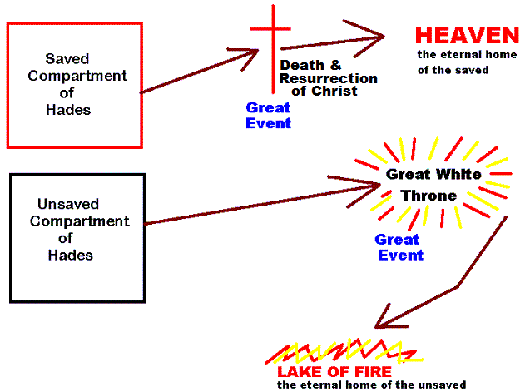

Again, Death represents the grave out of which these dead people are resurrected. Hades represents the realm which was the holding place for their spirits. In verse 13, we saw Death and Hades delivered up their dead – meaning the lost souls were reunited with their bodies in resurrection to appear before the Great White Throne Judgment (cf. Dan. 12:2; Jn. 5:29; Acts 24:15). Now resurrected, both of these realities (body and soul united) will be cast into the lake of fire.

First death involved the separation of soul from the body, where the soul went to the holding prison of Hades and the body to the grave. Second death involves the person, resurrected as soul and body, being cast into hell.
In the resurrection of damnation, they will be fitted with a body suited for eternal torment. Just as the believer's resurrection body is suited for eternal glory, the resurrection body of unbelievers is suited for eternal torment.

Their whole being, body and soul, will experience eternal punishment in the lake of fire for all eternity. That is the second death, or what is often termed eternal death (cf. Matt. 25:41, 46; Rev. 14:11).

Slide # 21

Matthew 10:28 (NKJV)
28 And do not fear those who kill the body but cannot kill the soul. But rather fear Him who is able to destroy both soul and body in hell.

The lake of fire is a burning lake of sulfur (brimstone) (cf. 19:20).

“Fire is used more than twenty times in the NT to depict the torment of hell (cf. v. 10, 15, 14:10, 19:20, 21:8, Matt. 3:10-12, 5:22, 7:19, 13:40, 42, 50, 18:8-9, 25:41, Mark 9:44, Lk. 3:9, 16-17, Jn. 15:6, Heb. 10:27, Jude 7) … The Bible also depicts hell as a place of total darkness, which will isolate its inmates from each other (Matt. 8:12; 22:13, 25:30, 2 Peter 2:17, Jude 13); as a place where the worm (possibly emblematic of an accusing conscience [or continual deterioration] devouring the wicked will never die (Isa. 66:24, Mk. 9:44); as a place of banishment from God’s kingdom (Matt 8:12, 22:13); and as a place of unending sorrow, where there is “weeping and gnashing of teeth” (Mat. 8:12, 13:42, 50; 22:13; 24:51; 25:30; Lk. 13:28.) – John MacArthur

15 And anyone not found written in the Book of Life was cast into the lake of fire.

This is one of the most sobering verses in all the Bible.

In the end, every person here will either be in the Book of Life, or they will be cast into the lake of fire. Either you're in the book of life, or you will be in the lake of fire. It’s one or the other. One of these is your destiny – all depending on what you do with Jesus in the here and now.

Elsewhere in the book, the Book of Life is called “The Lamb’s Book of Life.”
Jesus, as the Lamb of God who takes away the sin of the world, is uniquely the possessor of this book, which gives the record of all His blood-bought children.

Slide # 22
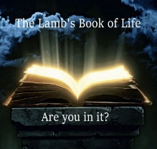

Slide # 23
CAST INTO THE LAKE OF FIRE…

The beast (Antichrist) and the False Prophet – Rev. 19:20
The devil – tormented forever and ever – Rev. 20:10
Anyone not found written in the Book of Life – Rev. 20:15

At the Great White Throne Judgment, there will be a JUDGE but no jury; a PROSECUTION, but no defense; and a SENTENCE with no appeal.

The only way to get your name in the book of life is to receive Jesus Christ as personal Lord and Savior by faith alone. Have you done that? (cf. Jn. 1:12).

If you were on trial to determine whether you were a Christian or not, what would the verdict find? What do the “works” of your life really say? I mean your works day in and day out when only God is watching. What does the evidence really point to?

Come to Christ for forgiveness.

Slide # 24

Acts 13:38–39 (NKJV)
38 Therefore let it be known to you, brethren, that through this Man is preached to you the forgiveness of sins;
39 and by Him everyone who believes is justified from all things from which you could not be justified by the law of Moses.

Come to Christ for forgiveness. Believe on Him as your Savior who died for all your sins, and as your risen Lord (Master) who rose again the third day.
Coming at the end of the book, the warning is stark and grave! God doesn’t want anyone to go to the Lake of Fire; hence, very strong warnings are given. Jesus spoke more about Hell than He did Heaven. Jesus spoke more about HELL than anyone else in the Bible.

Years ago, there was a great tsunami in Asia, killing approximately 150,000 people - Indonesia having the greatest percentage. The authorities knew it was coming an hour before it hit, but the WARNING failed to get out to the people. The people said that the incoming Tidal Waves could be heard for several minutes like a LOUD PLANE, but the people failed to take refuge, with deadly results.

God’s warnings have gone out!

God desires all to be saved and to come to the knowledge of the truth of Jesus (1 Tim. 2:4-6). He is not willing that any should perish but that all should come to repentance (2 Pet. 3:9).

Let me conclude this message with a pastoral appeal. I am aware that on any given Sunday both the lost and the saved are listening. Thus, the wheat (the saved) and the tares (pretenders) grow together. In Matthew 13, in the parable of the wheat and tares, Jesus said an enemy (Satan) has planted tares amongst the wheat. Outwardly, the tares look very similar to the wheat! In reality, the tares are cultural Christians who look like Christians, but they are pretenders. The servants asked if they should remove the tares…

Slide # 25
Matthew 13:29–30 (NKJV)
29 But he said, ‘No, lest while you gather up the tares you also uproot the wheat with them.
30 Let both grow together until the harvest, and at the time of harvest I will say to the reapers, “First gather together the tares and bind them in bundles to burn them, but gather the wheat into my barn.” ’ ”

As a minister of the Word, I am accountable to teach the whole counsel of God, including the reality of the Lake of Fire for all those who reject Jesus as Lord and Savior!

Slide #26
Acts 20:26–27 (NKJV)
26 Therefore I testify to you this day that I am innocent of the blood of all men.
27 For I have not shunned to declare to you the whole counsel of God.

Do with it what you will, but you have been warned! As the Bible says in Hebrews 10:31, “It is a terrifying thing to fall into the hands of the living God.”

Come to Jesus! Flee from the wrath to come! Flee to the refuge found in Jesus (Matt. 3:7; Heb. 6:18-19).

A man on his deathbed said to me, “Preacher, you don’t need to talk to me about the future. I’ll take my chances. I believe God is going to be just and righteous and let me present my works.” I told him, “You are right. He is just and righteous, and He will let you present your works. That is what He says He is going to do. But I have news for you: At that judgment, nobody is saved, because you cannot be saved by your works.” – J. Vernon McGee

Are you going on the basis of “the book of your life,” or are you going on the basis of being in the “Lamb’s Book of Life?” In order to be saved, you have to discard your book of achievements entirely, all your self-efforts, and put all your faith entirely and alone in Jesus as Lord and Savior.

Slide # 27
Philippians 3:8–9 (NKJV)
8 Yet indeed I also count all things loss for the excellence of the knowledge of Christ Jesus my Lord, for whom I have suffered the loss of all things, and count them as rubbish, that I may gain Christ [discarded all self-efforts – all self-righteousness]
9 and be found in Him, not having my own righteousness, which is from the law, but that which is through faith in Christ, the righteousness which is from God by faith;

On Judgment Day before the Great White Throne, all will discover that “all our righteousnesses are like filthy rags.” (Isa. 64:6). The only good work that will get one into the kingdom is the finished work of Jesus on the cross! In His dying breath, Jesus said, “It is finished!” (Jn. 19:30).

The only way in is through the Savior, Jesus. Only when we put our trust in Him ALONE as Savior and risen Lord is our name written down in the Book of Life. The way in is through FAITH in Jesus! We are saved by grace alone through faith alone in Christ alone!
So let me ask you the all-important question: Is your name written down in the Book of Life – the Lamb’s Book of Life?

Come to Jesus! Believe on Him as Savior and Lord!

Believe on the Lord Jesus Christ and you will be saved!

