SBC – Aug. 2, 2026
Psalm 100:1-5 (NKJV)
“God-Pleasing Worship”

Psalm 100 follows on the heels of Psalms 93-99, which are commonly called “Royal Psalms”, “Enthronement Psalms”, or “Kingship Psalms.” As such, it serves as a fitting benediction to these Psalms, which emphasize the Lord’s Kingship rule.

We don’t know who wrote Psalm 100. It is a call to worship set in the context of a Levitical/Temple worship setting.

Perhaps the ancient editors felt that the royal psalms demanded the response of worship provided by this psalm. – Nelson Study Bible

Slide # 1

Psalm 100

“God-Pleasing Worship”

vv. 1-2 A Call to Worship
v. 3 Worshiping God as Creator and Shepherd
v. 4 Thankful Worship
v. 5 Worshiping God for His Goodness and Faithfulness

A Psalm of Thanksgiving.

This heading is more literally “A Thank Offering.”

1 Make a joyful shout to the Lord, all you lands!

This is a call to exuberant worship! Passive worship or just going through the motions is unacceptable. Now, of course, everything is to be done decently and in order (1 Cor. 14:40) and in the spirit of self-control, which is part of the fruit of the Spirit (Gal. 5:22-23).

A joyful noise is one of gladness that expresses a heart thrilled with God and worshiping Him. This is true HEART worship! The focus is squarely on God. It’s not about show – but about God!

Various commentators mention that the language here would be in keeping with how a king would be greeted by his subjects when he appeared among them. A beloved king would be greeted joyfully!
This worship is directed to the LORD, which more literally is YHWH – the covenant-keeping God of Israel.

The name YHWH has the idea of God being eternal and unchanging in His character and therefore totally faithful.

There is some debate over how “all you lands” should be understood. The Hebrew word “eretz” (land) is often used in reference to the land of Israel but can also be used generally of a specific country or the entire earth. It is a matter of interpretation.

Slide # 2

• Eretz Yisrael (ארץ ישראל): The Land of Israel.
• HaAretz (הארץ): "The land" or the name of Israel's oldest daily newspaper.

For example, I have a book by Mordecai Naor titled, “The Twentieth Century in Eretz Israel.”

The Psalm is addressed to the people of Israel; all the earth (Hb. Eretz, land) is the particular name for the land of Israel.
– The Moody Bible Commentary

You could take it either way here – in the sense of the land of Israel or to the earth at large. I tend to lean toward the land of Israel since the context here is very Jewish in orientation.

But certainly God intended the Jews to be a witness nation to the end that all the world might know the one true God.

In the last couple of days, Benjamin Netanyahu (the prime minister of Israel) was saying that Israel and the Evangelicals are partners. He said that Christians and Jews are partners, but then he emphasized that in Judeo-Christian that Judeo comes first and that Christianity builds upon the Jewish foundation. This, of course, is true.

All this to say, that while the text may have Israel directly in view, it has application to the whole world as God is calling people out of all the nations to be true worshipers.

2 Serve the Lord with gladness; Come before His presence with singing.

The context here is one of worship! In the Bible, serving and worshiping are very closely connected. In fact, worship is often seen as one aspect of serving God.

Slide # 3

Matthew 4:10 (NKJV)
10 Then Jesus said to him, “Away with you, Satan! For it is written, ‘You shall worship the Lord your God, and Him only you shall serve.’ ”

Serve here is used interchangeably with worship. Worship is a form of serving God. People often wonder how they can serve. How about worship? Worship is a form of serving, and serving is a form of worship.

Now that I am a retired preacher, I find myself becoming an expert on telling young pastors how they should conduct their services. There is one criticism I want to make concerning my own ministry, and that is that I did not have enough praise included in the services. We ought to praise God more. We ought to worship God more.
– J. Vernon McGee

And our worship should be filled with joyful gladness. The fruit of the Spirit is JOY (Gal. 5:22-23).

Paul said, “Rejoice in the Lord always. Again I will say, rejoice.” (Phil. 4:4).

Nehemiah 8:10 says, “The joy of the LORD is your strength.”

2 Corinthians 9:7 says, “God loves a cheerful giver.” It is a privilege to serve/worship the LORD, and we should be joyful worshipers!

God is honored in joyful worshipers. Now of course, we experience all kinds of emotions in life, but still through it all there is to be the undergirding of joy. If you can’t be a joyful worshiper, then why are you even going through the motions? God is pleased with a cheerful giver, and I think it safe to say what pleases Him is a joyful worshiper.

The following illustration by EJ Pace makes the point.

Slide # 4

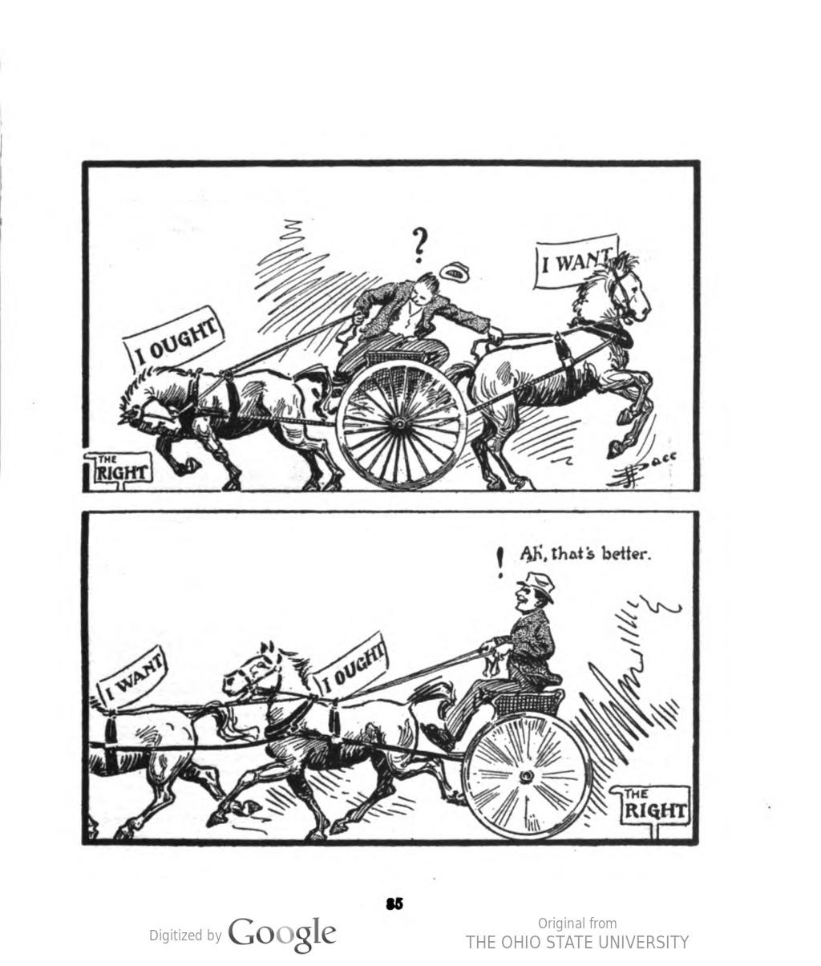

When we get our “wanter” in the right place, the “ought” will follow properly!

God is not about sour, doleful, drab, worship! God wants us to celebrate Him! “Serve the LORD with gladness.” By the way, this indicates that you are in charge of your attitude when it comes to worship. You determine what attitude you bring to church. You determine where your focus is going to be!

Serve with gladness, “Come before His presence with singing.” We need to be cognizant that we are meeting with God. This is a go-to meeting with God! God is the most important person here. His presence is here! He is here.

And we are to come before Him with singing.
In the Bible, singing is most often indicative of joy. It is the overflow of being filled with the Spirit as seen in Ephesians 5.

Slide # 5

Ephesians 5:18–21 (NKJV)
18 And do not be drunk with wine, in which is dissipation; but be filled with the Spirit,
19 speaking to one another in psalms and hymns and spiritual songs, singing and making melody in your heart to the Lord,
20 giving thanks always for all things to God the Father in the name of our Lord Jesus Christ,
21 submitting to one another in the fear of God.

Here are the three defining traits of being filled with the Spirit: 1) Singing/Joy; 2) Thanksgiving; 3) Submitting. But note that singing heads the list! This is indicative of Spirit-filled worship!

Singing is not the only way to praise the Lord, but it is a chief way to praise Him. “Come before His presence with singing.”

After issuing a call to joyful worship, the writer now gives us some motivating reasons for this worshipful response.

3 Know that the Lord, He is God; It is He who has made us, and not we ourselves; We are His people and the sheep of His pasture.

Proper worship begins with recognition of God for Who He is. It recognizes YHWH as God!

God has revealed Himself in conjunction with nature and conscience. But in terms of special revelation the MAIN way God has revealed Himself is in conjunction with Israel.

Slide # 6

God revealed Himself as YHWH (the covenant-keeping God of Israel) first to Moses in Exodus 3 and then more extensively in Exodus 6.

YHWH is God most sacred name! It is His covenant Name. It is the name by which He has forever identified Himself with Israel. You want to know who the one true God is. Look to Israel!
It is through Israel that God has made Himself known in conjunction with His name YHWH. The Exodus happened in conjunction with the Jews. God revealed Himself in the wilderness journey of the Jews. The law was given through the Jews. The prophets were Jewish. The Messiah was Jewish. The apostles were Jewish. The Bible is essentially a “Jewish” book.

True worship begins with knowing that YHWH (the God who has revealed Himself through Israel is GOD!

Commentators note the close connection in thought between Psalm 100:3 “Know that the LORD is God” and Israel’s statement of faith verse as found in Deut. 6:4.

Slide # 7

Deuteronomy 6:4 (NKJV)
4 “Hear, O Israel: The Lord our God, the Lord is one!

God has uniquely revealed Himself in conjunction with being the God of Israel. And as such He is CREATOR God. He created them as a people! They are not a self-made people, although many secular proud Jews would like to think so.

Israel is a miracle people – a totally God-made people. Abraham was impotent. Sarah was barren. They were reproductively double-dead. They were both “older than dirt,” so to speak, and yet God miraculously caused Sarah to conceive and bring forth the child of promise, which began the fulfillment of God’s promise to make from Abraham a special nation that we now know as Israel.

Though God’s actual creation of every human being is understood here, this phrase seems to refer to God’s making and blessing Israel as a nation (cf. Deut. 32:6, 15; Ps. 95:6; Isa. 29:22, 23; 44:2).
– John MacArthur

And then the writer says, “We are His people and the sheep of His pasture.”

Not only is God the CREATOR of His people, but He is also their SHEPERD! As I have gotten older few things are more comforting than the realization that we as God’s people are constantly under God’s shepherding care (cf. 1 Pet. 5:7).
Shepherds do everything for the sheep! They care for them. They guide them. They provide for them. God is our Shepherd and we are His sheep.

No wonder Psalm 23 has been a favorite of God’s people through the centuries. “The LORD is my shepherd; I shall not lack…” He takes care of me all along the way and even when I walk through the valley of the shadow of death He will still be there with me. His goodness and mercy (faithfulness) will pursue me all the days of my life and ultimately bring me to dwell in the house of the LORD forever!

Often in the hospital I share the comforting reality that the LORD is OUR SHEPHERD!

The LORD is God; this means that He is unapproachably high. But we also read that we are His; and this tells us that He is intimately nigh. – William MacDonald

Slide # 8

v. 1 – LORD (YHWH – eternal/unchanging)
v. 3a – God (Elohim – Supreme One)
v. 3b – Creator
v. 3c - Shepherd

The LORD is eternal and unchanging; He is God, the Most High God; He is our Creator. He is our Shepherd. What a comfort!

And this calls for worship…

4 Enter into His gates with thanksgiving, And into His courts with praise. Be thankful to Him, and bless His name.

There is a famous atheist named Bart Ehrman who wrote a book titled, “God’s Problem.” In the book, he says, “The problem I have is this: I have such a fantastic life that I feel an overwhelming sense of gratitude for it. I’m fortunate beyond words, but I don’t have anyone to express my gratitude to. This is a deep void inside of me, a void of wanting someone to thank, and I don’t see any plausible way of filling it.”

One commentator responded by saying,

To say “I am thankful for something” without saying “I am thankful to someone” is ultimately a meaningless exercise.”

True faith starts with recognizing the God of the Bible as One true God who has ultimately revealed Himself in the person of the Lord Jesus Christ.

True belief is really an act of worship, and true worship expresses itself in thanksgiving. To have true faith is to be thankful! And we can’t be thankful enough. Ephesians 5:20 says, “giving thanks always.” Our very faith is seen in a spirit of thanksgiving. It is to be a major component in worship. It is indicative of being a true worshiper who worships in spirit and in truth.

Hence the exhortation to “Enter into His gates with thanksgiving and into His courts with praise.”

This is a call to public worship!

It teaches that there is a special aspect of thanksgiving that involves the whole people of God together and not just the private prayers of individuals.” - James Montgomery Boice

People who claim to be God’s people and yet refuse to assemble collectively in worship flat out disobey the word of God which plainly tells us not to forsake the assembling (Heb. 10:25).

It is interesting that both the individual (1 Cor. 6:19-20), and the church collectively (1 Cor. 3:16) are called the temple of God. Worship involves both realities. To not assemble in worship is to really miss out on serving God as He intends in the matter of worship.

In thanksgiving we recognize and express how much God has done for us and what He therefore means to us. And we should do this publicly! We should come earnestly with thanksgiving and praise as we endeavor to bless His name.

To bless God’s name is to bless His person – it is to worshipfully honor Him for Who He is and what He does on our behalf. We are blessing to God when we bless Him in worship involving thanksgiving and praise.

And to round out the Psalm, the writer gives a comprehensive summary overview of WHY we should so joyfully and enthusiastically worship the LORD!
5 For the Lord is good; His mercy is everlasting, And His truth endures to all generations.

When it says YHWH is good it means that He does everything right with perfect love and justice in accordance with what is ultimately the BEST and GOOD for His people. Also, it has the nuance that God is benevolent, working for the benefit of His people in keeping with His character.

Slide # 9

Nahum 1:7 (NKJV)
7 The Lord is good, A stronghold in the day of trouble; And He knows those who trust in Him.

Romans 8:28 (NKJV)
28 And we know that all things work together for good to those who love God, to those who are the called according to His purpose.

His mercy is more literally His “hesed.” Hesed is such a profound and complex word that the King James translators struggled to come up with an adequate translation considering 14 different ways to communicate it. They ended up with “loving-kindness” but it often translated as “steadfast love” or “loyal love.” It is a beautiful combination of love and faithfulness.

His “hesed” (loyal/steadfast loving faithfulness) is everlasting. God never changes. His faithfulness endures forever. It expresses His covenant faithfulness.

And then His “truth” endures to all generations. The idea here is His truthfulness or faithfulness. God is forever good for His promises. That never changes because He never changes.

At the end of a thousand years of unfaithfulness God says to His people Israel…

Slide # 10

Malachi 3:6 (NKJV)
6 “For I am the Lord, I do not change; Therefore you are not consumed, O sons of Jacob.

And yet many today want to say He does, in fact, change, and therefore He is no longer good for His promises to Israel. What blasphemy! We should call it for what it is!

We are called to serve God in worship! Put some effort into it. He is worthy!

Slide # 11
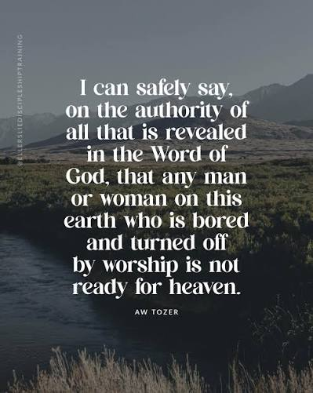

Jesus said that the Father is seeking for true worshipers (Jn. 4:23-24). To be a true believer is to be a true worshiper, and yet we can get slack in our walk and in our worship.

We are called to worship joyfully and with heart – enthusiastically!

We should thus worship because of Who God is as YHWH God, because He is the Creator, because He is our Shepherd, because He is good, because of His covenant faithfulness, and because His trustworthiness endures to all generations.

Yes, make a JOYFUL shout to the LORD all you lands. Come before His presence with singing.

Well, with that, it is only fitting that we close this worship service with a song and closing prayer.

