SBC – July 5, 2026
#44
Revelation 19:11-16 (NKJV)
“The Second Coming of Jesus Christ”

Prayer

The book of Revelation comes with an inspired outline as seen in Revelation 1:19.

Slide # 1

Revelation 1:19 – Inspired Outline
Revelation 1:19 (NKJV)
19 “Write the things which you have seen, and the things which are, and the things which will take place after this.
- “have seen” – Past (Vision of Christ) – Ch. 1
- “which are” – Present (Church Age) – Ch. 2-3
- “after this” – Future (Post-Church Age) –Ch. 4-22
- - Scene in heaven –Ch. 4-5
- - Tribulation – Ch. 6-18
- - Second Coming – Ch. 19
- - Kingdom – Ch. 20
- - Eternal State – Ch. 21-22

Slide # 2

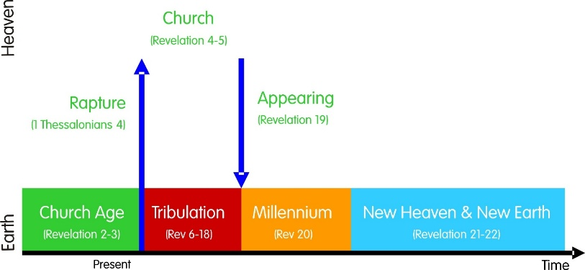

Following the Rapture of the Church, the earth will experience the Day of the Lord’s judgment. Organized rebellion against God will reach it apex in the rule of Antichrist. This system is called Babylon. It will fall under the judgment of God, and all of heaven will celebrate. This celebration will culminate in the marriage of the Lamb, which will be followed by the marriage of the Lamb celebration in the kingdom.

But prior to that taking place, there is the business of final judgment that must take place in relation to Christ’s Second Coming. And that is where the text goes now in Revelation 19:11-16.
About 1/5 of the Bible was written as prophecy. About 1/3 of those prophecies relate to Christ’s coming. There are at least 333 prophecies in the OT regarding the coming Christ. 109 of these prophecies were fulfilled literally to the letter at His first coming, which means that 224 of them remain to be fulfilled at His Second Coming. And just as sure as all those related to His first coming were literally fulfilled, just as sure will all those related to His Second Coming be literally fulfilled.

There is a sense in which everything before this in the Book of Revelation is an introduction to this revelation (unveiling) of Jesus Christ. – David Guzik

This is what the whole book of REVELATION has been moving toward. It is now here!

“The second coming of Christ is the most anticipated event in human history. It is the ultimate fulfillment of our Lord’s promise to return. It is also the culmination of all biblical prophecy. The return of Christ is the final apologetic! Once He returns, there will be no further need to debate His claims or the validity of the Christian message. The King will come in person to set the record straight. Revelation 19 is probably the most dramatic chapter in the entire Bible. It is the final capstone to the death and resurrection of Christ.” - Edward Hindson

Slide # 3

Hebrews 10:12-13 (NKJV)
12 But this Man, after He had offered one sacrifice for sins forever, sat down at the right hand of God,
13 from that time waiting till His enemies are made His footstool.
This is the moment Jesus has been waiting for, and now we see Him not seated, but MOUNTED and coming in climactic judgment to reign.

In relation to His bride, the emphasis is on Him being the Lamb, but now in relation to His coming it is on His Kingship and Lordship. He is coming as King of kings and Lord of lords. The imagery throughout is one of a conquering King.

“This paragraph has always seemed to me almost too overwhelmingly glorious for exposition.” – Wilbur Smith

Certainly no one can begin to exhaust this text, but it is here for a reason, and there is much we can glean from it.

Revelation 19:11–16 (NKJV)
11 Now I saw heaven opened, and behold, a white horse. And He who sat on him was called Faithful and True, and in righteousness He judges and makes war.

Revelation 4:1 and Revelation 19:11 mark two pivotal points in the book of Revelation.

Slide # 4

4:1 A Door Open in Heaven 19:11 Heaven Opened

Rapture Revelation

Coming “in the air” Coming “to the earth”

Coming for His Saints Coming With His Saints

Slide # 5
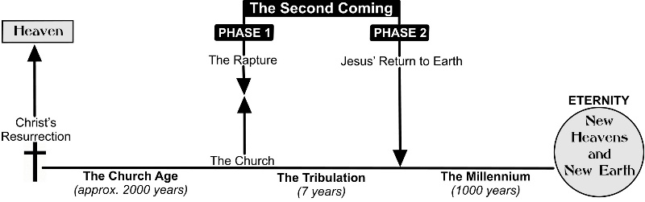

“I saw heaven opened” specifically answers to Rev. 1:7

Slide # 6
Revelation 1:7 (NKJV)
7 Behold, He is coming with clouds, and every eye will see Him, even they who pierced Him. And all the tribes of the earth will mourn because of Him. Even so, Amen.

John saw heaven opened and behold a white horse.

The irony here is amazing. When Jesus Christ opens the first seal – which introduces the Tribulation period – the first thing mentioned in Revelation 6:2 is a rider on a white horse. This is the Antichrist deceptively coming as a man of PEACE.
“What do you think of when you hear the word Antichrist? A crazed madman? A diabolical fiend? A modern Adolf Hitler? A shameless egomaniac? While all of these images are accurate, none of them picture what Antichrist will be when the world gets its first impression of him.” -Mark Hitchcock

He comes on the scene rather inconspicuously as the little horn (Dan. 7:8). He comes as a great peacemaker, entering into a 7-year covenant with Israel as seen in Daniel 9:27.

“Antichrist will come with the olive branch of peace in his hand. He will step on the scene and accomplish what generations had considered impossible. He will solve the Middle Eastern peace puzzle. He will rid the world of terrorism. He will be hailed as the greatest peacemaker who has ever lived. He will usher in a time of false peace at the dawn of the Tribulation… Can’t you just see it now? He will be Time magazine’s man of the year. He will be interviewed on 60 Minutes. He will capture the Nobel Peace Prize hands down.” – Mark Hitchcock

Slide # 7

1 Thessalonians 5:3 (NKJV)
3 For when they say, “Peace and safety!” then sudden destruction comes upon them, as labor pains upon a pregnant woman. And they shall not escape.
Very POSSIBLY the ongoing unrest in the Middle East may well be part of the stage-setting process that makes way for the “great Peace Maker” who is in fact Antichrist to come on the scene.

In the Roman Empire, when a Roman General won a victory, he would come back home riding on a WHITE HORSE. It signified victory, conquest, and triumph. So with Jesus, this signifies the Messiah/Warrior coming in victory and triumph.

The first time he came meek, mild, and lowly, riding into Jerusalem on a donkey (cf. Matt. 21:4-7). A king riding on a donkey was a symbol of peace (cf. John 12:14-15). The first time Jesus came humbly, bringing salvation by which we could have peace with God.

Slide # 8
Zechariah 9:9 (NKJV)
9 “Rejoice greatly, O daughter of Zion! Shout, O daughter of Jerusalem! Behold, your King is coming to you; He is just and having salvation, Lowly and riding on a donkey, A colt, the foal of a donkey.
That was His first coming…But now He is coming on a WHITE HORSE in power and glory as triumphant King of Kings and Lord of Lords!

The white horse is rich with symbolism, but the real attention is on the rider, as the remainder of the paragraph is focused on Him.

He who sat on the white horse is obviously Jesus. He is called “Faithful and True,” meaning Trustworthy and Genuine. He is good for His promises, and His character is real (cf. Rev. 1:5; 3:7, 14; 21:5; 22:6; also Isa. 11:3-4).

In contrast, the antichrist is a deceiver and a pseudo in his character. In Revelation 6:2, the Antichrist deceptively comes on a white horse. The text says, “he went out conquering and to conquer.” For a time he has his sway with the world. So much so, that in Rev. 13:4 the world says, “Who is able to make war with him?” Well, here we have the answer! It is the TRUE Christ Who comes to make WAR with him.

In righteousness He judges and makes war.

He comes making HOLY WAR on the wicked of the world. His actions of judgment are in accord with what is perfectly RIGHT. This is a “just war”! It is in accordance with God’s holiness. These people are getting what they truly deserve. It is right/righteous.

Slide # 9

Acts 17:30-31 (NKJV)
30 Truly, these times of ignorance God overlooked, but now commands all men everywhere to repent,
31 because He has appointed a day on which He will judge the world in righteousness by the Man whom He has ordained. He has given assurance of this to all by raising Him from the dead.”
At His first coming, Jesus came to save – to be the Savior of the World – at His Second Coming to JUDGE the world!
And what is in view is the battle of Armageddon. This is the “war” that is in view (cf. Rev. 16:14, 16; 17:14).

Some see Jesus in such a light that they say the loving Jesus would never make war on anyone.
They see Him only as the meek and mild Jesus, but they do see Him as the Lion of the Tribe of Judah. They do not see Him in all His power and holiness. They do not see Him as a God of vengeance!

Slide # 10

Exodus 15:3 (NKJV)
3 The Lord is a man of war; The Lord is His name.
245 times in the OT God is referred to as “The Lord of Hosts” – that is the God of the armies of heaven.

At His first coming He came on a “peace” mission riding on a humble donkey. At the Second Coming He comes as a man of war – to fully and finally put down all His enemies – all resistance will be squashed.

It will truly be a “shock and awe” campaign and no one will be able to resist Him!

Footnote: Revelation 19 is the classic NT text on the Second Coming of Christ, but note that it makes no mention of believers being caught up to meet Him. Rather, the entire emphasis is on them coming down from heaven WITH Him. Since the bride of Christ is already in heaven, it is clearly implied that they were translated there earlier. This is in harmony with Christ’s promise to the church to keep them from the hour of trial that will come upon the whole earth as seen in Revelation 3:10.

12 His eyes were like a flame of fire, and on His head were many crowns. He had a name written that no one knew except Himself.

His eyes are like a flame of fire is in keeping with the vision of Revelation 1:14 and the reference in 2:18. His eyes are able to fully penetrate all rebellion and unbelief. His gaze sees right through everyone. He is omniscient, and His judgment is totally accurate.

On His head were many crowns. Crows is the Greek word for “diadems,” meaning “kingly crowns” – crowns that apply to rulers.

In the old days, when a king was defeated, his crown was then given to the conquering king (cf. 2 Sam. 12:30). Earlier in the book, both Satan and Antichrist are depicted as wearing diadem crowns because of their authority over the worldly realm (cf. Rev. 12:3; 13:1).

But now Jesus has all the crowns of all the rulers of every realm because He is putting them all down. He rules over every ruler, over every sphere. He comes to rule supreme over every realm! And all those crowns now belong to Him!

Slide # 11
Revelation 11:15 (NKJV)
15 Then the seventh angel sounded: And there were loud voices in heaven, saying, “The kingdoms of this world have become the kingdoms of our Lord and of His Christ, and He shall reign forever and ever!”

All that these crowns signify we cannot say, but most certainly they indicate total and absolute sovereignty. Jesus alone is shown to be sovereign ruler over all.

And then the text says:

He had a name written that no one knew except Himself.

In Bible times, a person’s name was often more than a title; it represented a person’s character.

What this means we cannot say because we are not told. We have to leave it there. It does show us that there are things about Jesus we still don’t know. In the person of Christ there is awesome mystery too deep for us to fully comprehend. John could see the name, but he couldn’t comprehend it! His person is unfathomable – indescribable.

We can never fathom the depths of Christ. Theologians use the word “ineffable” to describe Him. It means Jesus is too overwhelmingly awesome and sacred to be described in words. Here, this unknown name evidently reflects this reality.
The secret things belong to the Lord our God (Deut. 29:29, cf. Judges 13:18 – wonderful-secret – and Isa. 9:6; also see Rev. 2:17, 3:12; and John 1:18).

13 He was clothed with a robe dipped in blood, and His name is called The Word of God.

He is clothed in a robe that is blood red in anticipation of the ensuing battle. This is reflective of Isaiah 63.

Slide # 12
Isaiah 63:2-3 (NKJV)
2 Why is Your apparel red, And Your garments like one who treads in the winepress?
3 “I have trodden the winepress alone, And from the peoples no one was with Me. For I have trodden them in My anger, And trampled them in My fury; Their blood is sprinkled upon My garments, And I have stained all My robes.
When Christ comes to Armageddon, it is going to be a blood bath – but this time it is not His blood that will be shed, but rather that of His enemies. This is the picture here.

His name is called the Word of God.

John is the only NT writer who refers to Jesus as the “Word”. His gospel starts out this way, as does the epistle of 1st John (cf. Jn. 1:1, 14; 1st Jn. 1:1, 5:7; Rev. 19:13).

The word “Word” is the Greek word “Logos,” referring to communication or expression. In effect, Jesus is the communication of God.

Slide # 13
John 1:18 (NKJV)
18 No one has seen God at any time. The only begotten Son, who is in the bosom of the Father, He has declared Him.

1 John 5:20 (NKJV)
20 And we know that the Son of God has come and has given us an understanding, that we may know Him who is true; and we are in Him who is true, in His Son Jesus Christ. This is the true God and eternal life.
Jesus communicates God to us. Word means the expression of thought. God expresses Himself and His reality through the Word. In Genesis 1, God spoke creation into being (cf. Ps. 33:6). In John 1, it says through the Word “all things were made” (Jn. 1:3). In the beginning the Word was with God and then Word was made flesh and dwelt among us (Jn. 1:1, 14).

So the idea of Jesus being “the Word” is that He is the expression of God – the revealer of God and His truth! He is “the image of the invisible God” (Col. 1:15); He is “the express image of His person” (Heb. 1:3). Jesus is the full and final revelation of God, and in view here in the book of Revelation is the consummation of that Revelation.

He revealed His love in full measure as the Lamb of God at His first coming as seen at the cross; now His righteousness/holiness is fully on display as the Lion of Judah in His holy judgment! Jesus is the communication of God, and at this point the world is really going to get the picture. Sadly, for a Christ-rejecting world, it will be too late.

As the “Word” He was able to speak the world into existence; at the end of the Tribulation He will speak armies out of existence.”
– Harold Berry

The armies of the earth are going DOWN! The armies in heaven are coming with Jesus in His return!

14 And the armies in heaven, clothed in fine linen, white and clean, followed Him on white horses.

Who are these armies in heaven?

Certainly, all the holy angels will be there, but they are probably not in view here in this verse (cf. Mt. 25:31; 2 Thess. 1:7). There are several reasons to believe these “armies” are essentially the saints in heaven – with special emphasis on the bride of Christ – that is, the church.

- The clothing of these armies is identical to that which is worn by the bride of Christ as emphasized in 19:8. The bride of Christ is the Church.

Slide # 14
Revelation 19:8 (NKJV)
8 And to her it was granted to be arrayed in fine linen, clean and bright, for the fine linen is the righteous acts of the saints.

Revelation 19:14 (NKJV)
14 And the armies in heaven, clothed in fine linen, white and clean, followed Him on white horses.

- These armies would seem to correspond to the “called, chosen, and faithful” of 17:14 who accompany the Lamb as He engages the antichrist and his forces in war. This is language that consistently relates to the saints, especially in relation to the church (cf. Rom. 1:7; Eph. 1:1; 1 Pet. 2:9).

- Also, the promise in Revelation 2:27 that the overcomers in the church will share in ruling with a rod of iron as Christ does here in 19:15 would indicate that the church is in view here.

I take it that essentially the bride of Christ – the church is in view; perhaps others, but certainly the church is involved here. However, the word “armies” is plural and may suggest several companies of people such as the OT saints and Tribulation saints, in addition to the church (cf. Jude 14-15).

Slide # 15
Jude 14-15 (NKJV)
14 Now Enoch, the seventh from Adam, prophesied about these men also, saying, “Behold, the Lord comes with ten thousands of His saints,
15 to execute judgment on all, to convict all who are ungodly among them of all their ungodly deeds which they have committed in an ungodly way, and of all the harsh things which ungodly sinners have spoken against Him.”
As I say, we know from other passages that all the holy angels will be here. It would seem appropriate that all of heaven is emptied out on this occasion. However, again I think the contextual emphasis is on the bride of Christ (the church), at this juncture.

If you are a member of Christ’s church – that is a true believer – circle the word “armies” because this includes you. You are here!

In most wars the general is in the back – while the armies are out in front doing the “hard” work of combat. In this case, the general – the King, is out in front and the armies are following.

In fact, they are merely spectators. They have no weapons, no swords, no shields, no armor - and they do not fight. All the fighting is done by the LORD Himself. Jesus single-handedly defeats the armies of the antichrist. We are simply there to celebrate and ride in the GRAND HEAVENLY PROCESSION of the King of Kings. We have the privilege of participation in the greatest of all events!

The rejected Savior is now returning in triumph as rightful ruler over all the world, and WE ARE WITH HIM! We are going to have a front row seat and watch Him single-handedly wipe out the antichrist and His forces!

What a sight this will be! Out in front is Jesus on a white horse with a multitude of crowns on His head, and streaming behind Him are millions of riders on white horses. This is the victory parade. This is Christ coming to the earth with His bride to conquer and then to celebrate with His bride. This is HIGH DRAMA!

Slide # 16
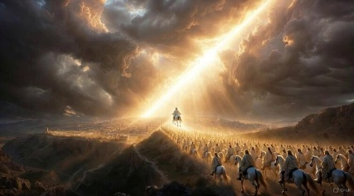

People wonder whether there will be animals in heaven – well I can’t say much about that, but I do believe there will be lots of white horses! And I for one intend to be riding one at this point. If you are a believer in Christ, you could insert your name here when it says “followed Him on white horses.”

15 Now out of His mouth goes a sharp sword, that with it He should strike the nations. And He Himself will rule them with a rod of iron. He Himself treads the winepress of the fierceness and wrath of Almighty God.

The word for sword here denotes a large sword approximately 5 feet long. It goes out of His mouth, which I take it symbolically relates to His Word, which in turn relates to His will.

All Jesus has to do is say the Word - to will it and He wipes out the nations in rebellion.

Slide # 17

Isaiah 11:4 (NKJV)
4 But with righteousness He shall judge the poor, And decide with equity for the meek of the earth; He shall strike the earth with the rod of His mouth, And with the breath of His lips He shall slay the wicked.
2 Thessalonians 2:8 (NKJV)
8 And then the lawless one will be revealed, whom the Lord will consume with the breath of His mouth and destroy with the brightness of His coming. (cf. Rev. 19:21)

And then it says, “He Himself will rule them with a rod of iron.”

This emphasizes that He will shatter them into defeat and submission. This is the fulfillment of Psalm 2:9 and Revelation 12:5.

Slide # 18

Psalm 2:9 (NKJV)
9 You shall break them with a rod of iron; You shall dash them to pieces like a potter’s vessel.’ ”

Revelation 12:5 (NKJV)
5 She bore a male Child who was to rule all nations with a rod of iron. And her Child was caught up to God and His throne.

The Christ-child was destined to rule with absolute unquestioned authority, and here He comes just as prophesied!

And it says, “He Himself treads the winepress of the fierceness and wrath of Almighty God.”

He treads the winepress of God’s wrath! This language emphasizes brutal judgment and wrath that crushes and smashes the enemies of God. This is high-intensity wrath from the hand of the Almighty delivered through Jesus!

The imagery of the winepress is vivid and colorful descriptive language related to judgment, as already seen in Revelation 14 (cf. 14:8, 10, 19-20; 16:19; 19:13). In the old days, the winepress consisted of two vats – one lower than the other with a duct connecting the two. Grapes would be thrown into the elevated one, and then people would get into the vat and stomp and crush the juice out of the grapes, resulting in the juice running into the lower vat.

Slide # 19
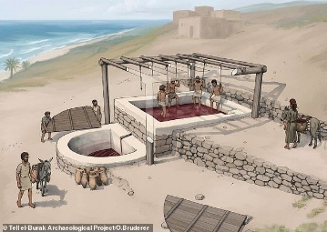
This is the picture of this judgment under the “feet” of Jesus Christ. He is going to stomp the rebel nations to where the blood is pictured as splattering as high as the horses bridles for the entire 200-mile length of the holy land as seen in Revelation 14:20.

Slide # 20
Revelation 14:19–20 (NKJV)
19 So the angel thrust his sickle into the earth and gathered the vine of the earth, and threw it into the great winepress of the wrath of God.
20 And the winepress was trampled outside the city, and blood came out of the winepress, up to the horses’ bridles, for one thousand six hundred furlongs [a distance of 200 miles].

No wonder Jesus is clothed with a robe dipped in blood.

Note the connection between “The Word of God” (the communication/expression of God in v. 13) and the fierceness and wrath of Almighty God here in verse 15. Clearly, Jesus, the expression of God, is expressing the wrath of God in full measure at this point. He is clearly communicating judgment.

As the humble Lamb of God, the blood of Christ was shed. But now as King of kings and Lord of lords, He crushes the lifeblood out of His enemies!

And note the language:

Out of His mouth…
He should strike the nations….
He Himself will rule…
He Himself treads the winepress…

This is Jesus working in solo! He Himself alone is doing this! The glory is His alone! This solo emphasis is also brought out in other passages such as Isaiah 63:1-6.

This also emphasizes that Jesus is ALMIGHTY GOD (cf. 1:8; 4:8; 11:17; 15:3; 16:7, 14; 19:6; 21:22). If He Himself alone does it – how can it be the wrath of Almighty God if indeed He is not God Almighty? The fact is Jesus is God!
He Himself treads the winepress of the fierceness and wrath of Almighty God because He is Almighty God!

The book both begins and ends with this emphasis!!

Slide # 21

Revelation 1:8 (NKJV) (Jesus speaking)
8 “I am the Alpha and the Omega, the Beginning and the End,” says the Lord, “who is and who was and who is to come, the Almighty.”
Revelation 19:15 (NKJV)
15 Now out of His mouth goes a sharp sword, that with it He should strike the nations. And He Himself will rule them with a rod of iron. He Himself treads the winepress of the fierceness and wrath of Almighty God.

16 And He has on His robe and on His thigh a name written: KING OF KINGS AND LORD OF LORDS

Sitting on a horse His robe and His thigh would be very visible.

Slide # 22
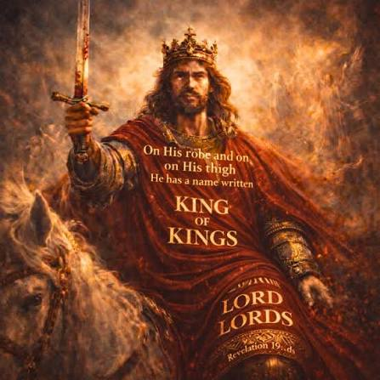

The title “King of kings and Lord of lords” in Scripture always denotes absolute sovereignty over all other kings and lords – over all other rulers and masters (cf. Deut. 10:17; Dan. 2:47; Phil. 2:9; 1 Tim. 6:15).
This is Christ's VICTORIOUS NAME! It denotes that He is the absolute supreme ruler over all other so-called authorities. It is to Him that every need will bow and every tongue confess that Jesus is Lord – to the glory of God (Phil. 2:9-11; 1 Tim. 6:15) .

Slide # 23
Matthew 24:30 (NKJV)
30 Then the sign of the Son of Man will appear in heaven, and then all the tribes of the earth will mourn, and they will see the Son of Man coming on the clouds of heaven with power and great glory.

- In righteousness He judges and makes war!
- He was clothed with a robe dipped in blood!
- Out of His mouth goes a sharp sword, that with it He should strike the nations!
- He Himself will rule them with a rod of iron!
- He Himself treads the winepress of the fierceness and wrath of Almighty God!

- Alleluia! For the Lord God Omnipotent reigns!

Marco Polo was a famous traveler from Venice who lived in the 13th century. As he lay dying, he was urged by his detractors to recant - to withdraw the incredible stories he had told about the lands of the Far East. But he refused, saying, “I have not told you the half of what I saw.”

We have been given a glimpse, but we really can’t begin to grasp the GLORY of Christ that will be displayed in the Second Coming!

Several times I have been invited to go overseas to minister the Word. I always ask if I can bring my wife, making that one of the conditions of my going.

Jesus is coming back, and He will not be coming alone. He is bringing His wife (the church) with Him!

1 Thessalonians 4:17 (NKJV)
17 Then we who are alive and remain shall be caught up together with them in the clouds to meet the Lord in the air. And thus we shall always be with the Lord.

“Thus we shall always be with the Lord.” Wherever the Lord goes we will go! Whatever involves Him will involve us! And this includes the coming marriage of the Lamb, His glorious Second Coming, and the Marriage Supper of the Lamb, and sitting on Christ’s throne with Him (Rev. 3:21).

We are not setting any dates!

Slide # 24
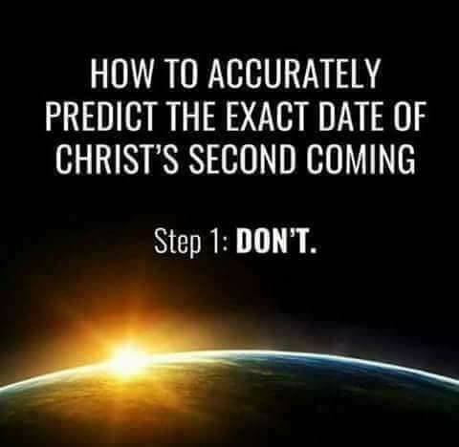

However, we know we are getting close. Paul tells us in 1 Cor. 10:11 that we are those “upon whom the ends of the ages have come.” He also says…

Romans 13:11 (NKJV)
11 …. knowing the time, that now it is high time to awake out of sleep; for now our salvation is nearer than when we first believed.

The writer of Hebrews says we “see the Day approaching” (Heb. 10:25).

We are not looking for specific signs, but there are stage-setting realities, and one of these is the rapid rise in antisemitism that is taking place around the world. We know the Bible says that in the end the entire world will march on Jerusalem in an effort to destroy the “the city of the great King” (Ps. 48:2).

Headlines this week like this are eyepopping for those who know the prophetic Scriptures.

Slide # 25
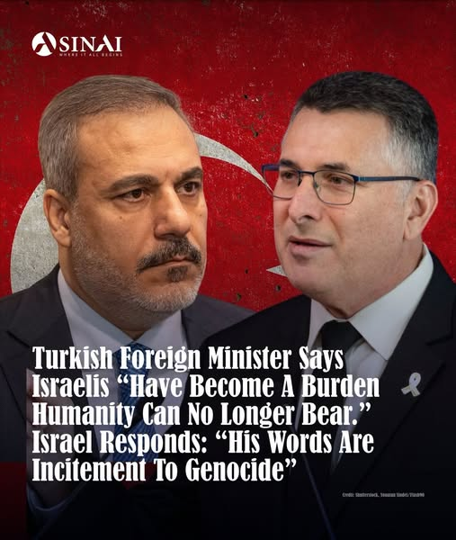
We know that in the end Gog and Magog (including Turkey) as seen in Ezekiel 38-39 are going to try and wipe out Israel; and then at the very end the whole world will march on Jerusalem as seen in Zechariah 12 and 14.

Slide # 26

Psalm 2:2–6 (NKJV)
2 The kings of the earth set themselves, And the rulers take counsel together, Against the Lord and against His Anointed, saying,
3 “Let us break Their bonds in pieces And cast away Their cords from us.”
4 He who sits in the heavens shall laugh; The Lord shall hold them in derision.
5 Then He shall speak to them in His wrath, And distress them in His deep displeasure:
6 “Yet I have set My King On My holy hill of Zion.”

Slide # 27
Psalm 2:8–12 (NKJV)
8 Ask of Me, and I will give You The nations for Your inheritance, And the ends of the earth for Your possession.
9 You shall break them with a rod of iron; You shall dash them to pieces like a potter’s vessel.’ ”
10 Now therefore, be wise, O kings; Be instructed, you judges of the earth.
11 Serve the Lord with fear, And rejoice with trembling.
12 Kiss the Son, lest He be angry, And you perish in the way, When His wrath is kindled but a little. Blessed are all those who put their trust in Him.

At the Second Coming, believers will share in the GLORY of it all, but the enemy world of God will experience the GORY judgment pronounced on them in the book of Revelation. We warned! Be wise! Be Ready!

Blessed are all those who trust in Him! Is your trust in Jesus?
Trust Him! Jesus is coming back!

Be ready! Live Ready!

