SBC – May 31, 2026
#40
Revelation 18:9-19 (NKJV)
“Earth Dwellers Broken Over Babylon’s Fall”

Prayer:

Everybody wants to know what the future holds, but only God knows.

Slide # 1


In the book of Revelation, what God does is gather up the whole of predictive prophecy and gives us a basic chronological order of how it all ends. First, He deals with the Church Age, which was not revealed in the OT, but then following that He deals at length with what concerns Israel and the world, concluding in the Second Coming and the kingdom of Christ that follows.

Slide # 2

Revelation 1:19 – Inspired Outline
Revelation 1:19 (NKJV)
19 “Write the things which you have seen, and the things which are, and the things which will take place after this.
- “have seen” – Past (Vision of Christ) – Ch. 1
- “which are” – Present (Church Age) – Ch. 2-3
- “after this” – Future (Post-Church Age) –Ch. 4-22
- - Scene in heaven –Ch. 4-5
- - Tribulation – Ch. 6-18
- - Second Coming – Ch. 19
- - Kingdom – Ch. 20
- - Eternal State – Ch. 21-22

The next great event on God’s prophetic calendar is the Rapture of the Church. It will happen suddenly and signlessly. The Church began that way on the day of Pentecost in Acts 2 and it will conclude the same way. When the Rapture happens, ALL of God’s children will instantly be removed from the earth. The true church will be gone!
But a FALSE church will be left behind, and in the first half of the Tribulation it will be a major player in world events as she will be intimately related to Antichrist in his rise to world domination.

Slide # 3
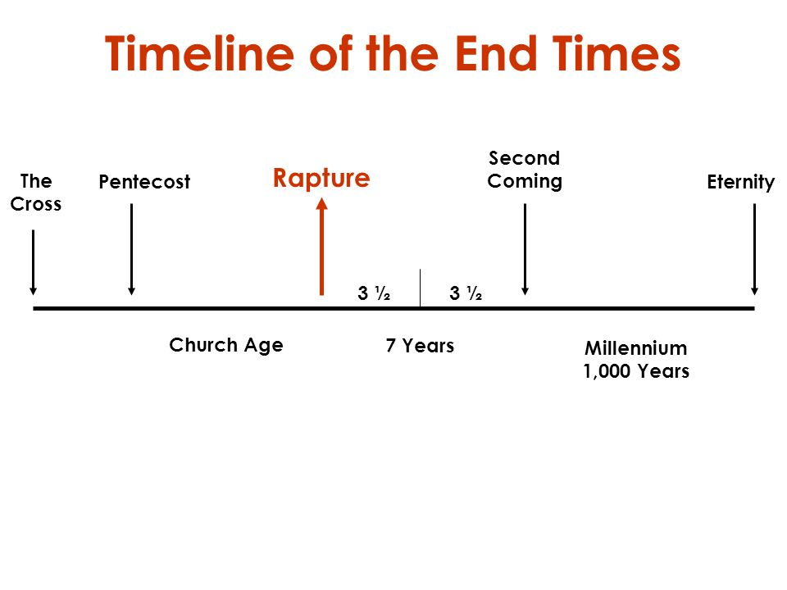
Down through history there has been a developing system of rebellion against God called the Babylonian System. Babylon represents unified, idolatrous rebellion against God. The culmination of this great system in the end has two aspects as seen in Revelation 17 and 18. One represents the ecumenical false Church that will be in league with Antichrist as seen in Revelation 17, and the other represents the final form of false religion under Antichrist as seen in chapter 18.

The first is called “Ecclesiastical Babylon” and is in view in the first half of the Tribulation; the second is called “Commercial Babylon” and is in view in the second half of the Tribulation. At that point both government and religion will become CENTRALIZED in Antichrist, and a major KEY to him governing the world both politically and religiously will be his control of COMMERCE. This is what we have presented in Revelation 18.

Slide # 4

THE BABYLONIAN SYSTEM
Idolatrous False Religion
(Genesis – Revelation)

Revelation 17 Revelation 18

Stage One Stage Two

A City (Papal Rome) A City (Babylon Revived)
“Church” & State in Union Religion & State in Union
Mystery Babylon Babylon the Great
Religious Emphasis Economic Emphasis
Rides the Beast (Control) Controls the World
Destroyed by Antichrist Destroyed by God
1st Half of the Trib 2nd Half of the Trib

The city of Babylon on the Euphrates River in Iraq (taking Scripture literally) is going to make a comeback in the last days. After Antichrist destroys this, the great harlot of apostate Christendom, with its headquarters in Rome, the power center of the world, will then transition to rebuilt Babylon, which will have emerged as the COMMERCIAL capital of the world in the last half of the Tribulation Period.

At this point everything will be about Antichrist as he controls the world, religiously, economically, politically, and economically. Revelation 13 is very clear that he is given authority over every tribe, tongue, and nation for the period of 42 months (Rev. 13:4-7). This is the apex and final form of the Babylonian System as controlled by Antichrist. But we see the end of it as prophetically spelled out in Revelation 18.

Last time we saw that Babylon (the capital) also represents a worldwide system. As such, she glorifies herself, lives luxuriously, and is full of self-sufficient pride (Rev. 18:1-8).

Babylon reflects life that is all about self: self-pride, self-gratification, self-confidence, self-sufficiency. This is Babylon: wealthy, prideful, self-indulgent – full of herself, but the Almighty will bring down this city and her great system with great rapidity, and she will not recover. This happens right towards the end of the Tribulation – in connection with the 7th bowl judgment and in close connection to the Second Coming (cf. 16:19).

Slide # 5
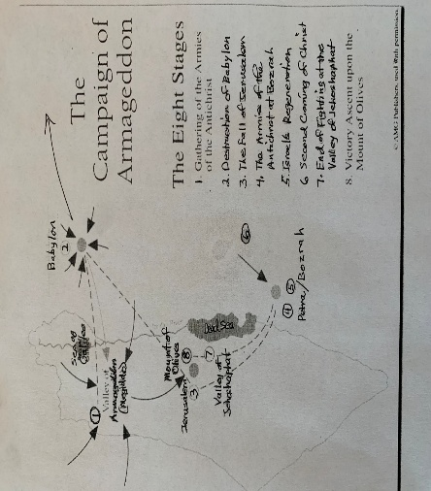
We could outline Revelation 18 in this way.

Slide # 6

Revelation 18 – Commercial Babylon

18:1-3 Pronouncement of Judgment
18:4-5 Warning: “Get Out of Town!”
18:6-8 Extent of Judgment and Why
18:9-19 Judgment Lamented by “Earth Dwellers.”
18:20-24 Judgment Celebrated by Heaven!

In our study last time, we saw that the climactic plagues of judgment will hit the city of Babylon fast and furious, and will climax with a fiery end! The whole city will go up in a ball of fire as God did to Sodom and Gomorrah in the OT.

Slide # 7
Isaiah 13:19 (NKJV)
19 And Babylon, the glory of kingdoms, The beauty of the Chaldeans’ pride, Will be as when God overthrew Sodom and Gomorrah.
Today in Revelation 18:9-19 we have the RESPONSE of those intimately involved with the city of Babylon and her idolatrous system under Antichrist.

Slide # 8
The Funeral Dirge for Babylon

18:9-10 – The weeping Monarchs

18:11-16 – The weeping Merchants

18:17-17 – The weeping Mariners

Revelation 18:9–19 (NKJV)
9 “The kings of the earth who committed fornication and lived luxuriously with her will weep and lament for her, when they see the smoke of her burning,

Many have noted the similarities between the description of Tyre’s fate in the OT and that of Babylon here (cf. Ezek. 26:17-19; 27:25-36).

Antichrist promised “the good life” to those who throw in with him.

The kings of the earth were on board, buying into his system that forbids anyone to buy or sell apart from allegiance to the beast. Worshipful allegiance was seen in taking the mark 666 (cf. Rev. 13:15-18). These kings were all in. They were in bed with Antichrist and his idolatrous system, here referred to as spiritual fornication.

Consequently, they lived high off the system, but now, as they see the city of Babylon going up in smoke, they weep and lament for her.

“Some of those crossing the Euphrates on their way to Armageddon (16:12) may actually see the smoke rising from the burning city…The rest will watch Babylon’s destruction through the world’s media.”
-John MacArthur
Politicians are generally all in favor of WHATEVER will bring about prosperity. For them, “It is the Economy Stupid.” They promise a chicken in every pot, and that is what the general populous people clamor for. Elections tend to swing on economics. It is the language the world understands, and Antichrist will cater to this reality.

The populous clamors: “Feed us, take care of us… meet our every need.” But when government provides for you – you no longer have “freedom” in many respects, and so it will be here. Government will do much for the people as long as they take the mark and are supportive of the SYSTEM.

For Babylon, the dollar is the ALMIGHTY, and of course this money god is tied to Antichrist, who claims he is God. They worship Antichrist in large part because it comes with the promise of financial prosperity.

Kings and people will do whatever, including taking the mark of the beast, to tap into this prosperity. Frankly, it is amazing what people will compromise for the sake of the money God!

But now all of a sudden this great ECONOMIC CENTER that was so KEY to the prosperity of the world is enveloped by fire, and the world is watching and wailing, with the kings taking the lead in this tearful brokenness.

Weep: to sob openly – to wail.
Lament: Denotes loud wailing and beating your breast in despair. It means to mourn fitfully.
This word “lament” (Gk. kopto) is the same word used in reference to the unbeliever's response at the second coming in Rev. 1:7.

Slide # 9

Revelation 1:7 (NKJV)
7 Behold, He is coming with clouds, and every eye will see Him, even they who pierced Him. And all the tribes of the earth will mourn because of Him. Even so, Amen.

They are not excited to see Him coming! They are mourning in terror at the realization that JUDGMENT DAY has arrived and their fate is sealed.

Note that in Revelation 17 the kings in league with the Antichrist will champion the destruction of “Mystery Babylon” (cf. Rev. 17:16), but here in chapter 18 the kings of the earth mourn the destruction of literal Babylon. This is a powerful argument that there are two aspects to last days of Babylon.

10 standing at a distance for fear of her torment, saying, ‘Alas, alas, that great city Babylon, that mighty city! For in one hour your judgment has come.’

They are mourning, but they do so at a DISTANCE for fear of her torment!

They keep their distance for fear that they themselves may go up in flames if they get to close. This is total annihilation by fire. There are no RESCUE efforts going on. It's “stay clear”! (cf. 18:4) This is EVIDENCE that a real city is in view!

By the way, the world has not given up on Babylon.

The archaeological site in Iraq is undergoing extensive preservation and restoration. Today, Iraqi authorities and the World Monuments Fund are actively stabilizing the ancient structures, waterproofing the Ishtar Gate, and restoring the Temple of Ninmakh.

As the prophecy in Zechariah 5 says, when the time is right “wickedness” will again be headquartered in the land of Shinar (the old name for Babylon) – see Zech. 5:5-11. God’s prophetic truth has a track record of becoming 100 percent literally fulfilled. When Antichrist pours the wealth of the world into this project it will be amazing how quickly it develops.
But then suddenly its over!

They cry, “Alas, alas” which in Greek is “ouai, ouai”. This appropriately sounds like what they are expressing, which is total anguish. In 8:13 it is translated as “woe”.

The fall of the city of Babylon represents the fall of a HUGE SYSTEM that affected the entire world. Many have surmised that this may be computer headquarters that coordinated the commercial empire of Antichrist.

Whatever all is involved, certainly this was CORPORATE HEADQUATERS of the world's economy. This represents a COLLAPSE of the world’s economy. And the world will weep and wail!

They call this city, “that great city Babylon” and refer to her as the “mighty city.” Having bought into the claims of Antichrist, they thought his capital city was invincible as he himself claimed to be.

And for a time it seemed true. So much of the whole world was affected by various plagues, but Babylon seemed to escape unharmed; but God was saving the worst for last (Rev. 13:4). Babylon is singled out for special judgment as seen in 16:19.

Slide # 10

Revelation 16:19 (NKJV)
19 Now the great city was divided into three parts, and the cities of the nations fell. And great Babylon was remembered before God, to give her the cup of the wine of the fierceness of His wrath.

This city was great and powerful – in terms of commerce, riches, influence, political power, etc. So much so that apparently the kings of the world felt she was invincible. This city would never fall; it was so great. But now they see the city smoldering in flames, and they are shocked and pained to the core!

They lament, “For in one hour your judgment has come.”

They bemoan the fact that it happened so SUDDENLY. This fact is brought out over and over as if they are shocked – they can’t believe it. Such a GREAT AND MIGHTY CITY and yet it is brought down in one hour – that is to say with great unexpected suddenness.
But the kings had been warned about this very context. There it was right there in the Word of God for thousands of years.

Slide # 11
Psalm 2:10-12 (NKJV)
10 Now therefore, be wise, O kings; Be instructed, you judges of the earth.
11 Serve the Lord with fear, And rejoice with trembling.
12 Kiss the Son, lest He be angry, And you perish in the way, When His wrath is kindled but a little. Blessed are all those who put their trust in Him.

11 “And the merchants of the earth will weep and mourn over her, for no one buys their merchandise anymore:

Here we have the businessmen – the traveling salesmen – those who buy and sell and were getting rich off the system. They are weeping and mourning over Babylon, but really their concern is their loss of “sales”. No more will Babylon be the catalyst in their financial enterprises. Babylon had been the major facilitator in their BUSINESS dealings; but now it's all come falling down.

The sorrow of the world is really about self. They cry and weep and are broken not because of their sin but because of their loss. Really it is all about SELF. Sometimes people mistake the emotions of “self-pity” for repentance. This is not repentance – they are feeling sorry for themselves.

True repentance is broken over sin; it is Godward in nature. It is broken over the fact is has offended God. Peter was broken after he denied the Lord and wept bitterly (Mt. 26:75). That was godly sorrow. Jesus told him, “The spirit indeed is willing, but the flesh is weak.” (Mt. 26:41) Peter was weak but he had a good heart.

In contrast was Judas! After he betrayed Jesus, he too was all broken up, but there was no Godward repentance. He felt sorry for himself to the point of suicide (cf. Mt. 27:5). That is worldly sorrow. It feels sorry for self! It’s all about self.

These folks mourning over Babylon represent the “Judases” of the world who have sold their souls out to the Babylonian commercial system of Antichrist and are now feeling really sorry for themselves because it is all over in such short order.
Slide # 12

2 Corinthians 7:10 (NKJV)
10 For godly sorrow produces repentance leading to salvation, not to be regretted; but the sorrow of the world produces death.
Now 28 items are listed relating to the STUFF they lived for. This was their God!

12 merchandise of gold and silver, precious stones and pearls, fine linen and purple, silk and scarlet, every kind of citron wood, every kind of object of ivory, every kind of object of most precious wood, bronze, iron, and marble;
13 and cinnamon and incense, fragrant oil and frankincense, wine and oil, fine flour and wheat, cattle and sheep, horses and chariots, and bodies and souls of men.

Most of the items listed relate to exotic things related to high living. This is what the Babylonian system was all about- STUFF – living for now – pampering self – wheeling and dealing in the fast lane – the life of luxury – the delicious life of excess and self-indulgence!

Babylon promised all that this life has to give.

“What a catalog of opulence! What a vivid picture of a great, commercial city, trafficking in every luxury the heart could desire. This is the world’s great Vanity Fair. It offers articles of adornment and display, beautiful things to grace the mansions of the world’s millionaires. It deals in exotic spices and perfumes, in delicacies for the table, in provisions for banquets, in slaves, and in the souls of men.
And Babylon imported all these things. They flowed into her new and magnificent harbor from the seaports of the world. The business magnates of the earth harnessed their industries, their export trade, their entire commercial enterprise, for Babylon; and the wealth of the world passed through her clearinghouse. Babylon’s demand for this world’s goods was insatiable; ever it clamored for more and more! But now nothing is left of the city. Her giant warehouses have gone up in smoke; the fabulous markets and shopping centers are reduced to smoldering rubble; her multimillionaires are dead.

In one hour, so great riches are brought to nothing, and the merchants, standing out of reach of Babylon, choking the arterial highways that lead to the city, watch with horror as their investments, their inventories, and their fortunes go up in smoke.” – John Phillips

That would seem to be a very accurate depiction!

Note at the end of verse 13 it says, “and bodies and souls of men”. This refers to the slave trade, which Babylon will also traffic in. We commonly in our context associate slave trade to a former barbaric time, but it will again emerge as a real reality in the last time in the Babylonian system. Even today in many parts of the world some form of slavery is a reality.

In view here is undoubtedly human trafficking, which in our own backyard is a major hidden issue. In view are such things as forced prostitution. We are not told exactly what form this “slavery” takes, but it obviously is in place to serve the wealthy intimately tied into the Babylonian system.

This final system of commerce championed by the beast will dehumanize humankind, as any system without God will do.
– David Jeremiah

This description of idolatrous opulence in verses 12-13 is then followed up by an interjection in verse 14 that is a statement of final judgment!

14 The fruit that your soul longed for has gone from you, and all the things which are rich and splendid have gone from you, and you shall find them no more at all.

The fruit in view is all the STUFF they lusted after and lived for is now gone! All the STUFF that was rich and splendid is GONE, and it is never coming back.

The words “no more” translate a double negative in the Greek text which is the strongest form of negation in the Greek language.
– John MacArthur

They traded the permanent for the very temporary and now it is over. The party is permanently over. They had their moment of debauchery – satisfying the flesh in every imaginable way, and they thought it would continue indefinitely, but SUDDENLY it is GONE! A Divine interruption brings it all crashing down.
“We all tend to live “ash heap lives”; we spend most of our time and money for things that will end up in the city dump”.
- Francis Schaeffer
Well, that is convicting!

It is good to remind ourselves regularly that “It will all burn!” Only what’s been used for Christ will last. People tend to be very impressed with STUFF and esteem lightly the things that really matter.

Slide # 13

Matthew 6:19-21 (NKJV)
19 “Do not lay up for yourselves treasures on earth, where moth and rust destroy and where thieves break in and steal;
20 but lay up for yourselves treasures in heaven, where neither moth nor rust destroys and where thieves do not break in and steal.
21 For where your treasure is, there your heart will be also.
Where your treasure is, is where your heart will be. These people in Revelation 18 clearly show that their treasure was in the STUFF of this life. They are the “earth dwellers” mentioned at least 10 times in the book, and so they mourn accordingly.

What is being illustrated is a little picture of hell. Hell is a place of unfulfilled desire. There is no satisfaction there! The flesh promises fulfillment but it never brings it. True satisfaction is found only in God.

Slide # 14
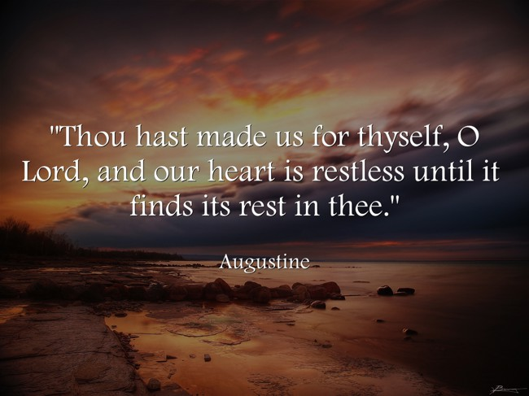
15 The merchants of these things, who became rich by her, will stand at a distance for fear of her torment, weeping and wailing,
16 and saying, ‘Alas, alas, that great city that was clothed in fine linen, purple, and scarlet, and adorned with gold and precious stones and pearls!

Everybody is staying clear! God has made a very clear, undeniable statement of judgment, and it is not safe to come near.

These merchants are the same men who will take the mark of the beast so that they may buy and sell (13:17). – David Levy

Just as the kings stood at a distance, so do the merchants and just as the kings were weeping and wailing (v. 9-10), so are the merchants.

Their hearts are truly broken! And the reason is that they love the world – they love themselves – they are into SELF AND STUFF, and now it's over.

They too cry “Ouai, Ouai!”

That great city the whole world was so enamored with, namely Babylon, was so impressive! It was the prized jewel of the world! It was the ritzy city of lights, glitter, glitz, and made available all that the flesh could enjoy. It will be the no-holds-barred SIN CITY of Antichrist. It will be the lap of wealth, luxury, and self-aggrandizement. But in “one hour” it is all coming DOWN! All that is left now is the weeping and wailing!

Slide # 15

Mark 8:36 (NKJV)
36 For what will it profit a man if he gains the whole world, and loses his own soul?

17 For in one hour such great riches came to nothing.’ Every shipmaster, all who travel by ship, sailors, and as many as trade on the sea, stood at a distance

Again, it is stated that her destruction comes in one hour – denoting a very short time frame! It is hard for them to accept that it could all end so abruptly. Note this is emphasized 4 times in the text.

Slide # 16
v. 8 … her plagues will come in one day…
v. 10 For in one hour your judgment has come.
v. 17 For in one hour such great riches came to nothing.
v. 19 For in one hour she is made desolate.

In particular, note the phrase, “came to NOTHING!” It is all for not! I have often said that for those who live for self and stuff at the end of their life you could write on their tombstone “Vanity” – emptiness – nothing.” It all counted for nothing! Talk about an EMPTY LIFE!

The impact is extensive, involving every shipmaster, all who travel by ship, sailors, and as many as trade on the sea.

Note the monarchs, merchants, and mariners are all standing at a DISTANCE (vs. 10, 15, 17)! They obviously have the sense that if you get too close, you may be consumed in the flames of Babylon. This is not a small fire. I think that whole HUGE area surrounding Babylon will go up in a ball of fire.

As a side note, it is amazing the resiliency of commerce in the world. The destruction of Babylon comes right at the end, and in spite of all the judgments that have fallen, Babylon continues to function right to the end. Back under the second trumpet judgment we read…

Slide # 17

Revelation 8:9 (NKJV)
9 And a third of the living creatures in the sea died, and a third of the ships were destroyed.

And yet Babylon continued to function. Amazing! Not until the fiery judgment of Revelation 18 is Babylon stopped.

Back before the year 2000, when all the rage was that Y2K was going to shut the world down, Dr. John MacArthur pointed out that this passage in Revelation 18 was dealing with the Day of the Lord, and even in the context of all these judgments, commerce still continues until the very end. He went on to say that he thought Y2K would not be any big deal – and you know what, he was right.

Slide # 18

Luke 17:28–30 (NKJV)
28 Likewise as it was also in the days of Lot: They ate, they drank, they bought, they sold, they planted, they built;
29 but on the day that Lot went out of Sodom it rained fire and brimstone from heaven and destroyed them all.
30 Even so will it be in the day when the Son of Man is revealed.

Don’t worry about the economy. It will function right to the very end. And beyond that we have a Father who knows and meets all our needs and therefore we are not to be like the pagan Gentiles who constantly worry about these things (Matt. 6).

However, now this great commercial empire has come crumbling down. Babylon was given space by God to do her thing – but judgment day has come, and it came in an hour, in a day – very quickly!
18 and cried out when they saw the smoke of her burning, saying, ‘What is like this great city?’

All three of these groups – kings, merchants, mariners, mourn the loss of this great city (v. 10, 16, 18). And they all are saying the same thing – they all have the same earthly perspective. They were all sold out to Babylon.

For the monarchs it was about power and control (v. 10), for the merchants it was about commodities (vv. 12-13), and for the mariners it was about income (v. 17). They were all beholden to Babylon!

Here in verse 18 they say, “What is like this great city?” They had such great admiration for this city. They thought it was incomparable, and really invincible. This sentiment is reminiscent of the worshipful sentiment regarding Antichrist in 13:4.

Slide # 19

Revelation 13:4 (NKJV)
4 So they worshiped the dragon who gave authority to the beast; and they worshiped the beast, saying, “Who is like the beast? Who is able to make war with him?”
In 13:4 they say, “Who is like the beast?”
In 18:18 they say, “What is like this great city?”

Previously, the word around the world was that the city and system of BABYLON was unparalleled in greatness. It was so incomparably great that it was unthinkable that it could be brought down – and certainly not in a day, not in an hour! But here they are!

19 “They threw dust on their heads and cried out, weeping and wailing, and saying, ‘Alas, alas, that great city, in which all who had ships on the sea became rich by her wealth! For in one hour she is made desolate.’

In total despair they cast dust on their heads, weeping and wailing.

Again they are bemoaning the fact that their source of “riches” is gone – in effect they are crying for themselves, not for Babylon perse. They are sorrowing the sorrow of the world which cries because of self and not because of sin.

Nothing so reveals the hardness of the human heart as their lack of sorrow over sin, and their great sorrow over worldly loss.

Again they are amazed at how QUICKLY this city is gone!

Today, with the complex connections that exist between governments and businesses, and with the interrelated computer systems, it would not take long for “Babylon” to collapse and the world’s economic system to be destroyed. – Warren Wiersbe

People really underrate God. They tend to overrate man and underrate God. Remember the statement back in verse 8, “strong is the Lord God who judges her.” One snuff of judgment and the whole thing goes up in smoke! It’s over!
All the wailing, lamenting, and weeping really is the beginning of hell for these folks. This comes right at the end of the Tribulation, and eternity is in plain view now.

These people are on the cusp of entering into the experience of anguish and despair that will never know relief – in that sense this is the beginning of hell for these folks – they will never recover from this because the King of kings is very shortly to appear, coming in the clouds of glory causing all the tribes of the earth to mourn.

Not only is Babylon aglow with fire and smoke, but on the horizon coming in the clouds of glory is the Almighty judge – the Lamb of God returning in all His glory – now what?

Babylon is about idolatrous MATERIALISM and self-gratification. In a nutshell, that is it. The people committed to this system live for self and stuff, and Antichrist offered the speed ramp to that end, and they bought into it, but so very SOON it all comes crashing down!

There is pleasure in sin for a season – for a very short season.
The fool lives for the short view – the wise person for the long view.
It is the temporal versus the eternal.

This Babylonian system lives for self and stuff with no thought for God.

What are you living for? God or Self/Stuff? The honest answer will tell you where you really stand with God.

Slide # 20

1 John 2:15–17 (NKJV)
15 Do not love the world or the things in the world. If anyone loves the world, the love of the Father is not in him.
16 For all that is in the world—the lust of the flesh, the lust of the eyes, and the pride of life—is not of the Father but is of the world.
17 And the world is passing away, and the lust of it; but he who does the will of God abides forever.

You can’t have it both ways! You can’t be a lover of God and lover of this world’s system at the same time!

Someone has said if you really want to know where a person stands check two things: 1) Check their Calendar, and 2) Check their check book. That is telling in terms of what a person is really living for, what really matters to them, who is really LORD of their lives.

Remember “Lot's” wife? As Lot and his family were told to flee Sodom, his wife looked back and instantly became a pillar of salt (Gen. 19:26).

Her heart was still in Sodom – she turned into a pillar of salt.

Where is your heart at? Does the Babylonian spirit own you? Are you living for self and what this world has to offer or are you truly living for Jesus?

What type of sorrow characterizes you? Worldly sorrow or godly sorrow?

The Babylonian character lives for the world and what it has to offer.
In contrast, the pilgrim character of the true Christian lives in light of the world to come.

The spirit of Antichrist promises you the world but gives you hell!

The Bible says our lives are like a vapor! Our time here is very fleeting.
Doesn’t it make sense to live life with an eternal perspective?

Chuck Swindoll shared this illustration: A Rabbi was talking to a very self-centered rich man. He asked the rich man to look through a window pane and see all the people out in the street. Then asked him to look into a mirror where all he could see was SELF! He then said, the difference is this: When you add just a little silver, all you can see is yourself. This defines the spirit of Babylon.

Note the sorry condition of Babylon when the judging hand of God settles on her.

Slide # 21

Babylonian Judgment Emphases

Weep/Lament/Mourn/Wail – (4 times, vv. 9, 11, 15, 19).
Alas, alas – (3 times, vv. 10, 16, 19).
Great/Mighty City (5 times, vv. 10, 16, 18, 19).
One hour (3 times, vv. 10, 17, 19).
Rich (3 times, vv. 15, 17, 19).
Distance (3 times, vv. 10, 15, 17)

It was GREAT WHILE IT LASTED – but so suddenly God delivers a fatal blow, and just that quick it is over!

So, as we study this passage, what should our response as God’s people be? I hear these people mock those who believe and warn of coming judgment as though we are all doom and gloom, being filled with fear and no joy. Boy, are they missing the point.
God has told His people so that we might know the truth and warn the world, but for us personally we are not concerned. We are God’s mouthpiece to call the world to repentance and warn them of the urgency of getting right with God. But we ourselves have a glorious hope!

Slide # 22
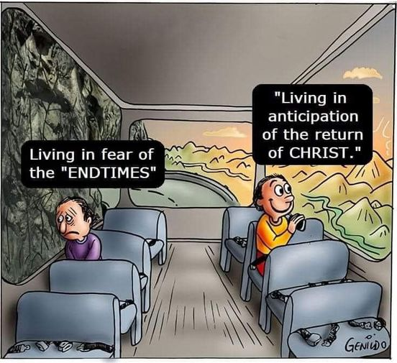
Slide # 23

Titus 2:13 (NKJV)
13 looking for the blessed hope and glorious appearing of our great God and Savior Jesus Christ,

We as believers should not have a doom-and-gloom outlook, not for ourselves; rather, we have a blessed hope!
We realize that we are just pilgrims passing through! Yes, we have all kinds of battles, struggles, failures, yet the Christian perseveres on the Pilgrim pathway toward our kingdom destination! And the goal on the journey is to be consistent with who we are as new creations in Christ.

Ephesians 5:15–16 (ESV)
15 Look carefully then how you walk, not as unwise but as wise,
16 making the best use of the time, because the days are evil.

Linda Ellis wrote a poem titled “The Dash.” A notable excerpt reads:

I read of a man who stood to speak at a funeral of a friend. He referred to the dates on the tombstone from the beginning… to the end. He noted that first came the date of birth and spoke of the following date with tears, but he said what mattered most of all was the dash between those years. For that dash represents all the time they spent alive on earth and now only those who loved them know what that little line is worth.
For it matters not, how much we own, the cars… the house… the cash. What matters is how we live and love and how we spend our dash. So think about this long and hard; are there things you’d like to change? For you never know how much time is left that still can be rearranged.

That dash on our tombstone - you know, the one that represents the life we lived between our start date and our end date? What we do during that time has eternal implications.

Only one life, “twill soon be past, Only what’s done for Christ will last.
Only one life, yes only one, Now let me say, “Thy will be done”;
And when at last I’ll hear the call, I know I’ll say ’twas worth it all”;
Only one life,’ twill soon be past, Only what’s done for Christ will last.
– C.T. Studd

It will be worth it all when we see Jesus!

Live for Christ! Live in light of eternity. Live with an eternal perspective!

In the end, ONLY what’s done for Christ will last!

