SBC – June 14, 2026
Psalm 111:1-10 (NKJV)
“Praise God for His Wonderful Works”

Psalm 111 and 112 are considered to be “twin Psalms,” suggesting that they have the same author, even though we don’t know who the author was. Some suggest David, but we don’t really know.

Both Psalm 111 and 112 begin with “Hallelujah.” Both of these Psalms are acrostic Psalms, having 22 lines in the Hebrew that correspond to the 22 letters of the Hebrew alphabet.

“The two psalms are an obviously matched pair. The first is an acrostic poem about God; the second is an acrostic poem about the godly man.” – James Montgomery Boice

It is also pointed out that Psalm 111 and 112, with their Hallelujah emphasis, properly prepare the way for the Hallel Psalms of 113-118.

Slide # 1

Psalm 111

“Praise God for His Wonderful Works”

v. 1 A Determination to Praise the LORD
vv. 2-3 The Study of God’s Great Works
vv. 4-6 Remembering God’s Great Works
vv. 7-9 The Nature of God’s Great Works
v. 10 What Should be Learned from God’s Great Works

Psalm 111 (NKJV)
1 Praise the Lord! I will praise the Lord with my whole heart, In the assembly of the upright and in the congregation.

“Praise the LORD!” is the translation of “Hallelujah” in the Hebrew. It more literally is translated as “Praise YHWH!” So this Psalm begins with the climactic high praise word.

The writer is determined to praise the LORD with his whole heart. He is holding back nothing!

God wants our “whole heart” in worship. A divided heart is unacceptable!

This praise is to be a PUBLIC affair, not merely private. Certainly private worship is good, but public worship with God’s people is a matter of mutual edification that brings glory to God. God designed us to function in fellowship, and that is certainly true of worship.

The idea of “assembly” is a Hebrew word that refers to a smaller, more intimate group, whereas “congregation” refers to the larger corporate gatherings of God’s people. In both contexts, the writer is determined to praise the LORD with his whole heart!

2 The works of the Lord are great, Studied by all who have pleasure in them.

The focus of praise is now on the WORKS of God which are mentioned five times in the ongoing context (v. 2, 3, 4, 6, 7).

What God does is GREAT! And they are studied by all who have pleasure in them. They are awesome, and it is exciting to study the details of how God works.

The word “works” here often has the connotation of God’s creation works – what He has made (cf. Ps. 8:3; 19:1; 102:25).

“In design, in size, in number, in excellence, all the works of the Lord are great. Even the little things of God are great.”
- Charles Spurgeon
Slide # 2
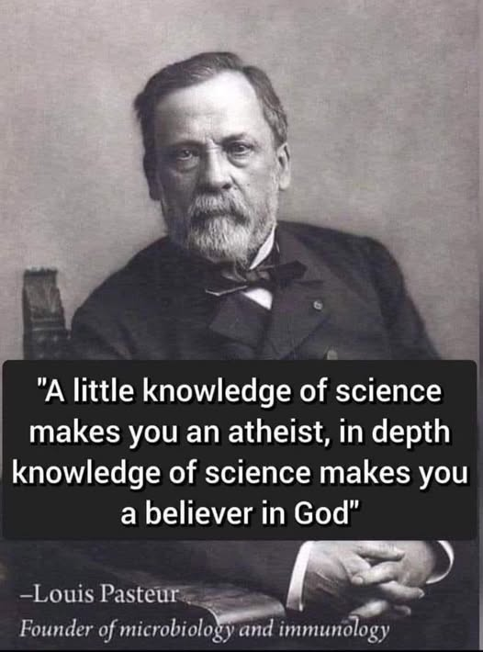
Slide # 3

Once you see the hand of God behind the whole of creation it is awesome and you want to learn more and more. It gives one great pleasure. Whole ministries are built around this like Answers in Genesis and the Institute for Creation Research.

Whether you go large or go small, the works of the Lord are great!

Vernon R. Cupps writes, "Dr. James F. Coppedge calculated the probability that a single insulin molecule (one of the simpler complex molecules in the human body) would form by chance as 1 in 10 to the 109th power - a probability most statisticians consider to be impossible." Just to be clear, this is a 10 with 109 zeroes behind it.

The average adult human body contains approximately 30 trillion cells. And they have to function in harmony for life to exist.

Slide # 4
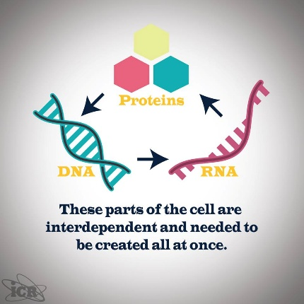

When we look into outer space, it blows your mind at what we continue to discover.

Slide # 5


Astronomers estimate that there are approximately 200 billion trillion stars (or 200 sextillion) in the universe. But that is just a guess, because they are constantly having to revise as they study and learn more.

Truly, “The heavens declare the glory of God.” (Ps. 19:1)
As we study the works of God’s creation, it should cause us to worship in awe at how awesome God truly is. He is unfathomably GREAT!

“There is a science laboratory in Cambridge, England, called the Cavendish Laboratory, named after the eighteenth-century English chemist and physicist Sir Henry Cavendish (1731-1810). It is distinguished by having the words of Psalm 111:2 inscribed over the entrance to its building as a charter for every believing scientist: Great are the works of the Lord; they are pondered by all who delight in them.” – James Montgomery Boice

3 His work is honorable and glorious, And His righteousness endures forever.

The NASB translates this as “Splendid and majestic is His work.” The word work here (Heb. poal) is thought to have God’s providential working in view (cf. Deut. 32:4). God’s work of guiding and arranging all things in harmony with perfect timing is awesome.

All is in keeping with God’s righteousness which endures forever!

But we should note that some commentators think the emphasis in this whole context is especially in relation to what God has done and is doing in regard to His chosen people. Certainly, as we go along that becomes a major emphasis. But both are true, God’s works in relation to creation and relation to the making of His people – both are GREAT realities, both are a great study.

4 He has made His wonderful works to be remembered; The Lord is gracious and full of compassion.

God wants His wonderful works to be remembered. After delivering His people from Egypt and faithfully bringing them through the wilderness and into the promised land, the people were instructed to set up “memorial stones” to serve as a constant reminder of what God had done (Josh. 4:1-7). Passover serves as a constant reminder of God’s deliverance. The Lord’s Supper serves as a constant remembrance of what God did for us at the cross!

It is so easy for us to lose sight of God’s wonderful works. They are to be remembered, and we need constant reminding.

The word “wonderful” is often descriptive of God’s saving acts. It is a dishonor to God to overlook His miracles of redemption that have brought about our so great salvation.

And we need to be mindful that it is the graciousness and compassion of the LORD that is behind these wonderful works.

5 He has given food to those who fear Him; He will ever be mindful of His covenant.

God provides for His people who are defined as those “who fear Him.”

Slide # 6

Psalm 37:25 (NKJV)
25 I have been young, and now am old; Yet I have not seen the righteous forsaken, Nor his descendants begging bread.

Jesus taught us to pray: “Give us this day our daily bread.” (Mt. 6:11). How faithful has God been to do this? When was the last time you went a day without eating because of a lack of food?

Indeed, “He has given food to those who fear Him” and we have the promise that He “will ever be mindful of His covenant.” Those in covenant relationship with God have the promise that He will never leave us nor forsake us (Heb. 13:5). God has promised to always be there for us and to take care of us.

In particular, Israel is in view here and undoubtedly God’s provision for them in their wilderness journeys.

Slide # 7

Deuteronomy 8:3–4 (NKJV)
3 So He humbled you, allowed you to hunger, and fed you with manna which you did not know nor did your fathers know, that He might make you know that man shall not live by bread alone; but man lives by every word that proceeds from the mouth of the Lord.
4 Your garments did not wear out on you, nor did your foot swell these forty years.

6 He has declared to His people the power of His works, In giving them the heritage of the nations.

The heritage of the nations is the land of Canaan that God gave to His chosen people Israel (cf. Deut. 7:1). God made known His power to Israel in that He promised He would give it to them and then He brought it to pass.

“…two [out]standing proofs of Divine kindness are the miraculous provision of food in the desert and the possession of the promised land.” - Alexander Maclaren

7 The works of His hands are verity and justice; All His precepts are sure.

What God does is true and fair! What He commands (His precepts) are sure! God’s precepts are His rules for living, His directives, His mandates.

“He is no fickle despot, commanding one thing one day and another [on a different day], but his commands remain absolutely unaltered.”
- Charles Spurgeon

The Word of God is SURE! You don’t have to wonder about it! What God has said stands!

8 They stand fast forever and ever, And are done in truth and uprightness.

Slide # 8
Isaiah 40:8 (NKJV)
8 The grass withers, the flower fades, But the word of our God stands forever.”

9 He has sent redemption to His people; He has commanded His covenant forever: Holy and awesome is His name.

Redemption is the act of delivering. It is the idea of God rescuing and liberating His people. God did this physically in relation to His people Israel in the OT when He brought them out of the bondage of Egypt. Ultimately, spiritual redemption has been provided in the cross-work of Jesus for all who will receive it, and one day Israel will enter into the good of it nationally.
Slide # 9

Romans 11:26–27 (NKJV)
26 And so all Israel will be saved, as it is written: “The Deliverer will come out of Zion, And He will turn away ungodliness from Jacob;
27 For this is My covenant with them, When I take away their sins.”

This appears to look at the redemption aspects of the Abrahamic covenant, which was declared frequently to be an “everlasting” or “forever” covenant (cf. Gen. 17:7, 13, 19; 1 Chron. 16:15, 17; Ps. 105:8, 10; Isa. 24:5). – John MacArthur

Yes, we as the church now tap into the blessing aspect of the Abrahamic Covenant, but the covenant relationship that God promised Abraham and his descendants is still in play and will yet ultimately be fulfilled in a New Covenant relationship with Israel, which will be applied at the Second Coming as Israel comes to repentance.

God’s Covenant Promises to Israel cannot be broken. God’s name cannot be changed.

His very name YHWH means “to be”, meaning He is unchanging in His character!

To claim God is not going to be good for His covenant promises to Israel makes God out to be a completely different God than is presented in the Bible. If that is the case, then nothing is certain!

Slide # 10


That is absolute heresy!

Slide # 11
v. 3 His righteousness endures forever.
v. 7 The works of His hands are truth…
v. 7 All His precepts are sure.
v. 8 They stand forever and ever.
v. 8 Are done in truth and uprightness.
v. 9 He had commanded His covenant forever.

Slide # 12
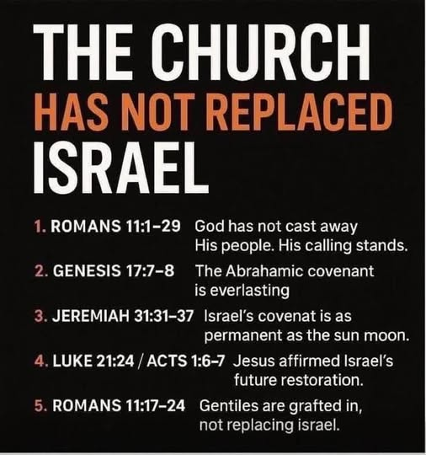

“He has commanded His covenant forever.”

And then note He, in effect, signed it with His name.

And “Holy and awesome is His name.” This serves to drive the point home concerning “He has commanded His covenant forever.”

God is absolutely Holy – totally set apart. There is no other like Him.

Slide # 13

Numbers 23:19 (NKJV)
19 “God is not a man, that He should lie, Nor a son of man, that He should repent. Has He said, and will He not do? Or has He spoken, and will He not make it good?

God’s name is His person! He is holy and awesome! The old KJV translated awesome as “reverend” with the phrase being, “reverend is his name.”

That alone is enough to make me not want to take the title “reverend.” I often say, “There is nothing to reverence about me, so don’t call me reverend.”

God alone is perfectly HOLY; His name alone is awesome!

10 The fear of the Lord is the beginning of wisdom; A good understanding have all those who do His commandments. His praise endures forever.

Recognizing the greatness of God’s works, one should appropriately fear Him. God should be regarded with respect, reverence, and awe. This proper attitude of the creature toward the Creator is the beginning of wisdom. – David Guzik

The fear of the LORD is just the beginning. To come to a true fear of the LORD where we properly reverence Him really happens in saving faith. The wicked have no fear of God, as Paul brings out in Romans 3:18.

Fear is not the idea of slavish fear but rather of a reverential awe of God borne out of repentance and faith.

Slide # 14

Matthew 10:28 (KJV)
28 And fear not them which kill the body, but are not able to kill the soul: but rather fear him which is able to destroy both soul and body in hell.

This is a concept more familiar from Proverbs but central to worship in the Psalms (cf. Pr. 1:7; 9:10). – The Moody Bible Commentary.

However, the wisdom literature in Job and Ecclesiastes also allude to this (Job 28:28; Eccl. 12:13).

“It is probably a safe bet to say that most people today are not much interested in wisdom. They are interested in making money and in having a good time. Some are interested in knowing something, in getting an education. Almost everyone wants to be well liked. But wisdom? The pursuit of wisdom is not a popular ideal.”
– James Montgomery Boice

Lots of people have knowledge, but MOST people never even touch true wisdom. They never even come to the beginning of it, which is the FEAR of the LORD! Without fear of the LORD, people have NO wisdom, as defined biblically!

The fruit of true wisdom is obedience. The fear of the LORD, wisdom, and obedience are all closely tied. This is the God-blessed life! And God is to be praised for it. Yea, His praise endures forever!

Throughout eternity we will be praising God for His wonderful works wrought on our behalf in our lives. We can never praise Him enough!

God’s people should not live in the past, but neither should we forget the past in terms of God’s wonderful works. God is to be praised forever for all He has done, for all He is currently doing, and for all that He will yet do!

Taking into account the greatness of God’s works, one should praise Him and never stop praising Him. The angels surrounding God’s throne see His greatness and the greatness of His works, and they never stop praising Him (Revelation 4:8).
-David Guzik!

And neither should we!

Psalm 111 begins with “Praise the LORD!” and it concludes with “His praise endures forever.”

Truly, God is to be praised for His wonderful works!

Indeed, may the name of the LORD be praised!

