SBC – May 3, 2026
Psalm 106:28-48 (NKJV)
“Israel’s Unfaithfulness to God” (Pt. Two)

Psalm 105 and Psalm 106 are companion Psalms, with 105 emphasizing God’s faithfulness and 106 emphasizing Israel’s unfaithfulness. And yet in spite of all Israel’s unfaithfulness, God remains faithful. That ultimately is the point.

The Psalm begins with a call to praise and thank God for His mercy (hesed – covenant faithfulness), and it ends with Hallelujah. In between is the long record of Israel’s unfaithfulness.

Last time in verses 1-27, we saw various examples of Israel’s unfaithfulness during the era of Moses. In verse 13 and again in verse 21, it says they forgot God. This Psalm shows how prone to wander are the people of God. And there are great warnings/lessons for us here. We must never think we are beyond it.

1 Corinthians 10:12 (NKJV)
12 Therefore let him who thinks he stands take heed lest he fall.

We left off at verse 27, which prophetically indicates that in the future Israel would be scattered among the nations. That is where habitual disobedience would lead – and it did.

Slide # 1
Psalm 106

“Israel’s Unfaithfulness to God”

vv. 1-5 The Invocation
vv. 6-7 Confession of Sin – Past and Present
vv. 8-12 God’s Mercy to Rebellious Israel
vv. 13-15 Lustfulness and Leanness
vv. 16-18 Envy Judged
vv. 19-23 Making God Their Adversary
vv. 24-27 Judgment in the Wilderness
vv. 28-31 God Sent a Plague
vv. 32-33 Provoking Moses to Sin
vv. 34-39 The Sin of Idolatry
vv. 40-43 God Turned Israel Over to the Gentiles
vv. 44-46 God’s Great Mercy to Israel
v. 47 A Prayer for Restoration
v. 48 The Benediction
Psalm 106:28–48 (NKJV)
28 They joined themselves also to Baal of Peor, And ate sacrifices made to the dead.
29 Thus they provoked Him to anger with their deeds, And the plague broke out among them.
30 Then Phinehas stood up and intervened, And the plague was stopped.
31 And that was accounted to him for righteousness To all generations forevermore.

In verses 28-33, we have two primary examples of Israel’s unfaithfulness.

This incident is dealt with in Numbers 25. The context is that since the false prophet Balaam could not curse Israel, he counseled king Balak and the Moabites to seduce the men of Israel through sensual seduction. And the plan worked swimmingly.

Slide # 2
Numbers 31:16 (NKJV)
16 Look, these women caused the children of Israel, through the counsel of Balaam, to trespass against the Lord in the incident of Peor, and there was a plague among the congregation of the Lord.

As the young women of Moab enticed the men of Israel to idolatry and immorality, they involved them in occult sacrifices. This provoked God's anger, and a plague broke out among them, killing 24,000.

The sinning was brazen and bold, but Phinehas took action.

Slide # 3
Numbers 25:6–8 (NKJV)
6 And indeed, one of the children of Israel came and presented to his brethren a Midianite woman in the sight of Moses and in the sight of all the congregation of the children of Israel, who were weeping at the door of the tabernacle of meeting.
7 Now when Phinehas the son of Eleazar, the son of Aaron the priest, saw it, he rose from among the congregation and took a javelin in his hand;
8 and he went after the man of Israel into the tent and thrust both of them through, the man of Israel, and the woman through her body. So the plague was stopped among the children of Israel.

It is interesting that this zealous action on the part of Phinehas to stop sin in the camp was accounted to him for righteousness as so stated here in verse 31.

This is the same language used of Abraham in Gen. 15:6 where it says, “he believed in the LORD, and He accounted it to him for righteousness.” Does this mean Phinehas was accounted righteous on the basis of his works? Of course not!

As you study the whole of Scripture we find that justification is by faith alone, however if it is the right kind of faith it will demonstrate itself in the life. This it the point of James. Paul emphasizes “Faith Saves” – James emphasizes “Faith Works”. We are saved by a faith that works. We are not saved by the works, but by the faith that works.

Slide # 4

Genesis 15:6 (NKJV)
6 And he believed in the Lord, and He accounted it to him for righteousness.

James 2:21–23 (NKJV)
21 Was not Abraham our father justified by works when he offered Isaac his son on the altar?
22 Do you see that faith was working together with his works, and by works faith was made perfect?
23 And the Scripture was fulfilled which says, “Abraham believed God, and it was accounted to him for righteousness.” And he was called the friend of God.

Abraham had the kind of faith that demonstrated itself. It is this kind of faith that saves. And the same was true of Phinehas.

It was his faith that was demonstrated in his action, proving his faith was real.

In this action, Phinehas, the grandson of Aaron, was promised the covenant of "perpetual priesthood" for himself and his descendants.
His righteous zeal resulted in him and his line being established perpetually as the key custodians of the priesthood.

32 They angered Him also at the waters of strife, So that it went ill with Moses on account of them;
33 Because they rebelled against His Spirit, So that he spoke rashly with his lips.

This is interesting! We know from Numbers 20 that when the people contended with Moses over a lack of water, Moses, in frustration and anger, struck the rock instead of talking to it as instructed by God (Num. 20:7-11). Because of this, Moses was not allowed to go into the Promised Land (Num. 20:12-13).

But note the emphasis here is not on Moses but on the sin of the people. It was the people who angered God; the people rebelled against the Spirit, causing Moses to speak rashly. Isn’t that interesting! Moses did the sinning, but the people here are blamed for causing it. They provoked it! Yes, Moses blew it, but the people pushed him!

Here we see that sometimes not only is the person who sinned accountable, but those who provoke the sin are also held accountable. Thus, sin can be a multidimensional issue!

Spurgeon noted that sometimes congregations provoke their leaders as Israel provoked Moses.

Slide # 5

“We ought also to be very careful how we treat the ministers of the gospel, lest by provoking their spirit we should drive them into any unseemly behaviour which should bring upon them the chastisement of the Lord. Little do a murmuring, quarrelsome people dream of the perils in which they involve their pastors by their untoward behaviour.”
-Charles Spurgeon

Verses 34-39 deal with Israel’s failures from the time of entering into the land until the Babylonian Exile.

34 They did not destroy the peoples, Concerning whom the Lord had commanded them,

God had clearly told the Israelites that when they came into the land they should destroy these wicked people.

God had given the Canaanites lots of space, and they became so wicked that God was done with them.

Slide # 6

Genesis 15:16 (NKJV)
16 But in the fourth generation they shall return here, for the iniquity of the Amorites is not yet complete.”

Leviticus 18:24 (NKJV)
24 ‘Do not defile yourselves with any of these things; for by all these the nations are defiled, which I am casting out before you.

Slide # 7

Deuteronomy 20:16–18 (NKJV)
16 “But of the cities of these peoples which the Lord your God gives you as an inheritance, you shall let nothing that breathes remain alive,
17 but you shall utterly destroy them: the Hittite and the Amorite and the Canaanite and the Perizzite and the Hivite and the Jebusite, just as the Lord your God has commanded you,
18 lest they teach you to do according to all their abominations which they have done for their gods, and you sin against the Lord your God.

This the children of Israel failed to do, and they fell because of just exactly as God had warned (cf. Jn. 1:21; 2:3).

35 But they mingled with the Gentiles And learned their works;
36 They served their idols, Which became a snare to them.

They intermarried! And sure enough, they learned to follow in their idolatrous ways, which became a snare to them.

As they say, “It is easier to pull someone down off the table than to pull them up onto it.” Certainly, we are to be reaching out to the lost with the gospel, but we must always guard ourselves from compromise (Jude 23).

1 Corinthians 15:33 (NKJV)
33 Do not be deceived: “Evil company corrupts good habits.”

37 They even sacrificed their sons And their daughters to demons,
38 And shed innocent blood, The blood of their sons and daughters, Whom they sacrificed to the idols of Canaan; And the land was polluted with blood.

They went so far into this idolatry as to even sacrifice their own children to demons. Paul is clear in 1 Corinthians 8:4 that an idol is nothing (1 Cor. 10:19).
However, there is demon activity behind the idol, and therefore, to sacrifice to idols is actually sacrificing to the demons that are behind it (1 Cor. 10:20). In sacrificing children to the god “Moloch” (2 Chron. 28:3; 33:6; Jer. 7:31, 19:2-6) they were actually sacrificing to demons! So in actuality, this involved them in demon worship!

Consequently, the land was polluted with innocent blood!

Slide # 8
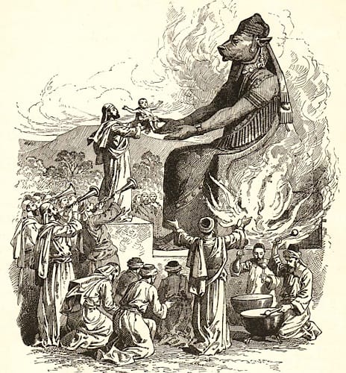

How can people believe in God and yet believe in the killing of children through abortion? Simply because they “serve idols.” Idolatry is perhaps the greatest of all sins because it opens the door to unrestrained evil – “My god gives me the right to choose!” etc. It gives sinners the licence not only to tolerate sin, but to sanction it, fanned by demonic influence.” – Ray Comfort

Those who create a god in their own image make a god that pleases them, and they do what they want. Years ago, the Washington Post wrote about a couple named Ed and Joanne. “In the past ten years, Ed and Joanne have begun to build their own church, salvaging bits of their old religion that they liked and chucking the rest. The first to go were an angry, vengeful God and hell – “That’s just something to scare you,” Ed said. They kept Jesus, “because Jesus is big on love.”

Slide # 9
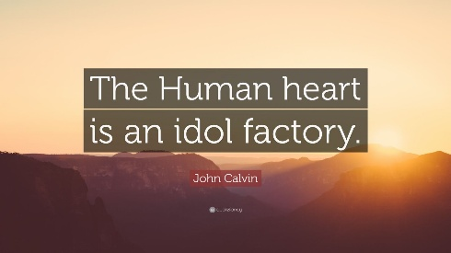

Yes, left to itself the heart is deceitful above all things and desperately wicked. It is an idol factory! (cf. Jer. 17:9).

39 Thus they were defiled by their own works, And played the harlot by their own deeds.

To "play the harlot" in the Bible symbolizes spiritual infidelity on the part of God’s people. As God’s people, they were in a covenant relationship with Him. To worship other gods or form pagan alliances was called playing the harlot, which is a metaphor for spiritual adultery.

And God did not appreciate it at all!

Verses 40-46 deal with the time of the Judges.

40 Therefore the wrath of the Lord was kindled against His people, So that He abhorred His own inheritance.

This is a really strong statement! “Wrath” and “abhorred” are strong words! Consequently…

41 And He gave them into the hand of the Gentiles, And those who hated them ruled over them.
42 Their enemies also oppressed them, And they were brought into subjection under their hand.
43 Many times He delivered them; But they rebelled in their counsel, And were brought low for their iniquity.

What we have here is the recurring cycle in the time of the Judges. As long as Joshua and the elders who served with him were on the scene, Israel stayed on track. But after their leadership was gone, Israel had the constant pattern of Sin, Servitude, Sorrow, Salvation, and Silence during the 300 year period of the Judges.

Slide # 10
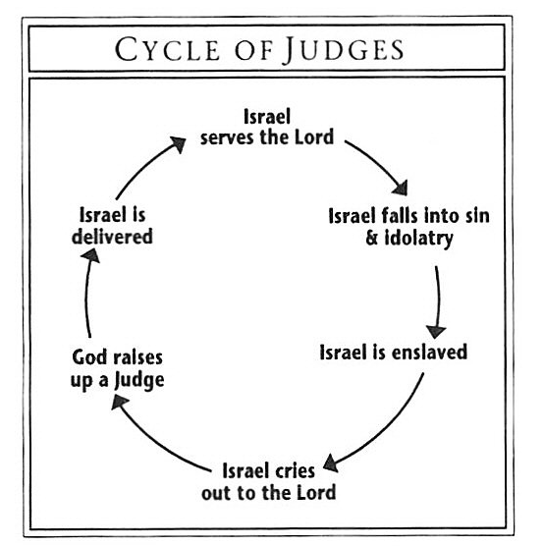

44 Nevertheless He regarded their affliction, When He heard their cry;
45 And for their sake He remembered His covenant, And relented according to the multitude of His mercies.
46 He also made them to be pitied By all those who carried them away captive.

Note the word “Nevertheless.” This speaks to God’s mercy – His covenant faithfulness! God was always there in the background for them. When they would cry out He would remember His covenant with them and bring relief “according to the multitude of His mercies.”

Mercies here is “hesed” emphasizing God’s covenant love! The door was always open on God’s end. His faithfulness continued to be in place. Even when they were under oppression, it was measured because of how He sovereignly worked in the hearts of those who ruled over them.

“This was particularly true as to the Babylonian captivity; for Cyrus gave them their liberty; Darius favoured them, and granted them several privileges; and Artaxerxes sent back Nehemiah, and helped him to rebuild Jerusalem and the temple.” - Adam Clarke

“Although the people were unfaithful to him, God nevertheless was faithful to them, which is why a psalm dealing with the sins of God’s people can end on a positive note.” - James Montgomery Boice

In His mercy, the Lord heard their cries and forgave them (Judg 3:9, 15; 4:3; 6:6, 7; 10:10; see Lev. 26:40-42), but this could not go on forever. – Warren Wiersbe

For the Jews, being expelled from the land is a climactic judgment because God has permanently identified Israel with this land of promise. It is even part of the unconditional Abrahamic covenant. For a Jew to be in exile is an incomparable tragedy. It is as if the blessing of God is removed and they are under His judgment.

The Scripture prophetically saw two things. 1) It saw they would come to the place they would have to be exiled out of the land for a prolonged period of time (cf. Lev. 26:27-39; Deut. 28:48-68) and 2) it foresaw the time when they would ultimately be restored to the land upon repentance (cf. Hos. 14:4-8; Joel 3:18-21; Amos 9:7-15; Mic. 7:14-20; Zech. 3:8-20; Zech. 12-14).

Slide # 11

Deuteronomy 4:27 (NKJV)
27 And the Lord will scatter you among the peoples, and you will be left few in number among the nations where the Lord will drive you.
Deuteronomy 4:30–31 (NKJV)
30 When you are in distress, and all these things come upon you in the latter days, when you turn to the Lord your God and obey His voice
31 (for the Lord your God is a merciful God), He will not forsake you nor destroy you, nor forget the covenant of your fathers which He swore to them.

In view of these realities, we have what amounts to a prophetic prayer in verse 47.

47 Save us, O Lord our God, And gather us from among the Gentiles, To give thanks to Your holy name, To triumph in Your praise.

This prayer on the basis of the Abrahamic Covenant (v. 4-5) and God’s faithful covenant love (hesed) anticipates that one day in answer to prayer and repentance God will fully restore His people to the land. And therefore the response is one of thanksgiving to God and triumph expressed in praise.

The Psalm then ends with this doxology.

48 Blessed be the Lord God of Israel From everlasting to everlasting! And let all the people say, “Amen!” Praise the Lord!

Blessed by YHWH – the God of Israel from everlasting to everlasting! He ever remains the God of Israel. His covenant faithfulness ever continues.

Therefore, the people are called upon to say “Amen!” and then the Psalm ends with the Hebrew word “Hallelujah,” which, translated, is “Praise the LORD!”

For all its exposure of the people’s ingratitude, this is essentially a Psalm of praise, for God’s extraordinary longsuffering emerges as the real theme and gives reality to the doxology that closes the psalm and the fourth book of the psalter (90-106). – David Jeremiah

As he says, this is the conclusion of the 4 divisions of the Psalms. Each division closes with a doxology.

Slide # 12
- Psalms 1-41 – Genesis – Man & Creation – Doxology, Ps. 41:13
- Psalms 42-72 – Exodus – Israel & Redemption – Doxology, Ps. 72:18-19
- Psalms 73-89 – Leviticus – Worship & the Temple – Doxology, Ps. 89:52
- Psalms 90-106 – Numbers – Sojourn on Earth – Doxology, Ps. 106:48
- Psalms 107-150 – Deut. – Praise and the Word of God – Doxology, Ps. 150:6

It is good to remind ourselves that these OT stories are written for our benefit. There are lessons here for us where we live right now.

Slide # 13

1 Corinthians 10:11–12 (NKJV)
11 Now all these things happened to them as examples, and they were written for our admonition, upon whom the ends of the ages have come.
12 Therefore let him who thinks he stands take heed lest he fall.

What are some things we can learn from this Psalm.

- We too are prone to wander. We must be vigilant (v. 6).
- Sometimes we can overlook and not appreciate what God has done for us (v. 7).
- It is so human to quickly forget God (v. 8-13).
- To be discontent at God’s provision and lust for more or other than what He provides is serious sin (v. 14). Sometimes God may give us what we want and send leanness into our soul (v. 15).
- To envy a position that is not God-appointed is very serious (v. 16).
- There is always the danger of falling into some form of idolatry (v. 19).
- Do not complain about God’s provision (v. 25).
- Don’t compromise and fellowship with evil doers (v. 28).
- It is serious sin to complain (v. 32).
- To not obey God’s clear commands is most serious (v. 34).
- To mingle with unbelievers in the sense of intermarriage is disastrous, leading to unthinkable sin (v. 35-39).
- God disciplines His people for their own good (v. 41-46).
- Through it all God ever remains faithful to His covenant promises (v. 45; 47-48).

To really mediate on these things, realizing we are made of the same stuff is humbling. And that is where we need to be – walking humbly with the Lord our God. We are ever dependent upon Him.

Micah 6:8 (NKJV)
8 He has shown you, O man, what is good; And what does the Lord require of you But to do justly, To love mercy, And to walk humbly with your God?

I don’t know about you, but there have been times when I have really felt like a failure in one way or another. It can be discouraging. But then many a time I have awoken in the morning and the Lord has brought Lam. 3:22-23 to mind.

Lamentations 3:22–23 (NKJV)
22 Through the Lord’s mercies we are not consumed, Because His compassions fail not.
23 They are new every morning; Great is Your faithfulness.

We are not always faithful, but God is always faithful! This is the pillow we rest our weary heads upon. Through it all, God ever proves Himself to be faithful – even in all our failures.

No wonder Psalm 106 begins and ends with Hallelujah!

Praise the LORD for the faithful God that He is! It’s all about Him!

