SBC – April 26, 2026
#35
Revelation 16:17-21 (NKJV)
“The Climactic 7th Bowl Judgment - Armageddon”

Prayer:

People often complain about the book of Revelation being too hard to understand. Perhaps if they studied the other 65 books, it would not be so difficult. Perhaps if we interpreted it “normally” as we do all the rest of Scripture, it would not be so difficult. Perhaps if we paid attention to the inspired outline given in Revelation 1:19, it would not be so difficult.

Slide # 1

Revelation 1:19 – Inspired Outline
Revelation 1:19 (NKJV)
19 “Write the things which you have seen, and the things which are, and the things which will take place after this.
- “have seen” – Past (Vision of Christ) – Ch. 1
- “which are” – Present (Church Age) – Ch. 2-3
- “after this” – Future (Post-Church Age) –Ch. 4-22
- - Scene in heaven –Ch. 4-5
- - Tribulation – Ch. 6-18
- - Second Coming – Ch. 19
- - Kingdom – Ch. 20
- - Eternal State – Ch. 21-22

We currently live in the Church Age, in which Christ is building a forever family called THE CHURCH, consisting of all believers, both Jew and Gentile. But one day Christ has promised to remove the Church from out of the world. It will happen in a moment, suddenly, and unexpectedly. Instantly, the church will be caught up to meet Christ in the air, and He will take us back to heaven. Then judgment will fall on the earth as the Antichrist takes his place in history.

Slide # 2
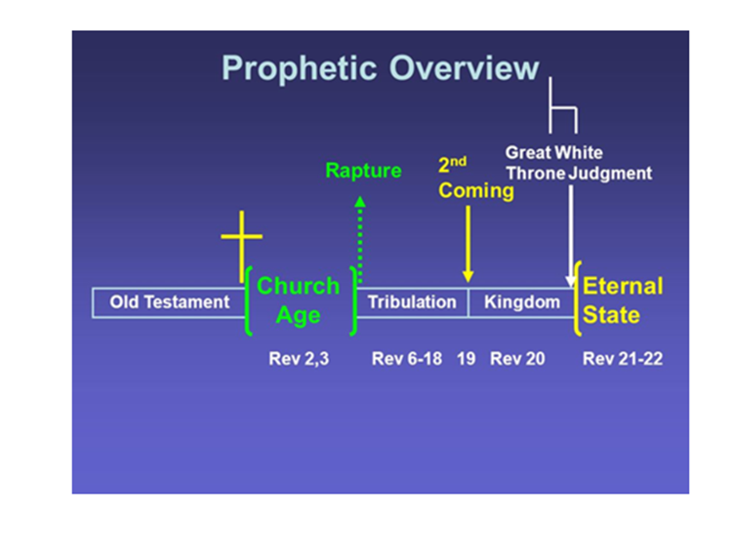
Immediately after the Rapture, a series of judgments in three movements will fall on the earth; namely, the seal, trumpet, and bowl judgments.

Slide # 3
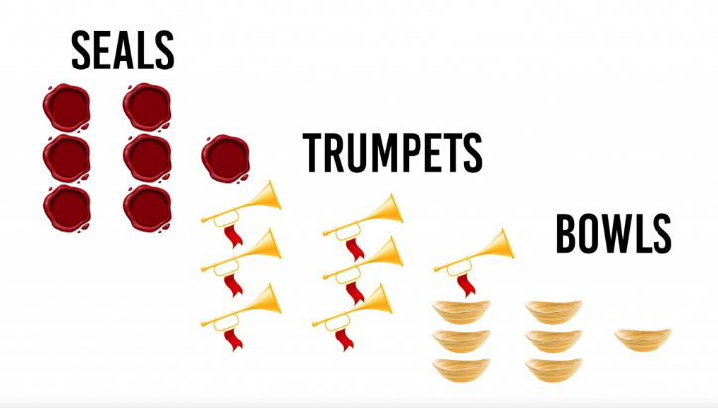

In Revelation 16, we have the climactic final bowl judgments that come in rapid fire right at the end. Last time we saw the 6th bowl judgment, which prepares the way for the climactic final 7th bowl judgment.

There we were shown that under demonic influence, the kings of the world are moved to the battle of the great day of God Almighty (Rev. 6:14). Furthermore, we are told they are gathered together to the place called Armageddon (6:16).

Slide # 4

Armageddon (Hebrew word)

Har (mountain)

Mageddon (Megiddo)

Armageddon = Mount Megiddo that overlooks the Valley of Esdraelon (also known as the Valley of Jezreel) in northern Israel.

Slide # 5
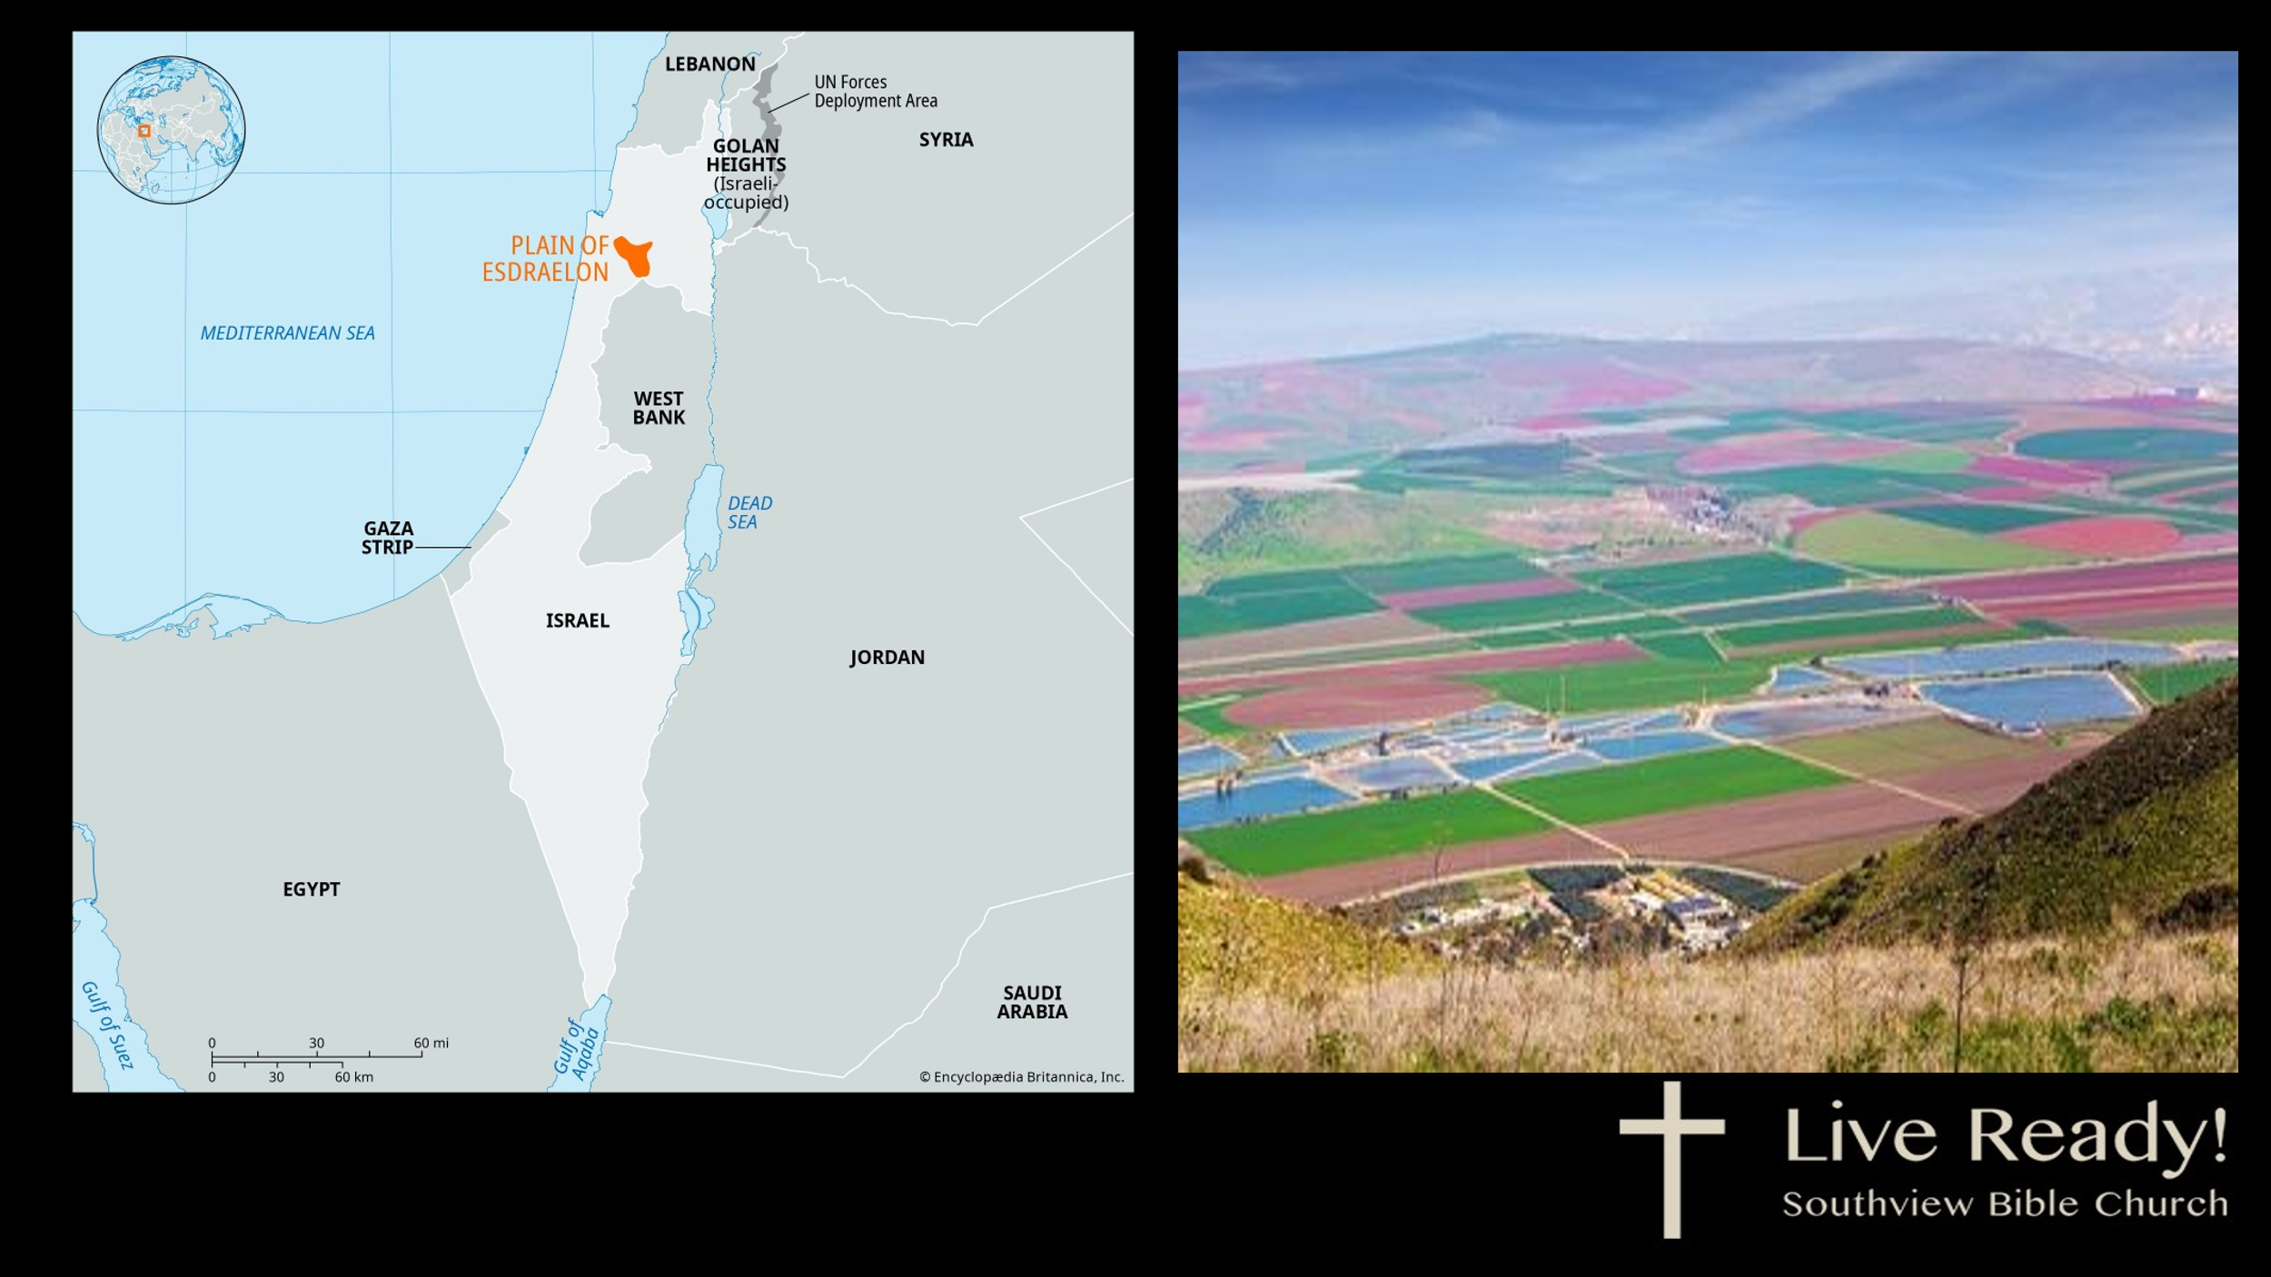
The scene is now set for Armageddon, which is now presented in the final and climactic 7th bowl judgment.

Revelation 16:17–21 (NKJV)
17 Then the seventh angel poured out his bowl into the air, and a loud voice came out of the temple of heaven, from the throne, saying, “It is done!”

It’s as though the whole atmosphere affected by Satanic influence is being cleansed through judgment. This includes the earth (v. 2), the sea (v. 3), the fresh waters (v. 4), the sun (v. 8), and finally, the air (v. 17) which are all targets of judgment. The whole realm related to human experience is undergoing judgment! There is no area left unaffected.

Upon this action, a LOUD voice came out of the temple in heaven. The temple in heaven is mentioned in reference to the seal, trumpet, and bowl judgments, but the emphasis is especially strong in relation to the BOWL judgments. We were told in 15:8 that at this point no one is allowed to enter the temple until the bowl judgments are completed – so clearly this voice is the voice of God.

Furthermore, we are told this voice comes from the THRONE. This is the seat of power and authority for the whole universe.

And the voice said, “It is done!” This anticipates the conclusion of the day of judgment on planet Earth! The judgment that follows is the climactic end. And really, what we have in verses 17-21 is a simple summary of what is further explained in chapters 17-19. So there is a lot happening in relation to this 7th and last bowl judgment.

This conclusion to the day of the Lord judgment has been anticipated for a while. In the interlude in preparation for the 7 bowl judgments we had this statement in 10:7.

Slide # 6

Revelation 10:7 (NKJV)
7 but in the days of the sounding of the seventh angel, when he is about to sound, the mystery of God would be finished, as He declared to His servants the prophets.

Of the 404 verses in Revelation, 278 of them allude to the OT Scriptures. No other writer in the NT uses the OT more than this. What we have in Revelation is the fulfillment of all that God had before revealed about the coming judgment of the last days.

The OT prophets repeatedly dealt with the last days' tribulation that would usher in the kingdom (cf. Ezekiel, Daniel, Isaiah, Jeremiah, Joel, Amos, Zechariah, etc.). But they only dealt with it in a generalized form and didn’t give us the fully developed picture. They just gave certain pieces of the puzzle, but there was a lot of mystery in the mix. Now the details, previously a mystery, are to be made known in the fulfillment.

The sound of the 7th trumpet ushers in the final 7 bowl judgments and as such it looks to the very end as seen in Revelation 11:15-19.

Slide # 7

Revelation 11:15–17 (NKJV)
15 Then the seventh angel sounded: And there were loud voices in heaven, saying, “The kingdoms of this world have become the kingdoms of our Lord and of His Christ, and He shall reign forever and ever!”
16 And the twenty-four elders who sat before God on their thrones fell on their faces and worshiped God,
17 saying: “We give You thanks, O Lord God Almighty, The One who is and who was and who is to come, Because You have taken Your great power and reigned.

Then again, we read in Revelation 15:1…

Slide # 8
Revelation 15:1 (NKJV)
1 Then I saw another sign in heaven, great and marvelous: seven angels having the seven last plagues, for in them the wrath of God is complete.

Thus, the end is repeatedly anticipated, and now it is upon us here at the end of chapter 16. We have now come to the final judgment, which is all-encompassing in nature and very comprehensive, as we will see.

This end-time war campaign called “Armageddon” is actually a somewhat prolonged event – perhaps involving several weeks.
We see snapshots of it in various places in the Scriptures, such as in Isaiah 2, Isaiah 24; Joel 3:9-7; Zech. 12 and 14. Here in Revelation 16:17-21 we have it summarized and then developed at some length in chapters 17-19.

The war of Armageddon will be the last great war of history and will be brought to a conclusion with the Second Coming of Jesus Christ. Israel will be right in the middle of it all as the world under Antichrist tries to remedy what they consider to be the Jewish problem. Thus, they will try to annihilate the Jews in what has been deemed the “final solution.” The whole entire world will be rallied against Israel and march on Israel with this goal. But alas, they are going to fail miserably, totally, and emphatically.

Note “It is done!” here in Revelation 16:17 is similar to Jesus on the cross saying, “It is finished!” However, there are different words used.

Slide # 9

“It is finished!” (Gk. Tetelestai, meaning “The Debts is Paid in Full.” It is a commercial term.

“It is done!” (Gk. Gegonen, meaning “A new reality has arrived!” It denotes an accomplished objective.

On the one hand, the debt of sin is paid in full; on the other hand, judgment on an unrepentant world is now complete.

When the full contents of the 7th bowl judgment are exhausted then all judgment will have been accomplished, in terms of pre-kingdom judgment related to Armageddon.

The entire rebel world system under Satan and Antichrist is about to go down completely, never to make a return. The religious harlot system that swayed the world is going down (Rev. 17); the religious/economic system by which Antichrist will rule the world is going down (Rev. 18); the military pride and power of Antichrist is going down (Rev. 19). It’s all going DOWN!

18 And there were noises and thunderings and lightnings; and there was a great earthquake, such a mighty and great earthquake as had not occurred since men were on the earth.

This is, in effect, the drum roll of heaven, introducing the most awesome judgment the world has ever seen or ever will see.
No sooner does the announcement of “It is done!” come from the throne room of heaven then there are noises, thunderings, and lightnings which are accompanied with this greatest ever, of all earthquakes!

The study of earthquakes is interesting. People often speak of the earthquakes that we are seeing in our time as “signs of the times”, but technically that is not correct.

All the prophesied earthquakes in the Old Testament are specific to the “day of the Lord”… in other words, those that are caused by divine judgment, and clearly referring to the time of God’s wrath.
-Wilfred Hahn

When Christ speaks of earthquakes that will take place in various places in Matthew 24:7, the context is “the beginning of sorrows” which relates to the beginning of the Tribulation Period – and not before it (cf. Mt. 24:8).

The assertion that earthquakes are increasing in fulfillment of Matt. 24:7 misinterprets Scripture. The context of Matthew 24:7 demands that this sign is for believers in the tribulation, who anticipate the return of the Lord; it is incorrect to refer to this passage as describing events during the church age. -Dr. Ron J. Bigalke

Earthquakes have been used distinctly by God to highlight some of the most important events of the Bible. The three main purposes for biblical earthquakes are judgment, deliverance, and communication. The lesson is obvious – God does not do anything really big without emphasizing it with an earthquake! – Steven A. Austin

Frankly, everything the world has seen post-flood has merely been what we might call “Earth tremors”, but the real EARTH QUAKES, what we might term WHOLE WORLD SHAKINGS, will take place in the Tribulation and especially here at the end. This will involve an earthquake of such a magnitude that nothing like it has ever happened before. This is totally unprecedented!

Slide # 10

Isaiah 2:19 (NKJV)
19 They shall go into the holes of the rocks, And into the caves of the earth, From the terror of the Lord And the glory of His majesty, When He arises to shake the earth mightily.
Isaiah 2:21 (NKJV)
21 To go into the clefts of the rocks, And into the crags of the rugged rocks, From the terror of the Lord And the glory of His majesty, When He arises to shake the earth mightily.

“The global earthquake at the judgment of the sixth seal (Rev. 6:12-17) had been so severe that “every mountain and island were moved out of their places.” This earthquake, however, is far worse – in fact, so terrible that “every island fled away and the mountains were not found” (Rev. 16:20).” – Henry M. Morris

There is a whole lot shaken going on – unprecedented shaking such as the world has never seen. All the earthquakes previous are just reminders of what is coming – warnings…

He’s the great great God of the Bible
He’s the great great God of all power
He’s the great God who can shake the world
He’s the great God of the hour!

We had better be building on the solid rock of Jesus, or it will all come crumbling down – it's just a matter of time.

19 Now the great city was divided into three parts, and the cities of the nations fell. And great Babylon was remembered before God, to give her the cup of the wine of the fierceness of His wrath.

Grammatically, three separate but related categories are involved here.

Slide # 11
- And the great city was divided into three parts…
- And the cities of the nations fell.
- And great Babylon was remembered…

In the book of Revelation, there are TWO cities that are called great, namely Jerusalem and Babylon.

The “great city” here in verse 19 is distinguished from Babylon so I don’t think “the great city” in the first part of the verse is the “great Babylon” mentioned at the end of the verse. It is also distinct from “the cities of the nations.” This leads to the conclusion that “the great city” in view here is probably Jerusalem. It is called “the great city” in 11:8.
This massive earthquake will evidently completely change the topographical outlay of the city in preparation for the kingdom. Jerusalem will be split into three parts.

Slide # 12

Zechariah 14:4 (NKJV)
4 And in that day His feet will stand on the Mount of Olives, Which faces Jerusalem on the east. And the Mount of Olives shall be split in two, From east to west, Making a very large valley; Half of the mountain shall move toward the north And half of it toward the south.

Jerusalem had experienced a severe earthquake earlier (11:13), but that was only partial in comparison to what is happening here.

The physical changes will prepare Jerusalem for the central role it will play during the millennial kingdom, when Christ will reign there as King (Ps. 110:2; Isa. 2:3; 24:23; Mic. 4:7). – John MacArthur

And the cities of the nations fell. This is all the cities of the Gentile nations. They are all flattened. They are all coming DOWN! All the pride of mankind is coming down. Everything they built to their glory. It’s all coming down.

And they will all be singing “Ring Around the Rosie” – “Ashes, ashes, we all fall down.”

Slide # 13

Isaiah 24:19–20 (NKJV)
19 The earth is violently broken, The earth is split open, The earth is shaken exceedingly.
20 The earth shall reel to and fro like a drunkard, And shall totter like a hut; Its transgression shall be heavy upon it, And it will fall, and not rise again.

All the cities of the world will all in mass fall down at once. They will all be reduced to rubble! (cf. Hag. 2:21-22)

And in this context, “great Babylon was remembered before God, to give her the cup of the wine of the fierceness of His wrath.” God has not forgotten.

Babylon is great because of the magnitude of its influence. Babylon is the mother of all false religions that spread out throughout the whole world and finds its final form under Antichrist. It is great in evil; it is great in scope in that it influences and impacts the entire world.

There are TWO great “epicenters” in the world. An epicenter is the key focal point of some major activity.

The Bible shows that in the history of the world, there are two “epicenter cities”. Redemptive history revolves around these two cities. One is Babylon and the other is Jerusalem. Babylon is “the city of man”, while Jerusalem is “the city of God”.

Interwoven throughout the Bible from Genesis to Revelation is the story of these two cities. Jerusalem is the most prominent city in the Bible, being mentioned over 800 times, while Babylon is second, being mentioned about 300 times. What these great cities typify is developed throughout the Bible and culminates in the book of Revelation.

From Genesis to Revelation, these two cities are tracked side by side. In Revelation 17-18, Babylon is destroyed forever. In contrast, in Revelation 21, the new Jerusalem comes down out of heaven as the capital city of the new heaven and the new earth and is the eternal abode of God and His people.

In the end, Man’s city falls, but God’s city remains for all eternity.

Note that there are two forms of last days Babylon – the one is represented in Revelation 17, where apostate Christendom is in league with Antichrist. But then Antichrist destroys this harlot, and the final form of Babylon is singularly seen in the religion of Antichrist. This is addressed then in Revelation 18. Here, the Babylonian system comes to full fruition.

Babylon is both a city and a system, and that seems to be the way it is used in these chapters. This is much the same way Americans speak of Wall Street or Madison Avenue. They are actual streets, but they also stand for the financial or advertising enterprises.
– Charles Ryrie

In Revelation 14:8, it says that “Babylon is fallen, is fallen, that great city,” and this is immediately tied with the beast worshipers who take the mark of the beast (14:9-11), indicating the very last form of Babylon is in view, which builds on everything that has gone before and is the apex of idolatrous Babylonian religion.
Babylonian religion is centered in unified idolatry. It goes back to the tower of Babel and Nimrod in Genesis 10-11. There unified idolatry involving the whole of mankind was in view. God mercifully broke it up by confusing the language, resulting in people being scattered over the face of all the earth (Gen. 11:9).

Satan could lead humanity away from the truth more easily if only one government existed and this single government happened to fall into the hands of anti-God forces… Satan’s purpose throughout history has been to subvert this divine ordering of nations and bring the world back together so that he once again can have unhindered control of it through one man.
– The Harvest Handbook of Bible Prophecy – p. 55

Commentators often debate how “Babylon” should be understood in Revelation. I argue for a literal understanding of the city of Babylon being the financial capital of Antichrist’s world empire. I will deal with this much more extensively in chapter 18, but note the following.

Many OT prophecies about the literal city of Babylon have never been fulfilled. Whenever the OT uses the word “Babylon,” it is always a reference to literal Babylon.

Isaiah 13-14 and also Jeremiah 50-51 depict Babylon’s final destruction. Babylon did fall to the Medo-Persian Empire in 539 BC as seen in Daniel 5:31. However, this historic fall does not match the cataclysmic language found in Isaiah and Jeremiah.

For example, Isaiah 13:19 and Jeremiah 50:40 emphasize that the destruction will be as complete and devastating as that of Sodom and Gomorrah. Once destroyed, it will never again be inhabitable and will never again be rebuilt. That does not define what has happened to this point in history with Babylon.

Babylon today contains excavated ruins and partial reconstructions such as those initiated by Saddam Hussein, who made himself out to be a second Nebuchadnezzar. The point is, there is still something there. It was not completely obliterated like Sodom and Gomorrah! It is still represented as being there!

For those prophecies to be fulfilled, there must be a last-days revival of the city of Babylon so it can be destroyed in fulfillment of these details.
Zechariah 5:5-11 shows that, in God’s providential timing, wickedness will be brought back to Babylon.

Slide # 14

Zechariah 5:7–8 (NKJV)
7 Here is a lead disc lifted up, and this is a woman sitting inside the basket”;
8 then he said, “This is Wickedness!” And he thrust her down into the basket, and threw the lead cover over its mouth.
Zechariah 5:10–11 (NKJV)
10 So I said to the angel who talked with me, “Where are they carrying the basket?”
11 And he said to me, “To build a house for it in the land of Shinar [Babylon]; when it is ready, the basket will be set there on its base.”

Slide # 15

Babylon Fallen (539 BC)

Zechariah 5 Prophecy (519 BC)

Long after historical Babylon had fallen, Zechariah’s vision (20 years
later) foresaw a coming rebuilt Babylon which has not yet been
fulfilled! This argues strongly for a FUTURISTIC fulfillment!

Human history is going to come full circle! Babylon, which hatched all the organized false religions of the world, will in the end be the center of climactic idolatry found in Antichrist. All the evil ideals found in Babylon will come to a complete fruition there. This, of course, relates to modern-day Iraq, which generally corresponds to the area occupied by Babylon of old.

It is this final form of Babylon under Antichrist that God will now give the cup of the wine of the fierceness of His wrath.” This is the epicenter of wickedness, and it is singled out for special, lengthy treatment as seen in Revelation 17 and 18.

20 Then every island fled away, and the mountains were not found.

Everything is going DOWN! The cities are going down, the islands are going down, the mountains are going down! It’s all going down!

Slide # 16

Haggai 2:6–7 (NKJV)
6 “For thus says the Lord of hosts: ‘Once more (it is a little while) I will shake heaven and earth, the sea and dry land;
7 and I will shake all nations, and they shall come to the Desire of All Nations, and I will fill this temple with glory,’ says the Lord of hosts.

In the violent shaking of the earth, the islands will be submerged in water and will no longer be found. The earthquake will be so bad that all the mountains of the earth will come crumbling down. We simply cannot imagine how incredibly cataclysmic this will be!

There were other violent earthquakes previously, but nothing compares to this (cf. Rev. 6:12; 8:5; 11:13, 19).

The entire earth is going to be reconfigured as God, in effect, in judgment, is taking down the old order in preparation for the coming kingdom order that will be instituted at Christ’s Second Coming.

Slide # 17

Isaiah 40:4–5 (NKJV)
4 Every valley shall be exalted And every mountain and hill brought low; The crooked places shall be made straight And the rough places smooth;
5 The glory of the Lord shall be revealed, And all flesh shall see it together; For the mouth of the Lord has spoken.”

The gentle rolling topography of the world as originally created will be restored. No more will there be great inaccessible uninhabitable mountain ranges or deserts, or ice caps. The physical environment of the millennium will be, in large measure, a restoration of the [pre-Flood] environment. – Henry M. Morris

And in this new reconfiguration, Jerusalem will evidently be the HIGHEST point on earth, making it a fitting setting for the THRONE of the great KING – the Lord Jesus Christ.

Slide # 18

Jeremiah 3:17 (NKJV)
17 “At that time Jerusalem shall be called The Throne of the Lord, and all the nations shall be gathered to it, to the name of the Lord, to Jerusalem. No more shall they follow the dictates of their evil hearts.

Isaiah 2:2 (NKJV)
2 Now it shall come to pass in the latter days That the mountain of the Lord’s house Shall be established on the top of the mountains, And shall be exalted above the hills; And all nations shall flow to it.

Furthermore, it may well be that in this new configuration, the whole world will once again be able to migrate by way of land to Jerusalem. Initially, before the Flood of Noah’s day, all the continents were connected. When the fountains of the great deep (Gen. 7:11) broke open, the world was then divided into the continents we know today. During the year-long flood, the plates of the earth shifted violently, pushing up mountain ranges that previously were gentle hills.

Answers in Genesis explains that the mountains formed rapidly during and after the Flood through catastrophic plate tectonics. As the pre-flood supercontinent broke apart, tectonic plates collided at high speeds, forcing sediments upward, folding soft rock layers, and causing immense vertical uplift as the floodwaters subsided.

Slide # 19

Psalm 104:6–8 (LSB)
6 You covered it with the deep as with a garment; The waters were standing above the mountains.
7 At Your rebuke they fled, At the sound of Your thunder they hurried away in alarm.
8 The mountains went up; the valleys went down To the place which You founded for them.

The Bible is very clear that the pre-flood world was a completely different world from what we have now in terms of how it was configured (cf. 2 Pet. 3:6). It would appear that in the final bowl judgment, catastrophic changes will once again take place, returning the earth somewhat to what it was like before the flood.

If you want to see the great high mountains, go see them now, because they are all coming down! And all this is in preparation for how the earth will be in the millennium kingdom of our Lord.

21 And great hail from heaven fell upon men, each hailstone about the weight of a talent. Men blasphemed God because of the plague of the hail, since that plague was exceedingly great.

In the Bible, we find that God often uses hailstones as a means of judgment (cf. Ex. 9:24; Josh. 10:11; Job 38:22-23; Isa. 28:2, 17; Ezek. 13:11-13; 38:22-23).

The term talent refers to the weight a normal man could carry, somewhere between 90 and 135 pounds. Therefore, commentators commonly say a talent weighs somewhere around 100 pounds. The largest hail stones every recorded in the United States are about 2 pounds. We can’t even begin to imagine the impact and destruction of 100-pound hailstones.

Slide # 20


If a person gets hit by a 100-pound hailstone, they would be instantly crushed – splat – it's over. No wonder the Bible says people will go into the caves of the earth.

Slide # 21

Isaiah 2:19 (NKJV)
19 They shall go into the holes of the rocks, And into the caves of the earth, From the terror of the Lord And the glory of His majesty, When He arises to shake the earth mightily.

It seems that God in his treasury of hail has these special hailstones stored up for this very occasion.

Slide # 22

Job 38:22–23 (NKJV)
22 “Have you entered the treasury of snow, Or have you seen the treasury of hail,
23 Which I have reserved for the time of trouble, For the day of battle and war?

What is happening here is that God is HUMBLING the rebellious PRIDE of mankind. Pride is the besetting sin of mankind. Pride dares to raise itself up against God. God is going to smash it down! God is going to pound rebellious mankind right into the ground! God is going to level the cities of mankind. He is going to flatten every HIGH thing – all the mountains are going down. ONLY GOD WILL be EXALTED in that day! God is going to win the LORDSHIP debate once and for all!

Slide # 23

Isaiah 2:11–17 (NKJV)
11 The lofty looks of man shall be humbled, The haughtiness of men shall be bowed down, And the Lord alone shall be exalted in that day.
12 For the day of the Lord of hosts Shall come upon everything proud and lofty, Upon everything lifted up— And it shall be brought low—
13 Upon all the cedars of Lebanon that are high and lifted up, And upon all the oaks of Bashan;
14 Upon all the high mountains, And upon all the hills that are lifted up;
15 Upon every high tower, And upon every fortified wall;
16 Upon all the ships of Tarshish, And upon all the beautiful sloops.
17 The loftiness of man shall be bowed down, And the haughtiness of men shall be brought low; The Lord alone will be exalted in that day,

Most people are going to die in the Tribulation. As Isaiah 24:6 says,“few men are left .” But the few that remain (remnant excepted) blaspheme God because of this plague of hail that is exceedingly great. Obviously, not all are killed, because those remaining are left blaspheming.

We could call Revelation 16 the blasphemy chapter because hardened humanity just blasphemes in response to these ultimate judgments that come upon them. There is no softening – only a hardening to the point of no return.

Slide # 24
Revelation 16:9 (NKJV)
9 And men were scorched with great heat, and they blasphemed the name of God who has power over these plagues; and they did not repent and give Him glory.
Revelation 16:11 (NKJV)
11 They blasphemed the God of heaven because of their pains and their sores, and did not repent of their deeds.
Revelation 16:21 (NKJV)
21 And great hail from heaven fell upon men, each hailstone about the weight of a talent. Men blasphemed God because of the plague of the hail, since that plague was exceedingly great.

To blaspheme is to speak irreverently of God! It is to curse Him!

No wonder the hail comes, for blasphemers are supposed to be stoned to death (Lev. 24:16). – Warren Wiersbe

Note they totally “believe” in God, they just won’t repent! It’s not a head issue, but rather a heart issue! They refuse to recognize God for Who He is, they refuse to accept Him as Lord! That is the great issue! A true saving faith is humbled before God and accepts Him for Who He is as Lord and Savior. This the hardened rebel world that refuses to do. NO matter what, they refuse to bow, they refuse to humble themselves, and so they will die right there.

Many people marvel at such descriptions of the severity of God. I marvel at the unconcern and wickedness of men’s hearts.
– Lehman Strauss

Of course, in the end every knee will bow, and every tongue will confess that Jesus is Lord to the glory of God the Father (Phil. 2:9-11). But hardened sinners go to their grave unrepentant!

I was reading some worldly person who was saying that God is compassionate, loving, forgiving, merciful, peaceful, and benign. Benign? Seriously? Have you read the book of Revelation?

In his book, “The Lion, the Witch and the Wardrobe” C.S. Lewis has a line about God that says, “He isn’t safe. But He’s good.” Better stated is that He is loving, but also HOLY! Those that reject His love will have to deal with His wrath.
In 1741, Jonathan Edwards preached a sermon titled “Sinners in the Hands of an Angry God.” It is one of the most famous sermons of all time.

“The God that holds you over the pit of hell, much as one holds a spider or some loathsome insect over the fire, abhors you, and is dreadfully provoked; His wrath towards you burns like fire; He is of purer eyes than to bear to have you in His sight; you are ten thousand times more abominable in His eyes as the most hateful venomous serpent is in ours. You have offended Him infinitely more than ever a stubborn rebel did his prince; and yet ’tis nothing but His hand that holds you from falling into the fire every moment.”
The coming day of the Lord judgment is literally “Sinners in the Hands of an Angry God.” This is the day God’s wrath will be poured out upon the world! As Jesus said, then there will be GREAT TRIBULATION such has never been before nor ever will be again (Mt. 24:21).

But humanity can’t say they haven’t been warned! The bulk of the book of Revelation, from chapters 6-18 is one long warning about this judgment that is coming!

And one day it will break upon the world with suddenness unexpectedly.

Slide # 25

1 Thessalonians 5:2–3 (NKJV)
2 For you yourselves know perfectly that the day of the Lord so comes as a thief in the night.
3 For when they say, “Peace and safety!” then sudden destruction comes upon them, as labor pains upon a pregnant woman. And they shall not escape.

People misunderstand the age of grace we live in. They think since we have never seen anything like described in Revelation that it will never happen. I would remind us that the people in Noah’s day never saw rain before the flood, either, but then it rained! The Bible is clear that in the last days scoffers will say, “Where is the promise of His coming?” (2 Pet. 3:4). They don’t understand that God, in mercy, is giving people space to repent (2 Pet. 3:9).

Slide # 26

Acts 17:30–31 (NKJV)
30 Truly, these times of ignorance God overlooked, but now commands all men everywhere to repent,
31 because He has appointed a day on which He will judge the world in righteousness by the Man whom He has ordained. He has given assurance of this to all by raising Him from the dead.”

Proverbs 29:1 (NKJV)
1 He who is often rebuked, and hardens his neck, Will suddenly be destroyed, and that without remedy.

… I once talked to a young man of about twenty-two.… He said he believed in God and in Christ intellectually and believed that the Bible was true and some day planned to accept Christ as his Savior. But first, he said, “I’ve got a lot of living to do.”
I remonstrated with him for some time, but finally, when I saw that I could not persuade him, I let him go, reminding him that the Bible says that he who, being often reproved, hardeneth his neck, shall suddenly be cut off and that without remedy. A week later, I heard that he was driving down the highway at about seventy miles an hour when a truck stopped in front of him with a tailgate down. He was instantly decapitated. I remembered the words that I had spoken to him. “He that hardeneth his neck shall suddenly be cut off and that without remedy. -James Kennedy in Evangelism Explosion

But for the believer in Jesus Christ we can rest on the words of Psalm 46.

Slide # 27
Psalm 46:1–3 (NKJV)
1 God is our refuge and strength, A very present help in trouble.
2 Therefore we will not fear, Even though the earth be removed, And though the mountains be carried into the midst of the sea;
3 Though its waters roar and be troubled, Though the mountains shake with its swelling. Selah

Psalm 46:10–11 (NKJV)
10 Be still, and know that I am God; I will be exalted among the nations, I will be exalted in the earth!
11 The Lord of hosts is with us; The God of Jacob is our refuge. Selah

Is your refuge in God? There is no other safe place in time or in eternity!

Believe on the Lord Jesus Christ, and you will be saved!

