SBC – April 19, 2026
#34
Revelation 16:10-16 (NKJV)
“Build Up to Armageddon”

Prayer:

The world is on a collision course with judgment day, with the climax being the battle of Armageddon, with Israel and Jerusalem right in the middle of it all.

Slide # 1

History involves 3 programs.

- The Nations
- Israel
- The Church

The book of Revelation sees the consummation of all three of these programs. In the OT, God was working with the nation of Israel as His witness nation, but when their Messiah came, they rejected Him. Consequently, in discipline, God has temporarily set Israel aside. However, God has also promised that ultimately Israel will be restored as they come to repentance. But right now, they are still under discipline.

During this extended time of discipline, God is doing something different than what was in the OT – namely, He is building a church family of believers in Jesus Christ from every nation, and the invitation is going out that whosoever will can come and be a part of this forever family.

Once the church is completed and taken to heaven (cf. Rev. 2-3), then God will judge the nations and finish His program with Israel, which ultimately sees them coming to repentance and being delivered from the Gentiles at the 2nd coming and going into the kingdom.

Slide # 2

Revelation 1:19 – Inspired Outline
Revelation 1:19 (NKJV)
19 “Write the things which you have seen, and the things which are, and the things which will take place after this.
- “have seen” – Past (Vision of Christ) – Ch. 1
- “which are” – Present (Church Age) – Ch. 2-3
- “after this” – Future (Post-Church Age) –Ch. 4-22
- - Scene in heaven –Ch. 4-5
- - Tribulation – Ch. 6-18
- - Second Coming – Ch. 19
- - Kingdom – Ch. 20
- - Eternal State – Ch. 21-22

The Bulk of Revelation deals with the climactic time of judgment following the church age, which is brought to a conclusion by the Second Coming of Christ. We find there a series of judgments with 3 movements – namely, 7 seal judgments, followed by 7 trumpet judgments, followed by 7 bowl judgments.

Slide # 3
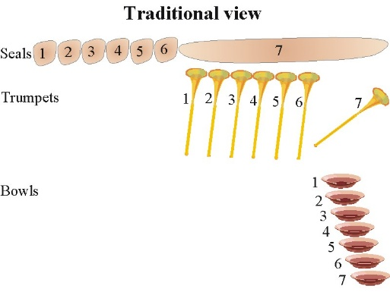

The bowl judgments are the FINALE – they are the climactic, most severe judgments. They are more universal in contrast to earlier judgments, which just involved part of the earth. In Revelation 16:1-9, we saw the pouring out of the first 4 bowls of God’s wrath. 1) The first bowl was poured out upon the earth and the beast worshipers were afflicted with painful sores. 2) The second bowl was poured out upon the sea, which turned to blood, and everything therein died. 3) The third bowl was poured out upon the fresh water, which became blood as God gives the people blood to drink because they systematically killed His people in mass. 4) The fourth bowl was poured out upon the sun, and people were scorched with great heat.

The response of this hardened mass of humanity at this point is not to humble themselves, not to repent and give God glory, but rather to blaspheme God for what is happening to them. They, in effect, are totally hardened in their rebellion, and God is pouring out His wrathful fury in full measure.

Today we turn our attention to the 5th and 6th bowls, which bring us right to the very cusp of Armageddon.
These things are happening right towards the end of the Tribulation period. These are the most severe and climactic of all God’s judgments!

The 5th and 6th bowls build up to the concluding 7th bowl judgement. The 7th bowl, in effect, is the battle of Armageddon, which (Lord willing) we will look at next time. Today we see the build up to Armageddon as seen in the 5th and 6th bowl judgments!

Revelation 16:10–16 (NKJV)
10 Then the fifth angel poured out his bowl on the throne of the beast, and his kingdom became full of darkness; and they gnawed their tongues because of the pain.

There is discussion as to where “the throne of the beast” (Antichrist) is located at this point. Some have made a case for Rome or Jerusalem, but I take it that Babylon is probably in view, as this great city is dealt with extensively in chapters 17 and 18.

Slide # 4

Revelation 16:19 (NKJV)
19 Now the great city was divided into three parts, and the cities of the nations fell. And great Babylon was remembered before God, to give her the cup of the wine of the fierceness of His wrath.

Revelation 18:10 (NKJV)
10 standing at a distance for fear of her torment, saying, ‘Alas, alas, that great city Babylon, that mighty city! For in one hour your judgment has come.’

Tucked away in Zechariah 5 is a very specific prophecy about last days Babylon. Zechariah 5:5-11 presents a vision of a basket that is full of wickedness, which is personified as a woman. A heavy lid is put on the basket to keep evil in check. Zechariah then sees the basket with the woman being carried away, and he asks WHERE it is being taken. He is then told that it is being carried back to the land of Shinar (which is the old name for Babylon), when the time is ready.

Slide # 5

Zechariah 5:8 (NKJV)
8 then he said, “This is Wickedness!” And he thrust her down into the basket, and threw the lead cover over its mouth.

Zechariah 5:10–11 (NKJV)
10 So I said to the angel who talked with me, “Where are they carrying the basket?”
11 And he said to me, “To build a house for it in the land of Shinar; when it is ready, the basket will be set there on its base.”

When Zechariah asked the interpreting angel where this basket of wickedness was being taken, the answer was “To build a house for it in the land of Shinar”.

House refers to a place of dwelling. In view is the CENTER, or the key base of operations. This will be located in the land of Shinar, which is Babylon. It is there that the basket will be set on its base or on its pedestal when the time is right! In effect, this will be the HEADQUARTERS for last days' wickedness!

After the flood, the first outbreak of evil in the world occurred at Babylon. Everything will come full circle. The world’s first capital city will be the place of its final city, Babylon. I believe this means that, in the end times, Babylon will become the world capital of an evil world economic system run by Antichrist (The Second Coming of Babylon -p. 99). – Mark Hitchcock

I take it that the throne of the beast here in Revelation 16:10 is probably the great city of Babylon. As the fifth angel pours out his bowl of wrath on Antichrist’s capital of Babylon, his entire kingdom is engulfed in DARKNESS. Suddenly, the entire world is cut off from the power center of Antichrist. They are all left in darkness.

It is hard to function in absolute darkness. And it is scary! This basically leaves the world of Antichrist dysfunctional. They are left to suffer in anguish – gnawing their tongues because of their pain. The pain in view evidently relates back to the first bowl judgment in which the beast worshipers were inflicted with a foul and loathsome sore (16:2). This hasn’t gone away. And now in darkness they writhe in pain!

This is a foretaste of hell which is described in similar terms.

Slide # 6
Matthew 25:30 (NKJV)
30 And cast the unprofitable servant into the outer darkness. There will be weeping and gnashing of teeth.’

“Gnawed their tongues” is the idea of chewing on their tongues to deal with the pain. Here they are in darkness with nothing but blood to drink and bathe in, and they are still dealing with the ulcers from the 1st bowl. They are hurtin for certain!

When people start chewing on their tongue instead of biting their nails for relief, you know they are experiencing excruciating pain with no relief in view. Tremendous agonizing distress is in view. That is hell!

You would think they would say “uncle” at this point, but they don’t. The human heart can get so HARD that no matter what a person goes through, they won’t repent. Such is the case of hardened depravity. Suffering either makes a person BITTER OR BETTER. One of two responses will be forthcoming. These people are steeled in bitter rebellion!

This is like the ninth Egyptian plague (Ex. 10:21-22), but worse because it aggravates the continuing effects of the previous plagues. Since the beast’s kingdom is worldwide, this amounts to a darkness that covers the whole earth. It may be assumed, however, that the faithful remnant in its place of refuge is untouched by the plague, just as were the children of Israel during the Egyptian darkness (Ex. 10:23). – Robert Thomas

11 They blasphemed the God of heaven because of their pains and their sores, and did not repent of their deeds.

These are the same people who, back in verse 9, were scorched by the fourth bowl judgment, then proceeded to blaspheme the name of God and refused to repent. Now, under the further affliction of the fifth bowl, blaspheme all the more and still refuse to repent of their deeds.

Note it specifically says they blaspheme “the God of heaven.” This phrase “God of heaven” is found only one other place in Revelation, namely in 11:13 where as a result of a great earthquake people “gave glory to the God of heaven” which is indicative of true conversion.

This phrase “God of heaven” is used repeatedly in Daniel 2, emphasizing God’s sovereign authority over history. It is a Lordship emphasis!
These people in Revelation 16 blaspheme the sovereign God over all and refuse to repent! They will not bow before His Lordship!

Repent means to change your mind – involving a complete change of attitude with regard to sin, which results in a change of direction in living. It is a change of thinking in the heart that then demonstrates itself in life. Repentance and Lordship go together. The essence of repentance is that it bows before the Lordship of God – recognizing His sovereign authority.

Many people think they can have an easy believism – a type of faith that is void of repentance and still go to heaven. No! Saving faith involves repentance – it is a change of mind kind of faith that says I am wrong about my sin – I need Jesus as my Savior, and I recognize Him for Who He is as my Lord/God-Master.

Easy believism says “I want Jesus as fire insurance,” but I have no change of mind about my sin. That won’t get you to heaven.

Slide # 7

Matthew 7:21 (NKJV)
21 “Not everyone who says to Me, ‘Lord, Lord,’ shall enter the kingdom of heaven, but he who does the will of My Father in heaven.
Only a life-changing kind of faith is a saving faith. We are not saved by works. We are saved by faith alone, but the faith does not remain alone – it bears fruit.

These hardened sinners are not repentant for what they have done. A huge thing in view has been the murder of countless of God’s people. They were part of the system that worked to wipe out the people of God, and that is why God has given them blood to drink, as seen in verse 6. They refuse to repent of their murderous, idolatrous, and immoral deeds, etc.

This is the last reference in Revelation to a lack of repentance (cf. 9:21, 16:9, 16:11). From here on out, it is a forgone conclusion that these people are beyond repentance. They are HARDENED beyond repentance! They are steeled in rebellion! But the emphasis is here made to show just how HARD these people are. No matter what, they will NOT repent!

12 Then the sixth angel poured out his bowl on the great river Euphrates, and its water was dried up, so that the way of the kings from the east might be prepared.

For the Romans, the Euphrates River was the great barrier of protection from invasion of the empires from the East. It is one of the great rivers of the world, stretching 1,800 miles from Syria to Babylon and then emptying into the Persian Gulf. It is first mentioned in Genesis 2:14 in the Garden of Eden. It formed one of the borders of the Promised Land (cf. Gen. 15:18; Deut. 1:7; 11:24; Josh. 1:4). The city of Babylon was located right beside this river in what is modern-day Iraq.

Slide # 8
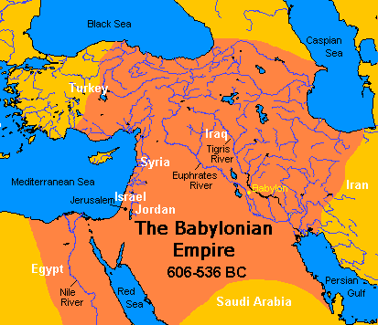

The “kings from the east” is literally “from the sunrising.” These are those from the Orient who are being brought to the Holy Land for Armageddon. If you go far enough east, you get to places like China and India, and a whole host of others along the way. It doesn’t tell us specifically who is involved, but just leaves it general.

Again, the word East is literally “sunrising,” which may suggest nations from the far east. Certainly, this drying up of the Euphrates would open up the way for the Antichrist and his forces to make a speedy maneuver from Babylon to Israel, but also allow for this great host from the far East to join him.

Note this drying up of the Euphrates is probably thought by these kings to be a really helpful thing in terms of their objective of flocking to the Holy Land to engage in war, but little do they realize that God is actually using this to bring about collective judgment on them there in the form of Armageddon. God sovereignly permits, promotes, and prevents. We certainly see some combination of that here.
Verses 13-16 are an expansion on the sixth bowl judgment of verse 12, but in the midst of it, verse 15 represents a parenthetical interjection.

13 And I saw three unclean spirits like frogs coming out of the mouth of the dragon, out of the mouth of the beast, and out of the mouth of the false prophet.

In the NT, demons are also called “unclean spirits.” They are morally unclean in their enmity with God. They are malicious beings that are evil and spiritually defiling in their influence. They seek to cause harm to people and denigrate God.

Note, it does not say they ARE frogs, but rather “like frogs.” In the OT, frogs were unclean animals (cf. Lev. 11:10, 41).

This graphic, revolting and disgusting illustration pictures the slimy, cold-blooded vileness of these demons, who seduce the kings into making the difficult journey to their doom at Armageddon under their deluding influence (cf. 1 Kings 22:19-22). – John MacArthur

Note the threefold emphasis on MOUTH; out of the mouth of the dragon (Satan – 12:9-17), out of the mouth of the beast (Antichrist – 13:1-10), and out of the mouth of the false prophet (13:11-18).

This is a propaganda campaign under demonic influence emanating forth from the mouth of this evil trinity! This demonically empowered propaganda will influence the world to come to Israel, evidently with the goal of eliminating God’s people, Israel.

Satan has always been a LIAR and a MURDERER (Jn. 8:44). He constantly slanders God’s people!

We are not told here what comes out of the mouth of this evil trinity as inspired by demons, but in Revelation 12 we find that Satan is “the accuser of the brethren,” we find that being cast to the earth he intensely goes after the woman (Israel – 12:13). And then again being enraged with the woman he makes war on her offspring “who keep the commandments of God and have the testimony of Jesus Christ.” (12:17).

Furthermore, the Bible clearly teaches that in the end, the whole world will be allied together in an effort to destroy Jerusalem.
It makes…sense that they are brought together for a final, all-out assault on Israel and the Jewish people. Satan’s age-long vendetta against the Jews will reach its climax. In this last-ditch effort, Satan will gather the armies in an attempt to wipe out any final vestige of the Jewish race. …Satan is the source of all anti-Semitism because he knows that God has promised to send Jesus, the Messiah, to rule and reign from Jerusalem and sit on David’s throne to rule over David’s kingdom. If Satan can eliminate the Jews, then he can thwart God’s promise from being fulfilled. -Ed Hindson

Exactly what this propaganda campaign involves, we are not told, but we see the results in verse 14.

14 For they are spirits of demons, performing signs, which go out to the kings of the earth and of the whole world, to gather them to the battle of that great day of God Almighty.

These are miracle-working demons! And their target is the kings of the earth. In addition to the kings of the east (v. 12), the whole rest of the world is now brought into the equation. This is a WHOLE world event brought into play by demonic influence!

The demons (as with their master Satan) are all about deception – in this case, miracle-working deception. Signs in the Bible are miracles. Jesus performed sign-miracles to show who He was as the promised Messiah.

These demons are probably performing deceptive sign-miracles that make the claim that collectively, under the leadership of Antichrist, they can yet overcome YHWH and His Christ. Thus, they persuade these kings that they are down but not yet out. These deceptive miracles will be very convincing.

Slide # 9
2 Thessalonians 2:9–12 (NKJV)
9 The coming of the lawless one is according to the working of Satan, with all power, signs, and lying wonders,
10 and with all unrighteous deception among those who perish, because they did not receive the love of the truth, that they might be saved.
11 And for this reason God will send them strong delusion, that they should believe the lie,
12 that they all may be condemned who did not believe the truth but had pleasure in unrighteousness.
THE LIE in this context is that the Antichrist is God over all. These miracles will undoubtedly buttress that LIE and be very convincing.

Slide # 10
Matthew 24:24 (NKJV)
24 For false christs and false prophets will rise and show great signs and wonders to deceive, if possible, even the elect.

Satan, at this point, will know that his time is very short. In Revelation 12:12, it says that he knows his time is short. With that reality in mind, Satan is going to throw all his deceptive influence into one final all-out effort to destroy God’s people, the Jews, whom God is forever linked to in an eternal covenant relationship.

Note that the whole goal of these demons is to gather all these kings to BATTLE. And what is this battle? It is the battle “of that great day of God Almighty.”

This is an all-out attack on God. Sovereignly, God is going to allow this gathering for His own purposes, but Satan has his own diabolical purposes. Of course, the purposes of God are going to win out as they always do. But both things seem to be in view, depending on which angle you want to look at it from, and which Scriptures you look at.

Slide # 11

Psalm 2:1–6 (NKJV)
1 Why do the nations rage, And the people plot a vain thing?
2 The kings of the earth set themselves, And the rulers take counsel together, Against the Lord and against His Anointed, saying, …

5 Then He shall speak to them in His wrath, And distress them in His deep displeasure:
6 “Yet I have set My King On My holy hill of Zion.”

Slide # 12

Revelation 17:14 (NKJV)
14 These will make war with the Lamb, and the Lamb will overcome them, for He is Lord of lords and King of kings; and those who are with Him are called, chosen, and faithful.”
Revelation 19:19 (NKJV)
19 And I saw the beast, the kings of the earth, and their armies, gathered together to make war against Him who sat on the horse and against His army.

What we have in Revelation 16 is the background to this great end-time gathering against the LORD, and we see here it is inspired by demons – miracle-working demons working through false chirsts and false prophets. And they will be very persuasive. The doctrines of demons are very persuasive to those in rebellion against the Lord.

But from another angle, it is God who brings all these armies together in the sense that He sovereignly allows it for His sovereign purposes.

Slide # 13
Joel 3:2 (NKJV)
2 I will also gather all nations, And bring them down to the Valley of Jehoshaphat; And I will enter into judgment with them there On account of My people, My heritage Israel, Whom they have scattered among the nations; They have also divided up My land.

Slide # 14
Zechariah 14:2–3 (NKJV)
2 For I will gather all the nations to battle against Jerusalem; The city shall be taken, The houses rifled, And the women ravished. Half of the city shall go into captivity, But the remnant of the people shall not be cut off from the city.
3 Then the Lord will go forth And fight against those nations, As He fights in the day of battle.

Note the emphasis here: This is “the battle of the great day of God Almighty.” This day is distinguished from all lesser days.

It is the GREAT DAY OF GOD ALMIGHTY! This is the day that God in one fell swoop, puts down the whole world!

On this day He will show that it is not “man’s day” or the “false Christ’s day” but rather the day of God Almighty!

On this day, God will assert His Almighty Power, showing that He ALONE is supreme! “His omnipotence and sovereignty will fully demonstrate itself on this occasion.” (Robert Thomas) This again is a strong LORDSHIP emphasis!
This is what Joel 2:31 termed, “the great and awesome day of the LORD.” This event is referred in various ways.

Slide # 15
A day of Vengeance – Isa. 34:8
The great winepress of the wrath of God (Isa. 63:2; Joel. 3:13; Rev. 14:19-20)
The great and awesome day of the Lord (Joel 2:31)
The harvest (Joel 3:13; Rev. 14:15-16)
The day burning like a furnace (Mal. 4:1)
The great and terrible day of the Lord (Mal. 4:5)

Here in verse 14, it is called “the battle,” but really this is probably better translated as “war” or “military campaign” because it would seem that in the BIG picture, there is a series of battles in view.

Armageddon is often referred to as a battle, but it is more accurate to call it a war or campaign because it will stretch over a distance of 200 miles and involve several stages or phases. – Mark Hitchcock

Slide # 16
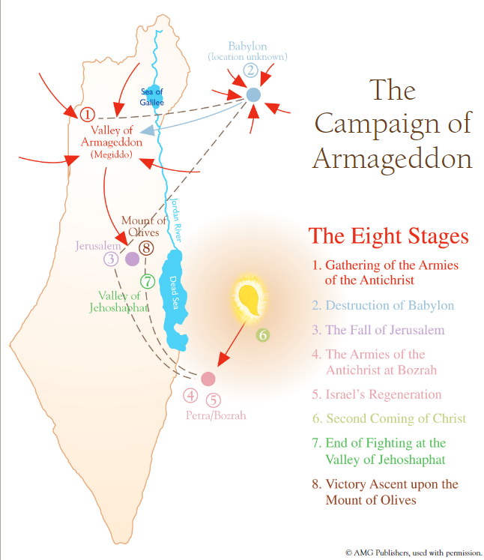

Into this context, we have a sudden interjection from Christ.
15 “Behold, I am coming as a thief. Blessed is he who watches, and keeps his garments, lest he walk naked and they see his shame.”

This is the third of seven beatitudes found in the book of Revelation (cf. 1:3; 14:13; 16:15; 19:9; 20:6; 22:7, 14). This blessing is pronounced on those who are found READY when Christ comes, so that they might avoid this time of Tribulation that will come upon the whole world.

I agree with the interpretive rendering of this verse by the Legacy Standard Bible, which makes this a parenthetical statement!

Slide # 17
Revelation 16:15 (LSB)
15 (“Behold, I am coming like a thief. Blessed is the one who stays awake and keeps his garments, so that he will not walk about naked and men will not see his shame.”)

Note, they have this verse in parentheses, indicating it should be taken as a parenthetical interjection, which I think is the right sense.

Christ was the first one to emphasize that His coming would be like that of a thief.

Slide # 18
Matthew 24:42–44 (LSB)
42 “Therefore stay awake, for you do not know which day your Lord is coming.
43 “But be sure of this, that if the head of the house had known at what time of the night the thief was coming, he would have stayed awake and would not have allowed his house to be broken into.
44 “For this reason you also must be ready; for the Son of Man is coming at an hour when you do not think He will.

Now realize that there are two aspects to Christ’s Second Coming. The first phase is when He comes at the Rapture for His Church; the second phase is when He comes to earth at the end of the Tribulation Period.

Now, which of these do you think will be unexpected? Before the Tribulation or after? How in the world could it be that He will come as a thief (unexpected) at the conclusion of the Tribulation? The world has just been through all the seal judgments, all the bowl judgments, and all but the last climactic bowl judgments.
These judgments involve wars all over the place, famine, the death of most of the world’s population, anarchy, great earthquakes that make the entire world quiver; trees, grass burned up; seas and fresh water turned to blood, the sun and moon partially darkened; the sun scorching people; an angel flying through the heavens proclaiming the gospel; demons openly tormenting people for 5 months; the powerful ministry of the two witnesses; the ministry of the 144,000 Jews; great hail; unparallelled persecution of both Israel and believers in Christ; the mark of the beast; incurable sores; worldwide darkness; etc.

That is not too subtle!

Not only does the Bible emphatically show us that this Tribulation Period will be for exactly 7 years. We know that from when Antichrist breaks his covenant with Isarel where will be exactly 3 and ½ years. We know from Revelation 13:5 that he is given unhindered power to continue for 42 months (3 and ½ years). You don’t have to be a math scholar to know when it will end! That is not too subtle. You can practically set your timer for this “thief.”

Jesus said, “as the days of Noah were, so also will the coming of the Son of Man be.” (Mt. 24:37) Let me ask you, when was the surprise element in Noah’s day? Did it happen before or after the judgment event? Did it happen before or during the judgment event? Did the surprise come 20 days after it started raining? NO! The rain of judgment took them by surprise at the beginning. As Matthew 24:39 says, “and did not know until the flood came and took them all away, so also will the coming of the Son of Man be.”

And not only that, Jesus said, when people see the phenomena of the Tribulation Period begin to happen, they should lift up their heads because “your redemption draws near” (Lk. 21:25-28). That is not unexpected.

Slide # 19
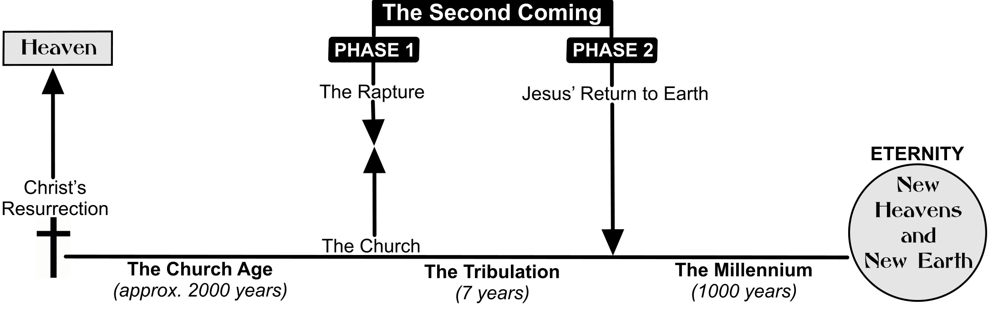
The book of Revelation is addressed to the churches (Rev. 1:4; 22:16). It serves various purposes, including correcting and exhorting the churches. But it also serves as an evangelistic tract.

The Tribulation Period doesn’t apply directly to the church, so why elaborate on this to the church? Well, the church as Christ’s witness is to warn the world of coming judgment and call them to repentance (cf. Acts 17:30-31). We are not left to wonder about this because Jesus, at the very end of the book, says these things are addressed to the churches, but then immediately says we are evangelistically inviting people to COME while they have opportunity.

Slide # 20

Revelation 22:16–17 (NKJV)
16 “I, Jesus, have sent My angel to testify to you these things in the churches. I am the Root and the Offspring of David, the Bright and Morning Star.”
17 And the Spirit and the bride say, “Come!” And let him who hears say, “Come!” And let him who thirsts come. Whoever desires, let him take the water of life freely.

In view of the coming judgment, the Spirit (the inner witness) is saying COME; the bride (the church – the outer gospel witness) is saying COME! This is what we are doing with the book of Revelation.

For 2000 years, this warning gospel invitation has been going forth from the church, which is the pillar and foundation of the truth!

After bringing the reader to the cusp of the ultimate climax of this coming judgment period, Christ interjects this warning as a call to respond so that you don’t find yourself in this unparalleled time of tribulation that will come upon the world.

“Behold” is an attention getter! Christ says, “Behold, I am coming as thief,” with the point being that people need to be ready! As we say around here, “Live Ready!”

And then Christ says, “Blessed is he who watches, and keeps his garments lest he walk naked and they see his shame.” “Shame” is a euphemism for “private parts.” It is the idea of being totally humiliated because you weren’t ready.
The imagery of keeping one’s “garments” is thought to be taken from a soldier or guard. In the Roman Empire, if a guard was caught sleeping, their clothes were taken from them, and they were shamed and disgraced by being naked. That would keep you awake!

In Christ’s teaching in Matthew 22:1-14, the person without the proper garments is shown to be a person who is not saved.

The main idea is to be READY so as not to be caught unprepared and therefore have to suffer the consequences!

After all we have studied and seen about this terrible time of suffering and judgment, it is fitting that such a final warning be given – BE READY!

Don’t be caught off guard at the rapture, or you will be shamefully left behind to face the Antichrist and the Tribulation!

Slide # 21

Luke 21:34–36 (NKJV)
34 “But take heed to yourselves, lest your hearts be weighed down with carousing, drunkenness, and cares of this life, and that Day come on you unexpectedly.
35 For it will come as a snare on all those who dwell on the face of the whole earth.
36 Watch therefore, and pray always that you may be counted worthy to escape all these things that will come to pass, and to stand before the Son of Man.”

16 And they gathered them together to the place called in Hebrew, Armageddon.

Verse 16 resumes the thought from verse 14. There we see that the demons gather all the kings of the earth together to the “battle of the great day of God Almighty.”

“God is directing this (v. 19); demons accomplish it by using earthly rulers (v. 16); Satan and the Beast and the false prophet are involved in it (v. 13); yet the kings of the earth will think they are making decisions of their own free will (Dan. 11:44). How intricate are the ways of God!” – Charles Ryrie

And then here in verse 16, we find “they gathered them together to the place called in Hebrew Armageddon.”

The word Armageddon is one of the most well-known Bible words, and yet it is found only here in the Bible. It refers to a location and an event.

The Location:

“The word is made up of two Hebrew words: Har (mountain) and Megiddo (a city in the northern part of ancient Israel). Megiddo was built on a hill, so the hill was called the mountain (har) of Megiddo – or Armageddon. The city of Megiddo overlooks a large valley variously known as the valley of Jezreel, the valley of Esdraelon, the plains of Megiddo, and the valley of Taanach.” – Mark Hitchcock

This large valley has been the site of more than 200 battles through the centuries.

Napoleon said, “What an excellent place into which all the armies of the world could be maneuvered.”

“The valley is rather large, being 14 miles wide and 20 miles long. Large as this area is, it obviously cannot contain the armies of millions of men, and it seems to be the marshalling point. Actually, the armies are scattered up and down the Holy land for a length of some 200 miles.” – John Walvoord

This apparently is the marshalling place – the staging area in preparation to overthrow Jerusalem and possibly the rock hewn city of Petra where the strong hold is for the protected remnant mentioned in Revelation 12.

Slide # 22
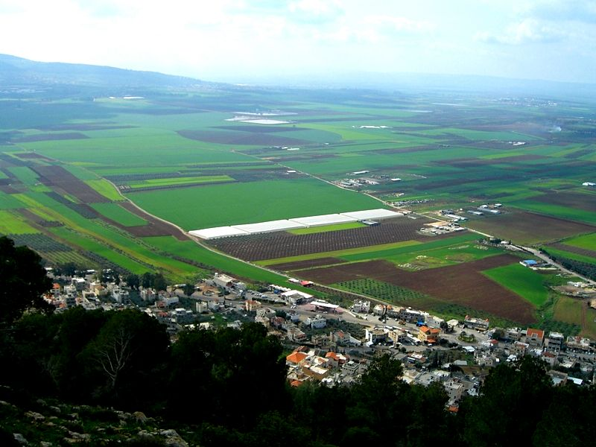
The Event: The purpose of these armies seems to be to destroy Jerusalem in particular. God’s purpose is to bring them together for judgment. This is the great showdown between Babylon (systematized rebellion under Antichrist) and God – between unified rebellion – all the collective force that man can muster under Satan’s power and influence versus GOD the ALMIGHTY!!!

Slide # 23

Zechariah 12:9 (NKJV)
9 It shall be in that day that I will seek to destroy all the nations that come against Jerusalem.
Zephaniah 3:8 (NKJV)
8 “Therefore wait for Me,” says the Lord, “Until the day I rise up for plunder; My determination is to gather the nations To My assembly of kingdoms, To pour on them My indignation, All My fierce anger; All the earth shall be devoured With the fire of My jealousy.
These are the main passages in the Bible that deal with the battle of Armageddon.

Slide # 24

- Psalm 2
- Isaiah 34:1-16
- Isaiah 63:1-6
- Joel 3:1-17
- Zephaniah. 3:8
- Zechariah 12:1-9
- Zechariah 14:1-15
- Malachi 4:1-5
- Revelation 14:14-20
- Revelation 16:12-16
- Revelation 19:19-21

The Bible plainly tells us we are living in the last days of the Church Age. We just don’t know how many of those days there are, but we know we live at the end (cf. 1 Cor. 10:11). Right now, the stage is being set for the last days' judgment, but we are not there yet. Specific SIGNS are not give to the church, but we do see trends and therefore we do see the day approaching as it says in Hebrews 10:25.
Slide # 25

Four Major Stage Setting Trends…

- Israel is back in the land.
- The configuring of Gog and allies as seen in the major players of Russia, Iran, and Turkey (Ezek. 38-39).
- Growing worldwide antisemitism.
- Growing apostasy in the professing church.

In the context of warning of coming judgment, Christ interjects the warning to be READY! And the whole context is one of an emphasis on LORDSHIP! To be ready, one has to be right with the Lord, which is to humble oneself and submit to the truth of His Lordship.

Slide # 26

Rev. 16:11 “the God of heaven” (Lordship Issue)

Rev. 16:11 “did not repent” (Lordship Issue)

Rev. 16:14 “great day of God Almighty” (Lordship Issue)

This whole context relates to the DAY OF THE LORD, in which the major issue is over the LORDSHIP of God! Into that very context, the prophet Joel speaks.

Slide # 27

Joel 2:32 (NKJV)
32 And it shall come to pass That whoever calls on the name of the Lord Shall be saved. For in Mount Zion and in Jerusalem there shall be deliverance, As the Lord has said, Among the remnant whom the Lord calls.

Lordship is always the issue. At the start of the Church on the Day of Pentecost Peter quoted from this very verse in Joel in calling the people to get saved. And then Paul in the most systematic presentation of the gospel as found in Romans, also quoted Joel as he made this the capstone of his invitation.

Slide # 28
Acts 2:21 (NKJV)
21 And it shall come to pass That whoever calls on the name of the Lord Shall be saved.’

Romans 10:13 (NKJV)
13 For “whoever calls on the name of the Lord shall be saved.”

As Savior, Christ died for all our sins, as Lord over all, He rose again. The resurrection proves His Lordship. For this reason, when doubting Thomas saw the risen Lord, he cried out, “My Lord and my God!” and Jesus responded that he had seen and believed. This is what it means to believe in the risen Lord.

For this reason, Paul in Romans 10:9 said if you confess Jesus as Lord and believe in your heart that God raised Him from the dead, you will be saved! The resurrection proves Christ’s Lordship – with the heart we believe it and with the mouth we confess it. Thus, “whoever calls on the name of the LORD shall be saved.”

In 1984, an Airlines jet crashed in Spain. Investigators studying the accident made an eerie discovery. The “black box” cockpit recorders revealed that several minutes before impact a shrill, computer-synthesized voice from the plane’s automatic warning system told the crew repeatedly in English, “Pull up! Pull up!” The pilot, evidently thinking the system was malfunctioning, snapped, “Shut up, Gringo!” and switched the system off. Minutes later, the plane plowed into the side of a mountain. Everyone on board died.
– John MacArthur in The Vanishing Conscience, p. 36

The book of Revelation is a warning message. The Church gives voice to the message, and the Spirit brings conviction, but each person must respond individually!

Judgment day is coming!

Believe on the Lord Jesus Christ, and you will be saved!

