SBC – March 29, 2026
#32
Revelation 15:1-8 (NKJV)
“Introduction to the Seven Last Plagues”

Prayer:

We live in the last days of the Church Age, which are described as “last days perilous times” (2 Tim. 3:1). And the reason they are described this way is because of the trend of abounding apostasy that will define the end of the Church Age.

The last days of the Church Age will be consummated by the Rapture of the Church – the removal of the Church in which Christ takes His bride (the Church) back to heaven. Immediately, God’s judgment will fall on the earth in which Antichrist is revealed in the making of a 7-year covenant with Israel, which is described as a “covenant with death” (Isa. 28:15).

The point is the last days of the Church Age segues into the last days of the Tribulation Period, which, while involving the whole world, will have Israel as the KEY focal point. And the KEY transition point will be the RAPTURE.

Slide # 1
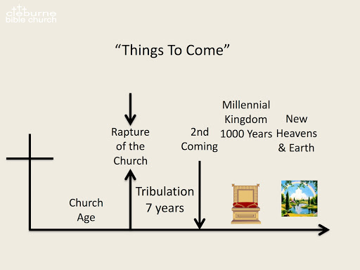

The book of Revelation comes with an inspired outline in Revelation 1:19, and it presents “last things” in basic chronological order with various background interludes in between.

Slide # 2

Revelation 1:19 – Inspired Outline
Revelation 1:19 (NKJV)
19 “Write the things which you have seen, and the things which are, and the things which will take place after this.
- “have seen” – Past (Vision of Christ) – Ch. 1
- “which are” – Present (Church Age) – Ch. 2-3
- “after this” – Future (Post-Church Age) –Ch. 4-22
- - Scene in heaven –Ch. 4-5
- - Tribulation – Ch. 6-18
- - Second Coming – Ch. 19
- - Kingdom – Ch. 20
- - Eternal State – Ch. 21-22

In Revelation 14, we have several snapshots of the last days of the Tribulation Period. This is all background information to the climactic concluding bowl judgments. But before we get to these climactic bowl judgments, we are first given more introductory information as seen in chapter 15.

In Revelation 15 we are given introductory information that sets the stage for the final climactic bowl judgments in chapter 16. This sets the stage for the finale of judgments. In the book of Revelation, there are three sets of judgments that, in one sense, are all interconnected. They become more severe and intense as we move towards the end.

In order, these are the seal, trumpet, and bowl judgments. All are contained within the seal judgments, but out of the 7th seal judgment come the 7 trumpet judgments, and then out of the 7th trumpet judgment come the 7 bowl judgments. So development looks like this.

Slide # 3
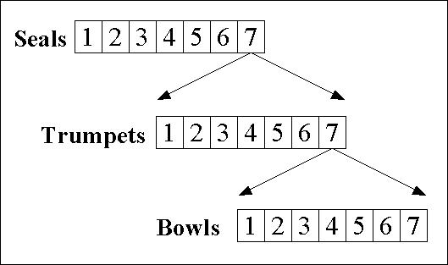

In between these three series of judgments, there are various interludes.

Slide # 4
JUDGMENTS and INTERLUDES

Rev. 6 – Seal Judgments
Rev. 7 [Interlude]
Rev. 8-9 – Trumpet Judgments
Rev. 10 – 11:14 [Interlude]
Rev. 11:15-19 Announcement of 7th Trumpet
Rev. 12-15 [Interlude – development of sub-plots]
Rev. 16 – Bowl Judgments
Rev. 17-18 - Epilogue

Each succeeding round of judgments gets more severe, and each round is given more background information before being presented. This last round (the bowl judgments) is the most severe and, therefore, is given more background information than any of the others.

To show you what I mean, in chapter 10, we are told that the sounding of the 7th trumpet will signal the end, and then, with its sounding in chapter 11, we have the announcement that the kingdom is being ushered in.

Slide # 5
Revelation 10:7 (NKJV)
7 but in the days of the sounding of the seventh angel, when he is about to sound, the mystery of God would be finished, as He declared to His servants the prophets.

Revelation 11:15 (NKJV)
15 Then the seventh angel sounded: And there were loud voices in heaven, saying, “The kingdoms of this world have become the kingdoms of our Lord and of His Christ, and He shall reign forever and ever!”

This was introductory to the final climactic bowl judgments, but then in chapters 12-15 we have the development of various background subplots that fill in various details in preparation for the ultimate round of judgments in chapter 16. That is a lot of background – a lot of build-up.

Slide # 6 (Climactic Bowl Judgments)
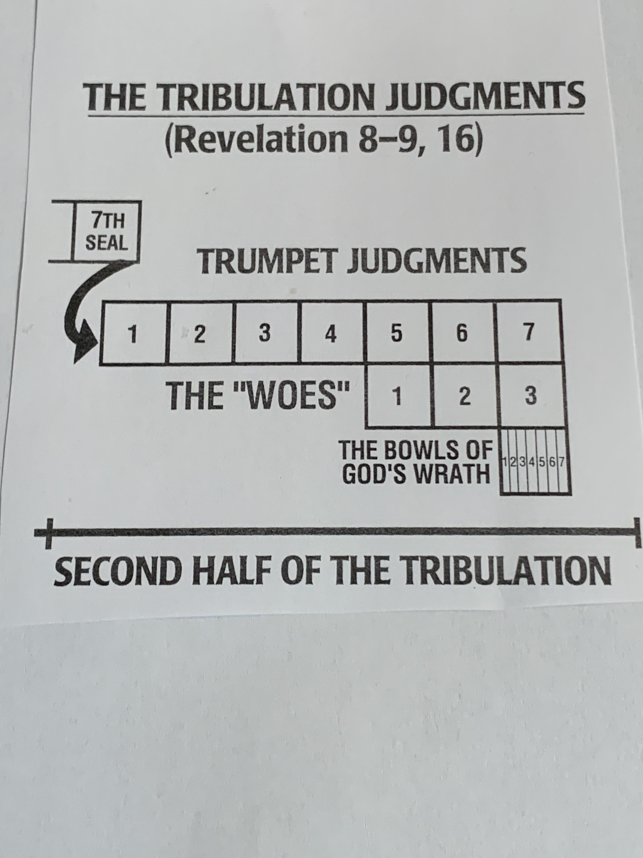
Revelation 15 is introductory to the Bowl judgments of chapter 16. Revelation 15 (in effect) is the “drum roll” to chapter 16. This is the introduction to the climax of the end-time judgments.

And that is where we pick up our study today.

Revelation 15:1–8 (NKJV)
1 Then I saw another sign in heaven, great and marvelous: seven angels having the seven last plagues, for in them the wrath of God is complete.

Note that the scene is here in heaven. We note that in the book of Revelation, there is this constant alternating back and forth between the scene in heaven and the scene on earth. This is a constant reinforcement that what is happening on earth is really being governed in accordance with the activity of heaven. And chapter 15 makes this very point once again.

Slide # 7

In Heaven: The Throne Room: (4:1-5:14) 6.
On Earth: The Seal Judgments (6:1-17) 7.

In Heaven: The 144,000 sealed; silence (7:1-8:6) 8.
On Earth: The Trumpet Judgments (8:7-9:21)

In Heaven: The little book (10:1-11)
On Earth: The two witnesses (11:1-13)

Slide # 8

In Heaven: Worship (11:14-19)
On Earth: Israel persecuted (12:1-13:18)

In Heaven: The 144,000 in glory; angelic activity (14:1-15:8)
On Earth: The seven Bowls – Fall of Babylon (16:1-18:24)

In Heaven: Christ’s Second Coming (19:1-16)
On Earth: Final judgments (19:17-20:10)

In chapter 12:1, John saw a great sign in heaven, which was that of a woman representing Israel. In 12:3, he saw another sign in heaven consisting of a great dragon representing Satan.
Now in 15:1 John sees yet another sign in heaven, which he calls “great and marvelous.” It is great and marvelous because it portends the ominous and terrible judgments that are about to fall on the earth. They are great and marvelous because, although the previous judgments were indeed severe, these are the GREATEST and most severe of all. The intensity here is so great as to have nothing to compare with it.

This sign is specifically said to be “seven angels having the seven last plagues, for in them the wrath of God is complete.” These angels signal that the end is not only near but that it is now HERE! The bitter dregs of God’s wrath is about to be poured out in full on mankind.

When it says these seven angels have the seven “last plagues,” the word “last” is the Greek word “eschatos” from when we get our word “eschatology,” which means “last things.” “The study of eschatology is the study of prophetic 'last things.”

Fittingly, the word “seven” is used 8 times in this brief chapter of Revelation 15. Seven, in the Bible, consistently is the number of completion, and so it is here in relation to the topic of judgment! With these seven last plagues God’s judgment on earth will be wrapped up.

Verse one forms a superscription to the whole of chapters 15 & 16. It, in effect, is a summary overview statement.

In Revelation 15, we really have two major subjects in view.

Slide # 9

Rev. 15:1-4 – The Tribulation Martyrs now in heaven as worshipful victors!

Rev. 15:5-8 – The 7 Angels through whom God is about to pour out His climactic judgments on the world.

2 And I saw something like a sea of glass mingled with fire, and those who have the victory over the beast, over his image and over his mark and over the number of his name, standing on the sea of glass, having harps of God.

Heaven is so “otherly” that we often find terms like “something like.” It was hard to describe, but John did his best.
John saw something like “a sea of glass mingled with fire.” Most believe this is essentially parallel to the “sea of glass, like crystal” that John saw in heaven before the throne in Revelation 4:6.

The scene before God’s throne was something like a crystal sea of glass shimmering, glistening, and perfectly tranquil. When Moses and the elders saw God Exodus 24:10 says, “And there was under His feet as it were a paved work of sapphire stone, and it was like the very heavens in its clarity.” Ezekiel 1:22 describes the firmament above the living creatures as being, “like the color of an awesome crystal.” We get the idea that the color of heaven is brilliant beyond comprehension.

But in this case, it says the sea of glass was “mingled with fire.” The context is that of God’s judgment about to be poured out on the earth as just stated in verse one. Hebrews 12:29 says, “Our God is a consuming fire.” Fire in the Bible is often associated with God’s judgment (cf. Num. 11:1; 16:35; Deut. 9:3; Pss. 50:3; 97:3; Isa. 66:15; 2 Thess. 1:7-9; 2 Pet. 3:7).

But also note that this scene in heaven is intimately connected to the martyrs who are victors over the beast, which is to say Antichrist.

And then for triple emphasis it says they were victors over his image in that they refused to worship his idol set up in the temple; and they refused to take his mark (666), although pressured to death to do so; and they are victors over then number of Antichrist’s name as they refused to take the number and identify with worshipful allegiance to him.

I am sure Antichrist thought he had the victory over them in killing them because they refused worshipful allegiance to him, but here they are in VICTORY, standing in heaven (cf. 7:9-14; 12:11; 13:7-10).

And note the language: They are standing on the sea of glass mingled with fire. This would hint that in their position of victory, they are really standing on the FIREY victory of judgment that God is about to pour out on the world of Antichrist. They have risen above it through their faith in Christ!

Furthermore, they have what are called “harps of God.” There are only two musical instruments represented in the book of Revelation, Trumpets and harps. Trumpets are used in reference to signal judgment, and harps are used as instruments of worship.

Consistently in the Bible, harps denote instruments of joy and celebration (cf. Ps. 33:2). There are four groups mentioned in heaven in Revelation that are associated with harps. They are the four living creatures (5:8); the 24 elders (5:8); the heavenly singers in Rev. 14:2-3; and here in 15:2, the martyred tribulation saints. It is an honor to worship God in this way!

3 They sing the song of Moses, the servant of God, and the song of the Lamb, saying: “Great and marvelous are Your works, Lord God Almighty! Just and true are Your ways, O King of the saints!

They sing two songs: the Song of Moses and the Song of the Lamb. Moses is here called “the servant of God,” which is more literally “the slave of God.” Those who have God as their MASTER at the end of the day sing the song of victory.

Moses is credited with two songs, which are found in Exodus 15 and that found in Deuteronomy 32. Most believe that the emphasis here is on Exodus 15, where Moses and the children of Israel celebrated in song to the LORD after He drowned the Egyptian army in the sea. It was a song celebrating God’s judgment over the enemy and the deliverance of His people.

Slide # 10

Exodus 15:1–2 (NKJV)
1 Then Moses and the children of Israel sang this song to the Lord, and spoke, saying: “I will sing to the Lord, For He has triumphed gloriously! The horse and its rider He has thrown into the sea!
2 The Lord is my strength and song, And He has become my salvation; He is my God, and I will praise Him; My father’s God, and I will exalt Him.

The song of the Lamb is spelled out in Revelation 5:8-14.

Slide # 11
Revelation 5:9–10 (NKJV)
9 And they sang a new song, saying: “You are worthy to take the scroll, And to open its seals; For You were slain, And have redeemed us to God by Your blood Out of every tribe and tongue and people and nation,
10 And have made us kings and priests to our God; And we shall reign on the earth.”
The song of the Lamb is the song of redemption. It celebrates triumph through Jesus the Savior who died for us!

Whereas the song of Moses puts the emphasis on physical deliverance, the song of the Lamb puts the emphasis on spiritual deliverance. And of course, in the end, they go together, for where you find one, you ultimately find the other.

“The song of Moses was sung at the Red Sea, the song of the Lamb is sung at the crystal sea; the song of Moses was a song of triumph over Egypt, the song of the Lamb is a song of triumph over Babylon; the song of Moses told how God brought His people out, the song of the Lamb tells how God brings His people in; the song of Moses was the first song in scripture, the song of the Lamb is the last. The song of Moses commemorated the execution of a foe, the expectation of the saints, and the exaltation of the Lord; the song of the Lamb deals with the same three themes”. – John Phillips

The song of Moses is closely identified with the Passover, which is ultimately fulfilled in Jesus and the song of the Lamb (cf. 1 Cor. 5:7).

But we are not left to wonder about the content and blend of these songs. These songs are rich with worshipful praise.

They say, “Great and marvelous are your works, Lord God Almighty!” Marvelous works are things that cause you to marvel in amazement! And they are GREAT in that they are awesome! And in context, these are works of judgment and deliverance – judgment on God’s enemies and the enemies of His people, and the deliverance of His own people. Throughout all eternity, we are going to be singing this song, and it will never get old!

“Just as His works were great and wonderful in judging the Egyptians at the Red Sea, they also are and will be great and will cause astonishment in punishing the world through the seven last plagues.”
-Robert Thomas

In worship, they call Him “Lord God Almighty!” No question about LORDSHIP in heaven! Lord (Kurios) means “Master.” God (theos) means “supreme One.” And Almighty means that “all power” belongs to Him! He is omnipotent! This defines God and makes Him worthy of all worship. Antichrist claimed to be all-powerful, but heaven knows the truth that only the God of heaven is the ALMIGHTY, which is about to be demonstrated in an undeniable way.
In praise they sing, “Just and true are your ways.” Notice heaven is not complaining about God being too severe or that His ways in some way are not right. No, they have nothing but praise for how He has worked, and for how He is about to work. This builds to the crescendo of Revelation 19 where at the Second Coming of Christ, heaven breaks out in climactic praise for judging the world in holiness.

Slide # 12

Revelation 19:1–3 (NKJV)
1 After these things I heard a loud voice of a great multitude in heaven, saying, “Alleluia! Salvation and glory and honor and power belong to the Lord our God!
2 For true and righteous are His judgments, because He has judged the great harlot who corrupted the earth with her fornication; and He has avenged on her the blood of His servants shed by her.”
3 Again they said, “Alleluia! Her smoke rises up forever and ever!”

And they exclaim, “O King of the saints,” which in the older manuscripts reads, “O King of the nations.” In context, this makes sense in light of what they go on to say in verse 4. Jesus is coming to rule over the nations! He is coming as KING OF KINGS AND LORD OF LORDS!

Note, there is not a word in their song about human goodness or achievement. Their songs are all about God and His greatness, and His great salvation. In heaven, it's all about God all the time!

4 Who shall not fear You, O Lord, and glorify Your name? For You alone are holy. For all nations shall come and worship before You, For Your judgments have been manifested.”

At this point, the martyrs of the Tribulation Period ask a rhetorical question which is then answered in the rest of the verse. They ask, “Who shall not fear You, O Lord, and glorify Your name?”

To properly fear God is to reverence Him for the GREAT God that He is, and in that act God’s name is glorified – He is exalted in worship for WHO He is. It is to submit to Him for Who He is Lord God Almighty Who is King of the nations!

This again involves the nature of a true saving faith response.
Slide # 13

Psalm 2:10–12 (NKJV)
10 Now therefore, be wise, O kings; Be instructed, you judges of the earth.
11 Serve the Lord with fear, And rejoice with trembling.
12 Kiss the Son, lest He be angry, And you perish in the way, When His wrath is kindled but a little. Blessed are all those who put their trust in Him.

In Revelation 16:9 we find that hardened sinners blaspheme God for the plagues they are enduring and refuse to “repent and give Him glory.” That is, they refuse to humble themselves before His LORDSHIP! That really is what this is all about! This is the Day of the Lord when the Lordship of God is on full display, and the world refuses to humble itself under that reality.

But then the rhetorical question is answered, and the end of the matter is then stated.

God alone is holy (cf. 1 Sam. 2:2; Ps. 22:3; 99:5,9; 111:9; Isa. 6:3; 57:15; Hab. 1:12). Holy means He is totally set apart and unique. There is no other like God – there is no other God. God is in a category all His own! And thus God ALONE is to be worshiped!

And this is going to be the outcome of the Day of the Lord judgments! The rebels will all be put down, and in the kingdom, all nations shall come and worship before Him. All those surviving and going into the kingdom will be true worshipers (cf. Jn. 4:23-24). To worship means to bow down before, to prostrate oneself in submission and obeisance (cf. Gen. 49:10; Dan. 7:14).

Slide # 14

Isaiah 66:23 (NKJV)
23 And it shall come to pass That from one New Moon to another, And from one Sabbath to another, All flesh shall come to worship before Me,” says the Lord.

Zephaniah 2:11 (NKJV)
11 The Lord will be awesome to them, For He will reduce to nothing all the gods of the earth; People shall worship Him, Each one from his place, Indeed all the shores of the nations.
What is going to bring this about is God’s judgments. When it says, “For your judgments have been manifested,” this is what we call “the prophetic perfect,” meaning something is so sure to happen that it is as good as accomplished already. God in judgment is going to bring the whole world into worshipful submission (cf. Zech. 14:16).

Slide # 15

Psalm 2:8–9 (NKJV)
8 Ask of Me, and I will give You The nations for Your inheritance, And the ends of the earth for Your possession.
9 You shall break them with a rod of iron; You shall dash them to pieces like a potter’s vessel.’ ”

In the very end, every knee will bow, and every tongue will confess that Jesus is Lord to the glory of God, as seen in Philippians 2:10-11.

5 After these things I looked, and behold, the temple of the tabernacle of the testimony in heaven was opened.

At this point, there is a shift in emphasis from the victors' worship in heaven to the emergence of the seven angels who come out of the temple in heaven to administer judgment!

The word “temple” here is the Greek word “naos” which refers to the most holy place. The word “tabernacle” means “dwelling place.”

“The temple tabernacle of the testimony” could be translated as “the sanctuary of the dwelling place of the ten commandments.” In view is the Holy of Holies, where the testimony of the Ark was located, which contained the 10 commandments, which is the point of emphasis here.

However, the Ark of the Covenant actually contained three things: 1) a golden pot of manna, Aaron’s rod that budded, and the two tablets of the 10 commandments (cf. Heb. 9:4).

Slide # 16
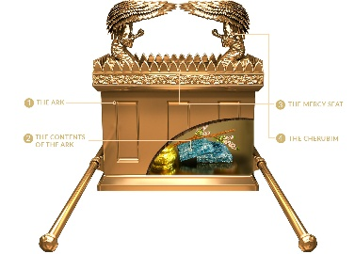
In the OT the tabernacle was sometimes called “the tabernacle of the Testimony” (Ex. 38:21; Num. 1:50, 53; 9:15; 10:11; Acts 7:44); and the tables of the law were called the “tablets of the Testimony” (Ex. 31:18; 32:15). Thus, the “tabernacle of the testimony” was so named because in contained the 10 commandments (cf. Ex. 25:16, 21; 40:20; cf. Ps. 78:5).

The whole point is that this Most Holy Place was intimately identified with God’s holy presence and His Holy Law.

In Hebrews 9:23 it that the things on earth related to the tabernacle/temple were “copies of things in the heavens.” (cf. Heb. 8:2, 5).

The emphasis here in Revelation 15:5 is on the TESTIMONY, meaning the Holy Law of God – the 10 commandments!

“The testimony” refers to what was written on the stones, which “testified” against sin. – Robert Thomas

The Most Holy place in heaven, most intimately associated with the presence of God and His Holy Law, was now opened, indicating that the basis of God’s judgment on earth is because of the violation of His Holiness as seen in the violation of His Holy Law. The judgments about to be administered are the expression of God’s righteousness in accordance with His Holy Law.

This scene serves to show WHY the world is being judged, and the clear implication is that the HOLY LAW OF God (the testimony) has been violated, which calls for judgment! This reveals both the source (Holy God) of the last plagues and the reason why (Violation of His Holy Law).

The very 1st command, “you shall have no other gods,” was totally disregarded by the world as it worshiped antichrist. They had no regard for the commands of God, and therefore, they are about to experience the full measure of His judgment. It seems this is what is being signified.

Someone may ask: Why is God holding the world accountable to the 10 commandments? Wasn’t that done away with the coming of Christ?

It is true that the Mosaic Law was given only to the Jews. It was a UNIT of 613 laws (cf. Ja. 2:10). It was never a means of salvation. No one is under the rule of the Mosaic Law today as a means of salvation or sanctification.

However, people at all times are accountable to the glory of God as a holy standard. The glory of God is His character and nature (cf. Ex. 33:18-19, 34:5-7) – what we commonly call God’s moral law.

Slide # 17

Romans 3:23 (NKJV)
23 for all have sinned and fall short of the glory of God,

People are not under the Law as a code, but they are responsible to the glory of God standard represented in the Law. The issue is THE GLORY OF GOD. The issue, therefore, is not accountability to the Law as a system of rule but accountability to the glory of God, which is represented in the Law. People of all times are accountable to this glory of God standard.

This standard is always in view, pre-law, under law, and post-law. In other words, the standard of God Himself is always the issue. What the Law did is REVEAL this standard in a pronounced way that enhanced what was previously known in the conscience of man. In his conscience, mankind knows that it is wrong to lie and steal, but the Law magnifies this reality.

As a code, the Law was given only to the Jews, but it illustrates universal truth – namely that all come short of the glory of God.

Slide # 18

Romans 3:19–20 (NKJV)
19 Now we know that whatever the law says, it says to those who are under the law, that every mouth may be stopped, and all the world may become guilty before God.
20 Therefore by the deeds of the law no flesh will be justified in His sight, for by the law is the knowledge of sin.

No one measures up to the glory of God standard as revealed in the Law for which all are accountable. This is Paul’s very point! And this continues to be a present-tense lawful use of the Law as seen in 1 Timothy 1:8-11.

We need to connect “by the law is the knowledge of sin” (Rom. 3:20), with “all have sinned and come short of the glory of God (Rom. 3:23).

The issue is not to put people under the Law but to show that they come short of the glory of God as revealed in the Law.
The Law is no longer binding as a system, but the glory of God is! The moral law continues to be a binding reality that no one can live up to. That is why we need Jesus. We need a Savior. We need the Lamb of God Who takes away the sin of the world (Jn. 1:29).

The reality is that there is a moral law accountability standard represented in the law that can only be answered by the righteousness of Christ, which is received by faith! But until one is saved by faith in Christ, they are accountable to God’s moral law, which is represented in the Mosaic Law.

The moral law (stated as the glory of God) never changes. God’s glory ever remains the standard, and the only way we can get there is through faith in Christ. When we put our faith in Christ, God imputes (or puts to our account) the righteousness of Christ. This is the only way in.

But outside of Christ, the entire world is accountable to this moral standard! That is why God held the Canaanites accountable even though they never had the law of Moses. They did have the law of God written on their hearts as seen in the reality of conscience (cf. Rom. 2:14-15) and therefore were accountable to God’s moral law (cf. Deut. 18:12; Lev. 18:24-25; 20:23).

God’s holiness, as represented in His holy law, has been violated, which calls for judgment, which is about to be administered by the seven angels who come out of the holy temple in heaven (cf. Rev. 11:19).

6 And out of the temple came the seven angels having the seven plagues, clothed in pure bright linen, and having their chests girded with golden bands.

Out of the temple, from the place of ultimate intimate holiness came seven angels who have the seven plagues. They are clothed in heavenly apparel, signifying holiness, purity, and glory as they are sent forth to administer God’s holy judgment (cf. Rev. 1:13; 19:14).

7 Then one of the four living creatures gave to the seven angels seven golden bowls full of the wrath of God who lives forever and ever.

Apparently, these “living ones” represent the highest order of angels who are closest to the throne. They are consistently associated with the immediate presence of God. So much so that sometimes they are referred to as “the guardians of the throne of God.” They appear throughout the book of Revelation in the very presence of God (cf. 4:6; 5:6; 6:1; 7:11; 14:3; 15:7; 19:4).
Here we find that one of them gave to these seven angels seven golden bowls FULL of the wrath of God.

In verse one, we saw these seven angels have the seven last plagues in which the wrath of God is complete, and here they are given bowls FULL of the wrath of God.

Full again denotes that which is comprehensive, complete, and total.

“The bowls are full to the brim with the hot anger of God. The fullness speaks of the devastating character as well as the finality of the coming divine judgement.” – Robert Thomas

The wrath they are to administer is God’s wrath. And God is specifically said to be the One “who lives forever and ever.” This is the wrath of the eternal God.

The phrase “forever and ever” is found 21 times in the book of Revelation, and 17 of those times it is applied to God’s unique eternal nature.

God by His very nature is ETERNAL, which is something that is totally beyond our finite minds to comprehend, but it is clearly what the Bible teaches. God never came into existence, and He will never go out of existence. He simply is eternal!

Footnote: This same phrase “forever and ever” is used in reference to the duration of punishment of the lost (Rev. 14:11) and also in relation to the eternal blessedness of the saved (Rev. 22:5). As long as God lives, the lost will suffer His punishment; as long as God lives, the saved will enjoy His blessedness, which is to say “forever and ever.”

8 The temple was filled with smoke from the glory of God and from His power, and no one was able to enter the temple till the seven plagues of the seven angels were completed.

At this point, the temple in heaven was filled with smoke from the glory of God and His power.

After the tabernacle was constructed and the work was completed the glory of the LORD filled the tabernacle so that even Moses was not able to enter in (cf. Ex. 40:34-35). After the temple was built and they place in it the ark of the covenant the glory of the LORD so filled the temple that the priest were not able to remain in it (1 Kings 8:10-11).
In this context, the smoke is evidently a symbol of God’s HOLINESS in response to sin. It signifies God’s holy presence in response to sin. The releasing of God’s HOLY wrath is thus defined by God’s glory and power.

When God gave the 10 commandments on Mount Sinai, it was accompanied by this phenomenon.

Slide # 19

Exodus 19:18 (NKJV)
18 Now Mount Sinai was completely in smoke, because the Lord descended upon it in fire. Its smoke ascended like the smoke of a furnace, and the whole mountain quaked greatly.

In Isaiah 6 when Isaiah saw the Lord on His throne in the temple. He reported this experience.

Slide # 20

Isaiah 6:3–5 (NKJV)
3 And one cried to another and said: “Holy, holy, holy is the Lord of hosts; The whole earth is full of His glory!”
4 And the posts of the door were shaken by the voice of him who cried out, and the house was filled with smoke.
5 So I said: “Woe is me, for I am undone! Because I am a man of unclean lips, And I dwell in the midst of a people of unclean lips; For my eyes have seen the King, The Lord of hosts.”

And with the filling of the temple with God’s glory and power no one was able to enter the temple until the seven plagues are completed.

This seems to indicate there will be no more intercession. Judgment at this point is imminent and irreversible. There will be no more delay! The time has come! The smoke of God’s glory and power filling the temple signals that an unalterable chain of judgment events is now set in motion!

Slide # 21

Lamentations 3:44 (NKJV)
44 You have covered Yourself with a cloud, That prayer should not pass through.

There comes a point of no return – a place where they no longer have a prayer. At this point, God is utterly unapproachable!

In the day of His judicial action, none need try to seek Him, for He will not be found. Grace will be withdrawn and prayer will go unanswered.
– Lehman Strauss

The temple is filled with smoke, indicating the presence of God in all his glory and power actively carrying out his judgement upon wickedness. Until the seven plagues are finished, no one is able to enter the temple. Once the time of final judgement has come, none can stay the hand of God. The time for intercession is past. God in his unapproachable majesty and power has declared that the end has come. No longer does he stand knocking: he enters to act in sovereign judgement. – Robert Mounce

The book of Revelation serves as a stark and severe warning that divine judgment is coming to the world and that now is the time to get right with God. It shows us that there is a point where it is too late. Therefore, we'd better respond while we can!

Slide # 22
Proverbs 29:1 (NKJV)
1 He who is often rebuked, and hardens his neck, Will suddenly be destroyed, and that without remedy.

Yes, in wrath God remembers mercy (Hab. 3:2). But mercy rejected results in certain judgment! God sent His two special witnesses with a worldwide ministry warning the world (Rev. 11). He sent the 144,000 Jewish evangelists (Rev. 7). He opened heaven and let earth see the throne and the people cried to the mountains and rocks to fall on them and hide them from the face of Him who sits on the throne and from the wrath of the Lamb (Rev. 6:12-17). God gave the world the witness of an innumerable number of saints, both of Jew and Gentile, whom they killed (Rev. 7). He sent an angel flying through the midst of heaven to proclaim the everlasting gospel to “every nation, tribe, tongue and people (Rev. 14:6).

God gave great grace even in the midst of this terrible time of tribulation. He gave opportunity after opportunity. But now His grace is exhausted. The time of full-blown judgment has come! The door of grace is shut! All that remains now is the final and full blow of God’s full wrath!
God tells us how it is all going to end…

Slide # 23

Zephaniah 3:8 (NKJV)
8 “Therefore wait for Me,” says the Lord, “Until the day I rise up for plunder; My determination is to gather the nations To My assembly of kingdoms, To pour on them My indignation, All My fierce anger; All the earth shall be devoured With the fire of My jealousy.

In view of this reality, the Scripture says, “Today, if you will hear His voice do not harden your hearts” (Heb. 3:15). The writer of Hebrews says, “See that you do not refuse Him who speaks…for our God is a consuming fire.” (Heb. 12:25, 29) And again he says, “It is a fearful thing to fall into the hands of the living God.” (Heb. 10:31)

On 9/11 in 2001, terrorists hijacked a jet and flew it into the Pentagon. The Pentagon is a massive place, but in the area where it was hit, there was an immediate huge fire, and smoke began filling the place to the point where people couldn’t see how to get out. One of the employees was by the emergency stairs, and he began yelling, “Come to my voice, Come to my voice”. Even though the people couldn’t see as they came to his voice, they were able to find their way to safety.

God is saying to the world, as His Word is proclaimed, “Come to My voice” – respond to My voice and be saved!”

Hebrews 3:7–8 (NKJV)
7 Therefore, as the Holy Spirit says: “Today, if you will hear His voice,
8 Do not harden your hearts as in the rebellion, In the day of trial in the wilderness,

Believe on the Lord Jesus Christ, and you will be saved!
And then you too will sing “THE SONG OF THE LAMB!”

