SBC – March 22, 2026
Psalm 104:1-35 (NKJV)
“Praise the God of Creation”

Psalm 104 has no title. However, since David wrote Psalm 103 and since both Psalm 103 and 104 begin and end the exact same way with, “Bless the LORD, O my soul!” many think David authored them both. The Septuagint lists David as the author. David is certainly a very good guess. In Psalm 104, the emphasis is on natural revelation, of which David was very much an admirer, as seen in Psalm 19:1-6.

Psalm 104 is thought to be a recasting of Genesis 1 in a poetic form, as it hits many of the creation themes found therein. But at the end, there is also an illusion to the coming eternal state as found in Revelation 21-22.

Psalm 104 emphasizes the sovereign providential care of God over His creation. Have you ever thought of what is involved in managing a city of several million people – all the details, all the moving parts constantly needing attention? But God manages and providentially cares for the entire world. When you reflect on it – it is truly awesome. And this is what Psalm 104 does.

Slide # 1

Psalm 104

“Praise the God of Creation”

vv. 1-9 The Greatness of God seen in Creation
vv. 10-18 God’s Providential Care for His Creatures
vv. 19-23 The Course of Nature
vv. 24-26 The Manifold Works & Wisdom of God
vv. 27-30 Creation’s Dependence Upon God
vv. 31-35 A Worshipful Response

Psalm 104 (NKJV)
1 Bless the Lord, O my soul! O Lord my God, You are very great: You are clothed with honor and majesty,

To BLESS the LORD (YHWH) means to actively praise, adore, and worship God for all He is and all He does. God is VERY GREAT as seen in natural revelation. We should appreciate creation because it points to the greatness of its CREATOR! We appreciate creation, but we worship the CREATOR!
He is clothed with “honor and majesty.” This is the language of royalty. Honor is often translated as “splendor.” Majesty speaks of God’s supreme greatness, sovereign authority, and awe-inspiring glory that defines and covers Him.

2 Who cover Yourself with light as with a garment, Who stretch out the heavens like a curtain.

There is mystery here, but God is identified with glorious light in a way we can’t comprehend.

Slide # 2

1 Timothy 6:16 (NKJV)
16 who alone has immortality, dwelling in unapproachable light, whom no man has seen or can see, to whom be honor and everlasting power. Amen.

As the Creator of the vast heavens, He stretches out the heavens like a curtain (cf. Isa. 40:22).

3 He lays the beams of His upper chambers in the waters, Who makes the clouds His chariot, Who walks on the wings of the wind,

Poetical language is employed here. The upper chambers built above the first story of the house were a place of privacy and seclusion. We see here the transcendence of God as He resides ABOVE all. The clouds are metaphorically His chariot, and He walks on the wings of the wind.

4 Who makes His angels spirits, His ministers a flame of fire.

This verse is quoted in Hebrews 1:7. The angels do God’s bidding.

They obey His will with the speed of wind and with the fervency of fire. – William MacDonald

5 You who laid the foundations of the earth, So that it should not be moved forever,
6 You covered it with the deep as with a garment; The waters stood above the mountains.

God laid the immovable foundations of the earth. He covered it with water.
Initially, the earth was covered with water (Gen. 1:2). But then on the 3rd day God separated the waters from the dry land. At that time, we believe there were mountains but they were not the high mountains we have today. After the flood, there was tremendous volcanic and systemic activity that resulted in the mountains being raised up to where they are today as the waters receded into their place.

The psalmist had in mind two events. The separation of the waters at creation (Genesis 1:9-10) and the global flood described in Genesis 7. – David Guzik

7 At Your rebuke they fled; At the voice of Your thunder they hastened away.
8 They went up over the mountains; They went down into the valleys, To the place which You founded for them.

The imagery is consistent with the cosmic flood in Genesis, (Gn. 7:18-20). …The flood waters receded, uncovering the mountains and redefining the valleys, restoring the earth to its natural state.
– Holman Study Bible

9 You have set a boundary that they may not pass over, That they may not return to cover the earth.

God set the water boundaries in keeping with His covenant promise to Noah that never again would the earth be destroyed by water.

Slide # 3

Genesis 9:11 (NKJV)
11 Thus I establish My covenant with you: Never again shall all flesh be cut off by the waters of the flood; never again shall there be a flood to destroy the earth.”

In verses 10-18, we have an overview of God’s providential harmonious care of creation.

10 He sends the springs into the valleys; They flow among the hills.
11 They give drink to every beast of the field; The wild donkeys quench their thirst.

On this side of the flood, we see that God has transformed the destructive capability of water into a constructive role. Thus, God even provides for the wild donkeys that virtually no one ever sees or has contact with. But God sees and He cares for them.

They live in dry and desolate wildernesses, and are neither ruled nor regarded by men, and are most stupid creatures, and yet are plentifully provided for by the care and bounty of Divine Providence.
– Matthew Poole

12 By them the birds of the heavens have their home; They sing among the branches.

God takes care of the birds, and they, in effect, sing His praises. I love to wake in the morning to their singing. It is a great way to start the day and a constant reminder of God and His care of creation.

13 He waters the hills from His upper chambers; The earth is satisfied with the fruit of Your works.
14 He causes the grass to grow for the cattle, And vegetation for the service of man, That he may bring forth food from the earth,
15 And wine that makes glad the heart of man, Oil to make his face shine, And bread which strengthens man’s heart.
16 The trees of the Lord are full of sap, The cedars of Lebanon which He planted,
17 Where the birds make their nests; The stork has her home in the fir trees.
18 The high hills are for the wild goats; The cliffs are a refuge for the rock badgers.

God providentially takes care of man and beast, both the eccentric and the common.

Storks are large, long-legged, long-necked wading birds with long, stout bills. Many species are migratory. Most storks eat frogs, fish, insects, earthworms, small birds and small mammals.

Slide # 4

Rock badgers are here thought to probably refer to hyrax which is a small/shy rock-dweller.

Proverbs 30:26 (NKJV)
26 The rock badgers are a feeble folk, Yet they make their homes in the crags;

Slide # 5


19 He appointed the moon for seasons; The sun knows its going down.
20 You make darkness, and it is night, In which all the beasts of the forest creep about.
21 The young lions roar after their prey, And seek their food from God.
22 When the sun rises, they gather together And lie down in their dens.
23 Man goes out to his work And to his labor until the evening.

In verses 19-23, we have the rhythm of nature. There is an amazing cycle and harmony in nature.

At night, the beasts of the forest come alive. They work the night shift. In the daytime, they sleep in their dens. Conversely, men go about their work in the daylight hours (normally) and at night cease from their work.

The solar and lunar cycles regulate the seasons, reflecting God’s dependability and sovereignty over creation. God controls the darkness and the light and the life cycles of night and day creatures.
– Holman Study Bible

The lion is known as “the king of the jungle,” and yet he is dependent upon God for his food. Again, all are dependent upon the providential provision of God.

24 O Lord, how manifold are Your works! In wisdom You have made them all. The earth is full of Your possessions—

It is awesome to contemplate the complex ecosystems God has put in place. None of these is random, but rather reflects irreducible complexity that demands a superintelligence behind it all. God’s works are manifold, that is, many-faceted, and they reflect the awesome wisdom of God. The earth is FULL of God’s possessions that He has made to bring glory to Himself.

The diversity in creation is amazing. God could have made a drab, colorless world, one season everywhere, only one variety of each plant and animal, cookie-cutter humans, no musical sounds, a few minimal kinds of food- but He did not, and how grateful we are. Only a wise God could have planned so many different things, and only a powerful God could have brought them into being. – Warren Wiersbe

25 This great and wide sea, In which are innumerable teeming things, Living things both small and great.
26 There the ships sail about; There is that Leviathan Which You have made to play there.

Sea water covers about 70 percent of the earth, and in it we find “innumerable teeming things, living things both great and small.”

There we find ships sailing, and there was found playing the Leviathan. The Leviathan today is extinct, but back in the early days of humanity, it played in the ocean. It was sort of a sea monster, seemingly corresponding to the dinosaurs that roamed the earth.

Slide # 6

Job 41:32–34 (NKJV)
32 He leaves a shining wake behind him; One would think the deep had white hair.
33 On earth there is nothing like him, Which is made without fear.
34 He beholds every high thing; He is king over all the children of pride.”

Humanity is humbled before this awesome sea-monster (cf. Job 3:8, 41:1; Ps. 74:14; 104:26; Isa. 27:1).

These descriptive words indicate a large, ferocious animal that crawled or walked on the bottom of a river or shallow body of water… It seems God pointed out two of the largest dinosaurs known to mankind in Job 40 and 41. One was a large plant-eater (behemoth), and the other was the “king over all the children of pride” (Job 41:34). Both of these animals could have been right there in or near the rivers where Job resided. – Tim Clarey, Ph. D – (ICR)

Slide # 7
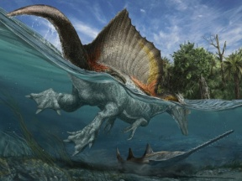

27 These all wait for You, That You may give them their food in due season.
28 What You give them they gather in; You open Your hand, they are filled with good.

Again, all are dependent upon God’s provision. But note, “You give them” and “they gather in.” God provides, but they must gather in. God provides for the birds, but He doesn’t throw it up into their nests. They must “gather in.” And so it is with us! God's sovereignty provides our daily bread, but at the same time, we must “gather in” through responsible work.

29 You hide Your face, they are troubled; You take away their breath, they die and return to their dust.
30 You send forth Your Spirit, they are created; And You renew the face of the earth.

God is sovereign over both life and death! He hides His face (so to speak), and they die, but He also brings forth new life so that life on planet earth continues. One generation reproduces another, allowing life on planet Earth to continue on perpetually. This is the ongoing cycle of life, and God is sovereignly behind it all!

31 May the glory of the Lord endure forever; May the Lord rejoice in His works.

This thing called life on planet earth is God’s doing – it is to the GLORY of God as Creator.
And may it be to the JOY of the LORD, may YHWH rejoice in His works. At the conclusion of creation week God saw all that He made and He saw that it was “very good.” (Gen. 1:31) May He continue to be pleased with what He has made is the sentiment here.

32 He looks on the earth, and it trembles; He touches the hills, and they smoke.

In the Bible, the earth trembling often signifies the awesomeness of God’s presence, either in judgment or signifying His awesome presence. It signifies creation, in effect, responding in fear and awe to its Creator. This happened at Mount Sinai (Ex. 19:18); it happened at the Resurrection of Christ (Mt. 28:2); and it will happen in regard to last days events.

Slide # 8

Isaiah 24:19 (NKJV)
19 The earth is violently broken, The earth is split open, The earth is shaken exceedingly.

Jeremiah 10:10 (NKJV)
10 But the Lord is the true God; He is the living God and the everlasting King. At His wrath the earth will tremble, And the nations will not be able to endure His indignation.

Slide # 9
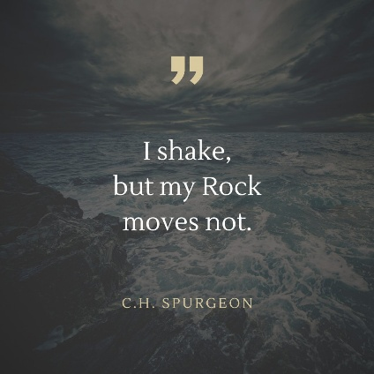

33 I will sing to the Lord as long as I live; I will sing praise to my God while I have my being.

The Psalmist is celebrating in worship to God for His providential care and His sovereignty over all as demonstrated in nature itself. Our study of nature should lead us to worship. He resolves to sing praises to God for as long as he lives!
34 May my meditation be sweet to Him; I will be glad in the Lord.

Not only do we outwardly worship God in song, but our inward thoughts are also a means of worship. Meditating on – reflecting on God is really a form of inward worship. The Psalmist's desire is that his thoughts and reflections on God would be sweet to him.

Slide # 10
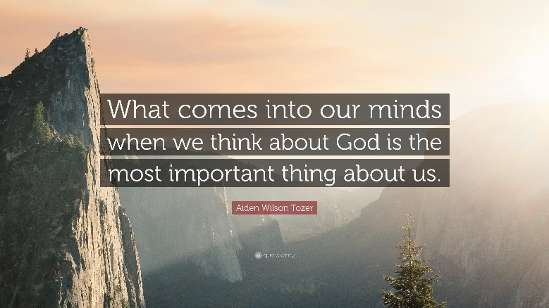

And then the Psalmist resolves to find his joy in the LORD!

Biblical meditation is pondering the truth and character of God. There is an old saying that says, “We master the Word through memorization, but the Word masters us through meditation.”

Slide # 11
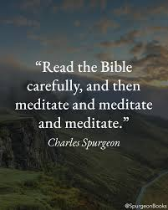

Meditating on the things of God brings forth great joy. Note the connection here between “meditation” and “gladness”. The one leads to the other.

35 May sinners be consumed from the earth, And the wicked be no more. Bless the Lord, O my soul! Praise the Lord!

At first glance, this seems harsh, but the writer longs for the time when earth will be restored, and pure worship will define all who live here. As such this prayer anticipates the new heaven and earth.
Then the curse will be removed, and all of nature will live in harmony as God intended. Then the earth will bring forth the worship that God so richly deserves.

As did Psalm 103 this Psalm also basically concludes with “Bless the LORD, O my soul!

But then it adds one more word in the Hebrew which is the word “Hallelujah” which is translated as “Praise the LORD!” It is the climactic praise word. This is the first of 23 times it is found in the Psalms.

Psalm 104 is a CREATION Psalm. It has become popular for many Christian commentators and teachers to say the issue of Creation is really not a primary issue. But I don’t see that in the Bible.

Genesis 1:1 begins with Creation. The Hall of Faith Chapter in Hebrews 11 begins with creation (11:3). This is the first example of a God-honoring faith. The gospel of belief, the gospel of John, begins here in John 1:1-3. In the book of Revelation in heaven, the first emphasis of worship is in relation to God the Creator. If one refuses to trust Jesus on the matter of Creation, do they really trust Him for anything else?

Slide # 12

Revelation 4:10–11 (NKJV)
10 The twenty-four elders fall down before Him who sits on the throne and worship Him who lives forever and ever, and cast their crowns before the throne, saying:
11 “You are worthy, O Lord, To receive glory and honor and power; For You created all things, And by Your will they exist and were created.”

When the angel flies through the heavens proclaiming the everlasting gospel this is his emphasis.

Slide # 13

Revelation 14:6–7 (NKJV)
6 Then I saw another angel flying in the midst of heaven, having the everlasting gospel to preach to those who dwell on the earth—to every nation, tribe, tongue, and people—
7 saying with a loud voice, “Fear God and give glory to Him, for the hour of His judgment has come; and worship Him who made heaven and earth, the sea and springs of water.”

I am not sure heaven sees this as a secondary issue, like so many want to claim. Can you really claim to believe in God if you doubt what He says about Creation? It seems to me that faith starts there! It takes God at His Word about Creation, and it worships!

Slide # 14
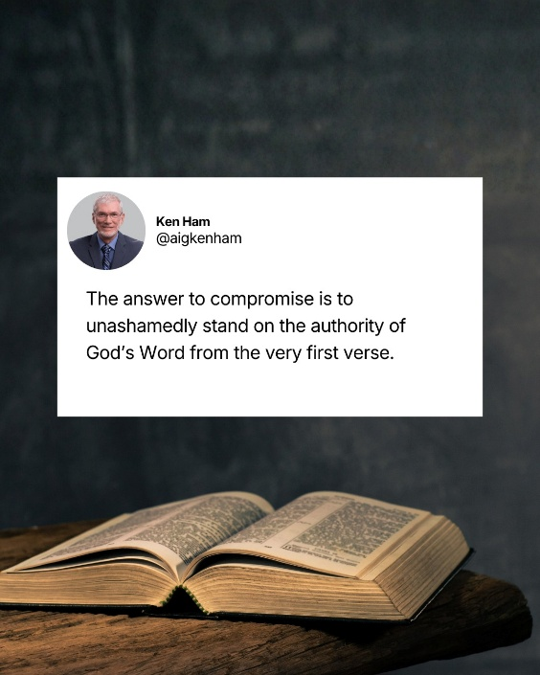

The study of natural science is but “thinking God’s thoughts after Him.” If earth and sky are declaring the glory of God (19:1), we who have been saved by grace ought to be glorifying Him even more.
– Warren Wiersbe

Indeed, Bless the LORD, O my soul! Praise the LORD!

