SBC – Jan. 18, 2026
#23
Revelation 12:1-6 (NKJV)
“Two Signs in Heaven”

Prayer:

The book of Revelation takes the whole of progressive revelation and puts the capstone on it. It draws on all the threads of revelation and ties them all together in the consummation of all things. It shows where the whole of redemptive history is leading and where it concludes.

Want to know the end of all things – read the book of Revelation. Only God knows the future, and we only know what we have been told. And what He has told us regarding the conclusion of all things is found here in the book of Revelation.

The book of Revelation is presented in a very orderly fashion. In 1:19 we have an inspired outline.

Slide # 1
Revelation 1:19 – Inspired Outline

Revelation 1:19 (NKJV)
19 “Write the things which you have seen, and the things which are, and the things which will take place after this.
- “have seen” – Past (Vision of Christ) – Ch. 1
- “which are” – Present (Church Age) – Ch. 2-3
- “after this” – Future (Post-Church Age) –Ch. 4-22
- - Scene in heaven –Ch. 4-5
- - Tribulation – Ch. 6-18
- - Second Coming – Ch. 19
- - Kingdom – Ch. 20
- - Eternal State – Ch. 21-22

The book of Revelation is put together in a straightforward chronological sense in terms of the seal judgments, followed by the trumpet judgments, followed by the climactic bowl judgments. These judgments grow in intensity and frequency the closer we get to the end of the Tribulation Period.

Slide # 2
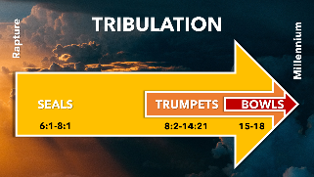
But note that between the chronological development of the judgments, there are various interludes in which background subplots are developed that enrich our understanding going forward. However, these interludes don’t necessarily present their information chronologically; they simply give more background information that relates to various aspects of the Tribulation Period, whether it relates to the beginning, middle, or end of the Tribulation.

Slide # 3

JUDGMENTS and INTERLUDES

Rev. 6 – Seal Judgments
Rev. 7 [Interlude]
Rev. 8-9 – Trumpet Judgments
Rev. 10 – 11:14 [Interlude]
Rev. 11:15-19 Announcement of 7th Trumpet
Rev. 12-15 [Interlude – development of sub-plots]
Rev. 16 – Bowl Judgments
Rev. 17-18 - Epilogue

At the end of Revelation 11, we have the sounding of the 7th trumpet, which serves to introduce the concluding climactic bowl judgments. However, these judgments are so great that more supplementary background information is given first before they come forth in earnest in chapter 16.

“The seventh trumpet has opened the way for a revelation of the seven bowl judgments, but for that revelation to be meaningful, a sketch of the hidden forces behind this great climax of history and of the personages that play a part in that climax is necessary.”
- Robert Thomas

In the interlude of Revelation 12-13, seven end-time players are symbolically introduced.

Slide # 4

Seven Key End Time “Players”

- The woman – Israel (Rev. 12:1-2, 6, 13-16)
- Dragon – Satan (12:3-4, 9, 12-13)
- Male Child – Christ (12:2, 5)
- Michael – Archangel (12:7-12)
- Rest of her offspring – Seed of the woman = saved people (12:17)
- Beast of the sea – Antichrist (13:1-10)
- Beast of the earth – False Prophet (13:11-18)

In Revelation 12, we are introduced to what is called “the unholy trinity,” which is the counterfeit counterpart to God. It consists of the devil corresponding to God the Father, the Antichrist corresponding to Christ, and the false prophet corresponding to the Holy Spirit.

Also in chapter 12, we find there are three characters in view: namely, the woman (Israel), the male child (the Messiah), and the dragon (Satan).

Revelation 12 has been called “The Great Chapter”.

Slide # 5

Revelation 12

A great sign – v. 1
A great red dragon – v. 3
Great wrath – v. 12
Two wings of a great eagle – v. 14

It is said that Revelation 12 is the most symbolic chapter in the most symbolic book of the Bible. However, the imagery involved should in no way be taken as allegorical. Each of the images is clearly explained in terms of identity. For example, the dragon is plainly said to be Satan in verse 9; the male Child in verse 5 is clearly said to be the One Who will rule all nations, which can only refer to Christ. And so forth.

Furthermore, all of the symbolism in view is taken from the OT Scriptures. Don’t look outside the Scriptures for interpretation, rather look at the Scriptures themselves, which make the sense plain.

When we let the author define symbols for us, their meanings become obvious. They all have their roots in the Old Testament. … John the apostle was steeped in Old Testament knowledge and tradition and that was the basis of his symbolic language.
– Edward Hindson

In Revelation 12, in the form of much symbolism, we have an overview of redemptive history involving the conflict of the ages and what is behind it.

It is said there are two great perplexing questions: 1) How in the world has Israel survived the extreme abuse it has experienced through the centuries? and 2) What is the underlying cause of virulent Antisemitism consistently seen throughout the world? The answer to both of those questions is found in Revelation 12.

Revelation 12:1–6 (NKJV)
1 Now a great sign appeared in heaven: a woman clothed with the sun, with the moon under her feet, and on her head a garland of twelve stars.

The Greek word (semeion) translated here as “sign” is the word John consistently used in the gospel of John for Jesus’ miracles. A sign points to some reality. In the case of Jesus’ sign-miracles, they pointed to the fact that He is Messiah-God. This word “sign” is found seven times in the book of Revelation (12:1, 3; 13:13-14; 15:1; 16:14; 19:19).

The sign in view here in Revelation 12:1 is called a “great sign,” meaning it has great significance in the story that is being communicated. It is sourced out of heaven with the authority of heaven behind it, but applies to what is happening on earth. The “woman” in view is symbolically clothed with the sun with the moon under her feet and on her head was a garland (or crown) of twelve stars.

The Roman Catholic Church says this woman represents Mary. However, the text goes on to say in verse 6 that the woman flees in the wilderness for 1260 days, which never happened to Mary and doesn’t apply to her. Others claim the woman represents the Church. But the woman is shown to give birth to Christ. However, the Church did not give birth to Jesus, rather it was Jesus who brought forth the Church. So that doesn’t fit.

The view that fits and is consistent with OT typology is that the woman in view here is Israel. The only other place in the Scriptures where this exact symbolism is in view as a package is found in Genesis 37:9.

Slide # 6

Genesis 37:9 (NKJV)
9 Then he [Joseph] dreamed still another dream and told it to his brothers, and said, “Look, I have dreamed another dream. And this time, the sun, the moon, and the eleven stars bowed down to me.”

Joseph’s dream clearly symbolized the family of Jacob who was renamed Israel. Clearly, it was Israel that brought forth the Messiah. As Jesus said, “salvation is of the Jews” (Jn. 4:22). The woman in view here represents Israel (cf. Isa. 54:1-6; Jer. 3:20; Ezek. 16:8-14; Hos. 2:19-20).

“The sun, moon and stars depict the glory and dominion which has been promised to [Israel] in the coming kingdom, just as they pictured Joseph’s ultimate rule over his father, mother, and brothers (Gen. 37:9-11).” – William MacDonald

The woman representing Israel is consistent with the whole surrounding context, which is Jewish in orientation. In Revelation 11, the Jewish temple is in view, the two special Jewish witnesses, and the ark of the covenant. All are Jewish in orientation, and that leads into Revelation 12 with its emphasis on the woman who is, in fact, Israel.

“The identity of this woman is the most critical issue in properly interpreting the Apocalypse. The woman symbolizes the nation and people of Israel.” – Edward Hindson

In the book of Revelation, there are three corporate religious entities that are referred to as a woman.

Slide # 7

The WOMAN (Israel) – Rev. 12:1-6

The great HARLOT (false Church/Religion) – Rev. 17:1-2

The Lamb’s WIFE (bride of Christ – the true Church) – Rev. 19:7-8

Before we leave this verse, I want to emphasize that the text says Israel is a great sign – literally a mega sign. The sense here is that of a “great and wonderous sign.” The identity of this figure (the woman in view) is especially important. The interpretation of the entire overview of redemptive history centers on this figure. It is key to the proper interpretation of the whole book of Revelation.

God has one witness, NATION, in the world, and that is Israel (Isa. 43:10). What God does in relation to Israel is a constant ongoing SIGN to the world that He, the God of Israel, is the One true God. The prophets were Jewish. The Scriptures are Jewish in orientation. The Messiah was Jewish.
The last days' prophecies center on Israel. It is for this reason that Israel being back in the land as prophesied is called the SUPER SIGN of the last days.

If you want proof of the God of the Bible, look at Israel. It is the GREAT SIGN that God has given that points to YHWH as the one true God. YHWH, as the Covenant-God, has so bound Himself up with Israel that His entire reputation is dependent on what happens to her.

Prophecy swirls around Israel, and when it is fulfilled, it proves that Israel’s God, as ultimately revealed in the Messiah, is the One true God.

Looking for a SIGN? Look to Israel! It is the GREAT SIGN that God has given – the great PROPHETIC sign that proves the God of the Bible!

There is a reason that Israel is constantly in the news. There is a reason the world is in constant agitation over Israel. The stage is being set for the last days' finale, and Israel (in terms of nations) is the KEY player. Indeed, Israel is the SUPER SIGN in terms of last days prophecy! And this has been the case throughout redemptive history.

Note the overview given here in Revelation 12. The reason Israel is God’s super sign is because of her connection with the Messiah.

John now presents a selective panoramic overview of the conflict of the ages regarding Israel that culminates in the Second Coming. Much of the history of Israel is telescoped in this section, hitting the high points related to the battle of the ages.

This means there are great gaps in the story – but if you connect the dots, you will see his thematic point showing that redemptive history swirls around Israel, her Messiah, and the activity of the devil.

2 Then being with child, she cried out in labor and in pain to give birth.

This verse symbolically portrays the condition in Israel as the Messiah was about to come forth from her. It was a painful context as the Jews were under the Gentile oppression of the Romans.
3 And another sign appeared in heaven: behold, a great, fiery red dragon having seven heads and ten horns, and seven diadems on his heads.

The driving force behind oppression of the Jews – especially in relation to her Messiah is this dragon who is shown to be the devil in verse 9. This dragon appears as another sign in heaven, and what is being signaled is the ultimate behind-the-scenes cause of antisemitism.

The Jews had a long history of oppression leading up the birth of the Messiah; the oppression intensified with the birth of the Messiah, and it will reach a climactic level just before Christ’s Second Coming.

What is symbolically portrayed here is the force behind this oppression of the Jews and her Messiah. This figure is portrayed as a great fiery red dragon. The picture is that of a vicious monster that is fierce and cruel in nature. Red might represent his bloody treatment of God’s people.

This dragon supports seven heads, which are thought to be seven consecutive oppressors of the Jews leading up to the Second Coming (cf. 13:1; 17:3, 9; also see Dan. 7:7-8, 20, 24). Commonly, these 7 are proposed to be 1) Egypt, 2) Assyria, 3) Babylon, 4) Medo-Persia, 5) Greece, 6) Rome, and 7) the Revived Roman Empire under Antichrist.

Slide # 8
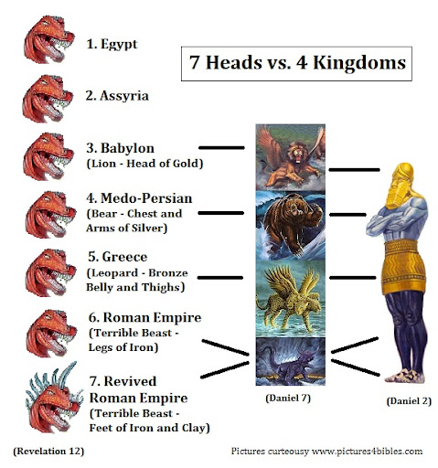
Satan himself is behind these seven heads, with the very last one taking the form of having 10 horns. Horns in the Bible are consistently a symbol of power and strength (cf. Ps. 18:2; 2 Sam. 22:3). As we continue on in Revelation, it is clear that these are 10 kings who bolster Antichrist into the position of being a one-world dictator (Rev. 17:12).
A diadem is a jeweled crown worn as a symbol of ruling authority. These seven heads, concluding with the 10-horned one, will have ruling authority over the Jews, and they will use it to Satanically oppress them. These seven heads are in effect Satan’s tools.

The issue in context is Satan’s passion to rule and to destroy Israel.

Satan has been allowed to have special influence over the world (cf. Lk. 4:6); he is the ruler of this world (cf. Jn. 12:31, 14:30; 16:11), and the god of this age (2 Cor. 4:4); but the special prize is Israel.

Israel belongs to God in a special sense, and it is from Israel that the Messiah comes, who ultimately destroys the Devil. Therefore, the devil has always sought to destroy Israel, thereby hoping to render God’s plan ineffective.

He has sought to do this in conjunction with the major world powers that have existed down through history ever since Israel has existed as a nation. Satan’s efforts in this regard became even more intense in relation to Christ’s first coming, and will be even more intense in relation to His Second Coming.

And he has used his demonic hordes to assist him in these efforts.

4 His tail drew a third of the stars of heaven and threw them to the earth. And the dragon stood before the woman who was ready to give birth, to devour her Child as soon as it was born.

The dragon (representing the devil) is still the subject. His tail drew a third of the stars of heaven resulting in them being thrown to earth.

Jesus spoke of “the devil and his angels” (Mt. 25:41). Angels are occasionally described in terms of “stars” (cf. Job 38:7; Rev. 9:1). In this case, these stars are identified with Satan and are described as being thrown down. We believe this is descriptive of their fall because of Satan’s influence, which resulted in them following him to their demise.

Slide # 9

Luke 10:18 (NKJV)
18 And He said to them, “I saw Satan fall like lightning from heaven.

“The stars must refer to angels who fell with Satan in history past. The similarity of this verse to Dan. 8:10, where the “host of heaven” is an apparent reference to angels, shows this. Already in Revelation, a star has been pictured as an angel (9:1). That factor, along with the reference to Satan’s angels in 12:8-9, adds credence to this explanation.” – Robert Thomas

Just think about how convincing Satan must have been to get one-third of the angels in heaven to follow him. Note these WERE (past tense) the “stars of heaven” but then they got expelled and thrown to the earth.

We don’t know how many angels there are, but this text would indicate that a total of 1/3 followed Satan to their eternal demise. They threw in with Satan and now totally support him in his evil intentions.

These are Satan’s demonic followers who assist him in his diabolical mission to try and destroy God’s plan for Israel and her Messiah.

In the middle of verse 4, the text fast-forwards to the time of Christ’s birth. Here it is plain that Satan’s intention was to destroy the Christ-child as soon as He was born. Verse 5 makes it very clear that this Child was indeed the Christ.

It was prophesied that Satan would try to cut off the woman and her seed long before Israel was a nation (Gen. 3:15). He tried to cut off Christ’s lineage by the death of Abel (Gen. 4); pollute the godly line of Seth (Gen. 6); produce a pseudo-son of promise in Ishmael (Gen. 16); destroy Israel in Egypt (Ex. 1) and in Persia (Est. 3:8-15); and kill Christ in Bethlehem (Mt. 2:16). – David Levy

At one critical point, the Davidic line was down to ONE single little boy, and had he been destroyed, it would have wiped out the possibility of God fulfilling the Davidic Covenant made with David. It would have undercut God’s plan of the Messiah being a descendant of David.

Slide # 10

2 Kings 11:1–3 (NKJV)
1 When Athaliah the mother of Ahaziah saw that her son was dead, she arose and destroyed all the royal heirs.
2 But Jehosheba, the daughter of King Joram, sister of Ahaziah, took Joash the son of Ahaziah, and stole him away from among the king’s sons who were being murdered; and they hid him and his nurse in the bedroom, from Athaliah, so that he was not killed.
3 So he was hidden with her in the house of the Lord for six years, while Athaliah reigned over the land.

Wow! That was close! Satan was one person away from victory! But alas God is sovereign and He prevented Satan from ultimately having his way. God allows him to only go so far!
But in view here in Revelation 12:4 is specifically the birth of Christ and Satan’s attempt to wipe Him out by way wicked Herod.

Slide # 11

Matthew 2:1–3 (NKJV)
1 Now after Jesus was born in Bethlehem of Judea in the days of Herod the king, behold, wise men from the East came to Jerusalem,
2 saying, “Where is He who has been born King of the Jews? …
3 When Herod the king heard this, he was troubled, and all Jerusalem with him.
Matthew 2:16 (NKJV)
16 Then Herod, when he saw that he was deceived by the wise men, was exceedingly angry; and he sent forth and put to death all the male children who were in Bethlehem and in all its districts…

But note that although this was carried out by Herod, it was really Satan the dragon who was behind this effort to devour the Christ-child. In reality, life is all about spiritual warfare. As Paul says, our real battle is not with flesh and blood but with the forces of darkness behind the scenes who use people as their pawns (cf. Eph. 6:12).

5 She bore a male Child who was to rule all nations with a rod of iron. And her Child was caught up to God and His throne.

This verse touches on the birth, ascension, and ultimate reign of Christ.

Satan did his best to try and destroy the Christ-child as soon as He was born, but alas, he was not successful. Indeed, the woman (Israel) bore a male Child.

And we don’t have to wonder what Child this is talking about because it goes on to say, “who was to rule all nations with a rod of iron.” Undeniably, this is talking about the Messiah, who is Jesus.
The destiny of this Child is to rule the nations and that with a rod of iron. This will be in fulfillment of the Messianic prophecy that comes straight out of Psalm 2 (cf. Rev. 2:27; 11:15).

Slide # 12

Psalm 2:8–9 (NKJV)
8 Ask of Me, and I will give You The nations for Your inheritance, And the ends of the earth for Your possession.
9 You shall break them with a rod of iron; You shall dash them to pieces like a potter’s vessel.’ ”

The smashing of the nations into submission is what we have presented in the judgments of Revelation. This is going to ultimately be fulfilled by Jesus Christ the Messiah!

Jesus was born to rule the world! This is His ultimate destiny.

Slide # 13

Luke 1:31–33 (NKJV)
31 And behold, you will conceive in your womb and bring forth a Son, and shall call His name Jesus.
32 He will be great, and will be called the Son of the Highest; and the Lord God will give Him the throne of His father David.
33 And He will reign over the house of Jacob forever, and of His kingdom there will be no end.”

Verse 5 is not stated in chronological order. Jesus was born, and yes, He is destined to rule the nations, but that is not the situation just yet. After His death and resurrection, He ascended to heaven where He is now seated at the right hand of God the Father (cf. Lk. 24:50-52; Acts 1:9-11).

And what is He doing there?

Slide # 14

Hebrews 10:12–13 (NKJV)
12 But this Man, after He had offered one sacrifice for sins forever, sat down at the right hand of God,
13 from that time waiting till His enemies are made His footstool.

The Ascension is proof of Christ’s victory over sin, death, and Satan (Eph. 1:20-23).

Satan failed to destroy Christ at His birth, He couldn’t hold Him in the grave, and Christ has now ascended back to heaven – out of the reach of a direct attack from Satan. So what does Satan do?

The text now fast-forwards to the future when the woman (Israel) will flee to her safe place from Antichrist in the wilderness. Since the devil couldn’t wipe out Christ, He will try and do the next best thing (in his mind), and that is to wipe out Israel. If Satan can destroy Israel, then God will be defeated, being unable to complete His plan as detailed in the prophetic Scriptures involving the ultimate restoration of Israel.

6 Then the woman fled into the wilderness, where she has a place prepared by God, that they should feed her there one thousand two hundred and sixty days.

Note there is a large span of time between the attempt by Satan to personally destroy the Christ as seen in verses 4 and 5 and this attack on the woman (Israel) here in verse 6. This is a time gap (at this point) of about 2000 years.

Note also that this outline completely bypasses the Church Age. It is completely passed over. Why? Because this has everything to do with Israel and nothing to do with the Church!

Slide # 15
Rapture

Christ’s birth/ascension [Church Age] Tribulation Period
Rev. 12:4-5 Rev. 12:6
(Israel) (Israel)

While the Church Age is going on, the major thing God is doing in the world is building His Church. Therefore, this is where Satan’s attention is as well. He is doing everything possible to try and destroy the Church.

But once the Church is gone (in the Rapture) then God will once again focus on the completion of His program for Israel. And right in step, Satan will then go after Israel with a passion. The Church got away, but Israel will still be here, and so that is where he now goes in all-out attack and destroy mode.
Also, note that the life, ministry, death, and resurrection of Christ in this text is passed over in silence. Why this great omission?

The point of the passage is to show that Satan’s goal is ultimately to defeat God by destroying God’s Christ. This has always been his goal. Satan does everything in his power to try to thwart the plan of God through His Christ.
His final effort will be to try and annihilate Israel (the woman) by bringing all the forces of the world against her. Once Antichrist goes into the temple and declares himself to be GOD ALMIGHTY it will be open season on the Jews! Jesus spoke to this very issue in Matthew 24.

Slide # 16

Matthew 24:15–16 (NKJV)
15 “Therefore when you see the ‘abomination of desolation,’ spoken of by Daniel the prophet, standing in the holy place” (whoever reads, let him understand),
16 “then let those who are in Judea flee to the mountains.

This abomination of desolation is the greatest act of idolatrous sacrilege in the history of the world. This is what Daniel 9:27 prophesied about.

Slide # 17

Daniel 9:27 (NKJV)
27 Then he [Antichrist] shall confirm a covenant with many for one week [7-year period]; But in the middle of the week [3 and ½ years in], he shall bring an end to sacrifice and offering. And on the wing of abominations shall be one who makes desolate, Even until the consummation, which is determined, Is poured out on the desolate.”

Slide # 18

2 Thessalonians 2:4 (NKJV)
4 who opposes and exalts himself above all that is called God or that is worshiped, so that he sits as God in the temple of God, showing himself that he is God.

This is the abomination of desolation prophesied about by Daniel and referenced by Christ in Matthew 24. And Christ instructs the Jews in Judea (the Jerusalem area) to at that point run for their lives and flee to the mountains.
This area is referred to as the wilderness here in Rev. 12:6. It is here that God will provide a hiding place for Israel from the Antichrist and provide for them for 1,260 days which corresponds to the last 3 and ½ years of the Tribulation Period.

Slide # 19
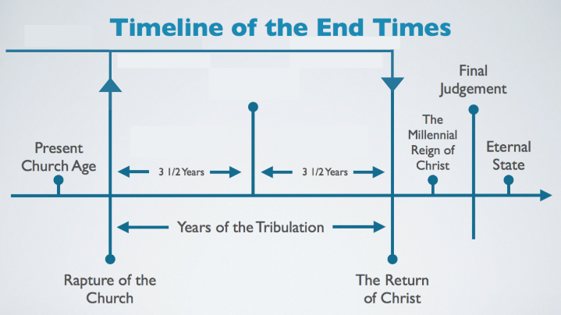

The wilderness is a harsh place of desolation. When Israel wandered in the wilderness, they were totally dependent upon God to provide for them – which He did supernaturally (cf. Ex. 16). This will again be that type of situation.

Slide # 20
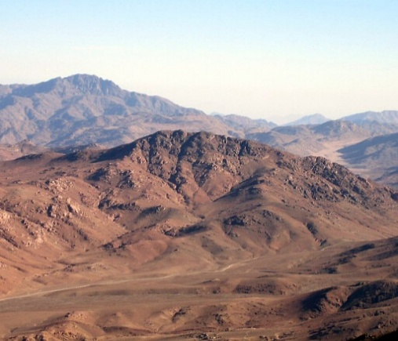

Slide # 21

Revelation 12:14 (NKJV)
14 But the woman was given two wings of a great eagle, that she might fly into the wilderness to her place, where she is nourished for a time and times and half a time, from the presence of the serpent.
In both verses (v. 6 and then v. 14) the woman (Israel) is said to be fed/nourished for a period of 3 and ½ years denoted as 1260 days in verse 6 and by “a time and times and half a time” in verse 14.

There are clues in the OT that this special “place prepared by God” is the area called Bozrah or in modern times called Petra (cf. Isa. 41:17-20; 63:1-6; Jer. 49:13-14; Micah 2:12; Dan. 11:41). This place is located in the Biblical land of Edom (modern Jordan). There is a deserted rock-hewn city there called Petra. It is about 125 miles south of Jerusalem. A major clue that this will be the special place of protection and provision is found in Isaiah 63.

Slide # 22
Isaiah 63:1 (NKJV)
1 Who is this who comes from Edom, With dyed garments from Bozrah, This One who is glorious in His apparel, Traveling in the greatness of His strength?— “I who speak in righteousness, mighty to save.”

The city of Bozrah will be the sheepfold [Bozrah means sheepfold in Hebrew] that will protect the Jewish remnant. … Petra is the current name of an abandoned city in southern Jordan located at Mount Seir within a basin. Petra, known in the Bible as Bozrah, will likely be the location where the Jewish remnant will flee during the middle of the tribulation. The only way in and out of the city is through a narrow passageway that extends for about a mile and is usually traveled by foot or on horseback.
--Fast Facts on Bible Prophecy, Thomas Ice and Timothy
Demy, pg., 40, 149

Slide # 23 – Map of Bozrah
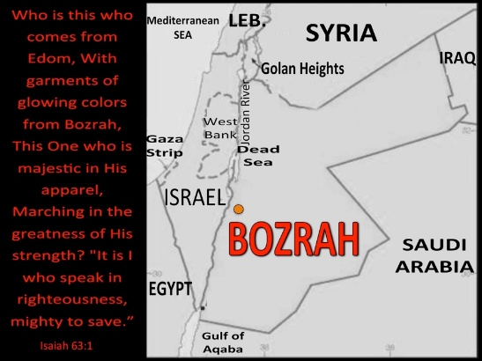

Slide # 24
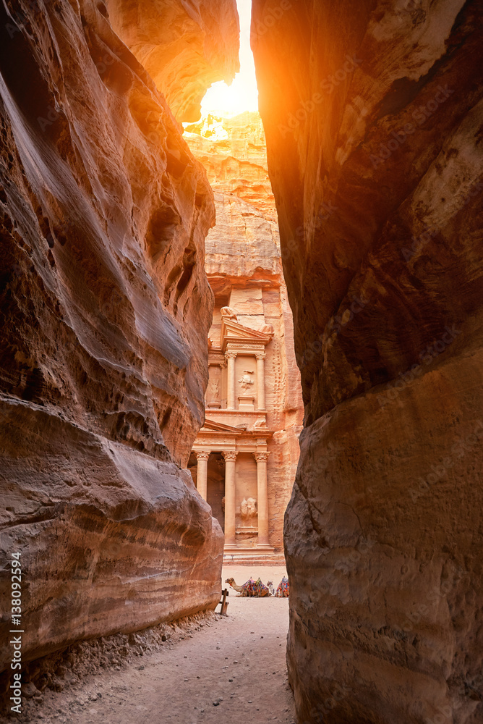

Slide # 25
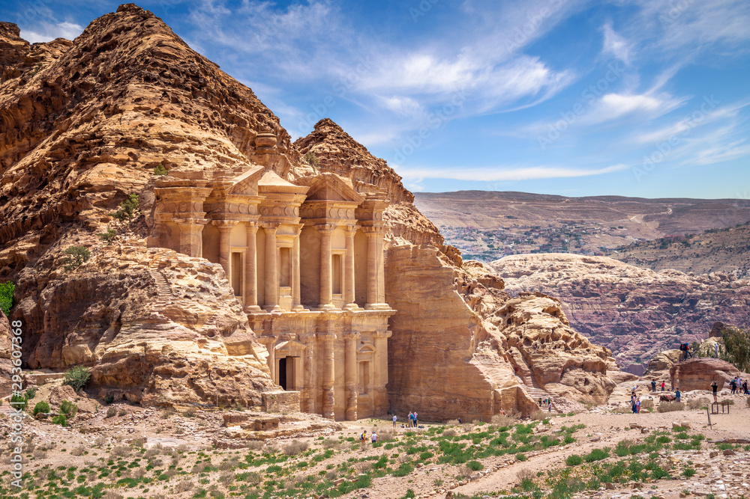

My LARGE file on Antisemitism…

What we have presented in Revelation 12:1-6 is an overview of Satanic hatred for Israel and her Messiah!

Why such hatred and fear of a people who never constituted more than a small minority among those who most hated and feared them? Why, nearly always and nearly everywhere, the Jews? …The universality, depth, and persistence of antisemitism is found in one word, or more correctly, one spiritual being. Satan. Anti-Semitism is the result of Satan’s desire to destroy God’s plan for the world. God’s plan is based in the nation of Israel and the Jewish people. … If Satan can destroy the Jewish people, he can destroy God’s plans for this earth. Thus, anti-Semitism of the Tribulation period is Satan’s final attempt to defeat God by destroying Israel and the Jewish people. – Mark Robinson (Jewish Awareness Ministries)

On Oct. 7, 2023, Hamas brutally attacked Israel and celebrated the murder of over 1200 Israelis in the most vicious of manners, and took hostage about 250 Israeli hostages hostage. They gleefully filmed it and made it known to the whole world. You would think that in the face of such inhumane brutality, the world would sympathize with Israel. Not so! Immediately in the days and months that followed there was a tremendous spike in Antisemitism throughout the whole world. In America, it is seen on both the left and the right!
My missionary friend, Bill Honsberger, met a man named Martin. He is a retired scientist and the head of the NYC chapter of atheists. And he is a Jew. Bill asked him: “As an atheist, how do you make sense out the incredible hatred towards your people? Nobody hates the ancient Assyrians, Hittites, Romans, Greeks, Egyptians, etc. But Jews are hated in cultures and countries where there literally are no Jews!” …Bill then says, “Like every Jewish person I have ever had this conversation with, Martin had no real answer.”

What to make of the persistent worldwide Antisemitism that is on the rise?
What to make of Israel’s preservation against all odds?
What to make of Israel back in the land?

Apart from the explanations found in Scripture, there is no rational or logical answer. This involves supernatural spiritual realities related to Satan and the sovereignty of God.

Israel continues to be God’s last days' SUPER SIGN! Last days prophecy swirls around Israel, and the stage is being set for the climactic finale. This is totally consistent with the prophetic Scriptures.

Johnny Cash sang a song titled: “Goin' by the Book”. In it, there is this refrain.

The prophets wrote about it.
And Jesus spoke about it.
And John got to take a look.
…It’s goin by the book!

Indeed it is!

Live Ready!

