SBC – Jan. 25, 2026
Psalm 94:1-23 (NKJV)
“Vengeance is Gods”

Prayer

This Psalm has no heading. Early Jewish tradition (LXX) credited David with writing it, but again that is early Jewish tradition.

Slide # 1

Psalm 94

“Vengeance is God’s”

vv. 1-3 - A Call for God to Judge
vv. 4-7 – Description of the Wicked
vv. 8-11 – Rebuking Senseless Fools
vv. 12-15 – Consolation for the Righteous
vv. 16-19 – Comfort for God’s People
vv. 20-23 – Advocacy from God

Psalm 94 (NKJV)
1 O Lord God, to whom vengeance belongs— O God, to whom vengeance belongs, shine forth!

There is something about the flesh that desires to get even. But the Bible is clear vengeance belongs to God.

Slide # 2

Deuteronomy 32:35 (NKJV)
35 Vengeance is Mine, and recompense; Their foot shall slip in due time; For the day of their calamity is at hand, And the things to come hasten upon them.’

Some people stop right after “Vengeance is Mine” as if not realizing that God is the speaker here and in doing so put themselves in the place of God. It is never good to play God!

LORD God is literally “YHWH EL”. YHWH is God’s covenant name emphasizing Him as never changing – ever faithful, and EL denotes God as the supreme Being over all.

Note the double emphasis in verse one on vengeance belongs to God. Repetition emphasizes intensity! Vengeance is the idea of “righteous vindication”. It is God’s place to pay back evil-doers for what they have done. It is not our place to get even. However, there is a place to pray for God to do it, which is what the writer does here.

Slide # 3

2 Thessalonians 1:6 (NKJV)
6 since it is a righteous thing with God to repay with tribulation those who trouble you,

As we work our way through the Psalm, we find that the wicked in this context were governmental leaders who were oppressing God’s people.

Interestingly enough, Paul in Romans 12:19-13:2 quotes the Scripture that vengeance belongs to God and then immediately says, to be subject to the governing authorities because they are appointed by God. This is true, but here in Psalm 94, we find the emphasis that they, too, are accountable to God and will be judged for mistreating God’s people.

Slide # 4
Psalm 11:3–4 (NKJV)
3 If the foundations are destroyed, What can the righteous do?
4 The Lord is in His holy temple, The Lord’s throne is in heaven; His eyes behold, His eyelids test the sons of men.

The answer is we can pray! We can pray for God to intervene and for God to deal with them. And so the writer prays, “O God, to whom vengeance belongs, shine forth!” The idea is for God show up and make an appearance in glorious fashion in the judgment of these wicked people who are abusing His people.

It is appropriate to ask God to dispense vengeance and trust His superior knowledge, wisdom, and timing in doing so. – David Guzik

2 Rise up, O Judge of the earth; Render punishment to the proud.

The proud need to be taken down, and God is just the One to do it, and so the writer appeals to God as the Judge of the earth to render appropriate punishment unto them. He is asking God to move into the action of judgment!
3 Lord, how long will the wicked, How long will the wicked triumph?

Even in heaven, the martyrs in the Tribulation Period are praying, “How long?”

Slide # 5

Revelation 6:10 (NKJV)
10 And they cried with a loud voice, saying, “How long, O Lord, holy and true, until You judge and avenge our blood on those who dwell on the earth?”

It is hard to wait when you are being oppressed! It sometimes seems like they have a free reign and will get away with it forever.

But in truth they are like a dog on a chain. The chain may be fairly lengthy but running full speed they will soon come to the end of their chain which will jerk them back to reality abruptly.

4 They utter speech, and speak insolent things; All the workers of iniquity boast in themselves.

These people are full of themselves. Just listen to them! “Insolent things” are arrogant, hard, rebellious things. They brag on themselves and how great they think they are. When you are this high up, there is only one way to go – DOWN! In truth, they are “workers of iniquity,” meaning that which is crooked or morally twisted.

5 They break in pieces Your people, O Lord, And afflict Your heritage.

Having no regard for God displays itself in the abuse of God’s people. “Your people here refers to the Jews as is seen in “Your heritage.” "God's heritage" (or inheritance) in the OT is a way of referring to His people—Israel. As such, they are His prized, chosen possession set apart for His purposes, and are protected under His care.

These wicked people have no regard for God’s covenant promises to Abraham, Isaac, and Jacob and their descendants. In their wicked arrogance, they dare to try to destroy and afflict the prized possession of God’s people.

In contrast, the mark of the righteous is a LOVE for God’s people.
6 They slay the widow and the stranger, And murder the fatherless.

Not only do they have no regard for God’s special chosen people, but they also have no regard for the most vulnerable of the land, and in fact take advantage of them to the point of killing them.

This shows no fear of God.

Slide # 6

Exodus 22:22–24 (NKJV)
22 “You shall not afflict any widow or fatherless child.
23 If you afflict them in any way, and they cry at all to Me, I will surely hear their cry;
24 and My wrath will become hot, and I will kill you with the sword; your wives shall be widows, and your children fatherless.

God does not appreciate this at all. It makes Him red hot angry! This is extreme wickedness!

7 Yet they say, “The Lord does not see, Nor does the God of Jacob understand.”

Talk about a LOW view of God! They think God does not see and that He does not know. They know about the God of Jacob, but it is all just theory to them. They don’t think God really knows what they are doing, and hence they think they can get away with it.

In response to the this the writer issues a stern rebuke!

8 Understand, you senseless among the people; And you fools, when will you be wise?

This is a rhetorical statement. They are senseless but should understand the FOLLY of what they are doing. He flat out calls them “fools” who have a total lack of wisdom.

[He] calls them “fools,” the word that combines the idea of “brutish” and “simpleton.” …These people were behaving like animals and not like humans made in the image of God. – Warren Wiersbe

9 He who planted the ear, shall He not hear? He who formed the eye, shall He not see?

This verse assumes the reality of a Creator, which by the way is an intelligent assumption to be made. The Bible starts there. The evidence is so overwhelming as to be undeniable.

Slide # 7
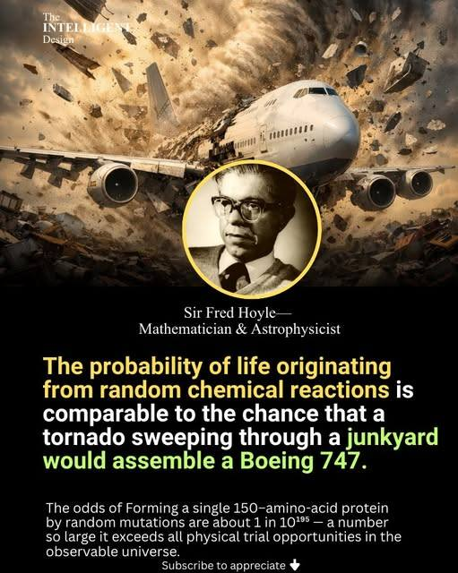

If the reality of a Creator is assumed, which it should be, then it makes no sense to think that He who planted the ear would not hear. It makes to sense that He who formed the eye cannot see. That is sheer folly!

Slide # 8
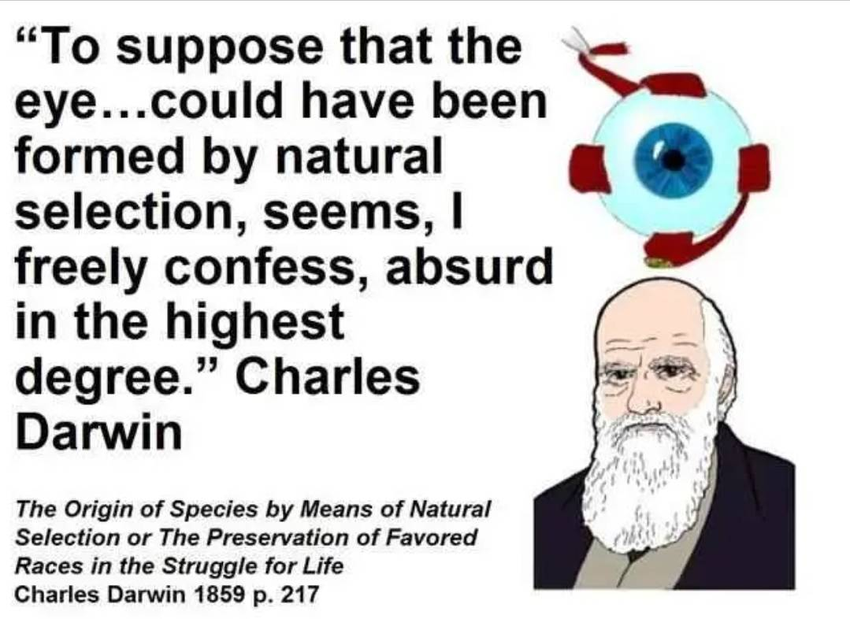
The intelligence represented in life demands a SUPER INTELLIGENCE behind it all. Intelligence demands intelligence, and the irreducible complexity of life, starting with the smallest cell, the function of the human brain, and DNA combined with the 1st and 2nd law of thermodynamics demands a Creator of HYPER-SUPER-INTELLIGENCE that is so far beyond us that we can’t even begin to comprehend it.

“The logic is inescapable, once the premise is accepted that God is our Maker. What the psalm does not contemplate is the crowning absurdity, reserved for modern man, of rejecting even this.”
- Derek Kidner

10 He who instructs the nations, shall He not correct, He who teaches man knowledge?

The sense here is that if God disciplines the nations, will He not know how to correct individuals? Again, this is a rhetorical question. Of course, God knows what He is doing and has a sovereign purpose in all that He brings into our lives. What happens to us is tailor-made to correct us, to teach us.

Yes, He instructs (or chastens) the nations (cf. Egypt, Israel) so that certainly the lesser (individual chastening) is an obvious deduction.

11 The Lord knows the thoughts of man, That they are futile.

YHWH knows the thoughts of man, and He knows that independent of Him they are futile/meaningless.

The word translated “thoughts” means “inventions, schemes, plans.
– Warren Wiersbe

In 1 Cor. 3:20, Paul quotes Psalm 94:11 in showing that the wisdom of the world is foolishness before God. They don’t have a clue as to the real ultimate meaning of life or the plan of God. They are full of empty theory and philosophy which Paul warns is “empty deceit” in Colossians 2:8.

Slide # 9

1 Corinthians 3:20 (NKJV)
20 and again, “The Lord knows the thoughts of the wise, that they are futile.”

The “self-wise” are not wise. Their thoughts are futile, empty, vain.

The wicked have big plans as they plot their nefarious ways, but in the end, they all come to nothing. When one leaves God out of their thoughts, all the thinking in the world is futile – vanity, of no ultimate value (cf. Rom. 1:21).

In contrast…

12 Blessed is the man whom You instruct, O Lord, And teach out of Your law,
13 That You may give him rest from the days of adversity, Until the pit is dug for the wicked.

There is a context here related to correction as seen in verse 10. The word translated “instructs” in verse 10 is the same word translated “instruct” here in verse 12. In other translations, it is translated as “chastens” or “disciplines”.

The blessed person here is the one who learns from discipline. The word (law) corrects him, and he is blessed in this (cf. 2 Tim. 3:16). The law brings about correction in his life. The Bible is clear in both the OT and the NT that God disciplines those that He loves.

Slide # 10
Proverbs 3:11–12 (NKJV)
11 My son, do not despise the chastening of the Lord, Nor detest His correction;
12 For whom the Lord loves He corrects, Just as a father the son in whom he delights.

Hebrews 12:6 (NKJV)
6 For whom the Lord loves He chastens, And scourges every son whom He receives.”

In this process, the end result is “rest” for those trained by it. When the believer realizes that God is using the affliction of the wicked for a profitable disciplinary purpose, it gives him relief in that he can rest in that reality. In this process, he realizes this is how God works UNTIL “the pit is dug for the wicked.”

Judgment day is coming for the wicked! God allows it to go on for only so long, but in the meantime, He is using it. We can REST in this reality! God is sovereign over all that is happening, and He is using it – but at the same time, JUDGMENT DAY is coming for the wicked.
Footnote: This intersects with the discussion about discipline. It is not always just because of some specific sin. Some discipline is educational in nature, and God’s people are BLESSED in the process.

Faith enables the afflicted psalmist to see his troubles as part of God’s education for him. – William MacDonald

And in truth (as seen in Job), even the most righteous are not beyond disciplinary afflictions God allows in our lives. Who are we to quibble with them?

Slide # 11
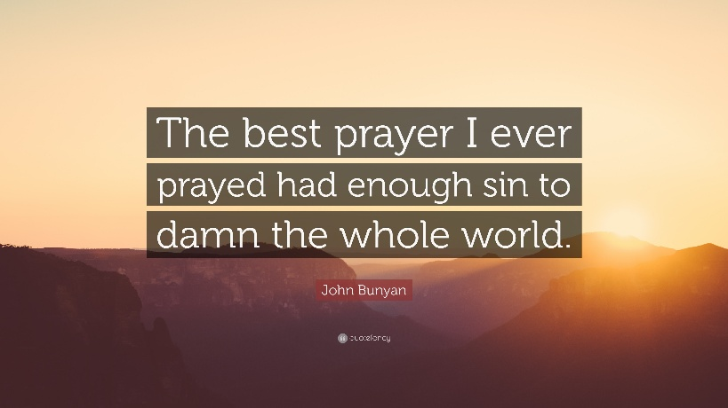

14 For the Lord will not cast off His people, Nor will He forsake His inheritance.

In the midst of disciplinary hardships, it is good to remember that God is faithful. In context, the writer is thinking in particular about what his people, Israel, are going through.

YHWH will not cast off His people, nor will He forsake His inheritance. God is never going to be DONE with Israel. What a rebuke this is to those holding to replacement theology that says God has cast off Israel and that He is done with them, and has now replaced them with the church.

This total besmirches the character of God. It makes God out to be a liar in terms of His covenant promises to Abraham, Isaac, and Jacob. It really is a blasphemous position. Few seem to realize just how serious an error this really is, but God knows.

The text plainly says that YHWH will NOT cast off His people.
Some teach that God did cast off Israel, but this and many other passages contradict that idea. With repetition and emphasis, God insists: Nor will He forsake His inheritance. – David Guzik

This important truth was given to Israel in the context of severe discipline which serves to emphasize that no matter what the external circumstances look like, God has not abandoned His people (cf. Rom. 11:1).

Slide # 12

Romans 11:1–2 (NKJV)
1 I say then, has God cast away His people? Certainly not! For I also am an Israelite, of the seed of Abraham, of the tribe of Benjamin.
2 God has not cast away His people whom He foreknew. Or do you not know what the Scripture says of Elijah, how he pleads with God against Israel, saying,

15 But judgment will return to righteousness, And all the upright in heart will follow it.

In due time, righteous judgment will prevail, and all the upright in heart will follow in that way. Ultimate fulfilment awaits the coming of Jesus and the setting up of His righteous rule!

16 Who will rise up for me against the evildoers? Who will stand up for me against the workers of iniquity?

In the throes of this difficult time, it seemed like no one was there to bring relief from the evildoers for him. And in that context, he raised the question: “Who will stand up for me against the workers of iniquity?”

But he no sooner voices the question and then he answers it…

17 Unless the Lord had been my help, My soul would soon have settled in silence.

YHWH has preserved him! Even though it looked very bleak, God brought him through. He gives God all credit for preserving his life, admitting that apart from God’s help, he would have died.

And he came to this conviction…

18 If I say, “My foot slips,” Your mercy, O Lord, will hold me up.

I think this is what he has learned. This is where he has come to rest.

If his foot slips and he is on the way down, he now recognizes that YHWH’s mercy will hold him up. What a wonderful truth.

He uses two GREAT WORDS in combination here that underscore the faithfulness of God.

Slide # 13

Mercy (Hesed)

LORD (YHWH)

Hesed is one of the richest Hebrew words in the Bible. It describes God's faithful, deep, covenantal, and active love. It is translated as steadfast love or loyal love. It denotes a loyal, enduring, and compassionate bond, often translated as "loving-kindness." It reflects God's unchanging nature towards His people, even when they falter.

YHWH is the four-letter Hebrew name for God, meaning "He is," or "I am who I am," reflecting His self-existence, unchanging nature, and eternality (cf. Ex. 3:14). Since God is unchanging His character never changes and He is perfectly faithful always. The Jews considered YHWH to be God’s most sacred name.

Due to its holiness, it's not spoken, lest it be spoken in vain. Instead the Jews inserted the name Adonai ("Lord") or HaShem ("The Name"), when they read the Scriptures. The name YHWH is often associated with God’s covenant relationship with Israel and therefore is often referred to as God’s Covenant Name.

God, as the absolutely faithful, unchanging, eternal God, in a covenant relationship with His people, holds him up when he is slipping. It is the reality of God that keeps him from falling, no matter how perilous the circumstance.

As the psalmist reflects on this he says…

19 In the multitude of my anxieties within me, Your comforts delight my soul.

What a beautiful verse. This is a KEY verse in showing us how to cope when we are filled with frightful anxieties. In dealing with a multitude of anxieties that were overwhelming within him, he says, “Your comforts delight my soul.” In 2 Cor. 1:3 Paul refers to God as the “God of all comfort.”

What are these comforts? They are the truths about God that he has previously brought out in this Psalm and that which he is about to bring out.

Slide # 14

- Vengeance belongs to God
- God is the Judge of the earth
- Blessed is the man God instructs (teaches through discipline)
- Relief is found in resting in God’s sovereign care
- The LORD will not cast off His people
- Justice will ultimately be restored
- The LORD helps/preserves…
- In times of slippage, the LORD’s HESED upholds him
- God comforts his soul
- The LORD is his defense
- God is the ROCK of his refuge
- The LORD will cut off the wicked in their wickedness

You can write under all these realities “the comforts of the LORD.” These truths serve as a balm to the soul when a multitude of anxieties overwhelm.

20 Shall the throne of iniquity, which devises evil by law, Have fellowship with You?

This is yet another rhetorical question that demands the answer: Of course not! These rulers or judges sitting on their throne (position of power) are really wicked, putting into law that which is evil. They might “legalize” evil, but apart from repentance, they will never have fellowship with God (1 Jn. 1:5-6). They might look like everything is going their way, but they don’t have God, and in this, they really have nothing – nothing that really matters or lasts.

21 They gather together against the life of the righteous, And condemn innocent blood.

This is about as low as it gets. They legalize murder and plot together against the life of the righteous – they condemn innocent blood. This is the kind of evil in play that he has been so anxious about.

22 But the Lord has been my defense, And my God the rock of my refuge.

Here is the bottom line. YHWH has been his defense. God has protected him. God is his rock – his place of refuge. And he notes the end of the story is that they are coming down.

23 He has brought on them their own iniquity, And shall cut them off in their own wickedness; The Lord our God shall cut them off.

The fate of the wicked is terrifying, but they do it to themselves. God brings down on them their own iniquity. God’s vengeance matches their wickedness.

The repetition of “cut them off” matches the double emphasis of vengeance is God's as seen in verse 1. Thus, the Psalm concludes with the same emphasis that it began with. As the old preacher said, “Pay day some day!” Indeed!

In the end, God is going to set things right. Vengeance belongs to God!

When I am tempted to be vengeful regarding wrongdoing, I think of a few things.

- Jesus died for these people too, so I pray for them.
- As J. Vernon McGee said, “I have learned that God can handle these situations a whole lot better than I can do.” Leave it with God.
- God is sovereign and is using this in my life – ultimately to a good end. It has a purpose (Rom. 8:28).
- God can be trusted in this situation. He is faithful!
- In the end, God is going to right everything. Vengeance/vindication belongs to the LORD.

“In catacombs, in dungeons, in places of the uttermost desolation – when it has seemed to sense that the way of God was blocked, that His rule was overcome, that all evil things had gained the victory – these songs have arisen, proclaiming Him King, mocking all the vain and foolish thoughts of man, and declaring His ultimate victory.”
– Unknown Commentator

Praise the LORD, He ever remains our defense, the rock of our refuge and vengeance belongs to Him!

In Genesis 18:25 Abraham asked, “Shall not the Judge of all the earth do right?”

YES, He will! We can rest in this reality!

