SBC – Jan. 18, 2026
Psalm 93:1- (NKJV)
“The Greatness of God”

Psalm 93 and 95-100 emphasize the sovereign Kingship of God over the world. “YHWH Reigns” is the watchword of these Psalms.

Psalm 93 is known as one of the “Enthronement Psalms” along with Psalm 47; 95-99).

Though Psalm 93 has no official heading, the Jews, as seen in the Septuagint (an early Greek translation of the Hebrew Bible), attributed it to David. This tradition also said that the Levites would recite it on the sixth day of the week (Friday) in commemoration of God’s completed work of creation, where He commenced reigning over all.

In the Bible, there is a threefold emphasis regarding God’s KINGSHIP rule. Context determines which sense is being talked about.

- God’s Universal Kingdom Rule.

This aspect of God’s Kingdom rule emphasizes that He sovereignly rules from His throne over the whole of creation. This is true all the time and never changes.

Slide # 1

Psalm 103:19 (NKJV)
19 The Lord has established His throne in heaven, And His kingdom rules over all.

Daniel 4:3 (NKJV)
3 How great are His signs, And how mighty His wonders! His kingdom is an everlasting kingdom, And His dominion is from generation to generation.

- God’s Kingship Rule Over Israel in the O.T.

Slide # 2

1 Samuel 8:7 (NKJV)
7 And the Lord said to Samuel, “Heed the voice of the people in all that they say to you; for they have not rejected you, but they have rejected Me, that I should not reign over them.
1 Samuel 12:12 (NKJV)
12 And when you saw that Nahash king of the Ammonites came against you, you said to me, ‘No, but a king shall reign over us,’ when the Lord your God was your king.

- Messianic Kingdom Rule

Slide # 3

Daniel 2:44 (NKJV)
44 And in the days of these kings the God of heaven will set up a kingdom which shall never be destroyed; and the kingdom shall not be left to other people; it shall break in pieces and consume all these kingdoms, and it shall stand forever.

Luke 1:32–33 (NKJV)
32 He will be great, and will be called the Son of the Highest; and the Lord God will give Him the throne of His father David.
33 And He will reign over the house of Jacob forever, and of His kingdom there will be no end.”

What is in view in Psalm 93 is the universal kingdom rule of God! In this sense God rules over all – all the time. This never changes. However, in terms of the Messianic kingdom rule – that is yet future.

It is the Messianic kingdom rule (yet future) that is view in Christ’s ministry as seen in the gospels.

It is this Messianic kingdom that Christ taught us to pray that it would come, but it is yet future (cf. Mt. 6:10).

At present Christ is not sitting on David’s throne. He is not yet ruling in that sense. At present Christ is Lord of the Church, but He is not yet reigning as King.

This is so important to understand. There is so much errant teaching on the kingdom that many think we are already in the kingdom and should be doing kingdom miracles and so forth.

Rightly dividing the Word in this matter of the kingdom is very important.

Slide # 4
Psalm 93

“The Greatness of God”

vv. 1-4 The LORD Reigns
- Over the world (vv. 1-2)
- Over the sea (vv. 3-4)
v. 5 The LORD’s Authoritative Revelation

Psalm 93 (NKJV)
1 The Lord reigns, He is clothed with majesty; The Lord is clothed, He has girded Himself with strength. Surely the world is established, so that it cannot be moved.

The LORD reigns – more literally, YHWH reigns. That sets the tone for the entire Psalm. God rules over all! He is totally sovereign!

The word majesty is a complex word. It emphasizes God’s glory in terms of His greatness, authority, and power. This is what characterizes God. He is robbed in majesty – glorious greatness!

He envelopes Himself with strength! He is a strong God referred to as the ALL MIGHTY! This is seen in the fact that He established the world so that it cannot be moved.

The world would fly apart from God’s secure keeping of it. As it is – it is established. As someone has well said, “It cannot be moved, unless He moves it.”

And in judgment one day, He will move it, and it will be indescribably horrific.

Slide # 5

Isaiah 2:19 (NKJV)
19 They shall go into the holes of the rocks, And into the caves of the earth, From the terror of the Lord And the glory of His majesty, When He arises to shake the earth mightily.

Isaiah 24:19 (NKJV)
19 The earth is violently broken, The earth is split open, The earth is shaken exceedingly.
This is sinners in the hands of an angry God! God is what keeps the earth stable and secure, and it cannot be moved until He moves it. Colossians 1:17 says that in Christ “all things hold together.”

Thus, the world and its natural order are ordained by God. All the laws of nature are really God’s laws. They are not going anywhere until God supernaturally bypasses them in judgment!

2 Your throne is established from of old; You are from everlasting.

God is from everlasting, meaning He is eternal. He has no beginning and no ending. He just is. He is the eternal “I AM”.

And His throne is established from of old. This throne has been around forever – from of old. This is not a new reality, but a long-established one. This reality has been in place ever since creation itself. Earthly thrones come and go. They are all temporary, but in contrast, God’s throne endures.

God is on His established throne! He is not going anywhere! He reigns! Years ago, someone wrote a book titled “Still sovereign!” Amen! God’s eternal authority is an extension of Who He is as the eternal God!

Slide # 6
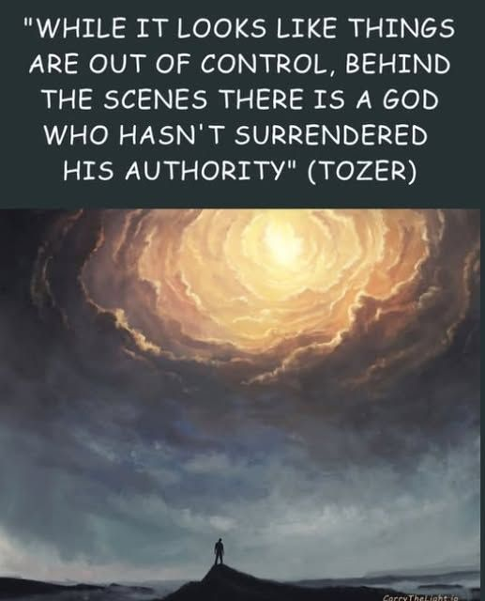

No matter what is happening, it is good to remind ourselves: God is still on the throne! He ever remains the supreme monarch – the ruler over all!

3 The floods have lifted up, O Lord, The floods have lifted up their voice; The floods lift up their waves.

Note the triple emphasis on “floods.” Floods are powerful! Floods are noisy! Floods are destructive!

Slide # 7
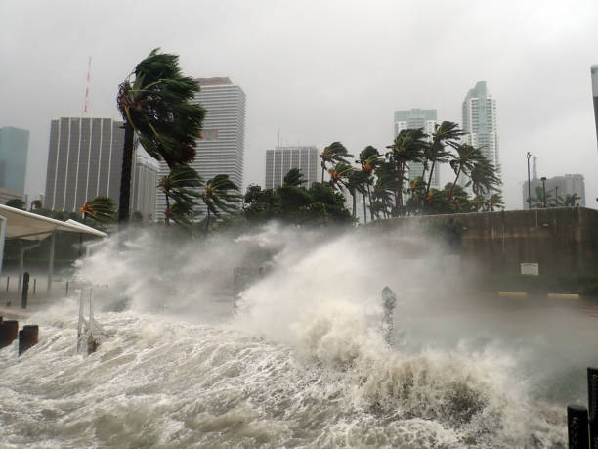

To the Jew, raging floods were a symbol of uncontrolled chaos! Some believe this represents turbulent rebellion against God.

It seems clear that he is thinking of the Gentile nations which have oppressed His people through the ages and which will conspire against Him when He comes to reign – William MacDonald

Various commentators think that Psalm 93 was written against the backdrop of Canaanite religion.

In Canaanite religion, Baal was the storm god. He battled other gods, such as Yam the sea god, and won out to be the top god.

But this top god position was precarious. He could be defeated at any time by another supposed god. The Canaanite gods were fragile, easily established, and could quickly be deposed. You never knew for sure if your god was going to be the top god or not. Anything could happen, and things could change just like that.

It is against this background that the words of Psalm 93 obtain their force. The living God is the King from the beginning of time; He is no recent claimant to power (vv. 1-2). As King, He exercises authority over all. He does not have to fear a resurgent sea (vv. 3, 4). Not only is the Lord omnipotent, but He is truthful and holy, unlike any of the gods of the Canaanite imagination. – Nelson Study Bible Note

The floods of this world have lifted up – they rise up in rebellion (as it were). They have lifted up their voice – they clamor and make all kinds of blasphemous claims about how great they are and what they will do; they lift up their waves – show of force. But…

4 The Lord on high is mightier Than the noise of many waters, Than the mighty waves of the sea.

The LORD reigns – the LORD on high is mightier. He is mightier than the noise of many waters. It doesn’t matter how many are the forces of rebellion or how much of a tumult they make – God is mightier.

He is mightier than the mighty waves of the sea!

None are higher or stronger than God! The greatest of forces on earth cannot compare to God. He reigns over all that might challenge or oppose Him.

One of my favorite Psalms is Psalm 29, which I have titled, “The Storm Psalm”. In the Psalm it says, “The God of glory thunders.” (v. 3) His voice (thunder) splinters the cedars Lebanon (v. 5). His voice makes the deer give birth and strips the forest bare (v. 9). And everyone in His temple says “Glory!” (v. 9) God is sovereign over the storm and it is awesome.

And the greatest storm the world has every known was the flood that covered the entire world in the days of Noah. And in reference to this David wrote:

Slide # 8

Psalm 29:10 (NKJV)
10 The Lord sat enthroned at the Flood, And the Lord sits as King forever.

And what does this say about Jesus? The LORD is mightier than the noise of many waters, than the mighty waves of the sea? What does this say about Jesus?

Slide # 9

Matthew 8:26–27 (NKJV)
26 But He said to them, “Why are you fearful, O you of little faith?” Then He arose and rebuked the winds and the sea, and there was a great calm.
27 So the men marveled, saying, “Who can this be, that even the winds and the sea obey Him?”

Who can this be?
Who is mightier than the noise of many waters?
Who is mightier than the mighty waves of the sea?

The LORD YHWH!
Who is Jesus?
The LORD YHWH!

No one else ever did a miracle like this! This is God-stuff. Only God has this kind of power!

5 Your testimonies are very sure; Holiness adorns Your house, O Lord, forever.

God’s “testimonies” is a poetic reference to His Word. How do we know about the reality of God establishing the world? How do we know about the established throne of God? How do we know about God’s power over the Red Sea? How do we know about Jesus calming the storm?

We know all these things based on the SURE Word of God!

God in history has so worked SIGN miracles in times past in various ways, but rarely were they normative.

Sign miracles in the Bible could be considered to be frequent only during three specific periods.

Slide # 10

Times when Miracles were Normative…

- During the time of the Exodus (Moses and Joshua)
- During the ministry of Elijah/Elisha.
- During the ministry of Jesus and the Apostles.

These sign-miracles served to authenticate God's messengers and His Word, and thus functioned as divine confirmation of New Revelation.

After the New Testament was complete, there is no more new revelation, hence no more confirming sign-miracles.

God’s pattern is to establish His truth through miraculous sign-miracles, but thereafter He intends that people believe the revelation that has been communicated – the “testimonies” of God.

Slide # 11

John 20:29 (NKJV)
29 Jesus said to him, “Thomas, because you have seen Me, you have believed. Blessed are those who have not seen and yet have believed.”

Hebrews 2:3–4 (NKJV)
3 how shall we escape if we neglect so great a salvation, which at the first began to be spoken by the Lord, and was confirmed to us by those who heard Him,
4 God also bearing witness both with signs and wonders, with various miracles, and gifts of the Holy Spirit, according to His own will?

God can work miraculously any time He wants to do so. However, sign-miracles are not operative today, because God’s book is complete. God can work miraculously any time He wants, but normative today is God working providentially in answer to prayer. God can work miraculously any time He wants, but the norm for today is to see the truth of Who God is in His greatness through His Word.

Note the truth of…

God’s reign..
His majesty…
His strength…
His establishing the world…
His established throne…
His eternal existence…
His mighty power over all the chaotic forces of nature…

How do we know all these realities? We know them because God had them communicated to us through His “testimonies” – His Word! The word “testimonies” is found more than 20 times in Psalm 119 in reference to the Word of God.

Note these truths are spoken specifically in reference to “YHWH” – the unchanging, faithful, covenant God of Israel. The name “YHWH” is found five times in the five verses of Psalm 93. This is what defines YHWH. We know about Him, the kind of God that He is in the special revelation He has given to us in the Scriptures.

God’s throne is established forever and so is His Word! It is very sure!

And so it will be seen that God’s Word is true after all, and all the promises he made concerning the defeat of His foes and the establishment of His righteous reign will be fulfilled.
– William MacDonald

The Psalm concludes with, “Holiness adorns Your house, O LORD, forever.”

God’s house in the OT was identified with His presence. Holiness defines God! It literally means “to be set apart.” There is none other like Him! God is totally unique – in a category all His own.

His holiness is connected to all He is and does, and could be said to adorn His very house. – David Guzik

God’s Holiness,
God’s Power,
God’s Sovereignty,

are incomparable!

The final clause, “O LORD, forever” emphasizes God’s great being and character are forever! He is unchanging and remains forever! God will never diminish or devalue over time! He ever remains the same. Thus, He reigns supreme as YHWH God!

Slide # 12

The Greatness of God…
He reigns as sovereign LORD.
He is majestic.
He is girded with strength.
He established the world
He is everlasting.
He is mighty over all.
His testimonies are very sure.
He is holy.
He is LORD forever.

Nothing is more powerful than the LORD; nothing is more steadfast than His reign; nothing is more sure than His revelation.
– John MacArthur

He’s the great great God of the Bible.
He’s the great great God all power.
He’s the great God Who can shake the world.
He’s the great God of the hour!

Indeed,

The LORD reigns..
His throne is established…
His testimonies are very sure!

And all God’s people said…

