SBC – Feb. 27, 2022
# 3
Zeph. 1:14-18 (NKJV)
“The Great Day of the LORD”

Slide # 1

Zephaniah

Theme: The Coming Day of the Lord

Outline:

1:1-2:3 Warning to Judah of God’s coming Judgment
2:4-3:8 God’s Judgment on specific nations
3:9-20 Future Restoration for Israel

The prophets in the OT called the people back to God – they called Israel to repentance. And they warned of coming judgment if the people did not repent. God certainly gave them great warnings before terrible judgment came.

Slide # 2
Jeremiah 7:25–26 (NKJV)
25 Since the day that your fathers came out of the land of Egypt until this day, I have even sent to you all My servants the prophets, daily rising up early and sending them.
26 Yet they did not obey Me or incline their ear, but stiffened their neck. They did worse than their fathers.

God’s pattern is to give great warnings before He brings great judgment. The world cannot say they have not been warned. The world cannot say we weren’t given lots of time and space. We right now live in what we call “the age of grace” but be very sure judgment day is on its way.

People keep thinking we are somehow going to make the world better. We are not. Only King Jesus is going to bring in the kingdom and make the world better. Until that time don’t expect anything. Yes, praise God for pockets of mercy and grace, but the overall trajectory of the pre-kingdom world is not that things are getting better but worse. In fact, the Bible plainly tells us that “in the last days perilous times will come” (2 Tim. 3:1).

The theme of Zephaniah is “The Coming Day of the LORD”. It is one of two books in the OT that has for its theme the Day of the LORD- the other being the book of Joel.
Zephaniah 1 presents three portrayals of the coming day of the LORD.

Slide # 3

Zeph. 1 – Portrayals of the Day of the LORD

- A GREAT FLOOD – Zeph. 1:2-3.
2) A GREAT SACRIFICE – Zeph. 1:7-13.
3) A GREAT BATTLE - Zeph. 1:14-18.

The day of the LORD theme was introduced in Zeph. 1:7. The Day of the LORD refers to the coming day of the LORD intervention in judgment. It is the day when the LORD directly displays His Lordship authority and power in judgment! And it is awesome – awesomely terrible as we will see in our study tonight.

The bulk of Scripture emphasizes two main “Day of the LORD” interventions in judgment. The first relates to the Babylonian Captivity and the second to the Tribulation Period leading up the Lord’s Second Coming. The first in essence was but a foreshadowing of what is yet to come. Of this coming Day of the LORD judgment Christ said this:

Slide # 4

Matthew 24:21 (NKJV)
21 For then there will be great tribulation, such as has not been since the beginning of the world until this time, no, nor ever shall be.

In relation to the Day of the LORD judgment theme we see both a near/partial and a distant/complete theme in the Scriptures. And often these two aspects are interwoven even as we see here in Zephaniah. For example in Zeph. 1:2-3 there is a universal aspect of coming judgment, but then in 1:4-17 the emphasis seems more local related to the time of the Babylonian Captivity. But then again in 1:18 the emphasis is again universal.

So the best way to see this is that Day of the LORD has overlapping traits related to both near and far and that the near fulfillment is a foreshadowing of what is yet to be fulfilled.

Slide # 5
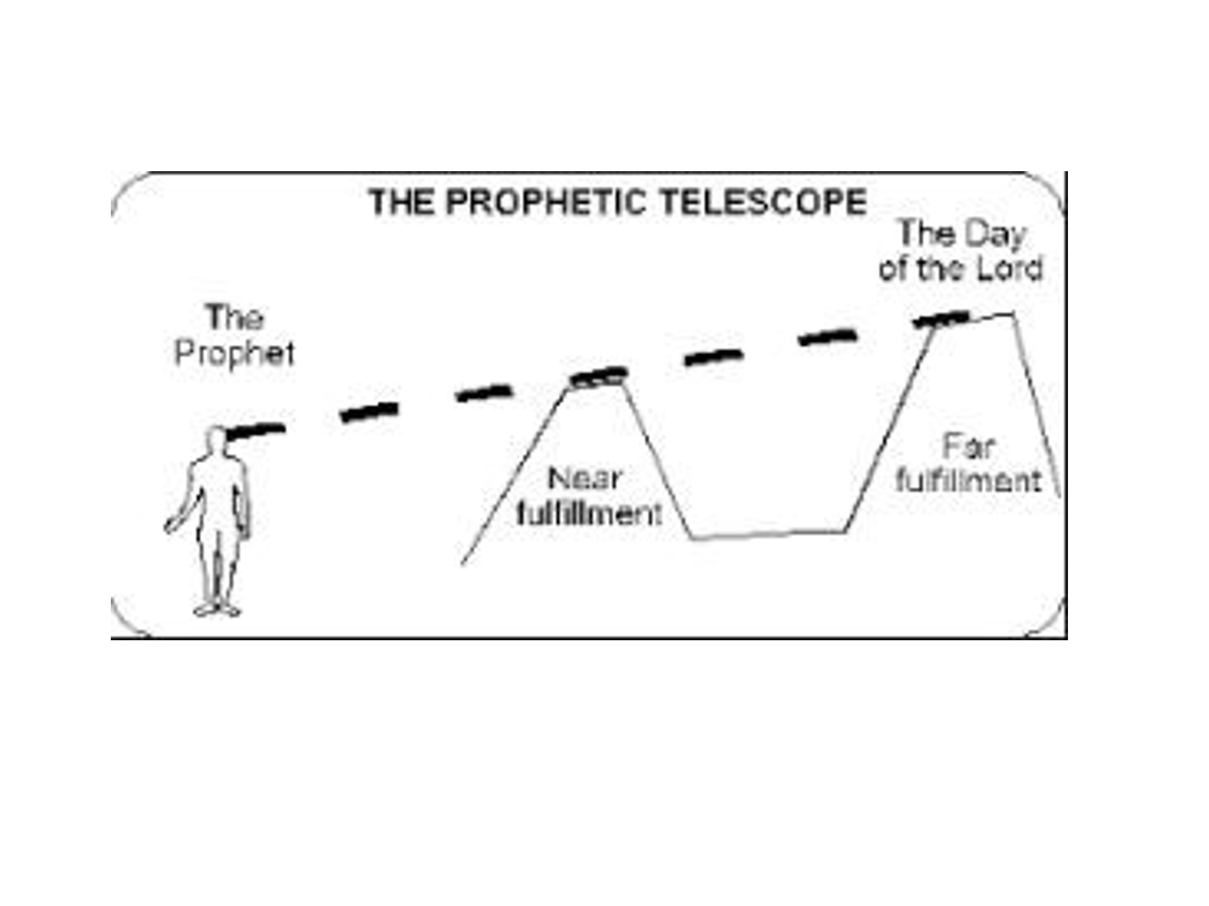
As we come to Zeph. 1:14-18 we have here the most vivid picture in the entire Bible of the terribleness of the coming Day of the LORD. It is worse than anyone could ever imagine.

Zephaniah 1:14–18 (NKJV)
14 The great day of the Lord is near; It is near and hastens quickly. The noise of the day of the Lord is bitter; There the mighty men shall cry out.

There is an emphasis on “near” here. In the Hebrew it is positioned first in the sentence in the emphatic position. This serves as a strong warning that this coming Day of God’s intervening judgment is imminent and should be taken seriously.

We think that Zephaniah probably wrote just prior to the semi-revival of 622 BC. That being the case, the Babylonians began their terror of besieging Jerusalem just 17 years later in 605 BC. There were 3 sieges of Jerusalem in 605, 597, and 586 BC – with the Temple being destroyed in 586 and essentially all the Jews being taken out of the land to Babylon.

17 years is not a long time. And yet, even then God was giving a little space to respond to the call to repent. This day of judgment was coming more quickly than anyone realized. It was much nearer than people realized. I wonder if the same is not true today!

Note the double emphasis: “The great day of the LORD is near” and then again, “It is near and hastens quickly.” Again, the warning was CLEAR and it was STRONG with the sense that NOW is the time to respond – to get right with God.
Slide # 6

Joel 2:11 (NKJV)
11 The Lord gives voice before His army, For His camp is very great; For strong is the One who executes His word. For the day of the Lord is great and very terrible; Who can endure it?

The noises of this day are bitter as even the strong men of battle cry out in terror! Bitter crying defines the day. Once the day falls upon them it will be too late. The day was approaching with great speed and would come with great and severe intensity. Urgency is all over these words!

15 That day is a day of wrath, A day of trouble and distress, A day of devastation and desolation, A day of darkness and gloominess, A day of clouds and thick darkness,

These words basically speak for themselves. They are dark and ominous. This is a day of wrath. This is sinners in the hands of an angry God. Note the words, wrath, trouble, distress, devastation, desolation, darkness, gloominess, clouds, thick darkness. This is dire and horrifying!

He presents a staccato effect stacking up adjectives designed to drive home the dreadful character of this coming Day of the LORD.

I think if we could actually see the terribleness of the coming Day of the LORD judgment you couldn’t make us be quiet. We would be fanatically warning people from the rooftops.

Slide # 7

Revelation 6:14–17 (NKJV)
14 Then the sky receded as a scroll when it is rolled up, and every mountain and island was moved out of its place.
15 And the kings of the earth, the great men, the rich men, the commanders, the mighty men, every slave and every free man, hid themselves in the caves and in the rocks of the mountains,
16 and said to the mountains and rocks, “Fall on us and hide us from the face of Him who sits on the throne and from the wrath of the Lamb!
17 For the great day of His wrath has come, and who is able to stand?”

In that Day the LORD will be known for Who He is – the Almighty God with whom we have to do! The world will be rockin and every category of people will be terrified beyond belief and trying to find somewhere to hide knowing that the great day of God’s wrath has come!

This section seems to point to the near fulfillment when Babylon subdued Judah (vv. 4-13), as well as a far fulfillment which will involve the whole earth (v. 18). – John MacArthur

16 A day of trumpet and alarm Against the fortified cities And against the high towers.

It is presented in a very picturesque way so vivid it’s almost like you can see it. The trumpet signaled an alarm, kind of comparable to sirens of warning that go off in our cities today. And this is happening in the most fortified cities and against the high towers. No place is safe or exempt. There is no escape. In this day they will be defenseless!

17 “I will bring distress upon men, And they shall walk like blind men, Because they have sinned against the Lord; Their blood shall be poured out like dust, And their flesh like refuse.”

God is behind this! He says, “I will bring distress upon men”. This is what it means to have God AGAINST you! This is not pleasant! They shall flounder and wander helplessly about like blind men. This is the curse God warned about for disobedience back in Deut.

Slide # 8
Deuteronomy 28:28–29 (NKJV)
28 The Lord will strike you with madness and blindness and confusion of heart.
29 And you shall grope at noonday, as a blind man gropes in darkness; you shall not prosper in your ways; you shall be only oppressed and plundered continually, and no one shall save you.

What a pitiful condition! There is nothing more serious than this. Of all the promises in the Bible and I have shared at the bedside of many dying people – of all the promises Romans 8:39 is one of the greatest where it says, nothing “shall be able to separate us from the love of God which is in Christ Jesus our Lord.” We cling to this in time and eternity! But this is not that! This is God’s wrath being experienced! This is the experience of being separated from God in His judgment! There is nothing more horrible!
And WHY was this going to happen? Well, God says, “Because they have sinned against the Lord”. This is the consequences of sinful rebellion that refused to repent – that refused to take God seriously.

As noted earlier in the chapter the people of Judah were heavy into idolatry, they did not seek the LORD, they couldn’t care less (cf. 1:4-6). But now what? Now the great Day of the LORD has come, and all hell has broken loose. Now what? What a terrible reality.

And the reason the warning is so strong is because God doesn’t want people to end up there.

In that day their blood would be poured out like dust and their flesh piled up like dung. The land would be turned into a slaughterhouse with dead bodies everywhere. Read the book of Lamentations. It was a time of wailing and lamenting. A time of unimaginable grief!

It came to be within the space of just a few short years of this warning! And yet few took the prophets’ warning seriously!

18 Neither their silver nor their gold Shall be able to deliver them In the day of the Lord’s wrath; But the whole land shall be devoured By the fire of His jealousy, For He will make speedy riddance Of all those who dwell in the land.

No one would be able to buy their way out of this. Silver and gold can’t deliver from the day of the LORD’S wrath! Money in that day becomes worthless!

When it comes to God there is only one thing that can ransom our soul and that is the blood of Jesus.

Slide # 9

1 Timothy 2:5–6 (NKJV)
5 For there is one God and one Mediator between God and men, the Man Christ Jesus,
6 who gave Himself a ransom for all, to be testified in due time,

Slide # 10

1 Peter 1:18–19 (NKJV)
18 knowing that you were not redeemed with corruptible things, like silver or gold, from your aimless conduct received by tradition from your fathers,
19 but with the precious blood of Christ, as of a lamb without blemish and without spot.

People put lots of stock in money, but in the end, it can do nothing for a person. In the day of God’s wrath, it is totally worthless! What will they do then? The Bible says to not “trust in uncertain riches but in the living God, who gives us richly all things to enjoy.” (1 Tim. 6:17)

Again, many commentators believe that verse 18 has a universal feel that will be fulfilled in the climactic coming Day of the Lord judgment in what we commonly call the Tribulation Period. He speaks here the whole land being devoured by the fire of God’s jealousy. Compare verse 3 where God says, “I will cut off man from the face of the land”.

The NASB translates this in verse 18, “And all the earth will be devoured”. The ESV renders it “all the earth shall be consumed”. In the end this is a whole earth phenomenon. The climactic Day of the Lord judgment as detailed in the book of Revelation involves the entire world and not just a part of it. The entire world will experience the day of His wrath at that time.

Several years ago, Oprah Winfrey famously renounced Christianity saying that when a preacher said God was a jealous God she wanted nothing to do with such a God. That is a really an arrogant position to take -as if she is the one to sit in judgment on God!

God is a righteously jealous God. After all He created us for Himself, and He has every right to expect our worshipful allegiance to Him and Him alone. There is a righteous jealousy. If someone hits on my wife, I am not going to be passive about it. A righteous anger combined with righteous jealousy (if indeed it is righteous) is not going to appreciate someone trying to take from me what rightfully belongs to me alone.

How much more the holy righteous God of the Bible being jealous over what is rightfully His to have. This is holy jealousy.

Slide # 11

Exodus 20:4–5 (NKJV)
4 “You shall not make for yourself a carved image—any likeness of anything that is in heaven above, or that is in the earth beneath, or that is in the water under the earth;
5 you shall not bow down to them nor serve them. For I, the Lord your God, am a jealous God, visiting the iniquity of the fathers upon the children to the third and fourth generations of those who hate Me,

Exodus 34:14 (NKJV)
14 (for you shall worship no other god, for the Lord, whose name is Jealous, is a jealous God),

Slide # 12

Deuteronomy 4:24 (NKJV)
24 For the Lord your God is a consuming fire, a jealous God.

Deuteronomy 6:15 (NKJV)
15 (for the Lord your God is a jealous God among you), lest the anger of the Lord your God be aroused against you and destroy you from the face of the earth.

God is a jealous God who tolerates no rivals! He demands full out allegiance and that He ALONE be recognized as God. The entire world (remnant excepted) has paid no regard to this jealous God.

Even in the midst of the coming Day of the LORD rebel humanity so committed to idolatry still will not repent in the face of God’s awesome display of overwhelming LORDSHIP.

Slide # 13

Revelation 9:20–21 (NKJV)
20 But the rest of mankind, who were not killed by these plagues, did not repent of the works of their hands, that they should not worship demons, and idols of gold, silver, brass, stone, and wood, which can neither see nor hear nor walk.
21 And they did not repent of their murders or their sorceries or their sexual immorality or their thefts.

Slide # 14

Revelation 16:9–11 (NKJV)
9 And men were scorched with great heat, and they blasphemed the name of God who has power over these plagues; and they did not repent and give Him glory.
10 Then the fifth angel poured out his bowl on the throne of the beast, and his kingdom became full of darkness; and they gnawed their tongues because of the pain.
11 They blasphemed the God of heaven because of their pains and their sores, and did not repent of their deeds.

God just demands that we give Him His due as God. Is that asking too much? Well, for rebel humanity it is. They refuse to do so and thus incur the full cup of His wrath!

God’s consuming passion is that people recognize Him to be the God that He is. He is going to purge the world of all rebels who refuse to do so.

Slide # 15

Zechariah 13:8–9 (NKJV)
8 And it shall come to pass in all the land,” Says the Lord, “That two-thirds in it shall be cut off and die, But one-third shall be left in it:
9 I will bring the one-third through the fire, Will refine them as silver is refined, And test them as gold is tested. They will call on My name, And I will answer them. I will say, ‘This is My people’; And each one will say, ‘The Lord is my God.’ ”

This is the great issue before the world! Will they bow before the Lordship of God – of Christ, or won’t they. In the end all rebels will perish under the judgment of God’s wrath and in the end every knee will bow and every tongue will confess that Jesus is Lord to the glory of God the Father (cf. Phil. 2:9-11). That is the end of the story!

God is jealous of His LORDSHIP and tolerates no other rivals!

The Christian should be careful not to adopt a complacent or cynical attitude regarding the day of the Lord (2 Pet. 3:3, 4), but instead should adopt an attitude of expectancy, because the event is sure and ever present on the horizon (2 Pet. 3:12).
– The Believers’ Study Bible

Slide # 16

2 Peter 3:11–12 (NKJV)
11 Therefore, since all these things will be dissolved, what manner of persons ought you to be in holy conduct and godliness,
12 looking for and hastening the coming of the day of God, because of which the heavens will be dissolved, being on fire, and the elements will melt with fervent heat?

The great Day of the LORD hung over the people in Zephaniah’s day and it hangs over the people in our day like the famous sword of Damocles.

The famed parable of the “sword of Damocles” was popularized by the Roman philosopher Cicero before the time of Christ. He told the story of Dionysius II, a tyrannical king who once ruled over the Sicilian city of Syracuse during the fourth and fifth centuries B.C. Though rich and powerful, Dionysius was supremely unhappy. He was tormented by fears of assassination.
One day after a court flatterer named Damocles showered him with compliments and remarked how blissful his life must be. Annoyed, the king replied, “Do you wish to taste it yourself and make a trial of my good fortune?”
When Damocles agreed, Dionysius seated him on a golden couch and ordered a host of servants to wait on him. He was treated to succulent cuts of meat and lavished with scented perfumes and ointments. Damocles couldn’t believe his good fortune, but just as he was starting to enjoy the life of a king, he noticed that Dionysius had also hung a razor-sharp sword from the ceiling. It was positioned over Damocles’ head, suspended only by a single strand of horsehair.
From then on Damocles feared for his life which made it impossible for him to savor the opulence of the feast or enjoy the servants. After casting several nervous glances at the blade dangling above him, he asked to be excused, saying he no longer wished to be so fortunate.

Slide # 17
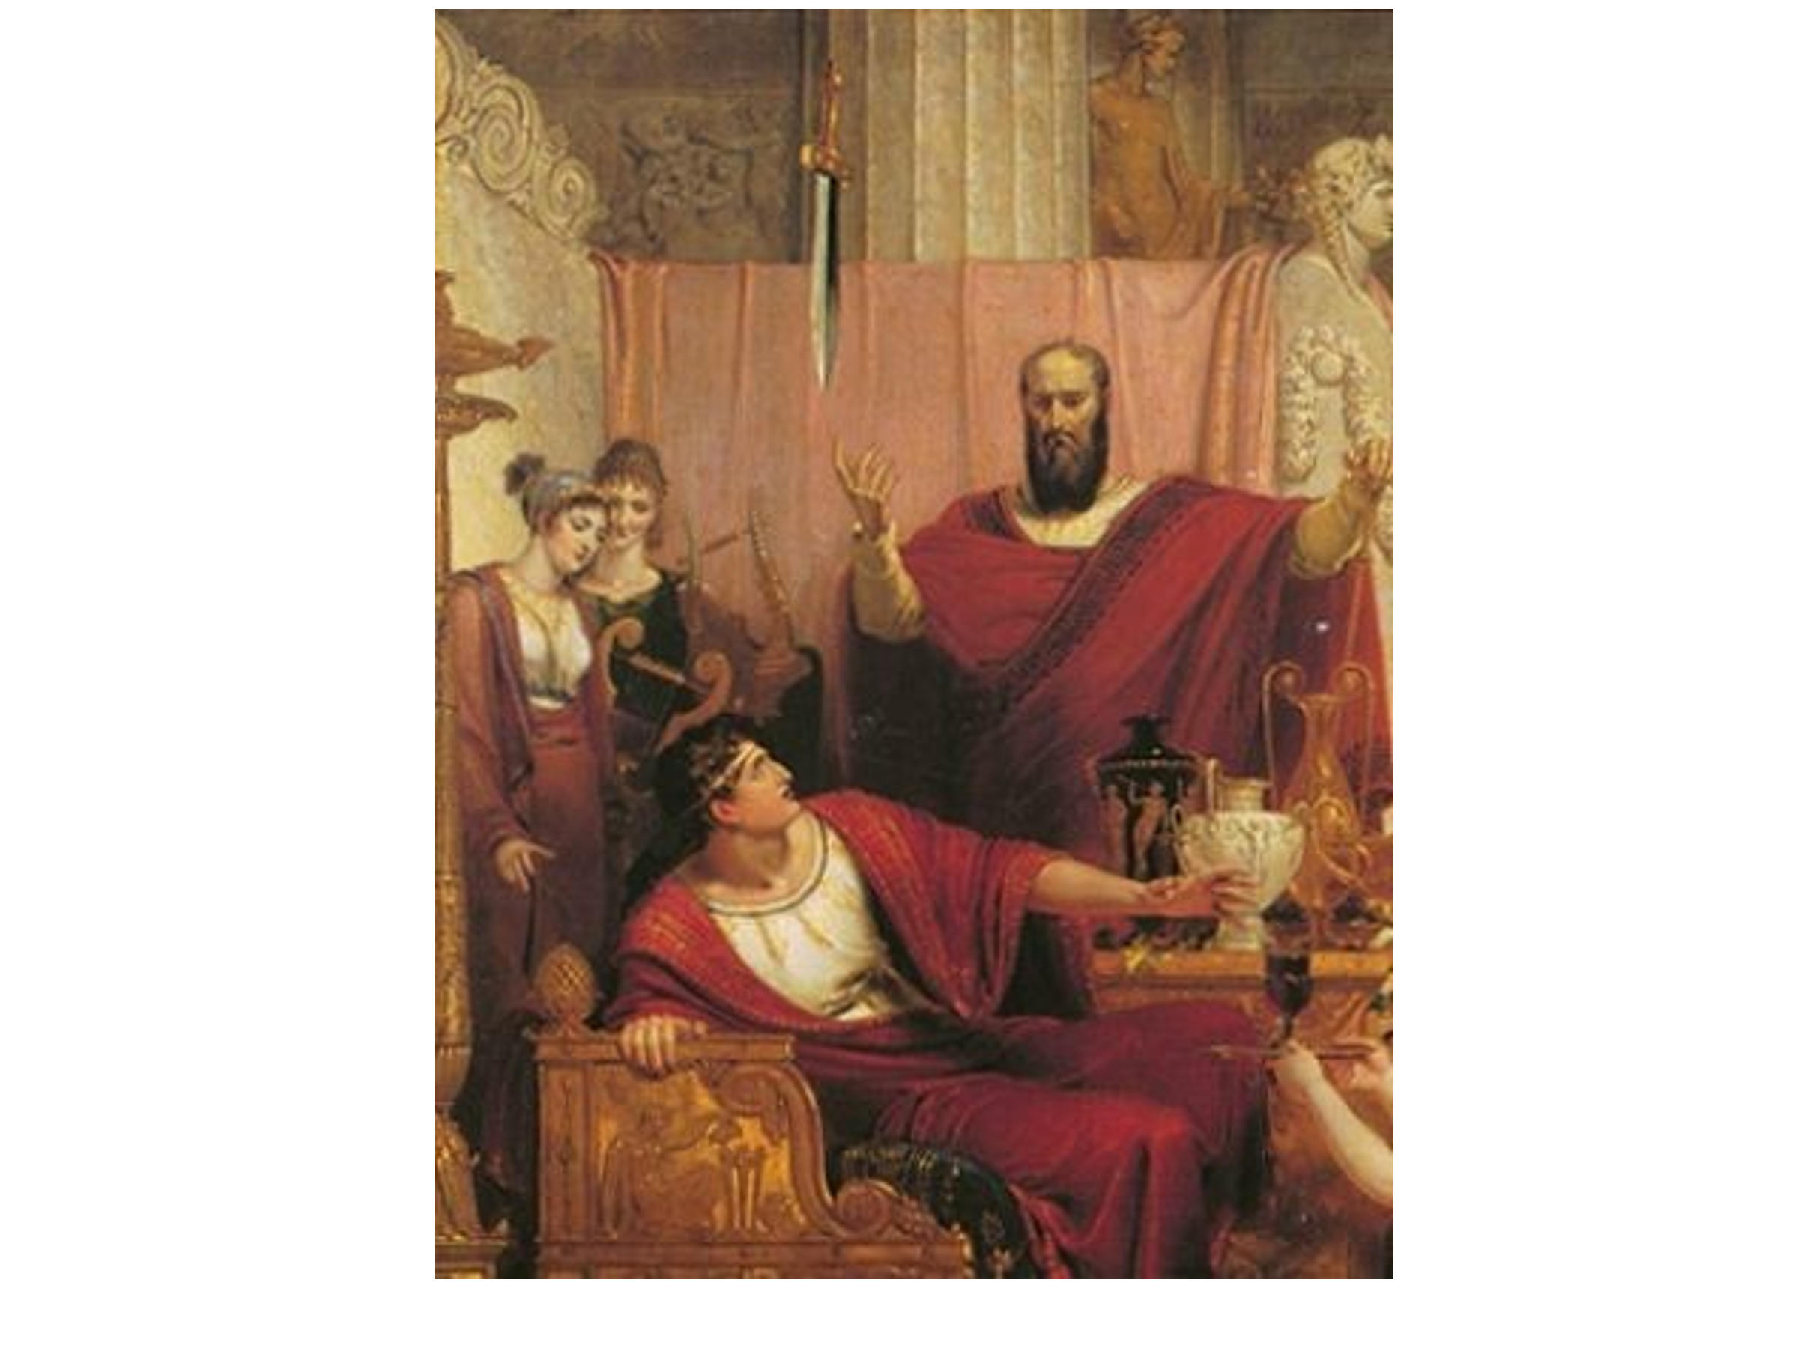
But here is the moral of the story applied to where we are today. The sword of the Day of the LORD judgment is dangling over the head of the world, but contrary to Damocles the world is oblivious to it. Contrary to Damocles the world is not seeking to get out of the place of danger. Rather they carry on with no fear of God or His coming judgment – even though the warning is clearly there. And in the meantime, the sword perilously continues to dangle and at some point at God’s sovereign direction it will come down in the Day of the Lord Judgment with horrifying results.

Slide # 18

Psalm 2:10–12 (NKJV)
10 Now therefore, be wise, O kings; Be instructed, you judges of the earth.
11 Serve the Lord with fear, And rejoice with trembling.
12 Kiss the Son, lest He be angry, And you perish in the way, When His wrath is kindled but a little. Blessed are all those who put their trust in Him.

In the end there are two categories of people. Those who refuse to embrace the Son in saving faith and perish in that way; and the blessed who put their trust in Him.

Where is your trust tonight? Blessed are all those who put their trust in Him!

