SBC – Nov. 21, 2021
# 42
Matt. 12:38-42 (NKJV)
“An Evil Generation Seeks A Sign”

Prayer:

Slide # 1

Theme: Christ the King

Outline:

Chps. 1-2 The Advent of the King. (Proving His LEGAL right to the
throne by His genealogy.)
Chp. 3 The Forerunner of the King and the King’s baptism.
Chp. 4 The Test of the King. (Proving His MORAL right to the throne
by not yielding to temptation; and exhibiting His kingdom
resume.)
Chps. 5-7 The Pronouncements of the King. (Proving His JUDICIAL right to the throne as seen in the wisdom of His kingdom teaching.)
Chps. 8-10 The Power of the King. (Proving His PROPHETICAL right to the throne by fulfilling prophecy.)
Chps. 11-12 The Rejection of the King.
Chp. 13 The Parables of the King.
Chps. 14-16 The Revelations of the King.
Chps. 17-20 The Instructions of the King.
Chps. 21-23 Formal Rejection of the King.
Chps. 24-25 The Predictions of the King.
Chps. 26-27 The Passion of the King.
Chp. 28 The Resurrection of the King.

Matthew 12 brings us to a major turning point in Christ’s ministry. Mathew writes to the Jews presenting various lines of evidence to show that Jesus is the prophesied/promised Messiah in the OT. The Messiah would be both God and Man in one person; He would be both Israel’s Deliverer and King.

After showing that Jesus has all the proper credentials of being the Messiah; that is in having the right linage, in demonstrating His impeccable moral qualifications; in showing how He precisely fulfilled Messianic prophecy; in showing Him to be unique in both His healing and teaching ministry; in all this Jesus is shown to be the legitimate Messiah. As such He was the Messianic King giving a little taste of the kingdom which was being presented to Israel on the condition of repentance – on the condition of properly receiving Jesus as the Messiah God!
But the religious leaders, who had great sway and influence over the people did not accept or appreciate Jesus. They felt threatened by Him. Jesus claimed to be “Lord” and as such he was a threat to their position of religious authority. Hence, the growing conflict between Jesus and the Jewish religious leaders.

It came to head when Jesus healed a demon-possessed man who was both blind and mute. The miracle was undeniable, but the Pharisees claimed Jesus did it by the power of Satan.

Jesus refuted this by showing the absurdity of their position emphasizing that only by being in the STRONGER position can one bind Satan the strong man and have his way with Satan’s demons and those he has in bondage. Jesus is this STRONGER reality. He ALONE has the POWER to bind Satan the strong man and have His way over him. Jesus ALONE is the ultimate DELIVERER when it comes to Satan.

Furthermore, Jesus said that to slanderously blaspheme by saying that He cast out demons by the power of Satan was really blasphemy against the Spirit which was unforgivable. Jesus then showed that a person’s words are an indicator of the heart, saying, “out of the abundance of the heart the mouth speaks” (Mt. 12:34). Jesus says by a person’s words they will be justified and by their words they will likewise be condemned (v. 37). The mouth tells on the heart and thus reveals the spiritual condition of the person.

And that brings us to Matthew 12:38 where we pick up our study today.

Matthew 12:38–42 (NKJV) (cf. the cross reference of Lk. 11:29-32)

38 Then some of the scribes and Pharisees answered, saying, “Teacher, we want to see a sign from You.”

Recall the thematic context here. Jesus had just done an extraordinarily unique miracle by healing a demon-possessed man who had been blind and mute which the Pharisees ascribed to the power of Satan. Now they are demanding yet another sign.

Goodness, its not like they hadn’t seen SIGNS! They were everywhere in Christ’s public ministry in overwhelming abundance.

Slide # 2
Matthew 4:23 (NKJV)
23 And Jesus went about all Galilee, teaching in their synagogues, preaching the gospel of the kingdom, and healing all kinds of sickness and all kinds of disease among the people.

Matthew 9:35 (NKJV)
35 Then Jesus went about all the cities and villages, teaching in their synagogues, preaching the gospel of the kingdom, and healing every sickness and every disease among the people.

And they ask for a sign? Here a sign, there a sign, everywhere a sign. Signs were in overabundance in Christ’s ministry all over the place! And they ask for yet another sign? This is crazy talk – really evil talk as Jesus will go on to show.

In the gospel of John in particular, the word SIGN is constantly used in reference to a miracle that had meaning. Jesus did not just do miracles for miracles sake. They had meaning. They were signs! They pointed to the TRUTH of Who He was as the Messiah. They fulfilled OT prophecy – so they were not just done in a vacuum. The miracles Christ did had special Messianic sign value related to the kingdom showing He was indeed the promised Messianic King.

This week I had a really fast-talking guy call me up and wondered if I would go up to the hospital and pray for someone that had Covid.

As I started to get name of the person, he wanted me to pray for he told me she was not able to use her arms and so forth and he wanted to know if I believed in healing. So, he was really pressing me on my theology of healing. I told him that I did not think the sign gifts were operative today but certainly God works through prayer. He took issue with this. I told him that in the gospels Jesus miracles are called SIGNS because they pointed to Him as being the Messiah King who brings in the kingdom - and no one is doing Messianic signs today.

It was like he didn’t hear me. He insisted (with a little bit of vulgarity) that such signs were still operative. I challenged him asking him if he had seen people raised from the dead and he assured me that he had (I am not sure why he didn’t just go to the hospital himself). At that point he said something like: “You don’t believe in the Holy Ghost and are just dried up with no life.” And as he was hanging up he said, “I got the wrong guy”.
Yes indeed! If you are looking for someone to perform SIGN MIRACLES and you are calling me – then for sure you got the wrong guy. In fact, you are 2000 years to late. Sign miracles were unique to Christ and His apostles – and especially to Christ who gave authority to do them.

But again, some of the scribes and Pharisees followed up on the event of blaspheming against the Spirit which claimed Jesus did miracles by the power of Satan, by asking for yet ANOTHER SIGN.

So, in this thematic context the sense of what they were saying seems to be this: “We claim you are doing miracles by the power of Satan, but if you are really doing them by the power of God prove it by doing a GOD-THING that even we can’t deny.

They were demanding a special spectacular miracle that would be an over the top blow your mind kind of evidence that the power Jesus was demonstrating was truly that of God. Thus, they were asking for a SPECIAL KIND OF SIGN MIRACLE even more sensational than what Jesus had previously done.

Here is the thing with unbelief. It never has enough evidence because it doesn’t really want to accept the truth. They are not really honest with the obvious truth!

Some Christians try to make the case for sign miracles today saying that unless they are performed people won’t come to believe. But they completely miss the point. God has given all the evidence needed. The issue is not a lack of evidence. The issue is hardened hearts that won’t respond to the ample evidence given. There is NEVER enough evidence for willful unbelief.

People sometimes say things like, “If I could just see a real miracle I would believe.” But that is contrary to what Jesus taught - contrary to Scripture.

Slide # 3
Luke 16:27–31 (NKJV)
27 “Then he said, ‘I beg you therefore, father, that you would send him to my father’s house,
28 for I have five brothers, that he may testify to them, lest they also come to this place of torment.’
29 Abraham said to him, ‘They have Moses and the prophets; let them hear them.’
30 And he said, ‘No, father Abraham; but if one goes to them from the dead, they will repent.’
31 But he said to him, ‘If they do not hear Moses and the prophets, neither will they be persuaded though one rise from the dead.’ ”

There is the reality of Spirit convicting people. There is the reality that the Word of God is living and powerful working in people’s hearts.

Slide # 4

Jeremiah 23:29 (NKJV)
29 “Is not My word like a fire?” says the Lord, “And like a hammer that breaks the rock in pieces?

Hebrews 4:12 (NKJV)
12 For the word of God is living and powerful, and sharper than any two-edged sword, piercing even to the division of soul and spirit, and of joints and marrow, and is a discerner of the thoughts and intents of the heart.

If the living God working through the living Word can’t get through then there is no hope. More signs would not be more effective! God’s way of working is through His Word. It is not a secondary thing – it is the essential thing. Faith comes by hearing and hearing by the word of God (Rom. 10:17).

Slide # 5

1 Corinthians 1:21–24 (NKJV)
21 For since, in the wisdom of God, the world through wisdom did not know God, it pleased God through the foolishness of the message preached to save those who believe.
22 For Jews request a sign, and Greeks seek after wisdom;
23 but we preach Christ crucified, to the Jews a stumbling block and to the Greeks foolishness,
24 but to those who are called, both Jews and Greeks, Christ the power of God and the wisdom of God.

What God has given in the Word is sufficient! It is what we call the sufficiency of Scripture! This is how God works by the Holy Spirit and what God has given is enough.
Are SIGNS or SCRIPTURE more convincing evidence? In truth, even signs are to be understood through the prism of Scripture – all pointing to the truth of the Christ and Who He is. It ALL goes back to Scripture.

They were looking for an additional SIGN that would be astonishing, breathtaking, off the charts clearly of God, and instead Jesus gave them A SIGN from Scripture! How is that for a sign? The signs in Jesus’ ministry all tied to Scripture. They were all a fulfillment of Scripture. They weren’t just done in a vacuum. They had meaning and purpose specifically tied to WHO He is as the Messiah as rooted in Scripture.

By the way, in contrast to Jesus who came operating in total harmony with Scripture, one day will come another Christ –who is commonly known as antichrist. And how will he come?

Slide # 6
John 5:43 (NKJV)
43 I have come in My Father’s name, and you do not receive Me; if another comes in his own name, him you will receive.

The antichrist will come in a vacuum, not claiming any Scriptural basis, not claiming any authority from God. No tie to anything – just championing himself to be God on the basis of his own claims. Jesus did NOT do that. He came with Bible credentials – prophetic credentials – the Father’s credentials. His whole ministry was interwoven with and tethered to God’s prophetic truth as found in the Scriptures. The really BIG thing is the Scripture.

They said we want another SUPER-SIGN…

39 But He answered and said to them, “An evil and adulterous generation seeks after a sign, and no sign will be given to it except the sign of the prophet Jonah.

This is really a powerful verse that I think has much application to where we are today in a context where Charismania has huge influence and sway over so much of professing Christendom.

Sometimes seeking for a SIGN is downright sinful! When the evidence is already more than sufficient it is plain evil and sinful to demand more. When Scripture is fully sufficient it is sinful to demand more evidence!

This rebuke from Christ seems applicable to those Christians today who are continually looking for miraculous manifestations of one kind or another. We already have the completed Word of God with abundant testimony to its inherent authority, not to mention the tremendous scientific evidence of creation and the historical evidence of Christ’s victory over death. So there is no need for further miraculous confirmation of our faith. – Henry M. Morris

Frankly, all this clamoring for extra miraculous signs signifies unbelief and a lack of understanding concerning God, His ways, and His Word.

Slide # 7

One of the most alarming trends is evangelicalism is the desire to experience God outside of Scripture via signs, wonders, and emotive mysticism. – Anthony Wood

This appetite for the miraculous that is sensational is really nothing new. John Calvin who lived about 500 years ago said this:

Slide # 8

Their requiring miracles of us is unreasonable; for we forge no new gospel but retain the very same whose truth was confirmed by all the miracles ever wrought by Christ and the Apostles. – John Calvin

Slide #9
It is well known that evangelical (fundamentalist) leaders of the 20th century diligently defended the Scripture from modernists aiming to “cut out” portions of the Bible. Now we live in a period of history where Scripture must be protected from mystics seeking to “add” upon the Bible. The battle for inerrancy is now the battle for sufficiency. – Anthony Wood

An especially egregious movement has arisen out of the Charismatic movement which is called “The New Apostolic Reformation”. It goes back to C. Peter Wagner at Fuller Seminary but in our day is popularized by people such as pastor Bill Johnson of Bethel Church in Redding CA which boasts 10,000 regular attenders.

The first great issue is that people like Johnson do not have a high view of Scripture and therefore say we need MORE than Scripture!
Slide # 10

“We’ve gone as far as we can with our present understanding of Scripture. It’s time to let signs have their place…” – Bill Johnson

To insist on the need for more signs and wonders today is to grossly misunderstand their purpose in relationship to the Messiah and His kingdom. And frankly it is a denigration of a HIGH VIEW of Scripture which in effect says the Bible is not sufficient – it is not enough!

Indeed, I think it is a legitimate application to say in this context that, “An evil and adulterous generation seeks after a sign”.

The idea of “evil” (Gk. poneros) is that which is morally bad or wicked. “Adulterous” speaks of unfaithfulness – unfaithful to God and His truth (cf. Jer. 3:10; Hos. 7:13-16; Isa. 57:3-8).

The Babylonian Exile essentially broke Israel of formal outward idolatry and yet here we find a problem of spiritual adultery in the hearts of the people was still very much in existence. Their legalistic hypocrisy that steered their hearts away from God and His truth was a form of spiritual adultery.

The evil and adulterous generation in view was the Jews of Christ’s time who in spite of all the evidence that He was the Messiah yet refused to believe in Him. They flagrantly sinned against the most brilliant LIGHT possible as seen in the person and ministry of Christ.

Yes, they sought after a SIGN but only because they were wicked! They were not sincere truth seekers. They were wicked not accepting the light given! Consequently, NO further sign would be given them.

They were not in charge. Who were they to demand a sign – especially coming from a position of perverse and unfaithful wickedness?

But Christ did indicate there would be ONE more sign given for them which as it turns is the ULTIMATE SIGN – namely the sign of Christ’s death, burial, and resurrection as illustrated in the prophet Jonah’s experience as further indicated in verse 40.

40 For as Jonah was three days and three nights in the belly of the great fish, so will the Son of Man be three days and three nights in the heart of the earth.
In effect, Christ says that Jonah was a prophetic sign. What happened to Jonah in the belly of the great fish was a type of death and burial which was followed by a restoration to life. In other words, Jonah’s experience illustrates the death, burial, and resurrection of Jesus Christ.

The parallel is clear: Jonah was in the belly of the fish for three days and three nights and the Son of Man would be in heart of the earth (meaning the grave) for three days and three nights.

The Bible is clear that the whole of Scripture revolves around a main theme which is the person of Jesus Christ and God’s salvation plan centered in Him of which the focal point was Christ’s death, burial, and resurrection.

Slide # 11
Luke 24:27 (NKJV)
27 And beginning at Moses and all the Prophets, He expounded to them in all the Scriptures the things concerning Himself.

[Here] the Lord Jesus Christ gave them the great key to the understanding of Scripture – that He Himself is its subject and that in Him the entire Book finds its unity. - C.I. Scofield

But here is the thing about revelation. We only know God’s plan as He reveals it to us. We never figure God out on our own. We only know the significance of what God is doing as He unveils it. And revelation was progressive – meaning we understand more and more as more and more is revealed. And it all builds on previous revelation. And the point is the revelation is now COMPLETE! The Book of God is complete! (cf. Jn. 16:13)

At the time of Jonah’s experience with the great fish no one at that time said, “Oh yeah, this is clearly a SIGN of the coming Messiah involving His death, burial, and resurrection.” No one saw that, but God did!

However, looking back we can see that this is what God had in mind all along. He sovereignly orchestrated it so that ultimately it would be a picture of Christ’s death, burial, and resurrection. But here is the point: We wouldn’t know this apart from God’s further revelation. We wouldn’t know it except for the fact that Christ has told us.

As such Jesus became the fulfillment of the SIGN in Jonah that God intended all along, and it fits perfectly with the overall picture of what the Messiah would do.
Slide # 12
Jonah 1:17 (NKJV)
17 Now the Lord had prepared a great fish to swallow Jonah. And Jonah was in the belly of the fish three days and three nights.

Because of the SIGN as found in Jonah and the language of Jonah as quoted by Christ in Matthew 12:40 some have insisted that Christ had to have been in the grave for three full days and three full nights in order for this to be accurately fulfilled.

So, various arguments have been put forth as to whether Christ was actually crucified on Wednesday, on Thursday, or as has traditionally been thought on Friday.

The problem with insisting on 3 full days and 3 full nights is that it then pushes the resurrection into the fourth day and the Bible is clear that Christ rose again on the 3rd day after His crucifixion. Christ repeatedly said that He would be “raised the third day” – not the fourth (cf. Mt. 16:21; 17:23; 20:19).

The most logical answer to this is that in Jewish reckoning any part of a 24 hour day can stand for the whole (cf. 1 Sam. 30:12-13; 2 Chron. 10:5, 12; Esther 4:16; 5:1).

Slide # 13
“A day and a night make an ‘onah (i.e. a 24 hour period) and the portion of an ‘onah is reckoned as an ‘onah”.
– Rabbi Elazar (c. A.D. 100)

So, the sense is that it was common for the Jewish people to regard even part of a day as representing a full 24 day. We see this a number of places in the OT Scriptures (cf. 1 Sam. 30:12-13; 2 Chron. 10:5, 12; Esther 4:16; 5:1).

So in this way of thinking: He was buried on Friday afternoon and resurrected on Sunday morning. Part of Friday is regarded as one 24 hour day, Saturday is one 24 hour day, and part of Sunday is regarded as one 24 hour day. Hence, in the Jewish way of reckoning Jesus was in the heart of the earth for three days and three nights and at the same time He arose on the third day.

This is most probably the proper way to understand this.
Footnote: The old KJV translated the sea creature as “whale” which is inaccurate. The Greek word (“ketos”) literally means “great sea creature” which is translated in the NKJV as “great fish”.

The number 3 is of great significance as found in Jonah and as repeatedly referred to by Christ.

Slide # 14

Matthew 16:21 (NKJV)
21 From that time Jesus began to show to His disciples that He must go to Jerusalem, and suffer many things from the elders and chief priests and scribes, and be killed, and be raised the third day.

Matthew 17:23 (NKJV)
23 and they will kill Him, and the third day He will be raised up.” And they were exceedingly sorrowful.

Matthew 20:18–19 (NKJV)
18 “Behold, we are going up to Jerusalem, and the Son of Man will be betrayed to the chief priests and to the scribes; and they will condemn Him to death,
19 and deliver Him to the Gentiles to mock and to scourge and to crucify. And the third day He will rise again.”

Slide # 15

Luke 24:21 (NKJV)
21 But we were hoping that it was He who was going to redeem Israel. Indeed, besides all this, today is the third day since these things happened.

It all fits perfectly. Christ was indeed in the tomb parts of three different days. Jonah had a 3-day experience in the belly of the fish; Christ repeatedly predicted He would rise again on the third day; and the disciples testified that indeed He was reported to be alive on the third day. This did not happen on the second day or on the fourth day – but precisely on the THIRD day just as Christ said it would happen in perfect accord with the Jonah typology and the Jewish understanding of “three days”.

Jonah was as good as dead – pictured as dead in the belly of the fish for 3 days. But he didn’t stay in that position.
Slide # 16

Jonah 2:10 (NKJV)
10 So the Lord spoke to the fish, and it vomited Jonah onto dry land.

This is a picture of resurrection – the resurrection of Christ. Normally, we would never envision this picturing the glorious truth of resurrection. Again, we would never figure out God’s pictures unless He tells us what He means by them.

But again, this reality of 3 days in the tomb followed by the resurrection is the ultimate sign that verified all of Christ’s claims. From there on out God holds the world accountable for the truth of the resurrection.

Slide # 17

Acts 17:30–31 (NKJV)
30 Truly, these times of ignorance God overlooked, but now commands all men everywhere to repent,
31 because He has appointed a day on which He will judge the world in righteousness by the Man whom He has ordained. He has given assurance of this to all by raising Him from the dead.”

The resurrection changed everything. God now holds all people everywhere accountable to the truth of it. He now commands all people to repent – that is to in faith align their thinking with the truth of Jesus Christ as the risen Lord Who is the God-ordained Judge of all. The proof of this is found in the resurrection which happened in perfect fulfillment of prophecy as illustrated in Jonah and predicted by Christ.

In the experience of Jonah, we have pictured in summary form the FULL gospel message. The GOSPEL means good news and it is what Jesus has done to save us from our sins. Paul spells it out in 1 Cor. 15.

Slide # 18

1 Corinthians 15:1–4 (NKJV)
1 Moreover, brethren, I declare to you the gospel…

3 … Christ died for our sins according to the Scriptures,
4 and that He was buried, and that He rose again the third day according to the Scriptures,

1 Corinthians 15:11 (NKJV)
11 … so we preach and so you believed.

The GOSPEL is all about Jesus and what He did. And He did it all – that is why it is a GOSPEL of GRACE. The only thing we do is BELIEVE and even this is because of God’s work in our hearts.

Slide # 19

Ephesians 2:8–9 (NKJV)
8 For by grace [the CROSS] you have been saved through faith, and that not of yourselves; it is the gift of God,
9 not of works, lest anyone should boast.

It’s not by works of any kind. Not by rituals, not by sacraments, not by baptism, not be acts of kindness, not by church membership. Only by faith in Christ and His finished work on the cross are we saved.

Then Jesus made this application…

41 The men of Nineveh will rise up in the judgment with this generation and condemn it, because they repented at the preaching of Jonah; and indeed a greater than Jonah is here.

Nineveh was the capital city of the Assyrian empire.

Slide # 20
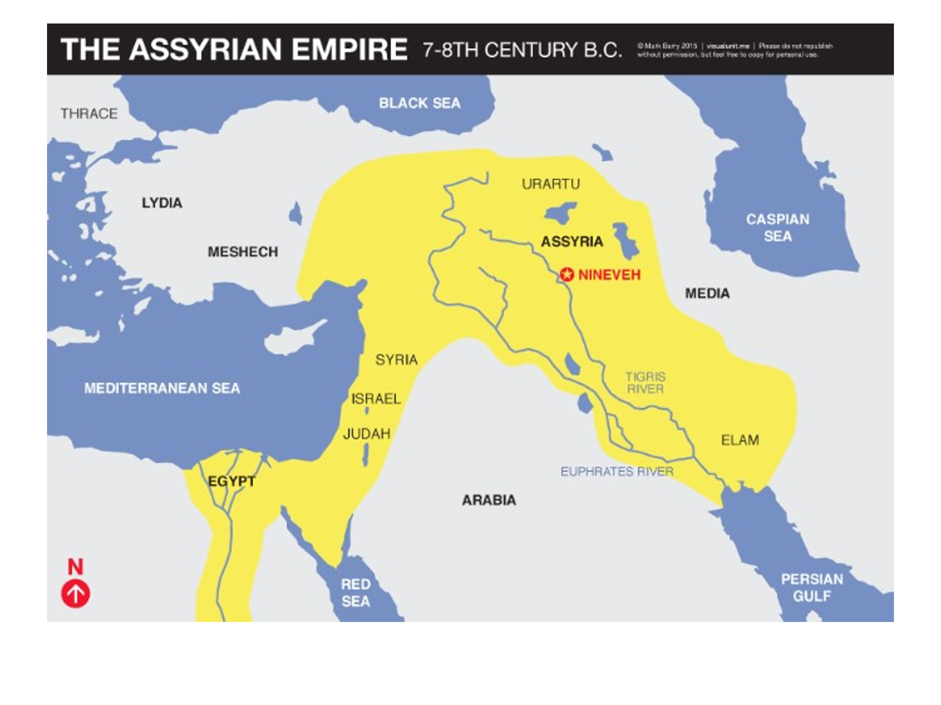
The emphasis here is interesting. Even though Jonah is ultimately a sign of Christ’s death, burial, and resurrection; here Christ pivots and makes the issue that of Jonah’s preaching and the Ninevites response of repentance.

In the grand scheme of things there are two great issues:
- The person of Christ and His work of salvation.
- How we respond to Him in belief or unbelief.

We might expect the emphasis at this point to be on some sort of SIGN that Jonah performed but that is not it. As far as we know Jonah did no sign whatsoever. As far as we know the Ninevites had no knowledge at all of Jonah’s experience inside the fish.

What Jonah did was preach, yes reluctantly, but he did preach, and the people repented. That is the point of emphasis here! Not a sign – but preaching.

Slide # 21
Jonah 3:4–5 (NKJV)
4 And Jonah began to enter the city on the first day’s walk. Then he cried out and said, “Yet forty days, and Nineveh shall be overthrown!”
5 So the people of Nineveh believed God, proclaimed a fast, and put on sackcloth, from the greatest to the least of them.

I want you to note that in Jonah 3:5 it says that they believed God but here in Matt. 12:41 Jesus says they “repented”. Well, let me ask you did they believe, or did they repent?

Repentance and believing always go together in saving faith. You can’t have one without the other. Repentance literally means “to have a change of mind” and that element whether explicitly stated or implicitly implied is always a reality in true saving faith.

But Jonah, reluctant as he was, PREACHED and the people responded in repentance and faith. And then Jesus says, “and indeed a greater than Jonah is here.”

This is interesting because the word “greater” is neuter in gender and not masculine in the Greek indicating something rather than someone is in view here. There is something GREATER on the scene than was found in Jonah. The emphasis here is on preaching, so the sense would seem to be that a greater PREACHER with an even greater MESSAGE is now on the scene in the person of Christ than was seen in person of Jonah.

Slide # 22
The comparison was not between two people, but between the two functions – a prophet’s and the Messiah’s, between a messenger of salvation and the instrument of salvation. – Ed Glasscock

And Christ was a PERFECT preacher.
Slide # 23

Isaiah 11:1–2 (NKJV)
1 There shall come forth a Rod from the stem of Jesse, And a Branch shall grow out of his roots.
2 The Spirit of the Lord shall rest upon Him, The Spirit of wisdom and understanding, The Spirit of counsel and might, The Spirit of knowledge and of the fear of the Lord.

This was seen in Christ’s ministry. When Jesus went back to His hometown of Nazareth and opened up the scroll to Isaiah and began to read and then explain that these things applied to Him the text in Luke 4:22 says the people “marveled at the gracious words which proceeded out of His mouth.” When Jesus got done teaching His Sermon on the Mount Matt. 7:28 says the “people were astonished at His teaching”. It blew them away. In John 7:46 they said, “No man ever spoke like this Man!”

When Jesus says the men of Nineveh will rise up in judgment the reference is to the custom in Jewish courts requiring the witness to stand when testifying in a case. In other words, the converted Ninevites will in the final judgment serve as witnesses against them.

This would really have rankled the Jewish pride – to think that these Gentiles in the OT would in the end be a witness against them as the favored people of God had to be humiliating.

These Gentiles at Nineveh in the OT responded to the preaching of Jonah, but in contrast these Jews on the scene during Christ’s ministry who had an even greater privilege of having even more light through an even greater preacher as seen in the Messiah’s ministry failed to repent (cf. Matt. 11:20-24).

42 The queen of the South will rise up in the judgment with this generation and condemn it, for she came from the ends of the earth to hear the wisdom of Solomon; and indeed a greater than Solomon is here.

Here Jesus refers to the queen of Sheba who came about 1200 miles from the Arabian peninsula (in what is present day Yemen) to hear the wisdom of Solomon as we read about in 1 Kg. 10:1-13 and 2 Chron. 9:1-12). To the Jews this was considered “the ends of the earth” (cf. Jer. 6:20; Joel 3:8)

Slide # 24
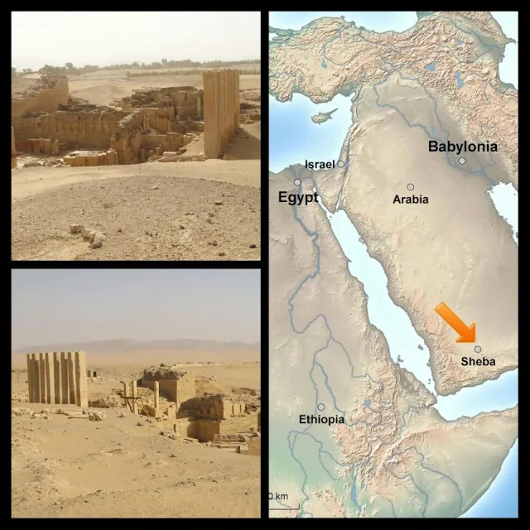

In context there is an underlying foreshadowing of the mission to the Gentiles. Jonah went to the Gentiles. The queen from the South was a Gentile. As seen earlier in the chapter in verses 18 and 21 the Messiah prophetically would “declare justice to the Gentiles” and “in His name Gentiles will trust”. Israel was now rejecting their Messiah but going forward many Gentiles would be receptive. Israel had the privilege of signs and wonders, but many of the Gentiles would respond simply to the power of the gospel message.

Jesus said the queen of the South will also rise up as a witness in judgment against the Jews of Jesus’ day because she responded to the WISDOM of Solomon and in contrast here they were not responding to the GREATER wisdom as found in the Messiah’s ministry.

Again, “greater” is of the neuter gender indicating SOMETHING greater – namely a GREATER TEACHING presented by a GREATER teacher. Solomon was the wisest man that ever lived apart from Christ, but Jesus was perfect wisdom incarnate. Col. 2:3 says that in Christ are “hidden all the treasures of wisdom and knowledge”. In 1 Cor. 1:24 Paul said that Christ is both “the power of God and the wisdom of God.”

So here is the major point of the text we have studied this morning. The Jews were all about miraculous SIGNS (cf. 1 Cor. 1:22). And signs have their place but the really BIG thing before God is the place of His Word. And again signs only have relevance in relationship to the Scriptures.

God works through His Word to bring people to faith. Even the whole sign working ministry of Christ was grounded in the truth of the Word.

The Jews looked for SIGNS but failed to see that the great issue was the TRUTH of Christ as taught by Him, as centered in Him, as fulfilled in Him. Recall that Paul in enunciating the gospel in 1 Cor. 15:3-4 emphasized repeatedly that it is “according to the Scriptures”. Miracles were never just about miracles – they were all about POINTING to the truth of who Jesus is. The Jews missed the MESSAGE the miracles pointed to. And to miss that message is to miss everything!

The emphasis here in context is on the primacy of preaching and teaching as illustrated by Christ in the ministry of Jonah and Solomon! They did no miracles – only preached the Word and shared the wisdom of God. This is what Jesus did. Yes, He did miracles par-excellent, but just as convincing was His WISDOM as seen in His preaching and teaching ministry which was also indicative of Him being the Messiah. This is what the Jews failed to see. Everything about Jesus was rooted in and shown to be a fulfillment of the prophetic Scriptures.

True converts are brought forth by the power of the Spirit working through the power of the Word. This is God’s method. People get all enthralled with signs and wonders, but true FAITH is ultimately connected to the Spirit’s ministry in the hearts of people in connection with the living Word of God. And once God’s truth is established there is no need to continue to invent the wheel or to continually have it reaffirmed by SIGN miracles.

After His resurrection Christ appeared to two disciples on the Emmaus Road and as He spoke to them note the emphasis He placed on the Word. He didn’t say, “Wow! This is quite the experience for you guys. This is what it’s all about.” No! He continued to put the MAJOR emphasis on the Scriptures and His fulfillment of them (cf. Lk. 24:44-47).

Slide # 25
Luke 24:25–27 (NKJV)
25 Then He said to them, “O foolish ones, and slow of heart to believe in all that the prophets have spoken!
26 Ought not the Christ to have suffered these things and to enter into His glory?”
27 And beginning at Moses and all the Prophets, He expounded to them in all the Scriptures the things concerning Himself.

Yes, signs have their place, but the central all-important issue is the Word of God. Faith takes God at His Word concerning God’s Son – the Lord Jesus Christ. It’s all about Him! (cf. 1 Jn. 5:9-13).

Have you believed or are you still looking for a sign? All the proof, all the evidence you need is found in God’s Book – the Holy Bible. It all connects to Christ and shows Him to be the true Messiah – the Lord and Savior of all who will believe on Him.

The Bible says, “Believe on the Lord Jesus Christ, and you will be saved” (Acts 16:31). Settle it today….

