SBC – Dec. 12, 2021
# 14
Esther 9:1-17 (NKJV)
“The Jews Defeat Their Enemies”

Slide # 1

Theme: God’s providential Care For His People

Outline:

Chapter 1 – Queen Vashti Deposed
Chapter 2 – Esther Becomes Queen
Chapter 3 – Haman’s Plot Against the Jews
Chapters 4-7 Esther’s Courage – Haman’s Plot Backfires
Chapter 8 The Jews Avenged
Chapter 9 The Feast of Purim Instituted
Chapter 10 Epilogue – Mordecai Exalted

The story of Esther is set in the context of the Persian Empire after the time of the Babylonian Captivity. Some of the Jews had gone back to the Promised Land but most remained outside the land in the context of Persia.

In that context a man who was a descendant of the ancient enemies of the Jews (an Agagite) became second in command in the land – right under the king. His name was Haman. He hated Mordecai the Jew who refused to bow before him, and he came up with a plot to have all the Jews killed throughout the vast Persian Empire on a certain day. And he also had plans to have Mordecai killed and proceeded to have a gallows built 75 feet high by which he would have Mordecai hanged.

But in the providence of God – God brought a beautiful Jewish girl by the name of Esther to the throne to be the queen who was used to thwart Haman’s plot. As she exposed Haman the king called for Haman to be hung on the same gallows which he had constructed for Mordecai.

Following this Mordecai was then promoted to prime minister – taking Haman’s position. The king’s law could not be altered – so Haman’s law calling for the massacre of the Jews on a certain day could not be changed. However, the king allowed for Mordecai to write up a counter decree which would allow the Jews to defend themselves on that very day.

This new decree was then sent out throughout the entire empire and the Jews rejoiced that they could prepare for and were allowed to defend themselves. And that brings us to the climax of the story in chapter 9.
Esther 9:1–17 (NKJV)
1 Now in the twelfth month, that is, the month of Adar, on the thirteenth day, the time came for the king’s command and his decree to be executed. On the day that the enemies of the Jews had hoped to overpower them, the opposite occurred, in that the Jews themselves overpowered those who hated them.

“D” day had arrived! This was the fateful day that Haman had coerced the king into signing into law which called for the extermination of the Jewish people.

Slide # 2
And this was the exact day that Mordecai had written a counter-decree allowing the Jews to defend themselves on and it too had the king’s irrevocable signature on it.

Verse 1b tells us the end of the story before telling us the story in that the Jews were able to overpower those who had hoped to annihilate them.

Slide # 3

Here is a powerful statement with regard to God’s providential preservation of the Jewish race in harmony with God’s unconditional promise to Abraham (Gen. 17:1-8). – John MacArthur

God in an everlasting covenant promised Abraham and his descendants that He would be their God forever and that He was giving them the land of Canaan as “an everlasting possession”. This requires that they as a people not be annihilated. It was Haman versus God!

And as noted throughout the story God providentially brought this to pass in contrast to what He did miraculously in the Exodus.
In both cases the supernatural power of God was put on display. Sometimes God works miraculously in bypassing the normal laws of nature and sometimes He works in harmony with those laws to accomplish His objectives. Both reveal the supernatural power and sovereignty of God.

2 The Jews gathered together in their cities throughout all the provinces of King Ahasuerus to lay hands on those who sought their harm. And no one could withstand them, because fear of them fell upon all people.

Note the emphasis that the Jews were simply seeking to protect themselves – they were given the right to defend themselves and take out those seeking to harm them. And they were very successful in this endeavor.

And the reason for their success is stated as being, “because fear of them [the Jews] fell upon the people. No one stood in the way of the Jews preventing them from dealing with those seeking to harm them.

In keeping with the theme of God’s providential hand preserving His people His name is never mentioned in the book but His finger prints are all over it. Here again we see this. This “fear” was providentially brought about by God which hindered the Jews enemies and gave the Jews the ability to freely carry out their defensive objectives.

When God brought His people through the Red Sea in the Exodus the children of Israel sang this song:

Slide # 4

Exodus 15:14–16 (NKJV)
14 “The people will hear and be afraid; Sorrow will take hold of the inhabitants of Philistia.
15 Then the chiefs of Edom will be dismayed; The mighty men of Moab, Trembling will take hold of them; All the inhabitants of Canaan will melt away.
16 Fear and dread will fall on them; By the greatness of Your arm They will be as still as a stone, Till Your people pass over, O Lord, Till the people pass over Whom You have purchased.

God has a way of working that puts the fear in people! Like I say He can do in miraculously (the Exodus) or providentially (Esther).
3 And all the officials of the provinces, the satraps, the governors, and all those doing the king’s work, helped the Jews, because the fear of Mordecai fell upon them.

God providentially worked through the appointment of Mordecai to the position of prime minister. That carried some weight with all the other governing officials to where they now wanted to HELP the Jews. They did not want to cross Mordecai. In their minds if you do so you might end up like his enemy Haman.

God had so providentially worked that the Jews were suddenly in the favored position of the entire government. It truly was a God-thing!

4 For Mordecai was great in the king’s palace, and his fame spread throughout all the provinces; for this man Mordecai became increasingly prominent.
5 Thus the Jews defeated all their enemies with the stroke of the sword, with slaughter and destruction, and did what they pleased with those who hated them.

Even though the governing officials got it that the spirit of the king was now totally behind the second decree and not the first, -still contradictory laws were still on the books. There was “Haman’s law” with the king’s signature calling for the annihilation of all the Jews (Esther 3:13), but at the same time there was also another law (“Mordecai’s law”) which allowed the Jews to destroy anyone who sought their harm (Esther 8:11).

Amazingly, even though the governing officials backed the Jews still there were many people in the capital city and throughout the kingdom who were still wanting to do the Jews harm and the Jews responded with “slaughter and destruction, and did what they pleased with those who hated them.”

6 And in Shushan the citadel the Jews killed and destroyed five hundred men.

Shushan was the main capital city. Citadel means fortress. So this was the fortified capital city.

Slide # 5

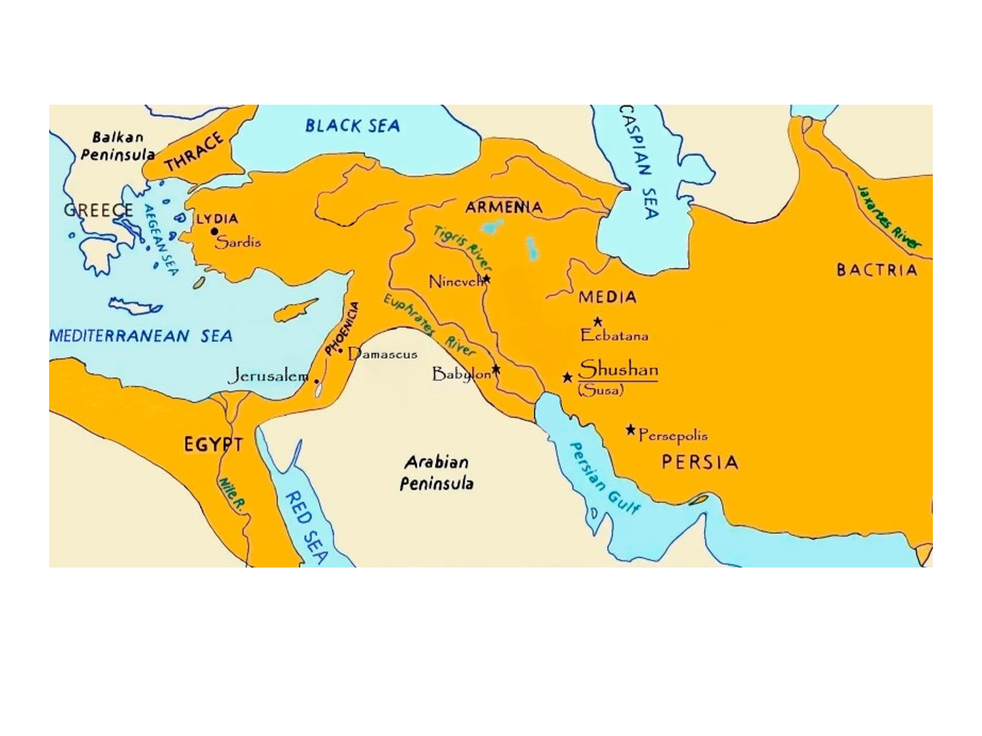
It is surmised that Haman may have still had a good number of supporters in the capital city. Whatever the case there were obviously a good number of people in this city that sought to do the Jews harm and 500 of them were killed on this day.

And then 10 other cities are also mentioned as seen in verses 7-9.

7 Also Parshandatha, Dalphon, Aspatha,
8 Poratha, Adalia, Aridatha,
9 Parmashta, Arisai, Aridai, and Vajezatha—

10 the ten sons of Haman the son of Hammedatha, the enemy of the Jews—they killed; but they did not lay a hand on the plunder.

Evidently the 10 sons of Haman were also involved with those that sought to destroy the Jews on this day and consequently they were all killed. Note the emphasis here on the fact that Haman was “the enemy of the Jews”. Three times in the book we have this description given of Haman (3:10; 8:1; 9:10). He is a model arch enemy of the Jews very much in keeping with his Amalekite background and an enduring example of what eventually happens to them and those who align with them (cf. Ex. 17:16; Deut. 25:17-19; 1 Sam. 15).

But then note the “footnote” here in verse 10, “but they did not lay a hand on the plunder.” This is stated 3 times in this chapter as found in verse 10, 15, and 16.

According to king’s decree spelled out in 8:11 the Jews had permission to plunder their attackers and take their possessions. But they did not do so. Obviously, the Jews had agreed far and wide among themselves not to do – but why?
Well, we are not told but it is surmised that perhaps just like Abram refused to take anything from the king of Sodom lest he would say, “I have made Abram rich” – perhaps that same logic was in view here (Gen. 14:22-24).

Perhaps the Jews at this point recognized the sovereign hand of God and realized they were a “God-made” people and therefore it would be inappropriate to take anything from their enemies. After all, 500 years earlier Saul had the kingdom removed from him because he had dared to plunder the Amalekites contrary to what God had commanded (cf. 1 Sam. 15:3, 9, 17-19).

Then again perhaps the Jews were simply wanting to show to the whole of society that their motives were only about self-protection and not about self-enrichment which was clearly the converse of Haman and his edict which called for the plundering of all the Jews possessions (3:13).

11 On that day the number of those who were killed in Shushan the citadel was brought to the king.
12 And the king said to Queen Esther, “The Jews have killed and destroyed five hundred men in Shushan the citadel, and the ten sons of Haman. What have they done in the rest of the king’s provinces? Now what is your petition? It shall be granted to you. Or what is your further request? It shall be done.”

The king is really into favoring Esther at this point. In effect, he recounts what has happened in the capital city and asks for a report on what has happened in the rest of the empire. And then in effect asks if there is anything else he can do for her saying, “It shall be done.”

13 Then Esther said, “If it pleases the king, let it be granted to the Jews who are in Shushan to do again tomorrow according to today’s decree, and let Haman’s ten sons be hanged on the gallows.”

Esther did have one more request. She asked that the Jews be able to defend themselves and take care of their enemies one more day in the capital city. She did not ask this in reference to the entire empire, but only in reference to Shushan – the capital city.

It is surmised that Esther must have gotten word that on the next day there were some who were planning a revenge attack on the Jews for what had happened and so she was asking that they be able to defend themselves for yet another day.
In addition, she also asked that Haman’s sons (already dead) be hanged on the gallows which would make a statement throughout the capital city that no one is to mess with the Jews (cf. Deut. 21:22-23; Num. 25:4; 2 Sam. 21:6).

Slide # 6

One tradition relates that it was only the Amalekites, or Agagites, of the same lineage of Haman, who actually tried to slay the Jews as Haman had planned. – Henry M. Morris

It is probably not a stretch to think they were major instigators but the text itself does not say they were the only ones involved here.

14 So the king commanded this to be done; the decree was issued in Shushan, and they hanged Haman’s ten sons.

The king granted Esther’s request and it also was put into law and carried out.

15 And the Jews who were in Shushan gathered together again on the fourteenth day of the month of Adar and killed three hundred men at Shushan; but they did not lay a hand on the plunder.

The next day the Jews killed another 300 people – proving Esther was right in calling for another day to finish the job. In total the Jews killed 800 people in the capital city over these 2 days.

And note again the emphasis that they did not lay a hand on the plunder.

16 The remainder of the Jews in the king’s provinces gathered together and protected their lives, had rest from their enemies, and killed seventy-five thousand of their enemies; but they did not lay a hand on the plunder.

Here we have a summary statement of what happened in the rest of the empire. As the Jews came together to protect themselves a total of 75,000 of their enemies were killed.

It is estimated that in the Persian empire at this time there were about 100 million people total, so this was a sizeable amount of people that were killed by the Jews on this day.
Just imagine if there had been no counter command and the Jews were not allowed to defend themselves. Indeed, it would have been a blood bath for the Jews with so many thousands still wanting them destroyed after the counter decree.

But as it was, we have no record of even a single Jew being killed on this day or on the follow up day in the capital.

Note the footnote: “had rest from their enemies”.

Slide # 7

Deuteronomy 25:17–19 (NKJV)
17 “Remember what Amalek did to you on the way as you were coming out of Egypt,
18 how he met you on the way and attacked your rear ranks, all the stragglers at your rear, when you were tired and weary; and he did not fear God.
19 Therefore it shall be, when the Lord your God has given you rest from your enemies all around, in the land which the Lord your God is giving you to possess as an inheritance, that you will blot out the remembrance of Amalek from under heaven. You shall not forget.

Slide # 8

In Deut. 25:17-19, Moses linked the people’s continued rest from their enemies with the command to “blot out the remembrance of Amalek from under heaven.” In this chapter, the blessing of rest for the Jewish people is associated with the destruction of their enemies (vv. 18, 22). This similarity with Deuteronomy reinforces the argument that Haman was a descendant of the Amalekites. This group may have been quite large by the time of King Ahasuerus.
– The Nelson Study Bible

17 This was on the thirteenth day of the month of Adar. And on the fourteenth of the month they rested and made it a day of feasting and gladness.

This becomes the making of the holiday known as Purim which we will deal with next time. As we will see the Jews in the capital city put off their festive celebrating until one day later because they were still dealing with some “unfinished business” on the 14th but they got there.
For secular historians this holiday is almost completely ignored or overlooked, but for the Jews it is a “never to be forgotten holiday” in history and is still carried on year after year.

This is one of the great occasions in the history of Israel during the times of the Gentiles in which God providentially intervened to preserve His people. This is largely His mode of operation during the times of the Gentiles leading up to the 70th week of Daniel.

Slide # 9

586 B.C. A.D. 33 ?
Babylonian Cross [Church Age….. ] 70th Week of Daniel
Exile

The Times of the Gentiles………………………………………………………

God’s Face is Hidden

All the way through the Times of the Gentiles until in the context of the 70th Week of Daniel at the time of war of Gog and Magog God’s face remains hidden from Israel. In other words, overt direct miraculous intervention that is clearly a God-thing is not seen. What is in view during this time is God’s providential workings – preserving His people in spite of themselves.

Slide # 10
Ezekiel 39:23–24 (NKJV)
23 The Gentiles shall know that the house of Israel went into captivity for their iniquity; because they were unfaithful to Me, therefore I hid My face from them. I gave them into the hand of their enemies, and they all fell by the sword.
24 According to their uncleanness and according to their transgressions I have dealt with them, and hidden My face from them.” ’

The story of Esther is a classic example of God’s providential care during the Times of the Gentiles. We don’t see God’s face – we don’t even have His Name mentioned, but His providence care is unmistakable!

A spectacular example God’s hidden face and yet providential care of Israel was seen in the 6-day war of 1967. Life Magazine reported it this way:

Astounding was the only word for it. In 60 hours the war that exploded upon the Middle East became a fact of history. Tiny Israel stood in the role of victor over the surrounding Arab nations that had vowed to exterminate her. Middle Eastern alliances, balances of power, even political boundaries, were of a new shape, as though mutated by a Biblical cataclysm. Seldom in military history has victory been so efficient or so visibly decisive in so short a span of time. So swiftly did Israel mount her assault that her adversaries were deprived of the means of winning almost before the world awakened to the fact a war was in progress. … The Israelis experienced an ecstasy which is given to few people of any generation to know. (Life, June 16, 1967, pp. 38, 38a)

Yes, indeed the providential care of God for His people Israel is still very much a reality and will be in place until God once again miraculously intervene and shows His face in the war of Gog and Magog.

Until then God’s face remains hidden, but His providential finger prints are all over Israel’s continued existence and preservation.

And praise God. His providential care of Israel is also continually manifest in our lives as well. We are in His sovereign good care! And we can rest easy there!

Praise God for His providential care!

