SBC – Dec. 19, 2021
“Christ – The Glory Connection”

Once again, we are celebrating the birth of Christ. And certainly, it is appropriate that we celebrate. Without the birth of Christ, we would have no salvation – no hope of GLORY!

On the night of His birth the angels couldn’t contain themselves and burst out in praise saying, “Glory to God in the highest and on earth peace, goodwill toward men!” (Lk. 2:14). The Shepherds on that same night went in haste to see the newborn Christ child.

There are many wonderful emphases in relation to the birth of Christ and the incarnation. We marvel at the prophecies fulfilled even telling us the specific place He would be born 700 years before it happened.

Slide # 1

Micah 5:2 (NKJV)
“But you, Bethlehem Ephrathah, Though you are little among the thousands [clans] of Judah, Yet out of you shall come forth to Me The One to be Ruler in Israel, Whose goings forth are from of old, From everlasting.”

You see there were TWO Bethlehems in Israel. One was up north called “Bethlehem of the North” or “Bethlehem of Galilee”. And then there was “Bethlehem of Judah” called Bethlehem Ephrathah in Micah 5:2 with Ephrathah being the old name for Judah.

Slide # 2
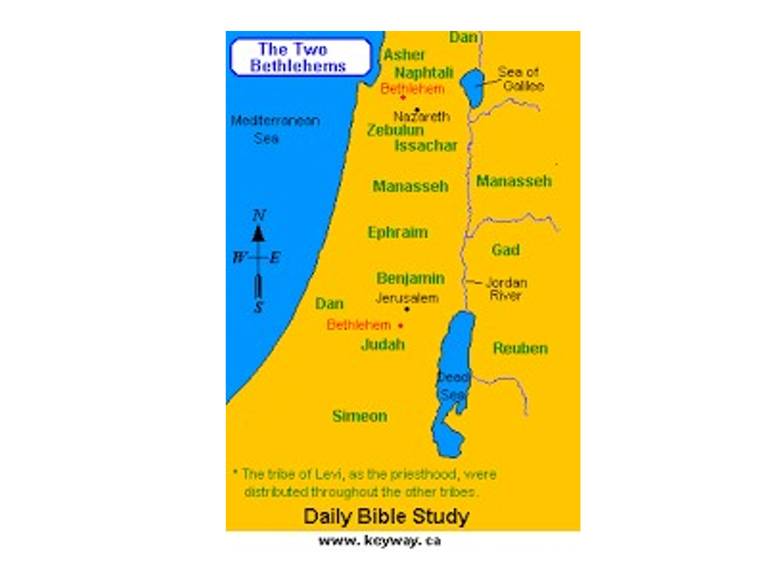
It wasn’t enough just to predict the Messiah would be born in Bethlehem - the exact address, with the exact zip code had to be right – and it was!
Even though Israel as a nation claims sovereignty, yet within the country there are many pockets that are controlled by the Arabs. One of those pockets is Bethlehem. Jews are not allowed in.

When we were in Israel our Jewish guide took us to a place in Jerusalem in which we could look over into Bethlehem and as he showed us the site, he said this is where Jesus was born. I couldn’t resist and I asked him “Why?” His response was, “Because I said so”. I said, “No, because the prophet said so.”. How true! This is where the prophet Micah said the Messiah would be born 700 years in advance and the Jewish leaders knew it full well.

Slide # 3
Matthew 2:1–6 (NKJV)
1 Now after Jesus was born in Bethlehem of Judea in the days of Herod the king, behold, wise men from the East came to Jerusalem,
2 saying, “Where is He who has been born King of the Jews? For we have seen His star in the East and have come to worship Him.”
3 When Herod the king heard this, he was troubled, and all Jerusalem with him.
4 And when he had gathered all the chief priests and scribes of the people together, he inquired of them where the Christ was to be born.
5 So they said to him, “In Bethlehem of Judea, for thus it is written by the prophet:
6 ‘But you, Bethlehem, in the land of Judah, Are not the least among the rulers of Judah; For out of you shall come a Ruler Who will shepherd My people Israel.’ ”

Thus, there are many fascinating insights related to the incarnation, but this morning I want to zero in on the word “glory”. There is a tremendous “glory theme” associated with Christ coming into the world as a man. And this “glory theme” is often touched on in our Christmas songs.

Silent night, holy night,
Shepherds quake at the sight,
Glories stream from heaven afar,
Heavenly hosts sing alleluia;
Christ the Savior, is born!
Hark! the herald angels sing Glory to the new-born King!
Peace on earth and mercy mild, God and sinners reconciled!
The old song says…

In the beauty of the lilies Christ was born across the sea,
With a glory in His bosom that transfigures you and me;

There is a glory found and revealed in the Person of Christ that is way beyond us! And we want to think about this glory this morning!

I want to consider with you…

- Christ came to reveal the GLORY of God to us.
- Christ came to make it possible for us to share in His glory.
- Christ came to bring many sons to eternal glory.

Slide # 4
Glory (Main Hebrew Word) kabod = “weight” used figuratively of that which carries heavy significance.

Glory (Main Greek Word) doxa = bright, excellence, splendor, brilliance, radiance, awesomeness.

Slide # 5
Glory isn't so much a thing as it is a description of a thing. Glory isn't a part of God; it's all that God is. Every aspect of who God is and every part of what God does is glorious. But even that's not enough of a description. Not only is he glorious in every way, but his very glory is glorious! (emphasis mine) – Paul Tripp

Glory is the indescribable, overwhelming, splendor and awesomeness of God’s PERSON and PRESENCE. It includes God’s beauty, power, and character. When thinking about God’s GLORY commentators often use the word AWESOME, but I would like to coin another word that can only be used only in reference to describing God’s glory and that is the word GODSOME! Godsome is God-awesome! It is awesome that applies singularly to God ALONE! In Isa. 42:8 God says He will not share His glory with any other. God’s glory is His glory ALONE!

God’s glory is thus indescribable (that is no description completely does it justice), and incomprehensible (in that we can never comprehend the full breadth of it). The glory of God is truly Godsome!

We see something of the glory of God in creation.
Slide # 6

Psalm 19:1 (NKJV)
1 The heavens declare the glory of God; And the firmament shows His handiwork.

Slide # 7
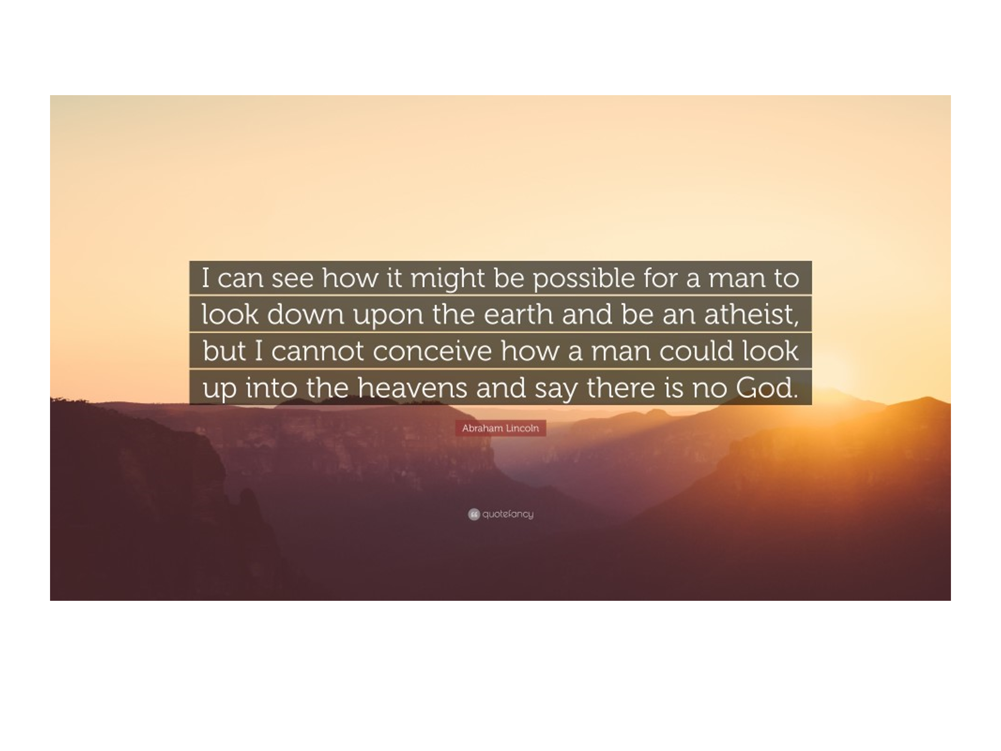
But it is broader than the heavens…

Slide # 8
Isaiah 6:3 (NKJV)
3 And one cried to another and said: “Holy, holy, holy is the Lord of hosts; The whole earth is full of His glory!”

All things which God has created on earth express his glory. His wisdom, goodness, power, and holiness, are seen every where. The whole of nature is an outstretched finger pointing to the glory of God. For this reason Romans 1:20 says people are “without excuse”.

People claim they can’t find God. Well, they can’t find God for the same reason the criminal can’t find the police – they aren’t looking for Him.
As Romans 1:18 says people suppress the truth which God has clearly shown to them (cf. Rom. 1:19; Ps. 19:1-6).

Slide # 9
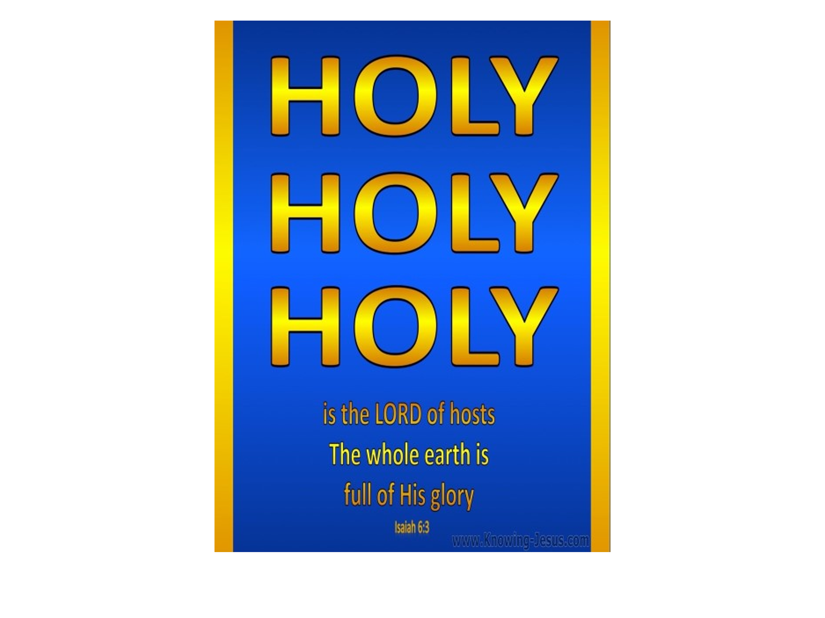
Holy means “unique”. There is none other like God (cf. Isa. 40:18, 25). And the whole earth testifies to the unique GLORY of God.

Even though God’s glory is on display everywhere there are times when God puts His glory uniquely on display in a dramatic and overt fashion. Such occurrences in the OT were times when people saw what they called the Shekinah glory. The word “Shekinah” literally means “to dwell”. The Jews used this word to refer to the radiance of God’s immanent presence.

God’s Shekinah glory was first manifest at the children of Israel left Egypt in the Exodus. As they journeyed God’s presence was visibly manifest in a cloudy pillar by day and a fiery pillar by night.

Slide # 10

Exodus 13:21–22 (NKJV)
21 And the Lord went before them by day in a pillar of cloud to lead the way, and by night in a pillar of fire to give them light, so as to go by day and night.
22 He did not take away the pillar of cloud by day or the pillar of fire by night from before the people.

Slide # 11
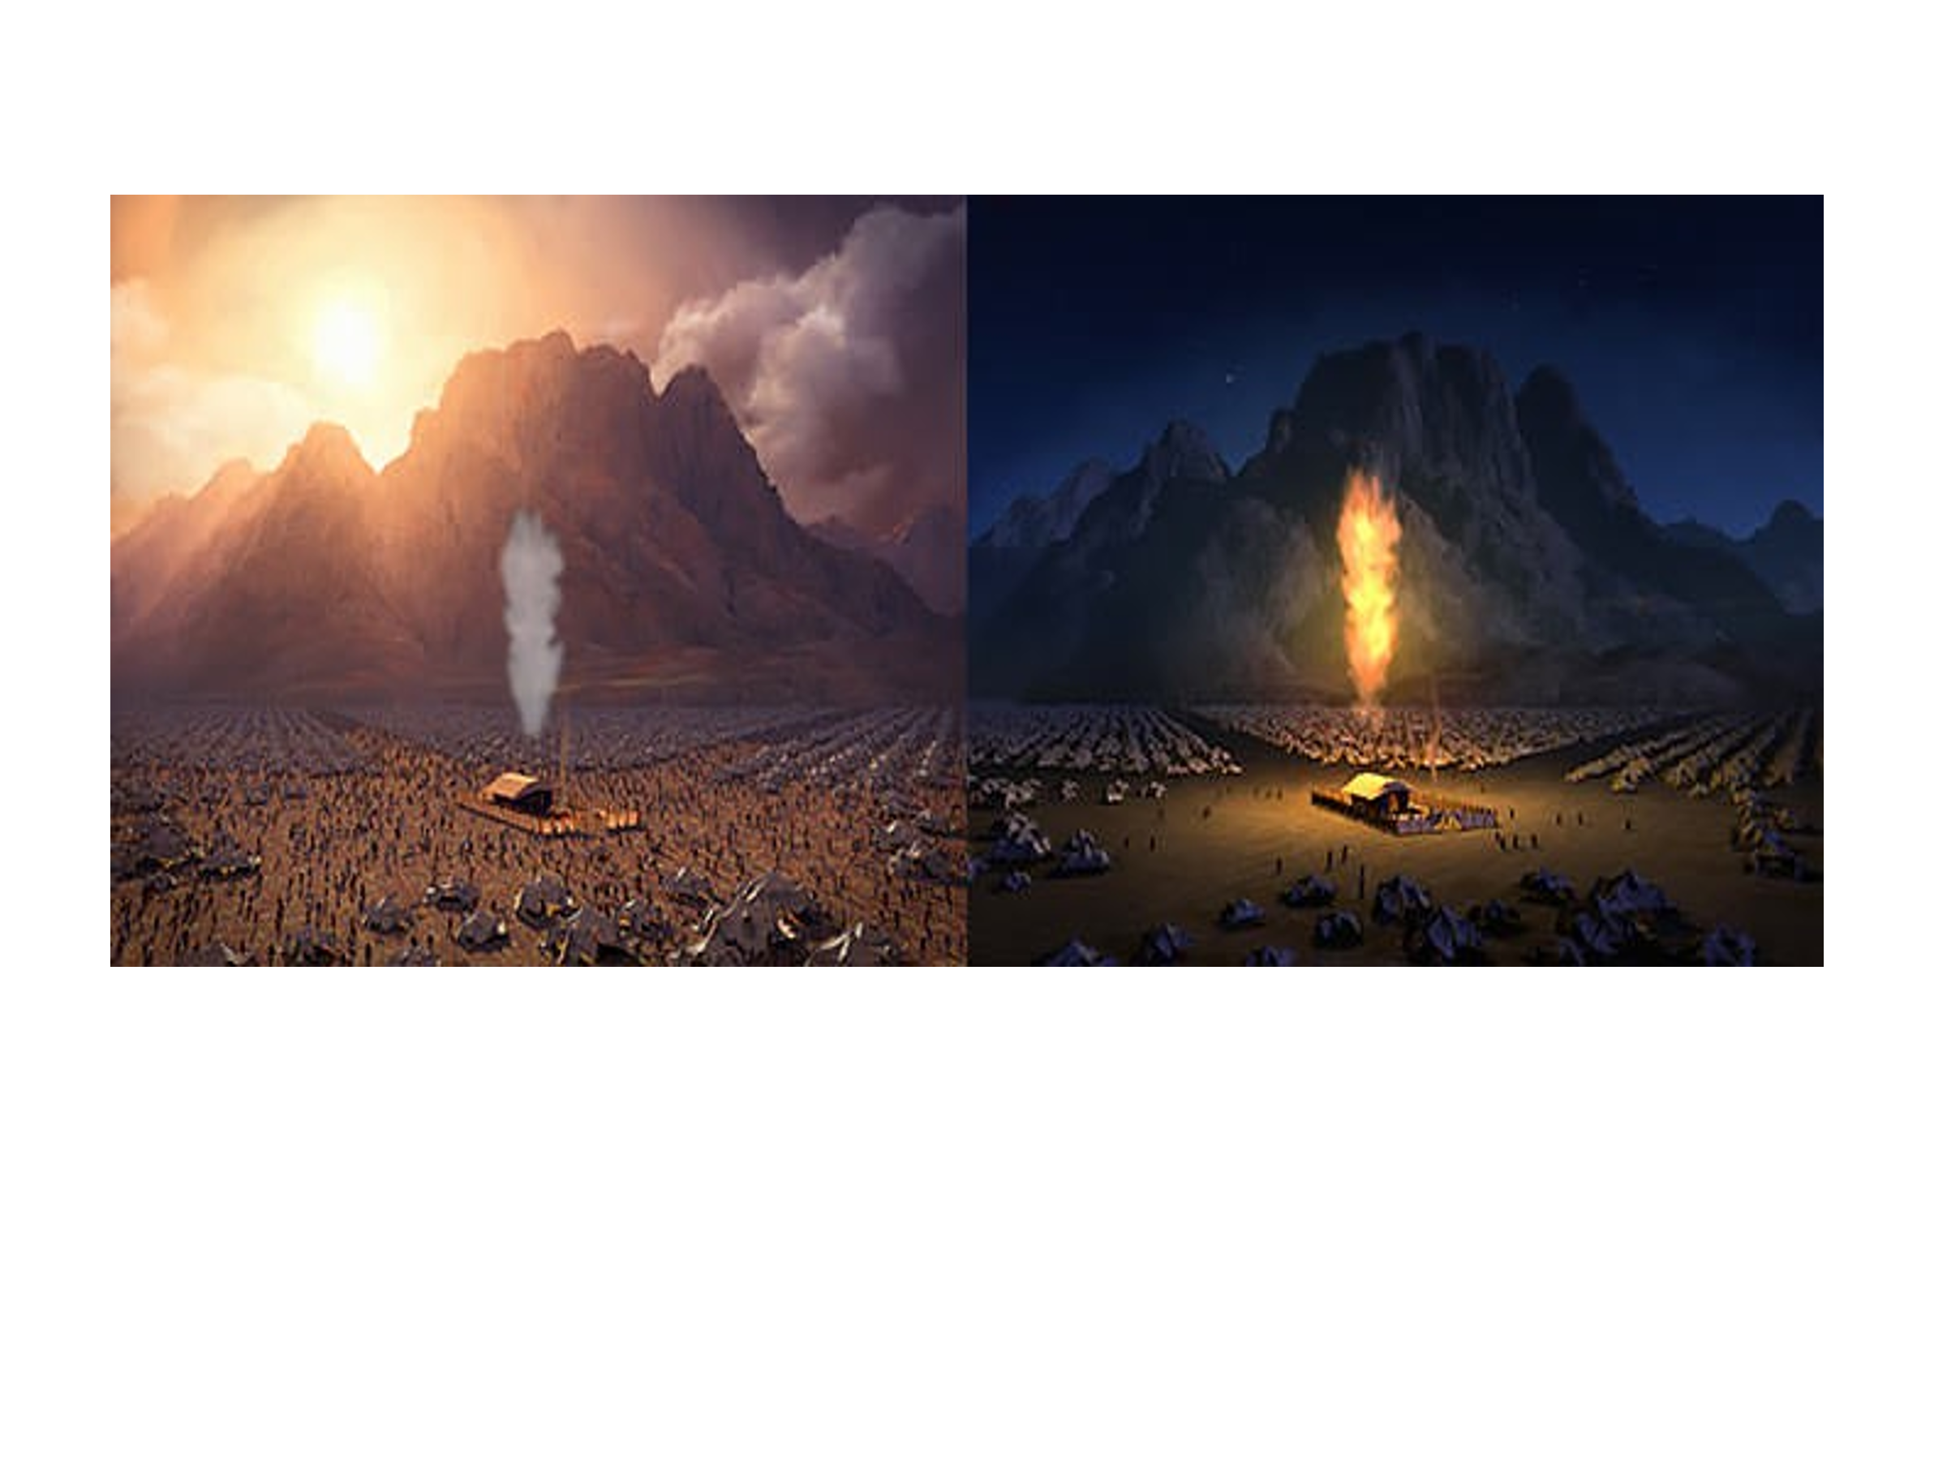
Human beings are fascinating! Humanity is the crowning work of God’s creation. As God went along in creation week we have the repeated phrase “And God saw that it was good”. But only after God created mankind as the finishing touch of creation – only then does it say, “VERY GOOD” (Gen. 1:31). God Himself was impressed with the whole of His creation – but especially the crowning work of making people in His very own image.

Slide # 12
Psalm 139:14 (NKJV)
14 I will praise You, for I am fearfully and wonderfully made; Marvelous are Your works, And that my soul knows very well.

Human beings uniquely fashioned in God’s image have the unique potential to know God, to appreciate God, to be true worshipers. Human beings are created with a God-consciousness. We are created with a moral constitution involving a conscience. Now indeed, a conscience can be hardened, weak, etc., and depravity has so messed us up that apart from divine intervention we never get back on track – indeed we don’t even so much as seek God on our own (Rom. 3:11).

Still, even fallen humanity still bears the image of God in a very marred sense (cf. Ja. 3:9). Universally, people have a God-consciousness (albeit suppressed – Rom. 1:18-20); universally people have a moral conscience – albeit skewed (Rom. 2:15), universally people have a fear of death and judgment (cf. Heb. 2:15); universally God has put eternity in the hearts of people where nothing here totally satisfies (Eccl. 3:11).

Slide # 13
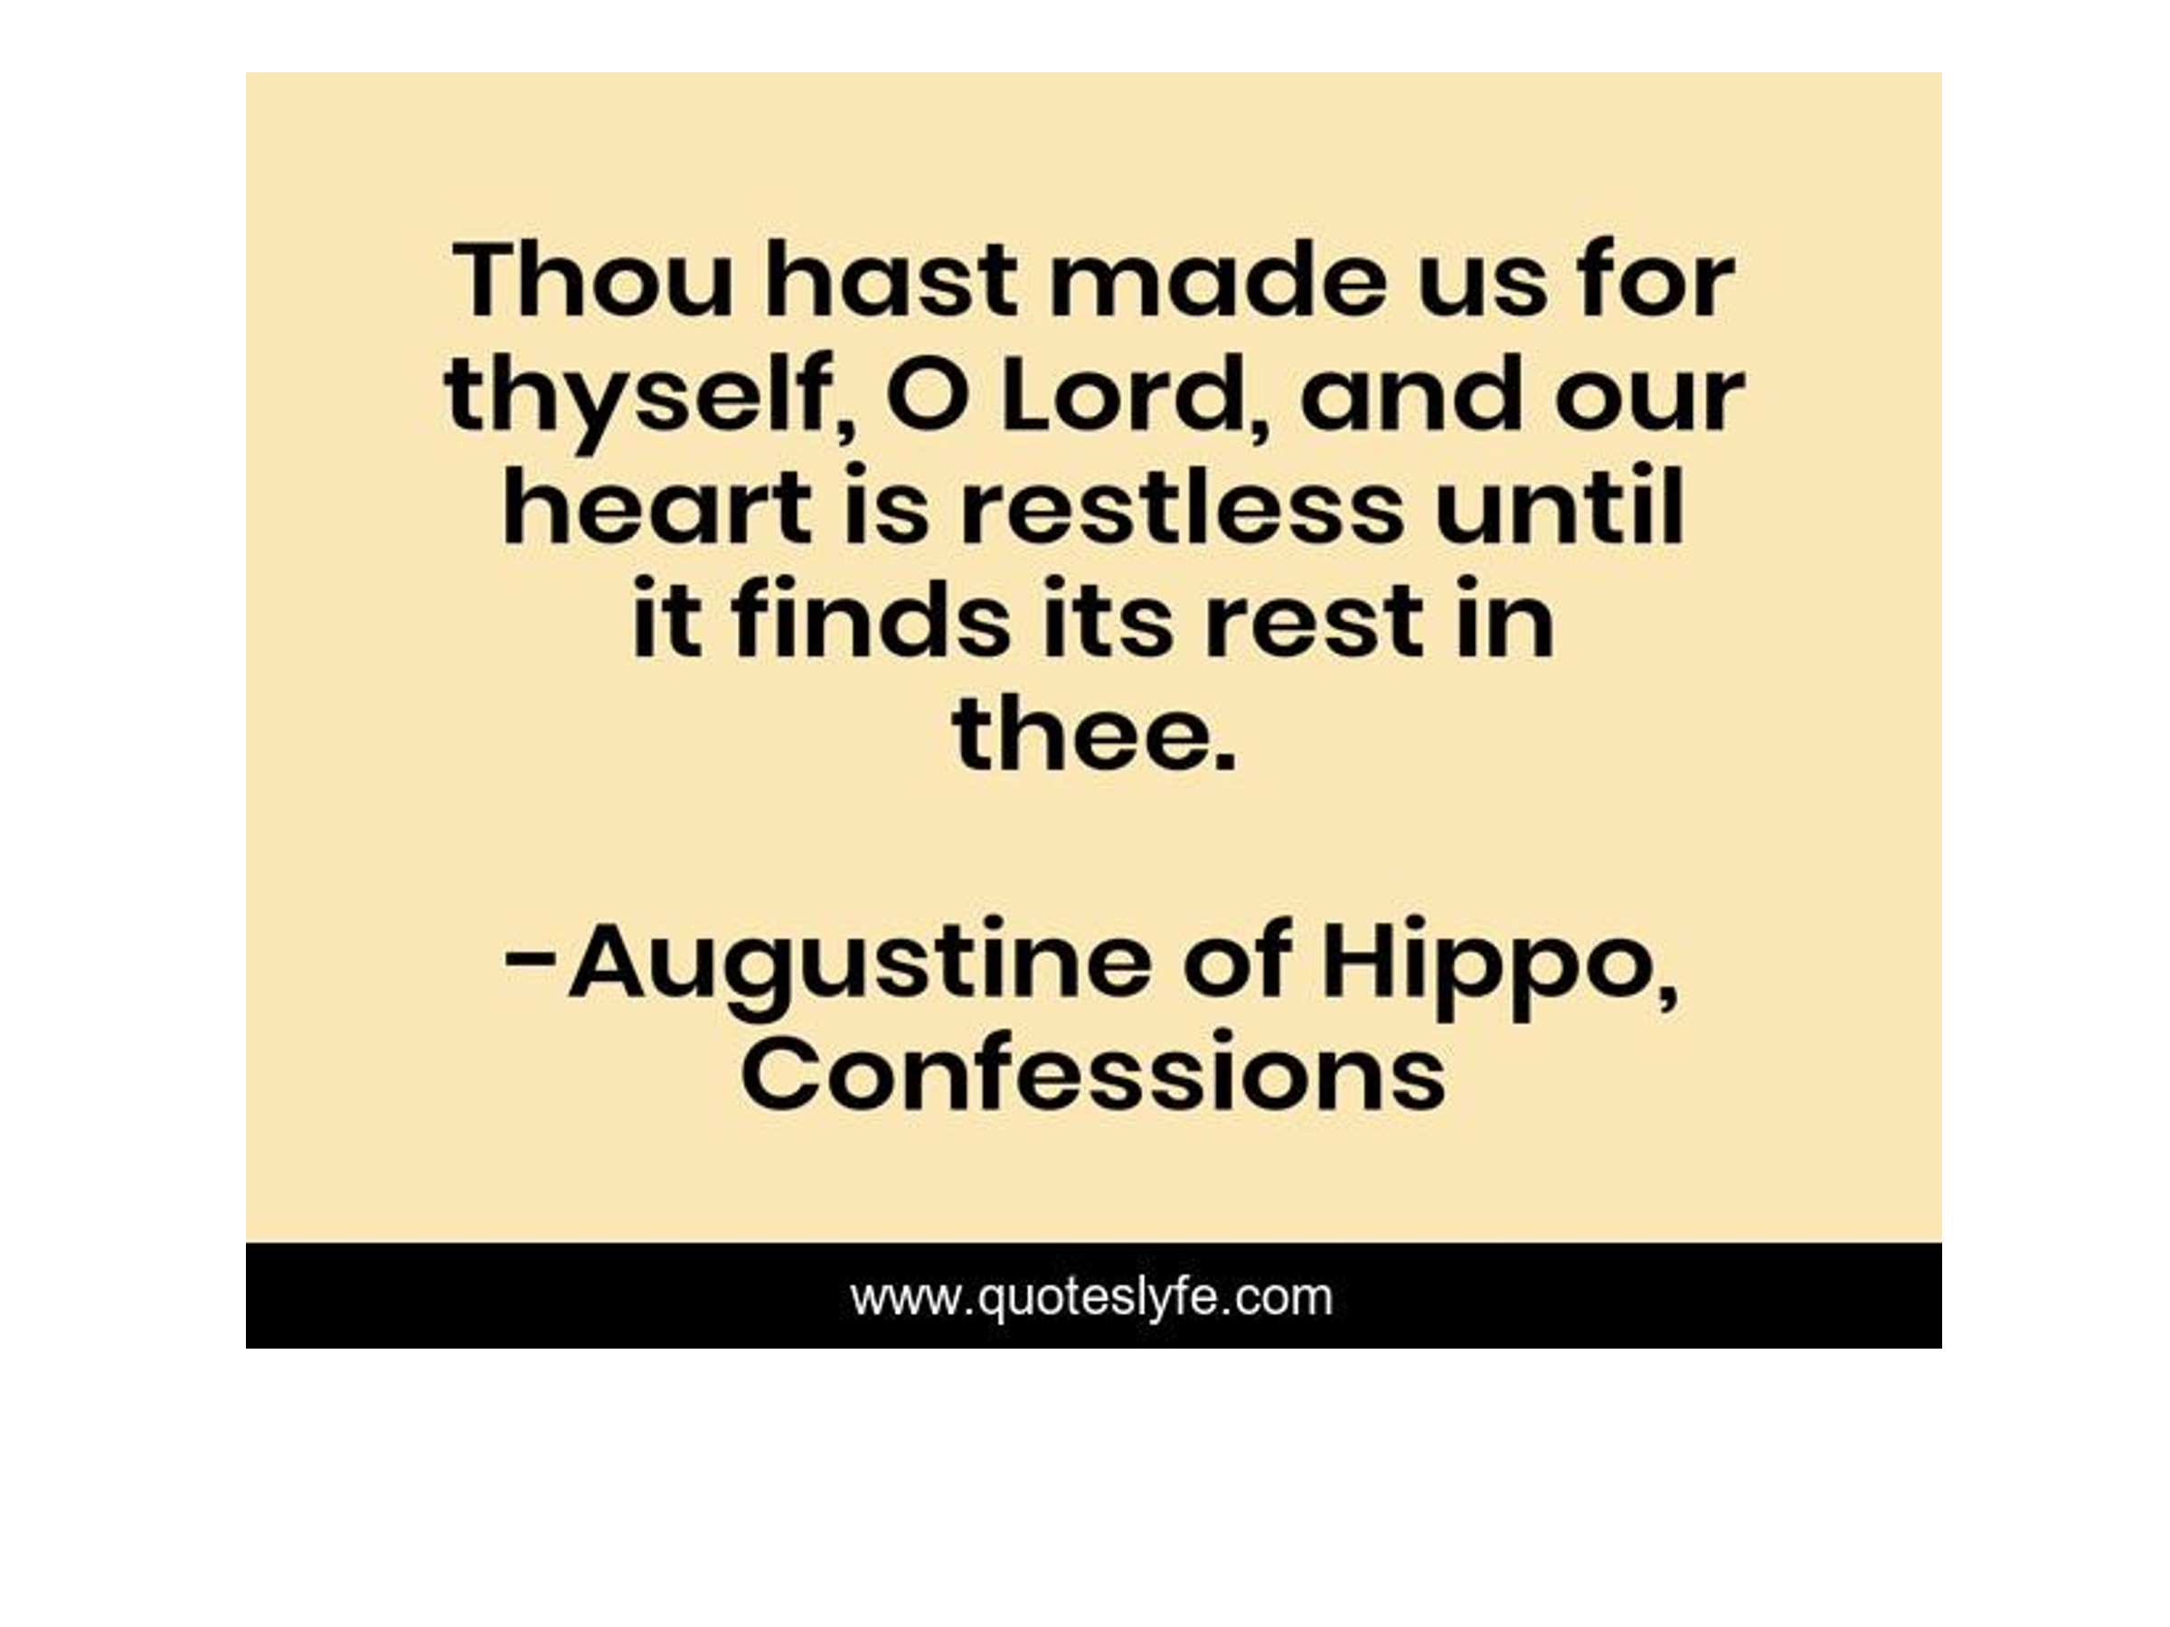
In a very real sense we were created in God’s image so that we might marvel at the GLORY of God and worship Him for Who He is in all His GLORY! Thus, ultimately God’s story is about GLORY! The story about Jesus is a GLORY STORY! And here is the exciting part – by the grace of God we as believers have a part in this glory-story. God had the crowning work of His creation in mind all along!

Jesus came from glory, revealed God’s glory, went to back to glory, and is one day going to take all God’s children to glory! Thus, Christ came to earth on a GLORY-MISSION that directly had humanity in view.
In the Bible we see both GENERAL revelation and SPECIAL revelation. We see the truth of God’s glory in general revelation (creation) in a general sense. But then there are occasions where God through special revelation reveals His glory in a very direct, special, and specific manner.

Following creation week the greatest demonstration of SPECIAL revelation that put God’s glory on display in spectacular fashion was the 10 plagues God brought against Egypt in the context of the Exodus. This unique series of miracles is the major miraculous HIGHLIGHT in the whole of the OT following creation week. It is referred to hundreds of times in the Scriptures.

In the OT the major miraculous event was the Exodus and in the NT it is the resurrection of Jesus Christ.

Slide # 14

Exodus 9:16 (NKJV)
But indeed for this purpose I have raised you up, that I may show My power in you, and that My name may be declared in all the earth.

It was in the context of the story of the Exodus that God revealed to Moses that His eternal Name is “I AM” (cf. Ex. 3:13-15). I AM simply means “to be”. God simply is! I AM signifies that He is the eternal, unchanging God. It was in the context of the story of the Exodus that God clearly revealed His covenant Name YHWH to the children of Israel. Thus, the GLORY of God through special revelation was clearly put on display in relation to the Exodus.

Following the Exodus God through special revelation gave what is called “The Law of Moses” to Moses. This too revealed much about the kind of God that He is. In that context at one point Moses asked God to show him His glory. God responded, “You cannot see My face; for no man shall see Me, and live.” (Ex. 33:20). No mortal can see God in His full glory and live!

So, in Exodus 33 God told Moses that He would allow Moses to see His back (only a partial view) of His glory as it passed by (cf. Ex. 33:21-23). God here used anthropomorphic terms meaning they speak of God in terms of human language. It is an accommodation to our limited ability to comprehend God; Who, in reality, is Spirit (cf. Jn. 4:23-24).

Slide # 15
Exodus 34:6–8 (NKJV)
6 And the Lord passed before him and proclaimed, “The Lord, the Lord God, merciful and gracious, longsuffering, and abounding in goodness and truth,
7 keeping mercy for thousands, forgiving iniquity and transgression and sin, by no means clearing the guilty, visiting the iniquity of the fathers upon the children and the children’s children to the third and the fourth generation.”
8 So Moses made haste and bowed his head toward the earth, and worshiped.

Note what God here revealed about His glory. It has much to do with His character. He proclaimed the name of YHWH. This is a revelation of His CHARACTER. The reality of God can be known from natural revelation – that is, from nature; as seen in Romans 1. However, the CHARACTER of God is known only by His own self-disclosure through special revelation; which is what we have here.

God begins by pronouncing His name, YHWH, twice. Whenever God repeats something, it is for emphasis. The name YHWH, by itself, means “self-existent” or “eternal”. It refers to God’s unchanging faithful character! And in Ex. 3, God attached this name to His covenant relationship with the people of Israel; which therefore signifies the “eternal God in an everlasting unchanging relationship with Israel”. Therefore, this NAME YHWH is referred to as the covenant NAME for God. It is considered God’s most sacred name.

When stated the second time, it is here linked with El – translated as “God” meaning “Supreme Deity”. So, the sense here is: YHWH passed before Moses and proclaimed “The eternal unchanging God in everlasting relationship with Israel – the eternal unchanging God in everlasting relationship with Israel – the Supreme Deity”.

Having doubly emphasized His most sacred covenant name, God then further disclosed His nature. He is sharing deeply about what kind of a God He really is.

The FIRST thing God reveals about Himself is that He is MERCIFUL. Isn’t that a wonderful reality? This word means “compassionate”. He is a God Who really cares. Linked with merciful is GRACIOUS. This refers to God’s undeserved favor. LONGSUFFERING means “slow to anger”. God is patient – He gives space for repentance (cf. 2 Pet. 3:9).
ABOUNDING IN GOODNESS. Goodness is the Hebrew word “hesed”, which is often translated “loving-kindness”, “steadfast love” or “loyal love”.
And TRUTH is the idea of faithful, truthfulness, loyal, dependable. But note He is also HOLY in that He cannot overlook sin.

How can it be that God by no means clears the guilty and at the same time He is merciful and forgiving of all kinds of sin. Well, implied between these two emphases is what the whole counsel of God teaches; namely, that those who reject God’s grace –those who refuse to avail themselves of it through repentance and faith, will by no means be cleared. Their guilt remains. If one rejects God’s forgiveness, they will “by no means be cleared”.

Note these attributes define God. They are His glory! God’s glory here has everything to do with the kind of God that He is. It has everything to do with His person, His nature, and His character.

Now fast forward to the birth of Christ – the incarnation of God in a human body. God had previously revealed His glory in creation, in special revelation events such as the Exodus, but now God was about to reveal His glory on a greater level than ever before.

- Christ came to reveal the GLORY of God to us in the context of a human body.

In 1 Cor. 2:8 Jesus is called “the Lord of glory”. In John 17:5 Jesus prayed, “O Father, glorify Me together with Yourself, with the glory which I had with You before the world was.” Jesus is the Lord of glory who came from glory and He brought the glory with Him. In the person of Christ glory came down.

But until His public ministry the glory of Christ was largely veiled. To all appearances Jesus looked like a regular person – in fact not to impressive at all. No one saw His glory as it was veiled.

Slide # 16

Isaiah 53:2 (ESV)
2 For he grew up before him like a young plant, and like a root out of dry ground; he had no form or majesty that we should look at him, and no beauty that we should desire him.

However, with Christ entering into His public ministry the GLORY of Who He was began to be revealed in snap shots of special revelation.

Slide # 17

John 1:1 (NKJV)
1 In the beginning was the Word, and the Word was with God, and the Word was God.

John 1:14 (NKJV)
14 And the Word became flesh and dwelt among us, and we beheld His glory, the glory as of the only begotten of the Father, full of grace and truth.

John 1:18 (NKJV)
18 No one has seen God at any time. The only begotten Son, who is in the bosom of the Father, He has declared Him.

The GLORY of Christ was that He uniquely put God on display in the context of a human body as only He could. He was fully God bottled up in a human body. That is Godsome!

After Jesus performed His first supernatural miracle in turning water into wine the Scripture says this:

Slide # 18

John 2:11 (NKJV)
11 This beginning of signs Jesus did in Cana of Galilee, and manifested His glory; and His disciples believed in Him.

In John 14:9 Jesus told Phillip, “He who has seen Me has seen the Father”. To see Jesus was to see God! And to see the truth of this is to see His GLORY! Col. 2:9 says “in Him dwells all the fullness of the Godhead bodily”. Paul in 1 Tim. 3:16 spoke of the great mystery in which in the Person of Christ “God was manifested in the flesh”.

In summary form John tells us a KEY reason that Jesus came was to reveal the truth of God to us.

Slide # 19

1 John 5:20 (NKJV)
20 And we know that the Son of God has come and has given us an understanding, that we may know Him who is true; and we are in Him who is true, in His Son Jesus Christ. This is the true God and eternal life.

The Scripture was clear that only God can save – ONLY God is Savior!

Slide # 20

Isaiah 43:11 (NKJV)
11 I, even I, am the Lord, And besides Me there is no savior.

Isaiah 45:21–22 (NKJV)
21 … And there is no other God besides Me, A just God and a Savior; There is none besides Me.
22 “Look to Me, and be saved, All you ends of the earth! For I am God, and there is no other.

God alone is Savior and besides Him there is no Savior!

And yet, the penalty of sin is death. Man is guilty and it must be man that pays for it. How can God alone be Savior and yet it be that man pays for the guilt of sin? A. God Himself became a man in the person of Christ. As God, Jesus can be Savior, and as a man, He is humanities representative who pays for our sin debt. God’s answer to this dilemma is the God-Man as found in the person of Jesus Christ. This is His glory. It is a Godsome thing!

In the words of the apostle Paul, “Christ the power of God and the wisdom of God.” (1 Cor. 1:24). It is this great and glorious truth that was made known to Joseph prior to the birth of the Christ child.

Slide # 21

Matthew 1:21–23 (NKJV)
21 And she will bring forth a Son, and you shall call His name Jesus, for He will save His people from their sins.”
22 So all this was done that it might be fulfilled which was spoken by the Lord through the prophet, saying:
23 “Behold, the virgin shall be with child, and bear a Son, and they shall call His name Immanuel,” which is translated, “God with us.”

It was this truth that was revealed to Mary by the angel Gabriel prior to the birth of Christ as seen in Mary’s response in Luke 1:47.

Slide # 22

Luke 1:47 (NKJV)
47 And my spirit has rejoiced in God my Savior.

It was this truth that was announced by the angels to the shepherds on the birthday of Jesus Christ.

Slide # 23

Luke 2:11 (NKJV)
11 For there is born to you this day in the city of David a Savior, who is Christ the Lord.

- Christ came to make it possible for us to share in His glory.

We were created by God in His image that we might share deeply with Him. That our fellowship might be with Him. That we on a very deep level might experience His glory and adore Him and worship Him because of it.

But sin ruined everything! The fall of mankind brought death and separation from God. Now instead of a glorious relationship with God mankind knew separation from God’s life and glory.

Enter Jesus Christ to remedy the situation.

Slide # 24

Hebrews 2:14–15 (NKJV)
14 Inasmuch then as the children have partaken of flesh and blood, He Himself likewise shared in the same, that through death He might destroy him who had the power of death, that is, the devil,
15 and release those who through fear of death were all their lifetime subject to bondage.

On the eve of His crucifixion, Christ in what is called His High Priestly prayer, made this request of the Father…

Slide # 25

John 17:24 (NKJV)
24 “Father, I desire that they also whom You gave Me may be with Me where I am, that they may behold My glory which You have given Me; for You loved Me before the foundation of the world.

It was Christ’s death on the cross that makes this possible! Jesus was born to die so that we might live with Him in glory.

Slide # 26

Colossians 1:13–14 (NKJV)
13 He has delivered us from the power of darkness and conveyed us into the kingdom of the Son of His love,
14 in whom we have redemption through His blood, the forgiveness of sins.

The basis for us having a position in the kingdom is all because of the blood of Christ that makes possible the forgiveness of sins. Indeed, a Savior was born Who is Christ the Lord. And He became our Savior by dying for all our sins. And He becomes our personal Savior when we believe on Him as our personal Lord and Savior.

Slide # 27

1 Timothy 4:10 (NKJV)
…we trust in the living God, who is the Savior of all men, especially of those who believe.

Jesus is the Savior of all men (potentially) but effectually and actually only of those who believe on Him. To make salvation yours you must personally believe on the Lord Jesus Christ. As John 1:12 says, “as many as received Him, to them He gave the right to become children of God, to those who believe in His name”.

Our glory journey begins with saving faith. In saving faith, we come to see the GLORY of God in the person of Jesus Christ. Saving faith is a life changing reality from which we never recover.

In saving faith we see Jesus in a way we have never seen Him before. We see His glory as God. We see it personally – we appropriate the truth of it personally. No one can see Jesus in this way and remain unchanged.
When Saul who became the apostle Paul saw the living/risen Christ on the road to Damascus it forever changed Him. He was never the same thereafter.

Slide # 28

Acts 22:6–11 (NKJV)
6 “Now it happened, as I journeyed and came near Damascus at about noon, suddenly a great light from heaven shone around me.
7 And I fell to the ground and heard a voice saying to me, ‘Saul, Saul, why are you persecuting Me?’
8 So I answered, ‘Who are You, Lord?’ And He said to me, ‘I am Jesus of Nazareth, whom you are persecuting.’
9 “And those who were with me indeed saw the light and were afraid, but they did not hear the voice of Him who spoke to me.
10 So I said, ‘What shall I do, Lord?’ And the Lord said to me, ‘Arise and go into Damascus, and there you will be told all things which are appointed for you to do.’
11 And since I could not see for the glory of that light, being led by the hand of those who were with me, I came into Damascus.

Saul’s conversion was a Lordship experience. When he saw the glory of the Lord and submitted to it, he was forever a changed man. In saving faith we have a similar experience – spiritually speaking.

Slide # 29

2 Corinthians 4:3–6 (NKJV)
3 But even if our gospel is veiled, it is veiled to those who are perishing,
4 whose minds the god of this age has blinded, who do not believe, lest the light of the gospel of the glory of Christ, who is the image of God, should shine on them.
5 For we do not preach ourselves, but Christ Jesus the Lord, and ourselves your bondservants for Jesus’ sake.
6 For it is the God who commanded light to shine out of darkness, who has shone in our hearts to give the light of the knowledge of the glory of God in the face of Jesus Christ.

In believing we come to see the “light of the gospel of the glory of Christ” which is the GLORY of God in the person of Jesus Christ. The true gospel is the gospel of the glory of Christ and Who He is as Lord-God.
This begins our “glory journey” but on the journey we are being transformed little by little into the image of Christ.

Slide # 30

2 Corinthians 3:18 (NKJV)
18 But we all, with unveiled face, beholding as in a mirror the glory of the Lord, are being transformed into the same image from glory to glory, just as by the Spirit of the Lord.

Those who have come to see the truth of Christ’s glory are changed by it and are being changed by it more and more as we behold His glory. This too is part of the glory story! But the end of the story is we as believers are headed for kingdom glory in which we will share intimately in God’s glory forever!

- Christ came to bring many sons to glory.

Christ came to reveal the glory of God to us in His person; He came to pay our sin debt so that we might share in His glory and even now as believers we are being changed as we behold His glory. And then finally, Christ is one day going to take us home to glory – into the very intimate presence of God where we will live forever.

We sing a song: “I’ve a home prepared where the saints abide, just over in the glory-land…”. That is the homeland. Brother Fay Green years ago use to talk about “the glory land” and now he has gone there.

Slide # 31

Hebrews 2:10 (NKJV)
10 For it was fitting for Him, for whom are all things and by whom are all things, in bringing many sons to glory, to make the captain of their salvation perfect through sufferings.

This is what Christ came to accomplish – to in the end bring MANY sons to glory. I am one of them – how about you? We are on our way to GLORY. Christ is bringing us ultimately home to GLORY – to the very intimate presence of God.

When you see a gorgeous sunset does it not fill your heart with wonder and awe. It is Godsome! But just think if the underside of heaven looks this glorious, what must the upper side look like. We can’t even imagine!

One day Jesus is going to come and when He returns to earth the second time He will come “with power and great glory” (Mt. 24:30). In the kingdom Isaiah prophesies…

Slide # 32

Isaiah 40:5 (NKJV)
5 The glory of the Lord shall be revealed, And all flesh shall see it together; For the mouth of the Lord has spoken.”

Habakkuk 2:14 (NKJV)
14 For the earth will be filled With the knowledge of the glory of the Lord, As the waters cover the sea.

Up to this point in history we see God’s general revelation of His glory in nature; we have certain recorded events where He showed His glory in spectacular fashion – such as in the Exodus; and we have record of the superior revelation in the incarnation in which Christ’s glory was put on display in His public ministry. But there is more to come for the children of God.

At the conclusion of the Tribulation Period Jesus Christ comes as LORD of lords and KING of kings. And we have this announcement in heaven.

Slide # 33

Revelation 19:1 (NKJV)
1 After these things I heard a loud voice of a great multitude in heaven, saying, “Alleluia! Salvation and glory and honor and power belong to the Lord our God!

All of heaven is stirred! The climactic praise word “Alleluia” has not been used in the NT until this very moment! But now it is fitting! They cry out that GLORY belongs to the Lord our God as an introduction to the Second Coming.

Slide # 34

Revelation 19:6–7 (NKJV)
6 And I heard, as it were, the voice of a great multitude, as the sound of many waters and as the sound of mighty thunderings, saying, “Alleluia! For the Lord God Omnipotent reigns!
7 Let us be glad and rejoice and give Him glory, for the marriage of the Lamb has come, and His wife has made herself ready.”

This is the day we have been waiting for. This is what Christ came for. This is the objective in bringing many sons to glory! Rom. 8:17 says as children of God we are “joint heirs with Christ” and that we will “be glorified together”. 1 Jn. 3:2 says, “when He is revealed, we shall be like Him, for we shall see Him as He is.”

When we get to the end of the book it’s all GLORY for the children of God forever. The last two chapters of the Bible at great length describe the beautiful dwelling place called the New Jerusalem where God’s people will live forever. Remember, I started this message by saying, “Glory is the indescribable, overwhelming, splendor and awesomeness of God’s PERSON and PRESENCE.” This is the great emphasis in Rev. 21-22 that will be eternally experienced by God’s people.

Slide # 35

Revelation 21:11 (NKJV)
11 having the glory of God. Her light was like a most precious stone, like a jasper stone, clear as crystal.

Revelation 21:23 (NKJV)
23 The city had no need of the sun or of the moon to shine in it, for the glory of God illuminated it. The Lamb is its light.

Slide # 36
Revelation 21:3 (NKJV)
3 And I heard a loud voice from heaven saying, “Behold, the tabernacle of God is with men, and He will dwell with them, and they shall be His people. God Himself will be with them and be their God.

Revelation 21:7 (NKJV)
7 He who overcomes shall inherit all things, and I will be his God and he shall be My son.

Glory is the intimate experience of God’s person and His presence. Christ is the glory connection. He became “God with us” and tabernacled amongst us so that we might be with God for all eternity (cf. Jn. 1:14).

As God’s people we have a glory future and it will be Godsome. And it is all made possible because of what Jesus did for us in coming to earth so that He might be our Savior!

Thus, properly understood “Christmas” – the celebration of Christ’s birth has everything to do with glory! God had GLORY in mind all along – His glory revealed; His glory shared!

On his deathbed, John Wesley, in his dying words said, “The best of all is, God is with us.”

When by His grace I shall look on His face,
That will be glory, be glory for me.

Indeed, that will be “the best of all”.

When a strong believer by the name of Joseph Everett was dying, he said, “GLORY! GLORY! GLORY!” and continued exclaiming “GLORY!” for over twenty-five minutes until he was ushered into GLORY!

No wonder Paul said:

2 Corinthians 9:15 (NKJV)
15 Thanks be to God for His indescribable gift!

His name shall be called “IMMANUEL” – GOD WITH US!

GLORY!

Merry Christmas everyone!

